Statistics on JADER

1. Drugs
- Frequencies of drugs:
  - A frequency of a drug is the number of cases in JADER having the drug.
  - Total: 8789 drugs
  - File: DrugFreq2.txt ( Tab delimiter)

- Numbers of drugs with different thresholds of frequency:
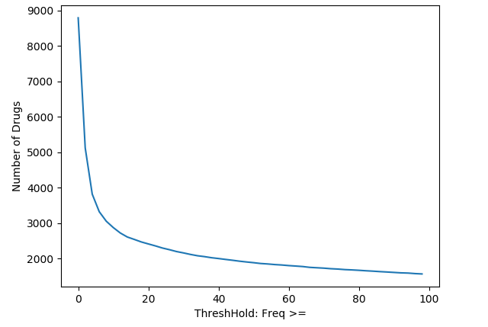

- Matching with DrugBank:
  - Perfect matching: The same names:
    - 1136 drugs.
    - File: MatchingDrug1.txt
  - Partial matching: a drug name in DrugBank is a word contained in a drug name in JADER or vice versa.
    - 1762 drugs in JADER to 901 drugs in DrugBank
    - File: MatchingDrug2.txt
    - Special cases in which JADER names is a combination of several drugs? (on a single line in the JADER data).
      - “manganese chloride / zinc sulfate combination” (manganese ?? zinc sulfate??)
      - How to process?
  - Typos fixing (Sorting candidates+Manually check):
    - 12 drugs
    - File: MatchingDrugH.txt
  - On matching drugs.
    - Total: 1540 drugs.
    - File: MatchingDrugFreq.txt
    - Threshold on matching drugs:
Threshold: 20? (1097 drugs)
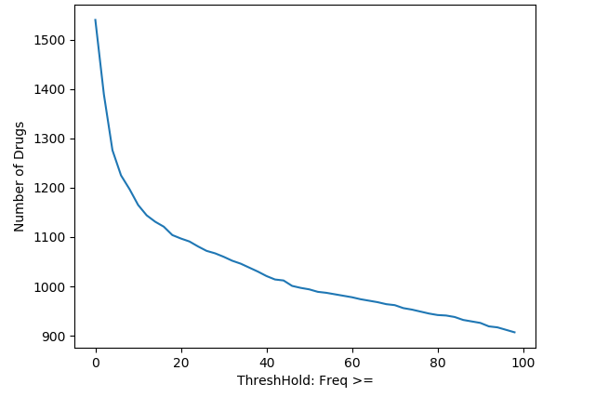

2. Completeness of patient factors:
- Total patients: 662885
  - Gender+Sex: 600378 (90.57%)
  - Gender+Sex+Weigth+Height: 238660 (36%)

3. Side effects:
- 9350 side effects
- File: SeFreq.txt
- Histogram:
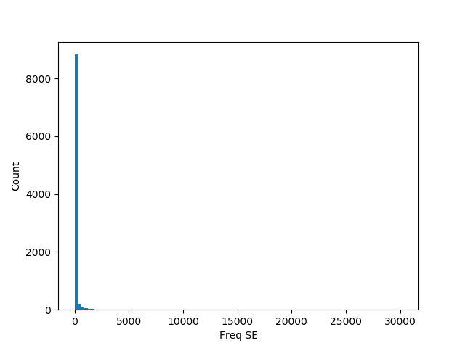
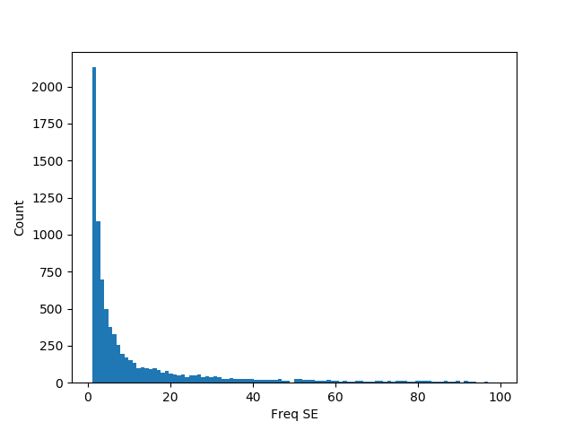
- Thresholds:
Threshold: 40

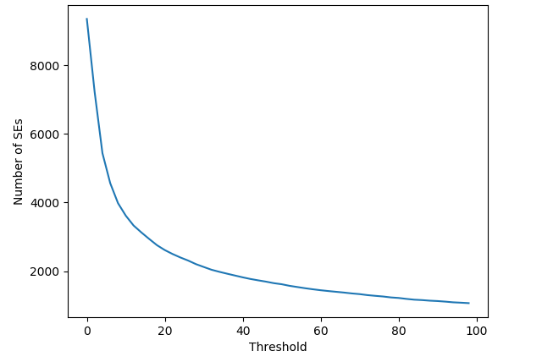

4. Duplicated drugs:

- For each case, they often have different timestamps (intended duplicate)
- Simplify:
  - Only one drug
  - With counts (number of times a drug used), or binary?

