Pokemon GO data analysis

Levi Waldron

Pokemon dataset from <https://www.openintro.org/stat/data/?data=pokemon>.

Option 1, after downloading the csv file to the same directory as this script (PokemonGO.Rmd):

pokemon <- read.csv("pokemon.csv")

Option 2, downloading from the internet:

pokemon = read.csv("https://www.openintro.org/stat/data/pokemon.csv")

pfit = lm(cp ~ species + hp + weight + height, data=pokemon)  
pfit2 = lm(cp ~ (species + hp + weight + height)^2, data=pokemon) #all 2-way interactions  
pfit3 = lm(cp ~ . - notes - name - attack_weak, data=pokemon) # all available predictors except for notes, names, and attack_weak.

# dplyr introduction

Help at <https://www.rstudio.com/wp-content/uploads/2015/02/data-wrangling-cheatsheet.pdf>

Create a dataset that excludes all columns whose name ends in "new" (notice the - before ends_with():

library(dplyr)

##   
## Attaching package: 'dplyr'

## The following objects are masked from 'package:stats':  
##   
## filter, lag

## The following objects are masked from 'package:base':  
##   
## intersect, setdiff, setequal, union

pokemon2 = select(pokemon, -ends_with("new"))

Exclude columns whose name ends in new, then keep only rows where the species is "Pidgey":

pokemon2 = pokemon %>%   
 select(-ends_with("new")) %>%  
 filter(species == "Pidgey")  
summary(pokemon$species)

## Caterpie Eevee Pidgey Weedle   
## 10 6 39 20

summary(pokemon2$species)

## Caterpie Eevee Pidgey Weedle   
## 0 0 39 0

# ggplot2 introduction

Help at <https://www.rstudio.com/wp-content/uploads/2015/03/ggplot2-cheatsheet.pdf>

## A blank canvas

ggplot2 plots are built up piece by piece. The following creates a blank plot, and store all the data to make that plot and build on it in the myplot object:

library(ggplot2)  
myplot = ggplot(aes(cp, cp_new), data=pokemon)

## A scatterplot

To add a scatterplot with colors and a legend, just add a geom_point() call. We could save this to a new object, like myplot2, but in this example we won't create any new object, just make a scatterplot:

myplot + geom_point(aes(color=species))

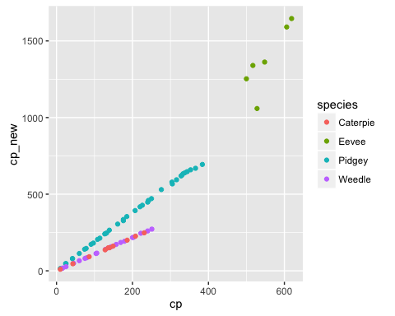

## A scatterplot plus regression lines

Try doing the following one by one, just adding new things to the existing plot. These functions are all documented in the ggplot2 cheat sheet. You can also try skipping some of the lines. Note that nothing will happen until there is a line that doesn't end in "+"

ggplot(aes(cp, cp_new), data=pokemon) +  
 geom_point(aes(color=species)) + #scatterplot  
 geom_smooth(method="lm") + #linear regression line and confidence bands  
 theme_bw() #get rid of the grey background

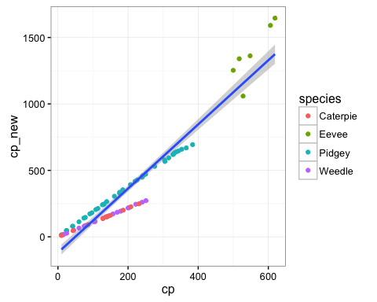

## Boxplot

Now let's make a boxplot:

ggplot(aes(species, cp), data=pokemon) +  
 geom_boxplot(fill="grey") +  
 ggtitle("Combat Power by Species") +  
 xlab("Species") +   
 ylab("Combat Power") +  
 theme_bw()

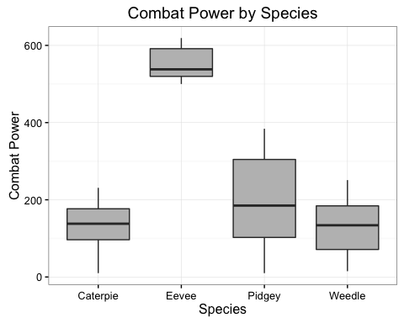

Try other kinds of plots, geom_violin and geom_dotplot...