**INSTALLING R and R Studio your computer**

**INTRODUCTION**

R and R Studio are separate software environments. R is offers a programming platform for scientific computing and graphic, whereas RStudio is an integrated development environment (IDE) or an add-on that allows users to run R in a more user-friendly environment.

RStudio in itself is not very useful without R. On the contrarily, you can use R without RStudio by using any text editor (for example, notepad, Emacs, vi) to write your scripts. As an IDE, RStudio makes it easier to write, run and debug R programs, especially for beginners. For this course it is highly recommend to installation of both R and Rstudio.

**\*\*\* Note**: You will need to install R first before installation RStudio.

The following instructions for installing R and R Studio should work for both **Windows** and **MAC** users.

**INSTALLING R**

* Point your browser to: <http://www.r-project.org/>.
* From the “*Getting Started*” section, click on “[download R](http://cran.r-project.org/mirrors.html)”.
* Scroll down to the end of the page and click on the closest CRAN mirror site.

Recommended CRAN site: <http://iis.stat.wright.edu/CRAN/> Wright State University, Dayton, OH.

* From the “*Download and Install R*” section, click on the link that corresponds to the operating system (OS) of your computer.

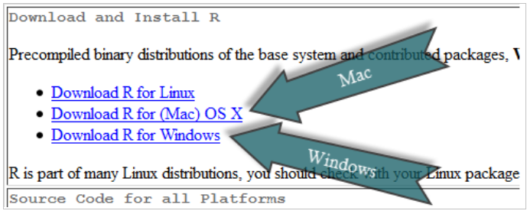That is:

* Click on “[**install R for the first time**](http://iis.stat.wright.edu/CRAN/bin/windows/base/)” (under base)

*You may need to save the file installation file (e.g., “R-3.3.1-win.exe”) and then click on it to start the installation process.*

When the dialog box opens, click “Yes”, “OK”, or “RUN.” The setup wizard should appear. Keep clicking “Next” (or change features **if you understand them**), until it is finished. You should now see the R icon ( ) on your desktop.

This completes the installation of base R on your computer. The next task is to install RStudio.

**INSTALLING R STUDIO**

Note: You must install R before you install RStudio!

* Download RStudio from <https://www.rstudio.com/products/rstudio/download/>
* Scroll to the end of the pricing information and choose the version recommended for your system, Mac or Windows.

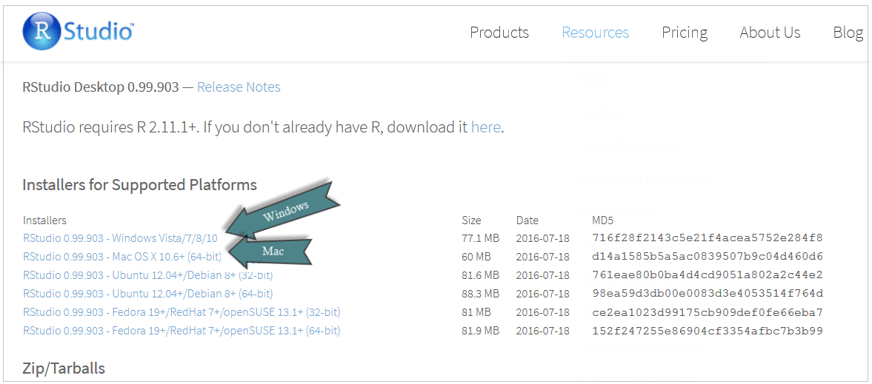

*You may need to save the file installation file (e.g., “RStudio-0.99.903.exe”) and then click on it to start the installation process.*

* Follow the directions to install RStudio on your computer.

*When the dialog box opens, click “Yes”, “OK”, or “RUN.” The setup wizard should appear. Keep clicking “Next” (or change features* ***if you understand them****), until it is finished.*

Unlike the installation of R, RStudio installation may not create an icon on your desktop. You can still access you through your search or Windows button.

RStudio’s command icon is

**USING R AND STUDIO**

Open R Studio by clicking on the icon.

If your installation was successful, you will see an IDE screen similar to the following:

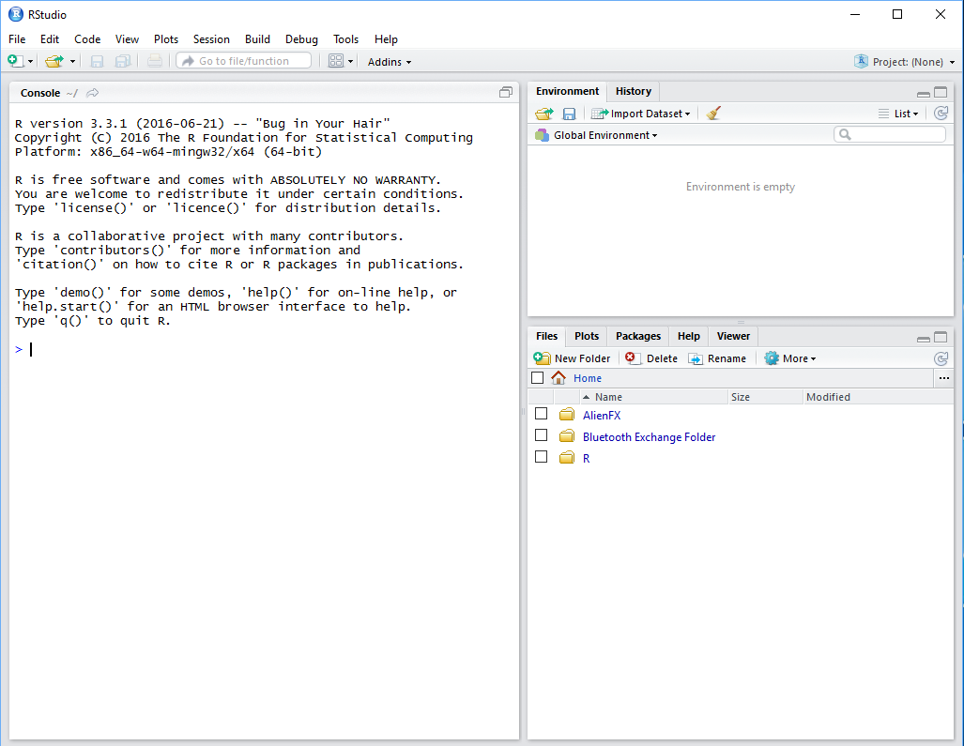

If you see the above screen, you’re ready to go!

**EXITING R AND R STUDIO**

You can exit both R and RStudio at the same time using File → Quit R Studio

Or you can type q() at the command prompt.

Note that this is the letter q followed by open and closed parentheses.