ECOG314 -- Suggested project guidelines -- A worked example using Wine dataset from UCI data repository

William Ampeh

September 12, 2016

## Demo on how to analyze a multivariate dataset from UCI ML data repository

### Reference materials

1. [This R Data Import Tutorial Is Everything You Need -- R bloggers](http://blog.datacamp.com/r-data-import-tutorial/)
2. [Importing Data Into R - Part Two -- R bloggers](http://www.r-bloggers.com/importing-data-into-r-part-two/)

## Data repositories

* [Financial Accounts of the United States](http://www.federalreserve.gov/datadownload/Choose.aspx?rel=Z.1)
* [DATA.GOV](https://www.data.gov/)
* [UCI Data Repository](http://archive.ics.uci.edu/ml/) -- Machine learning datasets

## Financial Data repositories

* [Federal Reserve](http://www.federalreserve.gov/releases) -- few clicks required financial_accounts_of_the_us.png
* [Data Market](https://datamarket.com/data/list/?q=provider:tsdl) one of the user friendly Websites -- few clicks required
* [INFORUM](http://inforumweb.umd.edu/econdata/econdatacontents.html) -- requires Inforum's database and regression package, G, to access that data

## Big Data repositories

* [Data Science Central](http://www.datasciencecentral.com/profiles/blogs/big-data-sets-available-for-free)
* [Big data made simple](http://bigdata-madesimple.com/70-websites-to-get-large-data-repositories-for-free/)
* [Amazon Web Service (AWS)](https://aws.amazon.com/public-data-sets/)
* [caesar0301/awesome-public-datasets](https://github.com/caesar0301/awesome-public-datasets)

## Steps:

1. Visit the [UCI wine data repository](http://archive.ics.uci.edu/ml/datasets/Wine) for a detailed description, the data dictionary and maintainer of the data

* results of a chemical analysis of the qualities of wines grown in the same region in Italy but derived from 3 different cultivars (a plant variety that has been produced in cultivation by selective breeding)
* 14 columns (dimensions, attributes)
* with 1st column containing the cultivar of a wine sample (labelled 1, 2 or 3)
* next 13 columns contain the concentrations of the 13 different chemicals in that sample

1. Setup your project workspace and cd into that direction (Session -> Set Working Directory -> Choose Directory (CNTRL+Shift+h)
2. Read dataset into R

* read.table(...)
* I always get a segment of the file first (for very large files) read.table("my_some_datatable_name.txt" header = TRUE, nrows = 25) # easier to work with smaller dataset

### 

### Step 1 of N: Point browser to the UCI wine dataset repository

* [UCI ML wine dataset repository](http://archive.ics.uci.edu/ml/datasets/Wine)

### Step 2 of N: Clear workspace, and set and cd into working directory

**R-CODE**

rm(list=ls())  
  
# Set working directory and set Project-related global variables  
setwd("C:/Users/William/Desktop/ECOG314/lecture_3")  
  
# You do not have to, but if you need to share variable between different functions you can use  
some_global_variable1 <<- 0 # take note of the <<-  
some_global_variable2 <<- 0   
  
max_steps <- 10  
   
# alternatively you can use  
assign("some_global_variable3", 0)  
  
some_local_variable1 <- 0

### 

### Step 3 of N: Read the multivariate dataset into R

#### Data structure

* Data consists of 1 row per of record (observation) wine sample.
* First column, the cultivar of a wine sample is labelled 1, 2 or 3
* Next 12 columns contain the concentrations of the 13 different chemicals in that sample.
* Columns are separated by commas.

#### Segments from the wine dataset:

#### Reading the data

* We use read.table() function to read in the data into R
* We use sep="," argument in read.table() to specify that columns are separated by commas.

**R-CODE**

mysample <- 25 # Using nrows, even as a mild over-estimate, will help memory usage  
 # -1 => skip record #1, i.e., the HEADER in the file, resulting in 177 records (observations)  
  
wine <- read.table(  
 file = "http://archive.ics.uci.edu/ml/machine-learning-databases/wine/wine.data", # filename at the UCI repository  
 header = TRUE, # filehas a header  
 sep = ",", # rows separated by commas  
 nrow = mysample # just the first n=25 rows + 1 header = 26  
 )

**R-CODE**

#--  
# check dimension of the data you have read -- data sanity check 1

dim(wine)

Output: [1] 25 14

**R-CODE**

class(wine)

Output: [1] "data.frame"

**R-CODE**

head(wine, n=5)

Output:

X1 X14.23 X1.71 X2.43 X15.6 X127 X2.8 X3.06 X.28 X2.29 X5.64 X1.04 X3.92 X1065  
 1 1 13.20 1.78 2.14 11.2 100 2.65 2.76 0.26 1.28 4.38 1.05 3.40 1050  
 2 1 13.16 2.36 2.67 18.6 101 2.80 3.24 0.30 2.81 5.68 1.03 3.17 1185  
 3 1 14.37 1.95 2.50 16.8 113 3.85 3.49 0.24 2.18 7.80 0.86 3.45 1480  
 4 1 13.24 2.59 2.87 21.0 118 2.80 2.69 0.39 1.82 4.32 1.04 2.93 735  
 5 1 14.20 1.76 2.45 15.2 112 3.27 3.39 0.34 1.97 6.75 1.05 2.85 1450

##### BIG DATA files, import and extract a random sample into R, then offload master file onto hard drive to free up memory

* Use read.table(...) function to read in the data into R
* Use sample(...) function to get a random sample from the raw data
* Use saveRDS(...) and rm(...) functions to saVE file to hard drive and remove BIG DATA file to free up memory
* For Ubuntu and Linux users, this can be done at the Operating System (OS) level
* shuf -n 10 > small_wine_data.txt
* Use nl wine_data.txt | shuf -n 10 to verify that the lines in file has been shuffled (randomized)

**R-CODE**

# to take a random sample of 25 rows from the file  
  
#   
n <- sample( x = c(1:178), # range of rows  
 size = 25, # number of ranomly selected rows  
 replace = FALSE # sample WITHOUT replacement  
 )  
  
cat(sprintf("\nRows selected at random: %s\n", paste(n, collapse = ', ')))

Output:   
## Rows selected at random: 175, 24, 97, 51, 5, 121, 104, 15, 149, 18, 78, 108, 146, 161, 111, 54, 26, 64, 166, 147, 58, 154, 49, 98, 60

**R-CODE**

# Read the data from source  
big_wine.df <- read.table( # we know from above that the class of object returned by read.table is a data.frame (.df extension)  
 file = "http://archive.ics.uci.edu/ml/machine-learning-databases/wine/wine.data", # filename at the UCI repository  
 header = TRUE, # file has a header  
 sep = "," # rows separated by commas. NOTE: We took out the comma after at the end of the line  
 # nrow = mysample # we are ready every line in the file  
 )  
  
# column names  
colnames(big_wine.df) <- paste("v", 1:dim(big_wine.df)[2], sep="") # v1, v2, ....v13, v14  
head(big_wine.df)

Output:

v1 v2 v3 v4 v5 v6 v7 v8 v9 v10 v11 v12 v13 v14  
 1 1 13.20 1.78 2.14 11.2 100 2.65 2.76 0.26 1.28 4.38 1.05 3.40 1050  
 2 1 13.16 2.36 2.67 18.6 101 2.80 3.24 0.30 2.81 5.68 1.03 3.17 1185  
 3 1 14.37 1.95 2.50 16.8 113 3.85 3.49 0.24 2.18 7.80 0.86 3.45 1480  
 4 1 13.24 2.59 2.87 21.0 118 2.80 2.69 0.39 1.82 4.32 1.04 2.93 735  
 5 1 14.20 1.76 2.45 15.2 112 3.27 3.39 0.34 1.97 6.75 1.05 2.85 1450  
 6 1 14.39 1.87 2.45 14.6 96 2.50 2.52 0.30 1.98 5.25 1.02 3.58 1290

**R-CODE**

# check dimension of the data you have read -- data sanity check 1  
dim(big_wine.df)

Output: [1] 177 14

**R-CODE**

small_wine.df <- big_wine.df[n, ] #every row specified by n. That is 86, 1

53, 78, 43, 13, 18 .... this changes if you do not specify a seed  
  
dim(small_wine.df)

Output: [1] 25 14

**R-CODE**

small_wine.df # see that indeed we are not using the entire dataset

Output:

v1 v2 v3 v4 v5 v6 v7 v8 v9 v10 v11 v12 v13 v14  
 175 3 13.27 4.28 2.26 20.0 120 1.59 0.69 0.43 1.35 10.20 0.59 1.56 835  
 24 1 13.50 1.81 2.61 20.0 96 2.53 2.61 0.28 1.66 3.52 1.12 3.82 845  
 97 2 12.29 1.41 1.98 16.0 85 2.55 2.50 0.29 1.77 2.90 1.23 2.74 428  
 51 1 13.83 1.65 2.60 17.2 94 2.45 2.99 0.22 2.29 5.60 1.24 3.37 1265  
 5 1 14.20 1.76 2.45 15.2 112 3.27 3.39 0.34 1.97 6.75 1.05 2.85 1450  
 121 2 11.56 2.05 3.23 28.5 119 3.18 5.08 0.47 1.87 6.00 0.93 3.69 465  
 104 2 12.51 1.73 1.98 20.5 85 2.20 1.92 0.32 1.48 2.94 1.04 3.57 672  
 15 1 13.63 1.81 2.70 17.2 112 2.85 2.91 0.30 1.46 7.30 1.28 2.88 1310  
 149 3 13.08 3.90 2.36 21.5 113 1.41 1.39 0.34 1.14 9.40 0.57 1.33 550  
 18 1 14.19 1.59 2.48 16.5 108 3.30 3.93 0.32 1.86 8.70 1.23 2.82 1680  
 78 2 12.33 0.99 1.95 14.8 136 1.90 1.85 0.35 2.76 3.40 1.06 2.31 750  
 108 2 12.22 1.29 1.94 19.0 92 2.36 2.04 0.39 2.08 2.70 0.86 3.02 312  
 146 3 13.88 5.04 2.23 20.0 80 0.98 0.34 0.40 0.68 4.90 0.58 1.33 415  
 161 3 13.69 3.26 2.54 20.0 107 1.83 0.56 0.50 0.80 5.88 0.96 1.82 680  
 111 2 12.52 2.43 2.17 21.0 88 2.55 2.27 0.26 1.22 2.00 0.90 2.78 325  
 54 1 13.74 1.67 2.25 16.4 118 2.60 2.90 0.21 1.62 5.85 0.92 3.20 1060  
 26 1 13.39 1.77 2.62 16.1 93 2.85 2.94 0.34 1.45 4.80 0.92 3.22 1195  
 64 2 12.17 1.45 2.53 19.0 104 1.89 1.75 0.45 1.03 2.95 1.45 2.23 355  
 166 3 13.45 3.70 2.60 23.0 111 1.70 0.92 0.43 1.46 10.68 0.85 1.56 695  
 147 3 12.87 4.61 2.48 21.5 86 1.70 0.65 0.47 0.86 7.65 0.54 1.86 625  
 58 1 13.72 1.43 2.50 16.7 108 3.40 3.67 0.19 2.04 6.80 0.89 2.87 1285  
 154 3 12.58 1.29 2.10 20.0 103 1.48 0.58 0.53 1.40 7.60 0.58 1.55 640  
 49 1 13.94 1.73 2.27 17.4 108 2.88 3.54 0.32 2.08 8.90 1.12 3.10 1260  
 98 2 12.37 1.07 2.10 18.5 88 3.52 3.75 0.24 1.95 4.50 1.04 2.77 660  
 60 2 12.33 1.10 2.28 16.0 101 2.05 1.09 0.63 0.41 3.27 1.25 1.67 680

**R-CODE**

#change the column names  
colnames(small_wine.df) <- paste("v", 1:dim(small_wine.df)[2], sep="") # v1, v2, ....v13, v14  
head(small_wine.df, n=5)

Output:

v1 v2 v3 v4 v5 v6 v7 v8 v9 v10 v11 v12 v13 v14  
 175 3 13.27 4.28 2.26 20.0 120 1.59 0.69 0.43 1.35 10.20 0.59 1.56 835  
 24 1 13.50 1.81 2.61 20.0 96 2.53 2.61 0.28 1.66 3.52 1.12 3.82 845  
 97 2 12.29 1.41 1.98 16.0 85 2.55 2.50 0.29 1.77 2.90 1.23 2.74 428  
 51 1 13.83 1.65 2.60 17.2 94 2.45 2.99 0.22 2.29 5.60 1.24 3.37 1265  
 5 1 14.20 1.76 2.45 15.2 112 3.27 3.39 0.34 1.97 6.75 1.05 2.85 1450

### 

### Step 4 of N: Handle Missing Values in data

After reading the dataset into R, do a summary on your data and deal with missing values in the data, See [Remove/Replace/Deal with NA entries](http://forums.psy.ed.ac.uk/R/P01582/essential-10/)

**R-CODE**

#maybe  
t(summary(small_wine.df)) # t(..) to transpose

Output:

v1 Min. :1.00 1st Qu.:1.00 Median :2.00 Mean :1.92 3rd Qu.:3.00 Max. :3.00   
 v2 Min. :11.56 1st Qu.:12.37 Median :13.27 Mean :13.09 3rd Qu.:13.72 Max. :14.20   
 v3 Min. :0.990 1st Qu.:1.430 Median :1.730 Mean :2.193 3rd Qu.:2.430 Max. :5.040   
 v4 Min. :1.940 1st Qu.:2.170 Median :2.360 Mean :2.368 3rd Qu.:2.540 Max. :3.230   
 v5 Min. :14.80 1st Qu.:16.50 Median :19.00 Mean :18.88 3rd Qu.:20.00 Max. :28.50   
 v6 Min. : 80.0 1st Qu.: 92.0 Median :104.0 Mean :102.7 3rd Qu.:112.0 Max. :136.0   
 v7 Min. :0.980 1st Qu.:1.830 Median :2.450 Mean :2.361 3rd Qu.:2.850 Max. :3.520   
 v8 Min. :0.34 1st Qu.:1.09 Median :2.27 Mean :2.25 3rd Qu.:2.99 Max. :5.08   
 v9 Min. :0.1900 1st Qu.:0.2900 Median :0.3400 Mean :0.3608 3rd Qu.:0.4300 Max. :0.6300   
 v10 Min. :0.410 1st Qu.:1.220 Median :1.480 Mean :1.548 3rd Qu.:1.950 Max. :2.760   
 v11 Min. : 2.000 1st Qu.: 3.400 Median : 5.850 Mean : 5.808 3rd Qu.: 7.600 Max. :10.680   
 v12 Min. :0.540 1st Qu.:0.860 Median :0.960 Mean :0.968 3rd Qu.:1.120 Max. :1.450   
 v13 Min. :1.330 1st Qu.:1.820 Median :2.780 Mean :2.557 3rd Qu.:3.100 Max. :3.820   
 v14 Min. : 312.0 1st Qu.: 550.0 Median : 680.0 Mean : 817.5 3rd Qu.:1195.0 Max. :1680.0

**R-CODE**

# what about  
apply(small_wine.df, 2, function(x) sum(is.na(x)))

Output:

v1 v2 v3 v4 v5 v6 v7 v8 v9 v10 v11 v12 v13 v14   
 0 0 0 0 0 0 0 0 0 0 0 0 0 0

**R-CODE**

# what about big wine  
t(summary(big_wine.df))

Output:   
 v1 Min. :1.000 1st Qu.:1.000 Median :2.000 Mean :1.944 3rd Qu.:3.000 Max. :3.000   
 v2 Min. :11.03 1st Qu.:12.36 Median :13.05 Mean :12.99 3rd Qu.:13.67 Max. :14.83   
 v3 Min. :0.74 1st Qu.:1.60 Median :1.87 Mean :2.34 3rd Qu.:3.10 Max. :5.80   
 v4 Min. :1.360 1st Qu.:2.210 Median :2.360 Mean :2.366 3rd Qu.:2.560 Max. :3.230   
 v5 Min. :10.60 1st Qu.:17.20 Median :19.50 Mean :19.52 3rd Qu.:21.50 Max. :30.00   
 v6 Min. : 70.00 1st Qu.: 88.00 Median : 98.00 Mean : 99.59 3rd Qu.:107.00 Max. :162.00   
 v7 Min. :0.980 1st Qu.:1.740 Median :2.350 Mean :2.292 3rd Qu.:2.800 Max. :3.880   
 v8 Min. :0.340 1st Qu.:1.200 Median :2.130 Mean :2.023 3rd Qu.:2.860 Max. :5.080   
 v9 Min. :0.1300 1st Qu.:0.2700 Median :0.3400 Mean :0.3623 3rd Qu.:0.4400 Max. :0.6600   
 v10 Min. :0.410 1st Qu.:1.250 Median :1.550 Mean :1.587 3rd Qu.:1.950 Max. :3.580   
 v11 Min. : 1.280 1st Qu.: 3.210 Median : 4.680 Mean : 5.055 3rd Qu.: 6.200 Max. :13.000   
 v12 Min. :0.480 1st Qu.:0.780 Median :0.960 Mean :0.957 3rd Qu.:1.120 Max. :1.710   
 v13 Min. :1.270 1st Qu.:1.930 Median :2.780 Mean :2.604 3rd Qu.:3.170 Max. :4.000   
 v14 Min. : 278.0 1st Qu.: 500.0 Median : 672.0 Mean : 745.1 3rd Qu.: 985.0 Max. :1680.0

**R-CODE**

#Elegant way to report missing values in a data.frame: http://stackoverflow.com/questions/8317231/elegant-way-to-report-missing-values-in-a-data-frame  
sapply(big_wine.df, function(x) sum(is.na(x)))

Output:

v1 v2 v3 v4 v5 v6 v7 v8 v9 v10 v11 v12 v13 v14   
 0 0 0 0 0 0 0 0 0 0 0 0 0 0

### Step 4 of N: Plotting Multivariate Data

After reading the dataset into R, the next step is usually to plot of the resulting data See [Scatterplot matrices in R](https://www.r-bloggers.com/scatterplot-matrices-in-r/)

#### A Matrix Scatterplot

For multivariate data, one usually makes a matrix scatterplot, showing each pair of variables plotted against each other. The scatterplotMatrix(...) function is available in the car package. That is: install.packages("car"); library(car)

**R-CODE**

#-  
# Plot #1: A matrix scatterplot  
windows()  
scatterplotMatrix(small_wine.df[, 2:6], # exclude column 1, class label  
 main="Small Wine Scatterplot Matrix" # title of plot  
 )

Output:

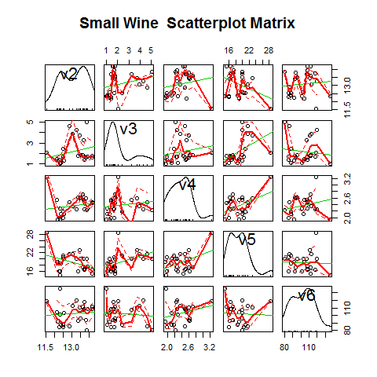

**R-CODE**

#--  
# panel.smooth function is built in.  
# panel.cor puts correlation in upper panels, size proportional to correlation  
panel.cor <- function(x, y, digits=2, prefix="", cex.cor, ...)  
{  
 usr <- par("usr"); on.exit(par(usr))  
 par(usr = c(0, 1, 0, 1))  
 r <- abs(cor(x, y))  
 txt <- format(c(r, 0.123456789), digits=digits)[1]  
 txt <- paste(prefix, txt, sep="")  
 if(missing(cex.cor)) cex.cor <- 0.8/strwidth(txt)  
 text(0.5, 0.5, txt, cex = cex.cor * r)  
}  
  
# Plot #2: same as above, but add loess smoother in lower and correlation in upper  
windows()  
pairs(big_wine.df[, 2:6],  
 lower.panel=panel.smooth, # lower portion of plot is the smooth plot  
 upper.panel=panel.cor, # uppper portion is a correlation plot  
 pch=23, # plot symbols, see http://www.statmethods.net/advgraphs/parameters.html  
 main="Big Wine Scatterplot Matrix",  
 na.action = na.omit # causes cases with missing values in any of the variables to be omitted entirely.  
 )

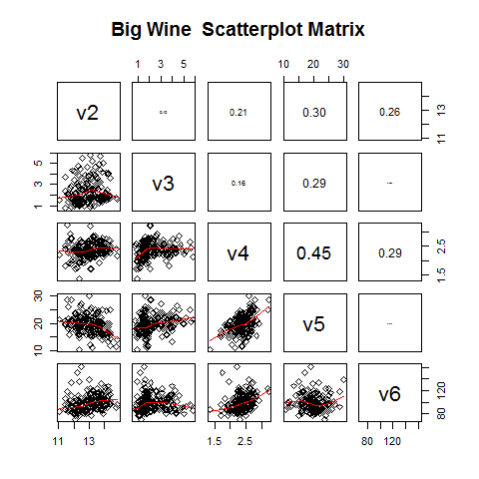Output:

##### 

##### Scatterplot with data Points labelled by group

Observation If you observe any interesting scatterplot for any two variables in the matrix scatterplot, plot that scatterplot in more detail, with the data points labelled by their group (their cultivar, i.e., v1 .. v14)

For example, the pair plot above, shows the 3rd column of the 4th row down is a scatterplot of V4 (x-axis) against V5 (y-axis). The figure shows a correlation of 0.45, that is a positive relationship between V4 and V5.

##### Zoom in on any interesting relationship with a plot

#Use plot(x= , y= ) or qplot(x= , y= ). I will use ggplot(data= ...)

**R-CODE**

# simplr plot  
## define base for the graphs and store in object 'p'  
  
v4_v5.plot <- ggplot(data = big_wine.df, aes(x = v4, y = v5, group=v1, color=factor(v1), shape=factor(v1)))  
  
## just plotting points (a.k.a., scatterplot)  
windows()  
v4_v5.plot + geom_point() # + #geom_line() # simple spaghetti plot

Output: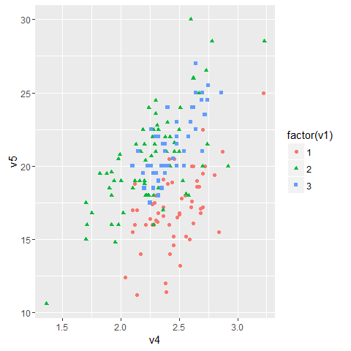

**R-CODE**

#---  
# A more elaborate plot  
# setup plot  
v4_v5.plot <- ggplot( # cool plotting package  
 data=big_wine.df, # dataset in this case a data.frame  
 aes(  
 x = v4, # x-axis  
 y = v5, # y-axis  
 colour= factor(v1), # color to use for the points  
 shape = factor(v1)  
 )) +   
 geom_point( size = 3) + # plot points only, with increased size  
 xlab("V4") + # x and y lables  
 ylab("V5)") +  
 ggtitle("Plot of V4 vs. V5 of the wine dataset")   
  
  
  
v4_v5.plot <- v4_v5.plot +   
 theme( # the beauty of ggplot, you can add layers later  
 plot.title = element_text(lineheight=1.2, face="bold", size=10.5 ), #beautify title  
 legend.position = c(1.01, 0.28), legend.justification=c(1,1), #position the legend  
 legend.position = "bottom", legend.justification=c(1,1), #position the legend  
 legend.text = element_text(size=6.5), #format legend text  
 axis.text.x = element_text(size=6.5), #format x-axis text  
 axis.title.x = element_text(size = rel(0.75)) #format x-axis title  
 )  
  
#--

#open a display window, else R will use RStudio's window  
windows()  
#-  
# Add aesthetic mappings  
#v4_v5.plot <- v4_v5.plot + geom_text(aes(colour = factor(v1), size=2))  
  
# now display the plot  
v4_v5.plot

Output

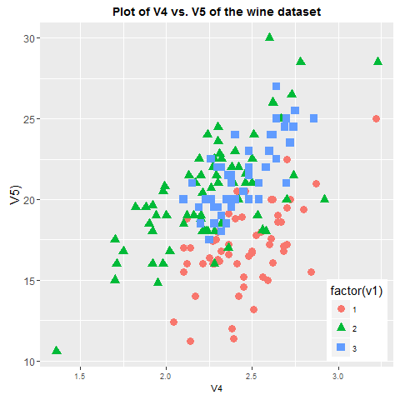

#### Observation fom detailed plot

We can see from the plot of x=V4 versus y=V5 that

wines from cultivar 1 seem to have lower values of V5 compared to the wines of cultivar 2 and 3

wines from cultivar 2 seem to have lower values of V4 compared to the wines of cultivar 1

### A Profile Plot

[Good reference for profile plot](https://cran.r-project.org/web/packages/profileR/vignettes/jss_profileR.pdf)

[Useful functions for Multivariate data analysis](http://www.uni-regensburg.de/wirtschaftswissenschaften/vwl-tschernig/medien/programmieren-mit-r/pmr_tut_multivariatedataanalysis.r)

Another useful plot is a profile plot which plots the value of each of the variables for each of the samples to show the variation in each of the variables.

* Use the function makeProfilePlot(...) to make a profile plot. ++ Note: The makeProfilePlot(...) function requires the RColorBrewer library

#### A profile plot of the concentrations of the first 9 chemicals in the wine samples in columns V2, V3, V4, V5, V6, v7, v8, v9 of the big_wine dataset

**R-CODE**

source("helper_functions/pmr_tut_multivariatedataanalysis_edited_by_william.r")  
  
# Gives us access to the following functions:  
# 1: makeProfilePlot  
  
chem.names <- paste("V", 2:9, sep="")  
  
mylist <- list(big_wine.df$v2, big_wine.df$v3, big_wine.df$v4, big_wine.df$v5,  
 big_wine.df$v6, big_wine.df$v7, big_wine.df$v8, big_wine.df$v9)  
  
#--  
windows()  
  
makeProfilePlot(mylist, chem.names,   
 title=sprintf("Profile plot of: %s", paste(chem.names, collapse = ', '))  
 )  
grid()

Output

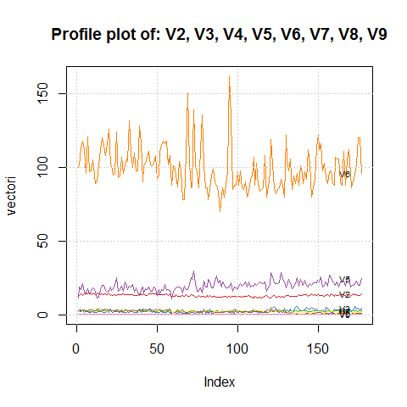

#### Observation fom detailed plot

We can see from the profile plot that * the mean and standard deviation for V6 is quite a lot higher than that for the other variables.

### Calculating Summary Statistics for Multivariate Data

* For statistics on a dataset refer to the Mosaic package.
* Here we would calculate 2 summary statistics for each of the variables in the wine data set
* Use sapply
* mean
* standard deviation

**R-CODE**

sapply(big_wine.df[, 2:9], mean) #mean and std of 2nd to 9th variables

Output

v2 v3 v4 v5 v6 v7 v8 v9   
 12.9936723 2.3398870 2.3661582 19.5169492 99.5875706 2.2922599 2.0234463 0.3623164

**R-CODE**

sapply(big_wine.df[, 2:9], sd)

Output

v2 v3 v4 v5 v6 v7 v8 v9   
 0.8088084 1.1193144 0.2750804 3.3360711 14.1740185 0.6264651 0.9986576 0.1246529

**R-CODE**

# per sample type  
group1_index = which(big_wine.df$v1 == 1); head(group1_index) # get the index

Output

[1] 1 2 3 4 5 6

**R-CODE**

group2_index = which(big_wine.df$v1 == 2); head(group2_index)

Output

[1] 59 60 61 62 63 64

**R-CODE**

group3_index = which(big_wine.df$v1 == 3); head(group3_index)

Output

[1] 130 131 132 133 134 135

**R-CODE**

sapply(big_wine.df[ group1_index, 2:9], mean) #mean and std of 2nd to 9th variables

Output

v2 v3 v4 v5 v6 v7 v8 v9   
 13.7363793 2.0158621 2.4560345 17.0620690 105.9827586 2.8408621 2.9810345 0.2901724

**R-CODE**

sapply(big_wine.df[ group2_index, 2:9], mean)

Output

v2 v3 v4 v5 v6 v7 v8 v9   
 12.278732 1.932676 2.244789 20.238028 94.549296 2.258873 2.080845 0.363662

**R-CODE**

sapply(big_wine.df[ group3_index, 2:9], mean)

Output

v2 v3 v4 v5 v6 v7 v8 v9   
 13.1537500 3.3337500 2.4370833 21.4166667 99.3125000 1.6787500 0.7814583 0.4475000

#### 

#### Observation

* We are only able to compute the mean and standard deviation of the 2-9 chemicals' concentrations for just cultivar 1 samples, or for just cultivar 3 samples, in a similar way. statistics by variable for the entire group.
* What about by group with with just 1 line of command? [Use google, e.g.: "r calculating standard deviation by group in a data"](http://stackoverflow.com/questions/16367436/compute-mean-and-standard-deviation-by-group-for-multiple-variables-in-a-data-fr)

##### Means and Variances Per Group

**R-CODE**

big_wine_groups.df <- t( big_wine.df %>% group_by(v1) %>% summarise_each(funs(mean, sd)) ) # transpose  
colnames(big_wine_groups.df) <- c("Group_1", "Group_2", "Group_3")  
  
#--  
# exclude row 1, V1  
big_wine_groups.df <- big_wine_groups.df[-(1), ]  
head(big_wine_groups.df)

Output

Group_1 Group_2 Group_3  
 v2_mean 13.736379 12.278732 13.153750  
 v3_mean 2.015862 1.932676 3.333750  
 v4_mean 2.456034 2.244789 2.437083  
 v5_mean 17.062069 20.238028 21.416667  
 v6_mean 105.982759 94.549296 99.312500  
 v7_mean 2.840862 2.258873 1.678750

**R-CODE**

#show me rowsnames containing the word "mean"  
# Use google: search for: "R show rownames that contain a word""  
#http://stackoverflow.com/questions/13043928/selecting-rows-where-a-column-has-a-string-like-hsa-partial-string-match  
  
index_of_row_name_contain_mean <- grep("_mean", rownames(big_wine_groups.df))

Output

2 3 4 5 6 7 8 9 10 11 12 13 14

**R-CODE**

#-  
# Now show the rows containing the word "mean"  
group.means <- big_wine_groups.df[index_of_row_name_contain_mean, ]   
group.means

Output

Group_1 Group_2 Group_3  
 v2_mean 13.7363793 12.278732 13.1537500  
 v3_mean 2.0158621 1.932676 3.3337500  
 v4_mean 2.4560345 2.244789 2.4370833  
 v5_mean 17.0620690 20.238028 21.4166667  
 v6_mean 105.9827586 94.549296 99.3125000  
 v7_mean 2.8408621 2.258873 1.6787500  
 v8_mean 2.9810345 2.080845 0.7814583  
 v9_mean 0.2901724 0.363662 0.4475000  
 v10_mean 1.8925862 1.630282 1.1535417  
 v11_mean 5.5263793 3.086620 7.3962500  
 v12_mean 1.0624138 1.056282 0.6827083  
 v13_mean 3.1446552 2.785352 1.6835417  
 v14_mean 1116.5862069 519.507042 629.8958333

**R-CODE**

#---  
# do the same for variance  
group.variance <- big_wine_groups.df[-c(index_of_row_name_contain_mean), ]  
group.variance

Output

Group_1 Group_2 Group_3  
 v2_sd 0.46163211 0.5379642 0.5302413  
 v3_sd 0.69340005 1.0155687 1.0879057  
 v4_sd 0.22912449 0.3154673 0.1846902  
 v5_sd 2.56137488 3.3497704 2.2581609  
 v6_sd 10.22465438 16.7534975 10.8904726  
 v7_sd 0.34187966 0.5453611 0.3569709  
 v8_sd 0.40083111 0.7057008 0.2935041  
 v9_sd 0.07064841 0.1239613 0.1241396  
 v10_sd 0.41241931 0.6020678 0.4088359  
 v11_sd 1.24930114 0.9249293 2.3109421  
 v12_sd 0.11746310 0.2029368 0.1144411  
 v13_sd 0.34550353 0.4965735 0.2721114  
 v14_sd 223.35276437 157.2112204 115.0970432

*** NEXT WE ARE GOING EXPLORE HOW WORK WITH A TOY DATASET ***

### Reading from a toy dataset

Most times it is better doing the exploratory work using a smaller dataset and then use the code written on your big dataset. An example is shown below:

**R-CODE**

toy.data <- read.table(header = TRUE, text = "  
Group_1 Group_2 Group_3  
4.0 2.9 4.5  
3.6 2.3 3.8  
3.7 2.9 4.0  
4.1 3.5 5.2  
3.9 3.7 3.9  
4.0 3.0 4.1   
")  
  
toy.data #show the data

Output

Group_1 Group_2 Group_3  
 1 4.0 2.9 4.5  
 2 3.6 2.3 3.8  
 3 3.7 2.9 4.0  
 4 4.1 3.5 5.2  
 5 3.9 3.7 3.9  
 6 4.0 3.0 4.1

#--

**R-CODE**

toy.df <<- melt(toy.data)

## Using as id variables

colnames(toy.df) <- c("v1", "v2")  
toy.df

Output

v1 v2  
 1 Group_1 4.0  
 2 Group_1 3.6  
 3 Group_1 3.7  
 4 Group_1 4.1  
 5 Group_1 3.9  
 6 Group_1 4.0  
 7 Group_2 2.9  
 8 Group_2 2.3  
 9 Group_2 2.9  
 10 Group_2 3.5  
 11 Group_2 3.7  
 12 Group_2 3.0  
 13 Group_3 4.5  
 14 Group_3 3.8  
 15 Group_3 4.0  
 16 Group_3 5.2  
 17 Group_3 3.9  
 18 Group_3 4.1

##### Boxplot  
p <- ggplot(toy.df, aes(v1, v2))  
p <- p + geom_boxplot(fill = "white", colour = "#3366FF") +  
 ylab("Length (in m)") + xlab("") +  
 ggtitle("Boxplot of the toy dataset")   
p # display plot

#ADD POINTS IF YOU WISH  
p <- p + geom_jitter(width = 0.2, aes(colour = v1), size=2) #add points  
p # display plot

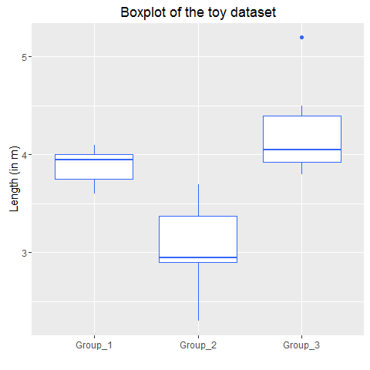Output

# beautify plot  
p <- p + theme(  
 legend.position = c(1.01, 0.19), legend.justification=c(1,1), #position the legend  
 legend.position = "bottom", legend.justification=c(1,1), #position the legend  
 legend.text = element_text(size=6.5)) #format legend text  
  
#plot  
windows()  
p

Output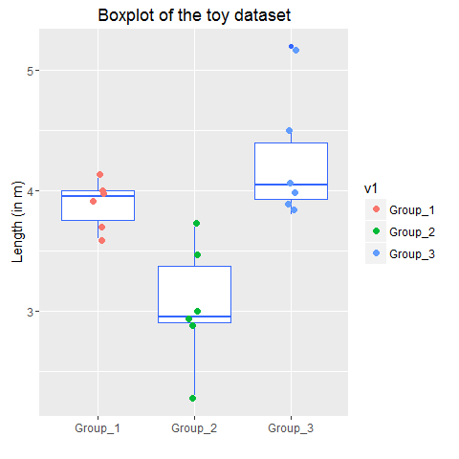

##### Descriptive Statistics

#--  
# Get N  
N.dim = dim( toy.df )  
N <- ( N.dim[1] * N.dim[2] ) - N.dim[1] # could have simply said N.dim[1], but setting program up for big_wine.df  
N

Output [1] 18

**R-CODE**

# group counts  
n <- toy.df %>% group_by(v1) %>% summarise_each(funs(length))   
n # data frame [3 x 14]

Output

# Source: local data frame [3 x 2]  
   
 v1 v2  
 (fctr) (int)  
 1 Group_1 6  
 2 Group_2 6  
 3 Group_3 6

#-

**R-CODE**

K = 3 # K = number of groups  
#--  
# Note  
# mean(big_wine.df) returns column means  
# mean( as.matrix(big_wine.df ) ) # one value.  
  
x_2bar <- mean(as.matrix(toy.df[, -c(1)] ))  
x_2bar

Output

[1] 3.727778

#-

**R-CODE**

toy.table <- toy.df %>% group_by(v1) %>% summarise_each(funs(length, mean, sd, min, max))  
toy.table$stderr <- toy.table$sd / sqrt(toy.table$length)  
toy.table$E <- qnorm(.975)*toy.table$stderr # margin of error 95% CI   
toy.table$lowerbound <- toy.table$mean - toy.table$E  
toy.table$upperbound <- toy.table$mean + toy.table$E  
  
descriptive.stats <- data.frame(  
 Groups = c(1:3),  
 N = c(toy.table$length),  
 Mean = c(toy.table$mean),  
 "Std Deviation" = c(toy.table$sd),  
 "Std Error" = c(toy.table$stderr),  
 "CI_Lower Bound" = c(toy.table$lowerbound),  
 "CI_Upper Bound" = c(toy.table$upperbound),  
 "Minimum" = c(toy.table$min),  
 "Maximum" = c(toy.table$max)  
 )

#--

#show table

Descriptive.stats

Output

# Groups N Mean Std.Deviation Std.Error CI_Lower.Bound CI_Upper.Bound Minimum Maximum

# 1 1 6 3.883333 0.1940790 0.07923243 3.728041 4.038626 3.6 4.1

# 2 2 6 3.050000 0.4969909 0.20289570 2.652332 3.447668 2.3 3.7

# 3 3 6 4.250000 0.5244044 0.21408721 3.830397 4.669603 3.8 5.2

##### 

### *** We will extend this to out wine dataset in out next lecture ***