Name: Marcy Jagdeo-Adekoya

Course: Expository Data Analysis

Date: 09/21/16

1. Economic Question

1. **Question**: How has the pattern of skilled migration of Caribbean nationals to United States changed since the removal of work-permit restriction amongst Caribbean member states?
2. **Importance**: Many countries in Caribbean have lost more than 70 percent of their labor force with tertiary education, which is among the highest rates of brain drain in the world (Mishra, 2006). With its close proximity to the Caribbean, the United States is a major hub for immigration. In 2009, the United States was home to 3.5 million immigrants from the Caribbean, who accounted for 9 percent of the foreign-born population and this number continues to grow. One of the main objectives of Caribbean Single Market and Economy (CSME) is full employment of labor in the region. It is important to measure the effects of this policy on both the sending and receiving countries.
3. **Hypothesis**: The free movement of labor within the Caribbean region has had an effect on the pattern of skilled migration to the United States after the implementation of the policy in 2008.

2. Data Sources

A.

1. American Community Survey 2000-2014 (IPUMS)

B. The dataset extracted from the Integrated Public Use Micro-data series (IPUM)

has a repeated cross-sectional structure with years ranging with 2000-2014. The unit of observation that will be used in this study is the individual

1. The observation variables, which will be used in the study, will include age, sex, birthplace, occupation, educational attainment and industry

D.

1. Dependent variable - share of immigration population residing in the United States
2. Independent variables (i.e. X-variables): age, sex, birth place, time dummy variable, occupation, educational attainment
3. Independent control variables – English as a native language, immigration status (naturalization) – in this case, these variables are used as control variables as they provide easier labor mobility within the United States as that provided by the CSME policy
4. In the large sample size, there may be missing variables in the dataset and will have to removed or coded accordingly prior to running the regression.

3. Charts, data and pictures and descriptive data

1. The following graph shows the number of Caribbean emigrants by country residing in the United States (2000-2014). This dataset motivates the research question as it provides insight on the movement of Caribbean nationals outside the region and implications for the CSME policy

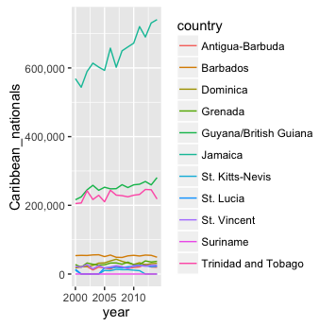

1. The following table shows the summary statistics of the variables used in the study:

|  |  |  |  |  |  |  |  |  |  |
| --- | --- | --- | --- | --- | --- | --- | --- | --- | --- |
| **Variable** | **mean** | **Sd** | **median** | **min** | **max** | **range** | **skew** | **kurtois** | **se** |
| YEAR | 2006.43 | 5.01 | 2007 | 2000 | 2014 | 14 | -0.06 | -1.44 | 0.01 |
| SEX | 1.57 | 0.5 | 2 | 1 | 2 | 1 | -0.27 | -1.93 | 0 |
| AGE | 44.97 | 17.78 | 45 | 0 | 95 | 95 | 0.08 | -0.39 | 0.04 |
| BPL | 267.84 | 15.88 | 260 | 260 | 300 | 40 | 1.53 | 0.34 | 0.04 |
| BPLD | 26824.3 | 1588.05 | 26042 | 26030 | 30040 | 4010 | 1.53 | 0.34 | 3.76 |
| CITIZEN | 2.35 | 0.53 | 2 | 1 | 3 | 2 | 0.1 | -0.94 | 0 |
| YRNATUR | 4857.21 | 3835.99 | 2005 | 1925 | 9999 | 8074 | 0.59 | -1.65 | 13.32 |
| YRIMMIG | 1986.03 | 12.61 | 1987 | 1910 | 2014 | 104 | -0.46 | 0.48 | 0.03 |
| YRSUSA1 | 20.4 | 12.67 | 19 | 0 | 93 | 93 | 0.62 | 0.33 | 0.03 |
| EDUC | 6.42 | 2.61 | 6 | 0 | 11 | 11 | -0.27 | 0.03 | 0.01 |
| EDUCD | 66.22 | 26.1 | 63 | 1 | 116 | 115 | -0.23 | 0.09 | 0.06 |
| DEGFIELD | 9.83 | 20.54 | 0 | 0 | 64 | 64 | 1.81 | 1.59 | 0.08 |
| DEGFIELDD | 984.5 | 2056.37 | 0 | 0 | 6402 | 6402 | 1.81 | 1.58 | 7.65 |
| OCC | 2454.98 | 2743.59 | 814 | 0 | 9920 | 9920 | 0.94 | -0.12 | 6.5 |
| OCC2010 | 5760.22 | 3108.32 | 5110 | 10 | 9920 | 9910 | 0.05 | -1.18 | 7.37 |
| IND | 3792 | 3686.4 | 948 | 0 | 9920 | 9920 | 0.26 | -1.73 | 8.74 |

1. The following graph shows the ratio of females to males emigrating to the United States

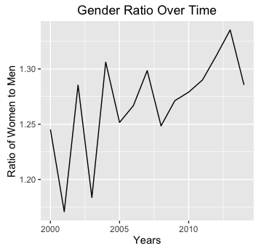

1. This graphs shows the age distribution of Caribbean emigrants from Jamaica to the United States. The error bar shows that this is fair variation in the distribution of Jamaican emigrants migrating the United States.

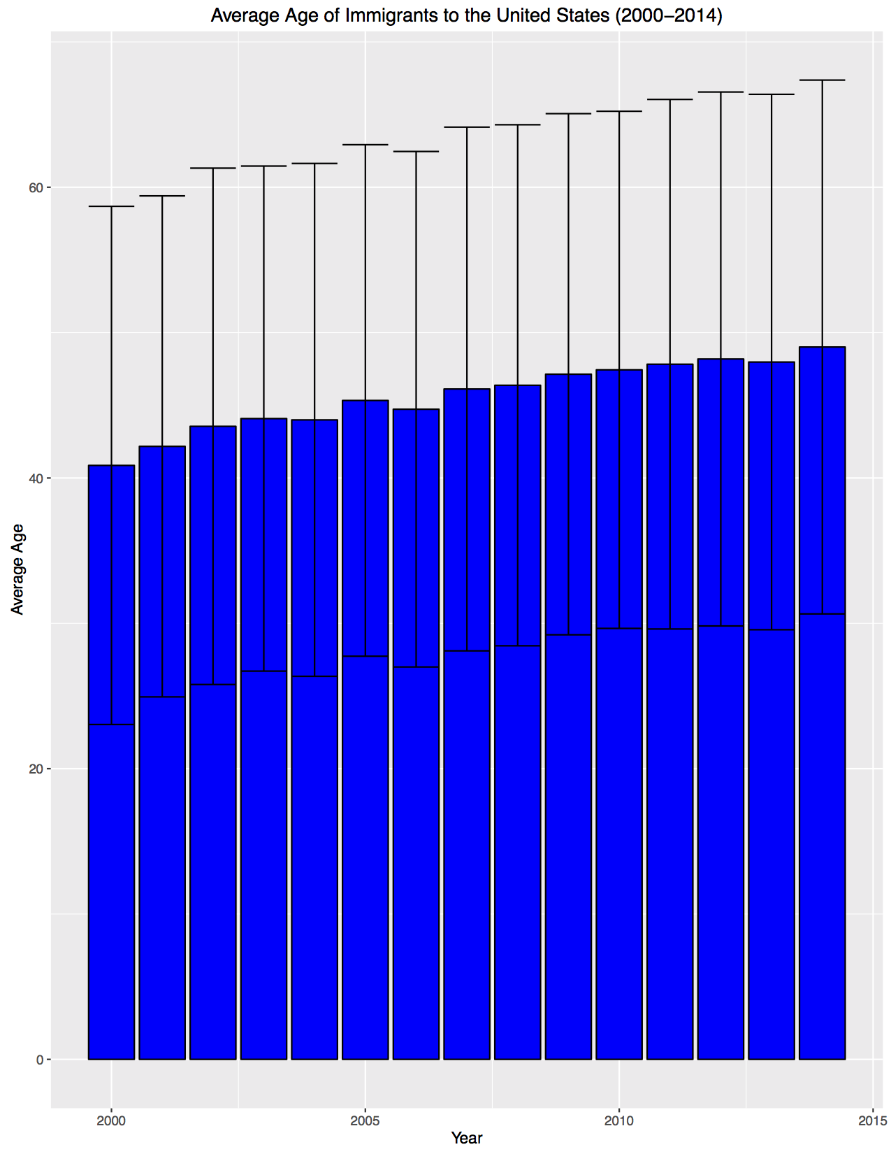

4. A discussion of next steps

1. To evaluate the casual relationship of the CSME policy and the yearly share of emigrants to the United States, ordinary least square regression models will be used in the study.
2. The following econometric models will be used in the study

**ϒit = β0i +β1X1+ β2X2+β3X3  … +εi**

Where :

ϒit – share of immigrant population (Caribbean nationality) – dependent variable

β1X1 – time dummy for the year of CSME implementation

β2X2 … - dummies for each country

**ϒit = β0i +β1X1+ β2X2+β3X3 +β4X4 +β5X5+β6X6 + β7X7 +εi**

Where:

ϒit – share of immigrant population (Caribbean nationality)

β1X1 – educational attainment

β2X2 – age

β3X3 - sex

β4X4 – occupation

β5X5 – Immigration status

β6X6 - English as a native language

β7X7 **–** time dummy for year of CSME implementation

1. To answer the question, a number of new variables will be need to be created by subsetting and incorporating dummy variables