Example Final Paper

Nathaniel Phillips

5/9/2017

# Note

The following is a template you can use for writing your final paper. In your paper, you should include all of your raw code in your document.

# Dataset Description

I obtained the data from the international chicken data repository. I don't know how the data were originally collected. The main columns in the data were as follows: *weight*, the weight of chickens in grams, *Time* the age in weeks of the chick at the time of measurement, *Chick* a unique number for each chicken, and *Diet* the diet given to the chick.

# Questions

I will answer the following questions in my paper.

1. How did the chicken weights generally change over time?
2. Was there a difference in the the average chicken weights as a result of the different diets?
3. ...
4. ...
5. ...

# Analyses

# Task 1: Load data  
# INSERT CODE HERE

Summary statistics from the data are presented in the following table.

# Task 2: Summary statistics from a dataframe  
# INSERT CODE HERE

## weight Time Chick Diet   
## Min. : 35.0 Min. : 0.00 Min. : 1.00 Min. :1.000   
## 1st Qu.: 63.0 1st Qu.: 4.00 1st Qu.:13.00 1st Qu.:1.000   
## Median :103.0 Median :10.00 Median :26.00 Median :2.000   
## Mean :121.8 Mean :10.72 Mean :25.75 Mean :2.235   
## 3rd Qu.:163.8 3rd Qu.:16.00 3rd Qu.:38.00 3rd Qu.:3.000   
## Max. :373.0 Max. :21.00 Max. :50.00 Max. :4.000

The data had 4 columns: weight, Time, Chick, and Diet:

# Task 3: Printing variable names  
# INSERT CODE HERE

## [1] "weight" "Time" "Chick" "Diet"

The data for Diet were originally coded as numbers, I recoded the Diet data as string variables

# Task 4: Recoding a variable  
# INSERT CODE HERE

# Task 5: Calculate simple summary statistics  
# INSERT CODE HERE

The mean weight of chickens across all data was 121.82, the median weight was 103 and the standard deviation was 71.07.

A table of frequencies showing how many observations there were for each diet is displayed in the following table:

# Task 6: Print a table  
# INSERT CODE HERE

(#tab:unnamed-chunk-11)*Number of chicks on each diet*

|  |  |
| --- | --- |
| Diet | Frequency |
| 1 | 220.00 |
| 2 | 120.00 |
| 3 | 120.00 |
| 4 | 118.00 |

# Task 7: Count outliers  
# INSERT CODE HERE

To see if there were any outliers in the weight data, I counted how many chicks had weights greater than 3 standard deviations above the mean, or less than 3 standard deviations below the mean. Using this procedure, I counted 3 outliers.

A scatterplot showing the relationship between time and weight is shown in the following figure

# Task 8: Scatterplot with regression line.  
# INSERT CODE HERE

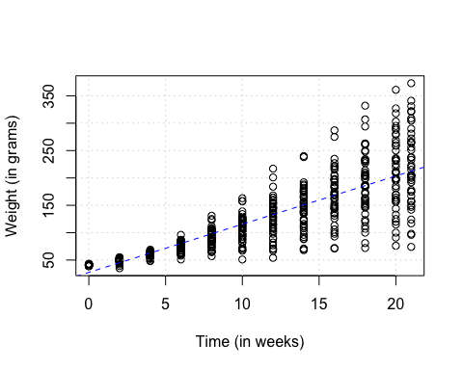

Scatterplot of chicken weights over time.

A histogram of the weight data are presented in the next figure

# Task 9: Histogram  
# INSERT CODE HERE  
  
  
# Task 20: Custom Function: my.hist()  
# Insert code here

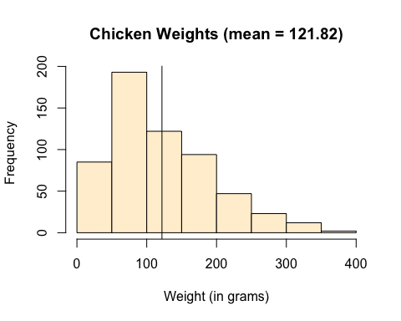

Distribution of weights across all data points.

Histograms separately for each diet are displayed in the next figure

# Task 20: Loop  
# INSERT CODE HERE

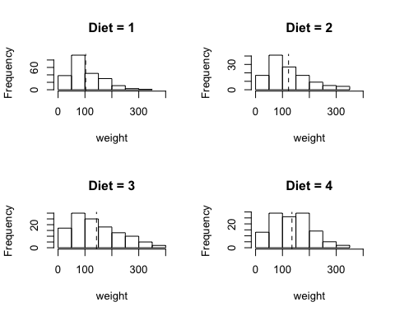

Histograms of the distribution of weights across time for each diet. Vertical lines are means.

A pirateplot showing the relationship between diet and weight is shown here:

# Task 10: pirateplot  
# INSERT CODE HERE

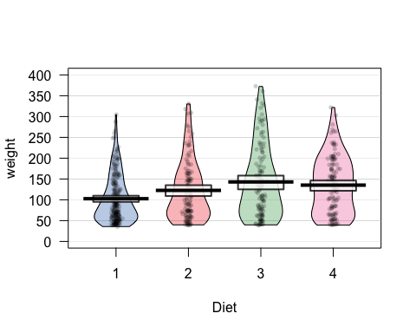

Pirateplot showing the distribution of chicken weights by diet. Horizontal lines show means while white boxes show Bayesian 95% highest density intervals.

The mean weight of chicks on each diet is shown in the following table:

# Task 11: Descriptive statistics across groups  
# INSERT CODE HERE

(#tab:unnamed-chunk-23)*Mean weights of chickens on each diet*

|  |  |
| --- | --- |
| Diet | Mean Weight |
| 1.00 | 102.65 |
| 2.00 | 122.62 |
| 3.00 | 142.95 |
| 4.00 | 135.26 |

# Task 12: 1 sample t-test  
# INSERT CODE HERE

##   
## One Sample t-test  
##   
## data: ChickWeight$weight  
## t = 7.3805, df = 577, p-value = 5.529e-13  
## alternative hypothesis: true mean is not equal to 100  
## 95 percent confidence interval:  
## 116.0121 127.6246  
## sample estimates:  
## mean of x   
## 121.8183

A one sample t-test comparing the weights of chickens to a null hypothesis of 100 was significant $M=121.82$, 95% CI $[116.01$, $127.62]$, $t(577)=7.38$, $p<.001$. The mean weight of chickens was significantly larger than 100 grams.

# Task 13: t-test with subset  
# INSERT CODE HERE

##   
## Welch Two Sample t-test  
##   
## data: weight by Diet  
## t = -2.6378, df = 201.38, p-value = 0.008995  
## alternative hypothesis: true difference in means is not equal to 0  
## 95 percent confidence interval:  
## -34.899942 -5.042482  
## sample estimates:  
## mean in group 1 mean in group 2   
## 102.6455 122.6167

A two sample t-test comparing the weights of chickens between diets 1 and 2 was significant $ΔM=19.97$, 95% CI $[−34.90$, $−5.04]$, $t(201.38)=−2.64$, $p=.009$, the weights of chickens was significantly higher in diet 2 compared to diet 1.

# Task 14: correlation test  
# INSERT CODE HERE

##   
## Pearson's product-moment correlation  
##   
## data: Time and weight  
## t = 36.725, df = 576, p-value < 2.2e-16  
## alternative hypothesis: true correlation is not equal to 0  
## 95 percent confidence interval:  
## 0.8109073 0.8599481  
## sample estimates:  
## cor   
## 0.8371017

A correlation test detecting a relationship between time and weight was significant $r=.84$, 95% CI $[.81$, $.86]$, $t(576)=36.73$, $p<.001$, as time increased, the weight of chickens increased.

# Task 15: correlation test with subset  
# INSERT CODE HERE

##   
## Pearson's product-moment correlation  
##   
## data: Time and weight  
## t = 15.449, df = 118, p-value < 2.2e-16  
## alternative hypothesis: true correlation is not equal to 0  
## 95 percent confidence interval:  
## 0.7485471 0.8697470  
## sample estimates:  
## cor   
## 0.8180325

A correlation test detecting a relationship between time and weight only for chickens on diet 2 was significant $r=.82$, 95% CI $[.75$, $.87]$, $t(118)=15.45$, $p<.001$, as time increased, the weight of chickens on diet 2 increased.

# Task 16: Chi-Square test  
# INSERT CODE HERE

##   
## Chi-squared test for given probabilities  
##   
## data: table(ChickWeight$Diet)  
## X-squared = 52.616, df = 3, p-value = 2.214e-11

To see if there was a significant difference in the number of chickes on each diet. I performed a chi-square test. The test was significant $χ^{2}(3,n=578)=52.62$, $p<.001$, indicating that chickens were not equally distributed amongst the diets.

# Task 17: ONE-WAY ANOVA  
# INSERT CODE HERE

## Call:  
## aov(formula = weight ~ factor(Diet), data = ChickWeight)  
##   
## Terms:  
## factor(Diet) Residuals  
## Sum of Squares 155862.7 2758693.3  
## Deg. of Freedom 3 574  
##   
## Residual standard error: 69.32594  
## Estimated effects may be unbalanced

## Df Sum Sq Mean Sq F value Pr(>F)   
## factor(Diet) 3 155863 51954 10.81 6.43e-07 ***  
## Residuals 574 2758693 4806   
## ---  
## Signif. codes: 0 '***' 0.001 '**' 0.01 '*' 0.05 '.' 0.1 ' ' 1

To see if there was a significant difference in weights between diets, I performed a one-way ANOVA. The test was significant , indicating that there was a significant difference between diets. Post-hoc tests showed significant differences between Diets 1 and 3 (diff = 40.30, p < .01), and Diets 1 and 4 (diff = 32.62, p < .01).

# Task 18: TWO-WAY ANOVA  
# INSERT CODE HERE

## Call:  
## aov(formula = weight ~ factor(Diet) + factor(Time), data = ChickWeight)  
##   
## Terms:  
## factor(Diet) factor(Time) Residuals  
## Sum of Squares 155862.7 2040908.0 717785.2  
## Deg. of Freedom 3 11 563  
##   
## Residual standard error: 35.70615  
## Estimated effects may be unbalanced

## Df Sum Sq Mean Sq F value Pr(>F)   
## factor(Diet) 3 155863 51954 40.75 <2e-16 ***  
## factor(Time) 11 2040908 185537 145.53 <2e-16 ***  
## Residuals 563 717785 1275   
## ---  
## Signif. codes: 0 '***' 0.001 '**' 0.01 '*' 0.05 '.' 0.1 ' ' 1

To see if there was a significant difference in weights between diets and time points, I performed a two-way ANOVA. The effect of both diet $F(3,563)=40.75$, $MSE=1,274.93$, $p<.001$, $η_{G}^{2}=.178$ and time $F(11,563)=145.53$, $MSE=1,274.93$, $p<.001$, $η_{G}^{2}=.740$ were significant. Post-hoc tests showed significant differences between all Diets except for 4 and 3 (diff = -7.69, p = 0.34). There were significant differences between almost all pairs of time periods.

# Task 19: REGRESSION  
# INSERT CODE HERE

##   
## Call:  
## lm(formula = weight ~ Time, data = ChickWeight)  
##   
## Coefficients:  
## (Intercept) Time   
## 27.467 8.803

##   
## Call:  
## lm(formula = weight ~ Time, data = ChickWeight)  
##   
## Residuals:  
## Min 1Q Median 3Q Max   
## -138.331 -14.536 0.926 13.533 160.669   
##   
## Coefficients:  
## Estimate Std. Error t value Pr(>|t|)   
## (Intercept) 27.4674 3.0365 9.046 <2e-16 ***  
## Time 8.8030 0.2397 36.725 <2e-16 ***  
## ---  
## Signif. codes: 0 '***' 0.001 '**' 0.01 '*' 0.05 '.' 0.1 ' ' 1  
##   
## Residual standard error: 38.91 on 576 degrees of freedom  
## Multiple R-squared: 0.7007, Adjusted R-squared: 0.7002   
## F-statistic: 1349 on 1 and 576 DF, p-value: < 2.2e-16

To see if time was related to weight, I regressed weight on time. Results showed a significant positive effect of time $b=8.80$, 95% CI $[8.33$, $9.27]$, $t(576)=36.73$, $p<.001$, $R^{2}=.70$, $F(1,576)=1,348.74$, $p<.001$

# Conclusion

The two most important results were that chickens gain weight over time, and Diet 3 lead to the highest weights while Diet 1 lead to the lowest weights.