Assigment #1

Brandon Moretz

### tasks

1. *(No actionable item).*
2. *Now that we have our data defined, let’s begin our exploratory data analysis by examining the correlations. We will want to compute the complete correlation matrix, and then consider visualizing a subset of those correlations for quick and easy comparison.* 
   1. *Which row or column of the correlation matrix are we most interested in?*
      1. We are interested in the row of the correlation matrix that is the corresponding index of the symbol we are looking at correlations for. We would also likely want to exclude the column that corresponds to this same index, as it will always have the value 1 (the row I, column I would be the matrix diagonal) which is the correlation of that symbol to itself.
3. *How about we make an even fancier data visualization of the correlations? The corrplot will allow us to visualize all pairwise correlations in the data.*

* 1. *Is the corrplot more useful or insightful than our simple barplot?* 
     1. I would not classify one as ‘better’ than the other, they each offer a slightly different perspective of the data. The corrplot offers utility in the form of being able to see the entire data set in a glance, for example the last row or last column of the corrplot has the same information as the barplot, however it is in my opinion less readable. If I were doing EDA using these two graphics, I would start with the corrplot to get a general summary, and then ‘dig in’ to specific stocks using the barplot.
  2. *What is the difference between a ‘statistical graphic’ and a ‘data visualization’?* 
     1. A ‘data visualization’ is a bespoke graphical representation of a subset of a data set that emphasizes the narrative one is trying to convey. Data visualizations wouldn’t generally export easily to new datasets given their highly customized nature. Statistical graphics I would classify as more standardized (less customized) graphical representations of specific characteristics of a dataset (i.e., boxplots, bar plots, histograms, scatterplots, density plots, etc.)
  3. With respect to the concept of multicollinearity, look at the corrplot and identify three stocks that should have low VIF values? Similarly, pick three stocks that should have high VIF values?
     1. Low VIF:
        1. DPS:DOW
        2. DPS:BAC
        3. DPS:HUN
     2. High VIF:
        1. VV:WFC
        2. HON:VV
        3. CVX:XOM

1. *In addition to statistical graphics and data visualizations we can use models as tools for exploratory data analysis. Modeling is an inherently iterative process, and we typically begin the modeling process by fitting some ‘naïve models’ that are nothing more than models that we believe are good starting points for the modeling process. Typically, we might start with a small model and the full model as our two initial naïve models. The full model also allows us to compute the VIF value for every predictor variable.*
   1. Is multicollinearity a concern for either of these models?
      1. There is a degree of concern for multicollinearity in both models, as there are several variables that have VIF scores over 2.5. Overall, I would say the concern for multicollinearity is greater in model 2 than in model 1. For model 1, this includes GS and MMM, and model 2 the variables BAC, GS, JPM, WFC, BHI, CVX, HAL, MMM, SLB and XOM.
   2. What value of VIF should make you concerned about multicollinearity?
      1. The numeric value of a VIF score that should warrant concern is a somewhat subject value depending on the model and the data at hand. However, in general, values over 10 are considered “very high”, values over 5 are considered “high” and over 2.5 “concerning”.
2. *First, plot the loadings for first two principal components from the principal components analysis.* 
   1. *What are the loadings?*
      1. The loadings (or component loadings) are the correlation coefficients between the variables (rows) and factors (columns).
   2. *When we plot the loadings, we can see relationships in the data. What groupings (or clusters) do you see in the plot of the first two principal components? Any surprises?*
      1. 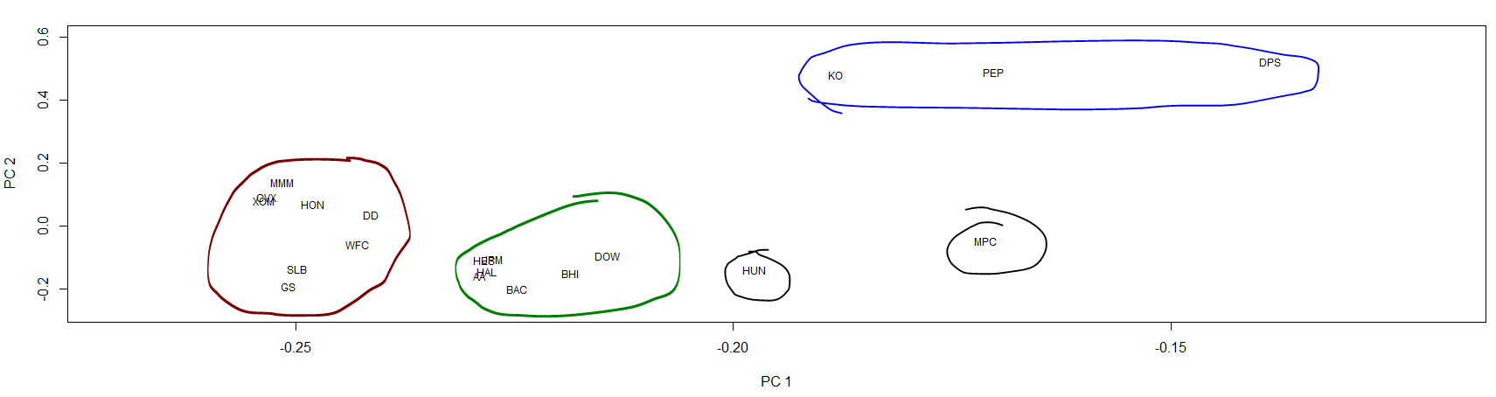There are definitely clusters of symbols for the first two loadings. The three major groups are circled below in red, green and blue. The black symbols are kind of in their own islands.
      2. 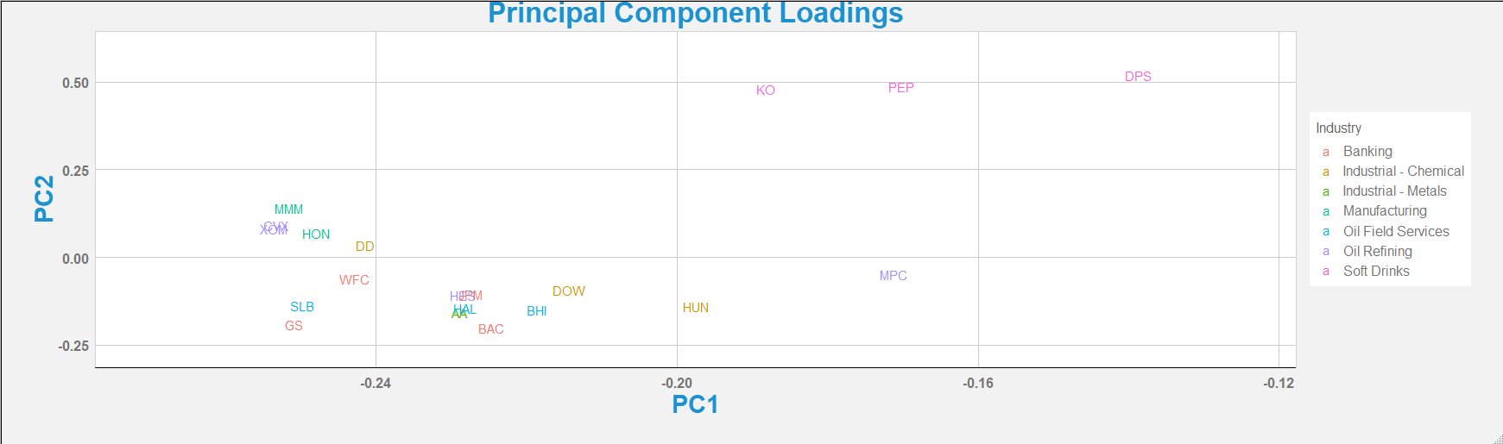Color code this plot by industry? Here are the ticker symbols and their industry. You do not need to use the colors that used in the table.

### Research

### Conclusion