What makes a house valuable?

A reproducible analysis for the Boston housing data

Outstanding student 1, Awesome student 2 and Great student 3

31/11/16

This short report shows a simple and non-exhaustive analysis for the price of the houses in the Boston dataset. The purpose is to quantify, by means of a multiple linear model, the effect of 14 variables in the price of a house in the suburbs of Boston.

We start by importing the data into R and considering a multiple linear regression of medv (median house value) in the rest of variables:

> # Import data  
> library(MASS)  
> data(Boston)

> mod <- lm(medv ~ ., data = Boston)  
> summary(mod)

Call:  
lm(formula = medv ~ ., data = Boston)  
  
Residuals:  
 Min 1Q Median 3Q Max   
-15.595 -2.730 -0.518 1.777 26.199   
  
Coefficients:  
 Estimate Std. Error t value Pr(>|t|)   
(Intercept) 3.646e+01 5.103e+00 7.144 3.28e-12 ***  
crim -1.080e-01 3.286e-02 -3.287 0.001087 **   
zn 4.642e-02 1.373e-02 3.382 0.000778 ***  
indus 2.056e-02 6.150e-02 0.334 0.738288   
chas 2.687e+00 8.616e-01 3.118 0.001925 **   
nox -1.777e+01 3.820e+00 -4.651 4.25e-06 ***  
rm 3.810e+00 4.179e-01 9.116 < 2e-16 ***  
age 6.922e-04 1.321e-02 0.052 0.958229   
dis -1.476e+00 1.995e-01 -7.398 6.01e-13 ***  
rad 3.060e-01 6.635e-02 4.613 5.07e-06 ***  
tax -1.233e-02 3.760e-03 -3.280 0.001112 **   
ptratio -9.527e-01 1.308e-01 -7.283 1.31e-12 ***  
black 9.312e-03 2.686e-03 3.467 0.000573 ***  
lstat -5.248e-01 5.072e-02 -10.347 < 2e-16 ***  
---  
Signif. codes: 0 '***' 0.001 '**' 0.01 '*' 0.05 '.' 0.1 ' ' 1  
  
Residual standard error: 4.745 on 492 degrees of freedom  
Multiple R-squared: 0.7406, Adjusted R-squared: 0.7338   
F-statistic: 108.1 on 13 and 492 DF, p-value: < 2.2e-16

The variables indus and age are non-significant in this model. Also, although the adjusted R-squared is high, there seems to be a*clear non-linearity:

> plot(mod, 1)

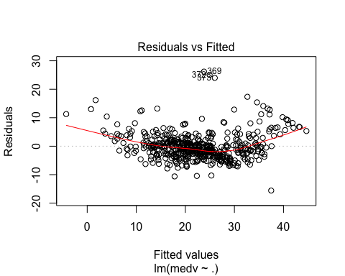

In order to bypass the non-linearity, we are going to consider the non-linear transformations given in Harrison and Rubinfeld (1978) for both the response and the predictors:

> modTransf <- lm(I(log(medv * 1000)) ~ I(rm^2) + age + log(dis) +  
+ log(rad) + tax + ptratio + I(black / 1000) +  
+ I(log(lstat / 100)) + crim + zn + indus + chas +  
+ I((10*nox)^2), data = Boston)  
> summary(modTransf)

Call:  
lm(formula = I(log(medv * 1000)) ~ I(rm^2) + age + log(dis) +   
 log(rad) + tax + ptratio + I(black/1000) + I(log(lstat/100)) +   
 crim + zn + indus + chas + I((10 * nox)^2), data = Boston)  
  
Residuals:  
 Min 1Q Median 3Q Max   
-0.71176 -0.09169 -0.00566 0.09895 0.79780   
  
Coefficients:  
 Estimate Std. Error t value Pr(>|t|)   
(Intercept) 9.756e+00 1.496e-01 65.221 < 2e-16 ***  
I(rm^2) 6.328e-03 1.312e-03 4.823 1.89e-06 ***  
age 9.074e-05 5.263e-04 0.172 0.863179   
log(dis) -1.913e-01 3.339e-02 -5.727 1.78e-08 ***  
log(rad) 9.571e-02 1.913e-02 5.002 7.91e-07 ***  
tax -4.203e-04 1.227e-04 -3.426 0.000664 ***  
ptratio -3.112e-02 5.013e-03 -6.208 1.14e-09 ***  
I(black/1000) 3.637e-01 1.031e-01 3.527 0.000460 ***  
I(log(lstat/100)) -3.712e-01 2.501e-02 -14.841 < 2e-16 ***  
crim -1.186e-02 1.245e-03 -9.532 < 2e-16 ***  
zn 8.016e-05 5.056e-04 0.159 0.874105   
indus 2.395e-04 2.364e-03 0.101 0.919318   
chas 9.140e-02 3.320e-02 2.753 0.006129 **   
I((10 * nox)^2) -6.380e-03 1.131e-03 -5.639 2.88e-08 ***  
---  
Signif. codes: 0 '***' 0.001 '**' 0.01 '*' 0.05 '.' 0.1 ' ' 1  
  
Residual standard error: 0.1825 on 492 degrees of freedom  
Multiple R-squared: 0.8059, Adjusted R-squared: 0.8008   
F-statistic: 157.1 on 13 and 492 DF, p-value: < 2.2e-16

The adjusted R-squared is now higher and, what is more important, the non-linearity now is more subtle (it is still not linear but closer than before):

> plot(modTransf, 1)

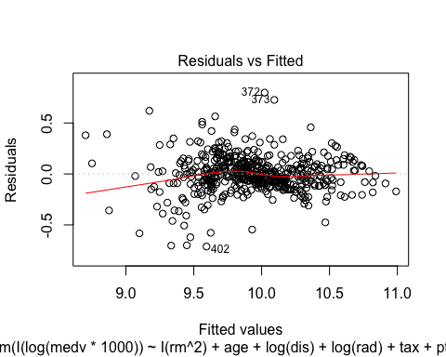

However, modTransf has more non-significant variables. Let's see if we can improve over the previous model by removing some of the non-significant variables. To that aim, we look for the best model in terms of the Bayesian Information Criterion (BIC) by stepwise:

> modTransfBIC <- stepwise(modTransf, trace = 0)

Direction: backward/forward  
Criterion: BIC

> summary(modTransfBIC)

Call:  
lm(formula = I(log(medv * 1000)) ~ I(rm^2) + log(dis) + log(rad) +   
 tax + ptratio + I(black/1000) + I(log(lstat/100)) + crim +   
 chas + I((10 * nox)^2), data = Boston)  
  
Residuals:  
 Min 1Q Median 3Q Max   
-0.71182 -0.09288 -0.00590 0.09763 0.79880   
  
Coefficients:  
 Estimate Std. Error t value Pr(>|t|)   
(Intercept) 9.7677775 0.1386224 70.463 < 2e-16 ***  
I(rm^2) 0.0063831 0.0012498 5.107 4.67e-07 ***  
log(dis) -0.1929697 0.0262514 -7.351 8.20e-13 ***  
log(rad) 0.0947128 0.0181870 5.208 2.81e-07 ***  
tax -0.0004115 0.0001062 -3.874 0.000122 ***  
ptratio -0.0312259 0.0046959 -6.650 7.79e-11 ***  
I(black/1000) 0.3643185 0.1025799 3.552 0.000420 ***  
I(log(lstat/100)) -0.3696816 0.0225919 -16.363 < 2e-16 ***  
crim -0.0118642 0.0012204 -9.722 < 2e-16 ***  
chas 0.0920105 0.0328785 2.799 0.005334 **   
I((10 * nox)^2) -0.0063382 0.0010951 -5.788 1.27e-08 ***  
---  
Signif. codes: 0 '***' 0.001 '**' 0.01 '*' 0.05 '.' 0.1 ' ' 1  
  
Residual standard error: 0.1819 on 495 degrees of freedom  
Multiple R-squared: 0.8059, Adjusted R-squared: 0.8019   
F-statistic: 205.5 on 10 and 495 DF, p-value: < 2.2e-16

The resulting model has a slightly higher adjusted R-squared than modTransf with all the variables significant.

We explore the most significant variables to see if the model can be reduced drastically in complexity.

> mod3D <- lm(I(log(medv * 1000)) ~ I(log(lstat / 100)) + crim, data = Boston)  
> summary(mod3D)

Call:  
lm(formula = I(log(medv * 1000)) ~ I(log(lstat/100)) + crim,   
 data = Boston)  
  
Residuals:  
 Min 1Q Median 3Q Max   
-0.75050 -0.13714 -0.01254 0.12003 0.88388   
  
Coefficients:  
 Estimate Std. Error t value Pr(>|t|)   
(Intercept) 8.876988 0.041663 213.065 <2e-16 ***  
I(log(lstat/100)) -0.495249 0.017291 -28.641 <2e-16 ***  
crim -0.011404 0.001208 -9.441 <2e-16 ***  
---  
Signif. codes: 0 '***' 0.001 '**' 0.01 '*' 0.05 '.' 0.1 ' ' 1  
  
Residual standard error: 0.2145 on 503 degrees of freedom  
Multiple R-squared: 0.7258, Adjusted R-squared: 0.7248   
F-statistic: 665.9 on 2 and 503 DF, p-value: < 2.2e-16

It turns out that **with only 2 variables, we explain the 72% of variability**. Compared with the 80% with 10 variables, it is an important improvement in terms of simplicity: the logarithm of lstat (percent of lower status of the population) and crim (crime rate) alone explain the 72% of the variability in the house prices. We add these variables to the dataset, so we can call scatterplotMatrix and scatter3d through R Commander,

> Boston$logMedv <- log(Boston$medv * 1000)  
> Boston$logLstat <- log(Boston$lstat / 100)

and conclude with the visualization of:

1. the pair-by-pair relations of the response and the two predictors;
2. the full relation between the response and the two predictors.

> # 1  
> scatterplotMatrix(~ crim + logLstat + logMedv, reg.line = lm, smooth = FALSE,  
+ spread = FALSE, span = 0.5, ellipse = FALSE,  
+ levels = c(.5, .9), id.n = 0, diagonal = 'histogram',  
+ data = Boston)

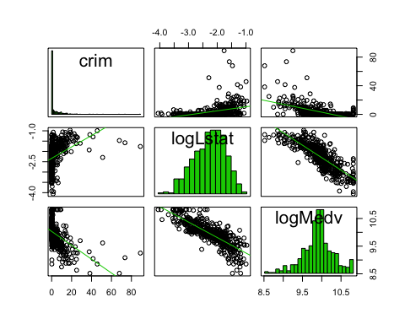

> # 2  
> scatter3d(logMedv ~ crim + logLstat, data = Boston, fit = "linear",  
+ residuals = TRUE, bg = "white", axis.scales = TRUE, grid = TRUE,  
+ ellipsoid = FALSE)

You must enable Javascript to view this page properly.