STAT509-001-HW1-Xinye Xu

## Q1

Suppose X is double exponential with mean 0 and standard deviation of 2. (a) As Y = X + 2 is a strictly increasing function, Yq = Xq + 2 = -0.2760889

source('startup.R') # for DExp  
library(fGarch) # cal for GED-Dist

## Loading required package: timeDate

## Warning in as.POSIXlt.POSIXct(Sys.time()): unknown timezone 'zone/tz/2018g.  
## 1.0/zoneinfo/America/Detroit'

## Loading required package: timeSeries

## Loading required package: fBasics

##

## Rmetrics Package fBasics

## Analysing Markets and calculating Basic Statistics

## Copyright (C) 2005-2014 Rmetrics Association Zurich

## Educational Software for Financial Engineering and Computational Science

## Rmetrics is free software and comes with ABSOLUTELY NO WARRANTY.

## https://www.rmetrics.org --- Mail to: info@rmetrics.org

library(ggplot2)

## Warning: package 'ggplot2' was built under R version 3.4.4

library(fBasics) # cal for skewness and kurtosis  
lambda = sqrt(2) / 2   
qdexp(p = 0.1, mu = 0, lambda) + 2 # (a)

## [1] -0.2760889

lambda2 = sqrt(2) / 2  
internal = log(1 / (5 * (exp(-2 * lambda2) + exp(2 * lambda2))))  
Xt = (lambda2)^2 / (internal)^2 # (b)

Question 1 (d)

As Y = 1/ (x+2)^2 is a symmetric function, so we cannot directly using a strictly decreasing or increasing function to calculate its quantile function.

$P(\frac{1}{(x+2)^{2}}≤X)=0.1$. So, $1-P\left(x≥-2+\sqrt{\frac{1}{X}}\right)+P\left(x≤-2-\sqrt{\frac{1}{X}}\right)=0.1$;

$1-P(x<-2+\sqrt{\frac{1}{X}})+P(x<-2-\sqrt{\frac{1}{X}})=0.1$

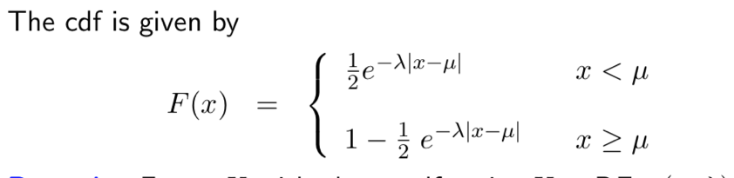

Based on the CDF above, $1-(1-\frac{1}{2}e^{-λ(-2+\sqrt{\frac{1}{X}})})+\frac{1}{2}e^{-λ(-2-\sqrt{\frac{1}{X}})}=0.1$;

$e^{-λ(\sqrt{\frac{1}{X}})}* (e^{-2λ}+ e^{2λ}) =0.2$. Then, we can calculate $X=\frac{λ^{2}}{(log⁡[\frac{1}{5*\left(e^{-2λ}+ e^{2λ}\right)}])^{2}}$. So $X$ = 0.05267021.

## Q2

1. Suppose have portfolio of 100 million dollars. Compute the value-at-risk and relative value-at-risk, at α = .002 for the following cases.
2. norm mean of 0 and std of .025. : Var_rel= 0.06942634; Var = 100m*Var= 6.94 million
3. GED-dist with a mean of 0 and std of .025 for the cases of ν = 0.5, 0.9, 1.4.:Var_rel= 0.1260278, 0.09758018, 0.08011714; and Var = 12.60, 9.76, 8.01 million.

# (a)  
norm_q <- qnorm(0.002, 0, 0.025)   
Var_a <- - (exp(norm_q) - 1)  
  
 # (b) qged from packate fGarch:  
l <- data.frame(0.5, 0.9, 1.4)  
l <- rbind(l, rapply(l, function(x) qged(0.002, mean = 0, sd = 0.025, nu = x)))  
l <- rbind(l, rapply(l[2,], function(x) -(exp(x) - 1)))

## Q3

1. From the graph below, it suggests that NASDAQ has postive increasing trend during the most of time between Jan/2015 to Dec/2018. It seems to be a little stable index of 5000 until a big fall at the beginning of 2016.Then it increased to the peak of 8000 and this upward trend ended nearly on the second half year of 2018. After that, it decreased to about 6000 on Dec 2018.

fin_dat <- read.csv("/Users/xuxinye/Desktop/Umich classes/STATS 509/Data/Nasdaq_daily_Jan1_2015-Dec31_2018.csv")  
fin_dat$Date <- as.Date(fin_dat$Date, format = "%m/%d/%Y")  
ggplot(data = fin_dat, aes(x = Date, y = Adj.Close))+geom_line()

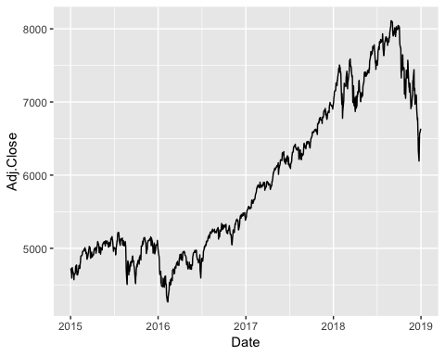

1. From below, it suggets that the log daily return has range form -0.04 to 0.05, both of these extreme points happened in 2018. And distributions for log-return has a mean that is close to 0 (0.0003). Also, by calculating the standard deviations(0.01030379), it's quite small. The daily log returns are quite symmetric with a slight negative skewness = -0.4940055 and its excess kurtosis is large, which is 3.187553, suggesting a heavier tail.So it can be modeled based on Double Exp distribution since Kurt of it is 3 and skew is 0. Plus, using boxplot, it suggests a negative heavy tail. So there might be ourliers.

log_ret <- diff(log(fin_dat$Adj.Close))  
summary(log_ret)

## Min. 1st Qu. Median Mean 3rd Qu. Max.   
## -0.0452630 -0.0038465 0.0007765 0.0003375 0.0055512 0.0567238

sd(log_ret)

## [1] 0.01030379

skewness(log_ret)

## [1] -0.4940055  
## attr(,"method")  
## [1] "moment"

kurtosis(log_ret)

## [1] 3.187553  
## attr(,"method")  
## [1] "excess"

fin_dat$log_ret <- c(NA, log_ret)   
ggplot(data = fin_dat, aes(x = Date, y = log_ret))+geom_line()

## Warning: Removed 1 rows containing missing values (geom_path).

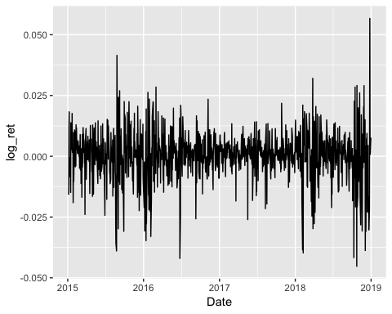

hist(log_ret, breaks = 200, main='log-daily-ret distribution', freq = FALSE)

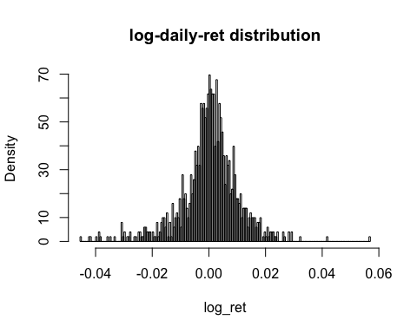

boxplot(log_ret)

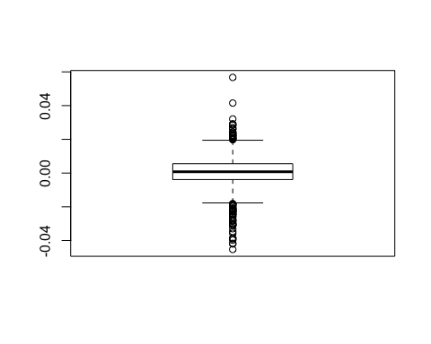

1. From (b), the estimate of the mean = 0.0003375 and standard deviation = 0.01030379, Relative VaR = 0.03424105。 Based on the .004-quantile data of log-returns, Relative VaR = 0.03820149, It suggests that Rel-VaR is a little bigger than one simulated by Double Exp. It's also in consistant with the conclusion that we have in (b) that excess kurtosis (3.187553) of data is larger than DExp's.

mu <- 0.0003375 # P0 <- fin_dat$Adj.Close[1]  
std <- 0.01030379  
lambda = sqrt(2) / std  
dexp_q <- qdexp(p = 0.004, mu, lambda)  
Var <- - (exp(dexp_q) - 1)  
Var_o <- - (exp(quantile(log_ret, 0.004)) - 1) # quantile of log return data

1. Based on the double exponential model in (c), derive (analytically) an estimate of the expected shortfall.

We know from (c), the estimate of the mean = 0.0003375 and standard deviation = 0.01030379, VaR = 0.03456694, so the VaR is larger than mean. So we have x >= miu in this case.

mu = 0.0003375

std = 0.01030379

lambda = sqrt(2) / std = 137.2518

X ~ DExp(0.0003375, 137.2518)

PDF_sf(x) =

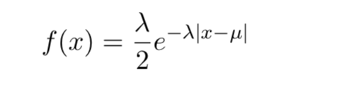

E(SF) =1/ $α*$ $\int_{VaR}^{+∞}{s*PDF_sf(s)ds}$ = 1/0.004 $\int_{VaR}^{+∞}{s*\frac{λ}{2}*exp⁡(-λ(x-μ))ds}$

*

= 0.04621624

Then it times the portfolio value (P) : ES = 0.04621624 * P for that time.

1 / (2 * 0.004) * exp(-lambda*(-dexp_q - mu))*(-dexp_q + 1/lambda)

## [1] 0.04621624

## Q4

It can be converted to Pr(log-ret >= log(110/100)), log-ret ~ N(0.1, 0.2^2); Then the prob = 0.509354 that it can selling at $110 or more.

pnorm(log(110/100), mean=0.1, sd=0.2, lower.tail = FALSE)

## [1] 0.509354

# lower.tail = FALSE: Pr(X > x); True : Pr(X < x);

## Q5

We know sum of iid normal dist is normal dist.So two year log-ret (R1 + R2) ~ N(0.08*2,2*0.15^2). It can be converted to Pr(two-year log-ret >= log(90/80)), Then the prob = 0.5788736 that it can selling at $90 or more.

pnorm(log(90/80), mean=0.08*2, sd=sqrt(2*0.15^2), lower.tail = FALSE)

## [1] 0.5788736