Single population proportion (3.1)

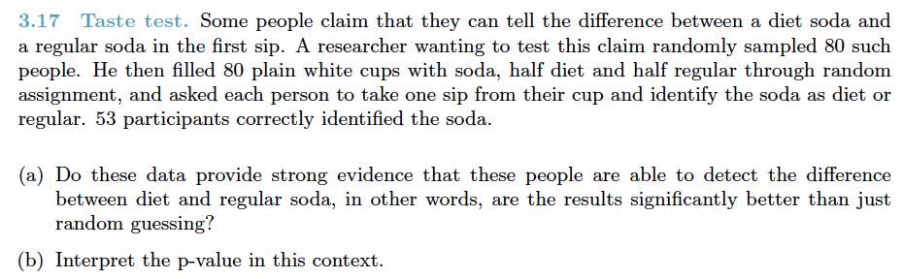

Two population proportions (3.2)

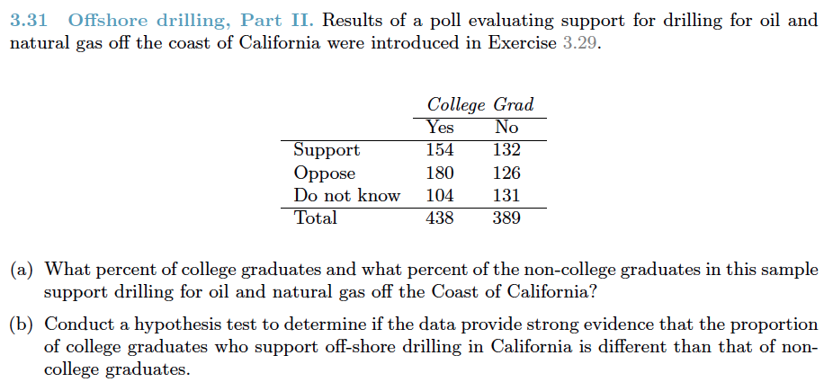

Single population mean (4.1)

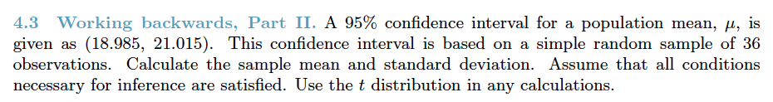

Single population mean: paired (4.2)

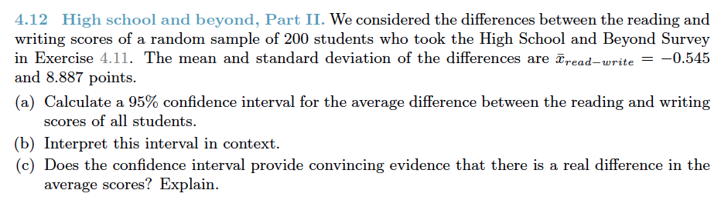

Two population means (4.3)

