Stata Markdown Tutorial

Cyrus Samii

January 2019

# Overview

Here are some notes and examples for using Stata Markdown from German Rodriguez. For instructions on installation and dependencies, refer to the Stata Markdown website.

I give examples of some things we might want to do in social science related projects.

# Simple Script Example

Here we replicate the simple example from German Rodriguez’s “Simple Script” example:

Let us read the fuel efficiency data that is shipped with Stata

. sysuse auto, clear  
(1978 Automobile Data)

To study how fuel efficiency depends on weight it is useful to transform the dependent variable from “miles per gallon” to “gallons per 100 miles”

. gen gphm = 100/mpg

We then obtain a more linear relationship

. twoway scatter gphm weight || lfit gphm weight ///  
> , ytitle(Gallons per Mile) legend(off)  
  
. graph export auto.png, width(500) replace  
(file auto.png written in PNG format)

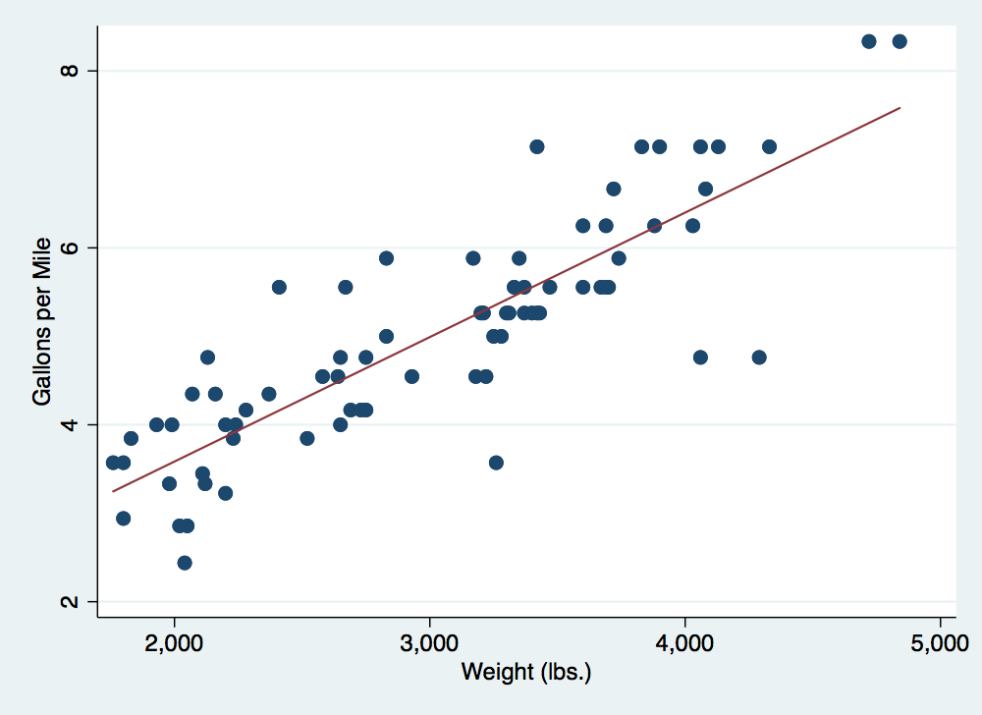

Fuel Efficiency

# A numbered list

Here is a list:

1. Foo
2. Foo 2
3. Foo 3