Outline of Steps for Accessing Athens and Git Remotely

**Download necessary software:**

1. Download VPN from https://itservices.uchicago.edu/services/vpn-cvpn. This requires your CNET ID and password.

2. Connect to cvpn.uchicago.edu using the VPN. You will need to do this every time you open easyVNC (see steps below).

2. Download easyVNC from https://sscs.uchicago.edu/page/running-easyvnc.

This requires having a username and password for access to Athens.

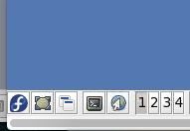

**Set up git repositories and environmental variables:**

1. Connect to cvpn.uchicago.edu.

2. Connect to Athens via easyVNC.

3. Create a folder inside your personal folder on Athens titled “Projects.”

3. Open xterm from the menu at the bottom left-hand corner of the screen.

4. Follow steps at the link below to generate an SSH key for your local computer. For step 4, to find the name of the generate SSH key, type “cat ~/.ssh/id_rsa.pub” into xterm and copy the output to the appropriate page of your github account.

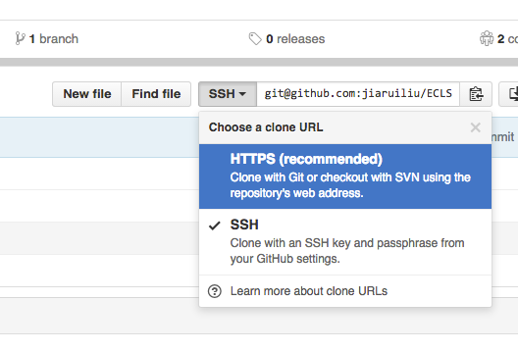https://help.github.com/articles/generating-ssh-keys/

5. CD into your projects folder from xterm and clone the git repositories you will need by going to the repository on your github.com page by copying the repositories https URL and typing in xterm: “git clone <copied url>”. Be sure you have been granted access to the repository.

6. Set up environmental variables:

- open xterm

- cd into your user folder

* edit the file “.bashrc”
* type each of the variables you want to declare as in separate lines as follows:
* export <variable>=<path of the variable>
* close the terminal
* open xterm and echo $<variable> and make sure it spits out the path of your variable.