**Python Installation Guide**

**ECON 381 – Intermediate Macroeconomics**

**Winter 2019**

**Python Installation**

1. Copy & Paste this link into your browser: <https://www.anaconda.com/download>.

2. Click Download under ‘*Python 3.7 version*’. Ensure you select the appropriate download for your computer's operating system (*i.e. Windows, macOS, Linux*).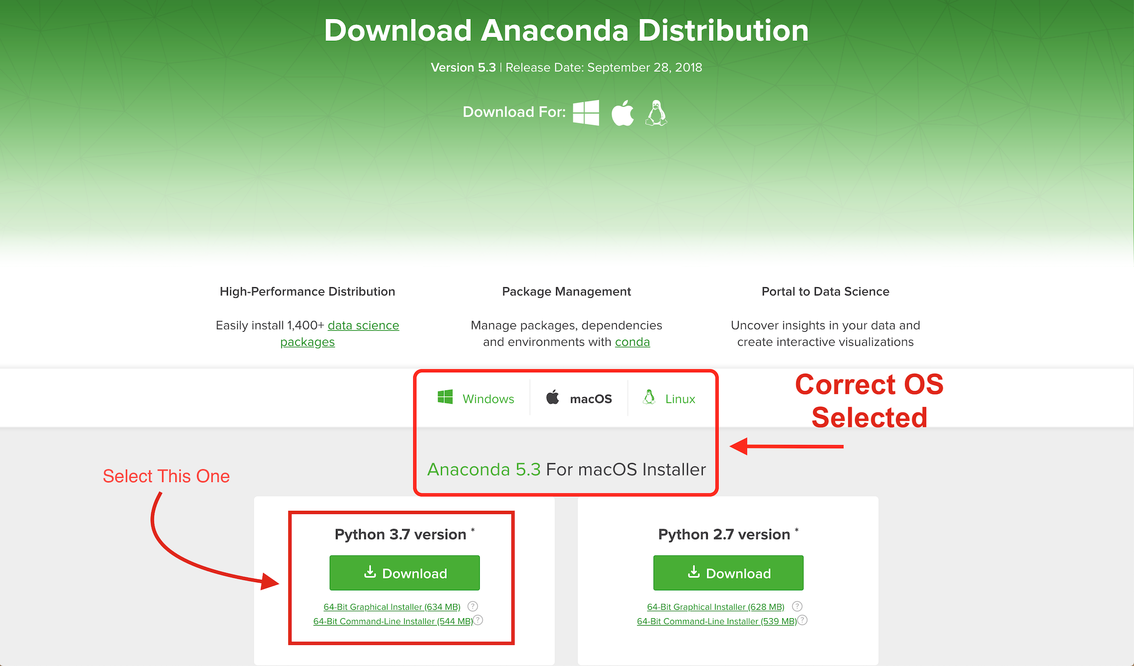

3. After downloading, an install helper will open on your computer. Complete the installation without changing any default settings.

4. After the installation is complete, find and open up the newly installed application called, “**Anaconda Navigator**” this will be the application you will use to interface with Python and Jupyter Lab Notebooks for the semester.

**Anaconda Navigator & Jupyter Lab**

1. Upon opening Anaconda Navigator, it will take you to a home screen which will display several apps you can use to interface with Python and other programming languages. For this class, we will be using **Jupyter Lab** (notice the distinction from Jupyter Notebook). Double click on Jupyter Lab to launch a new session.

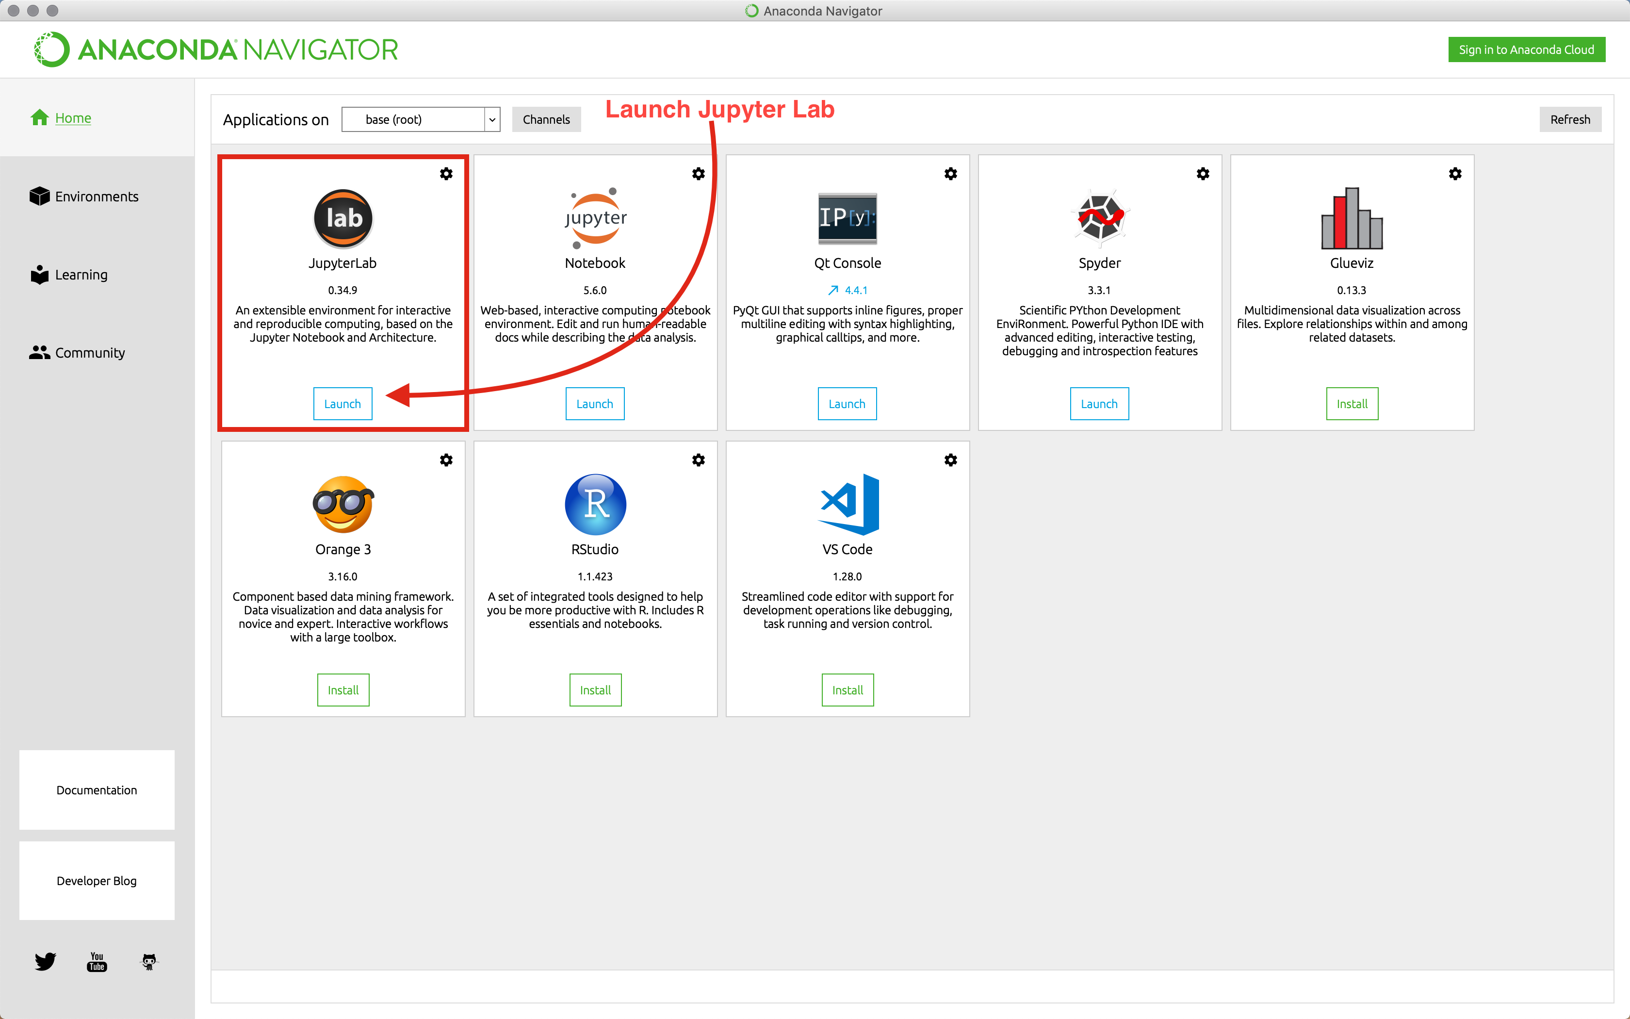

2. Now use the file explorer on the sidebar to navigate to your ‘econ_381’ folder on your computer. Where this folder is created and stored will be different for everyone. For example, I can access my folder by clicking **Documents >> College >> econ_381**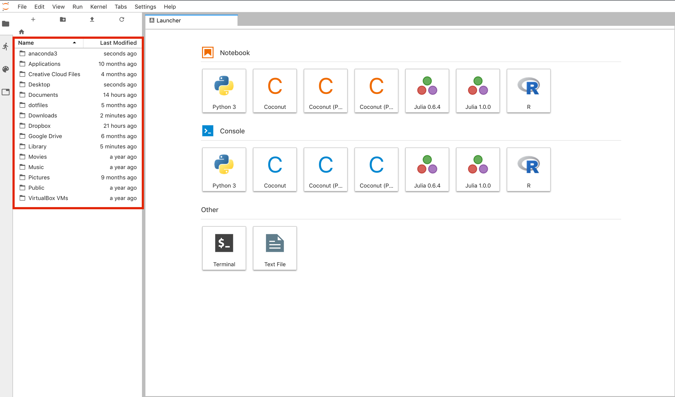

3. Once you have navigated to the proper folder, create a new Python Notebook by selecting **Python 3** under the **Launcher Tab**. This should open up an *Untitled.ipynb* in your browser.

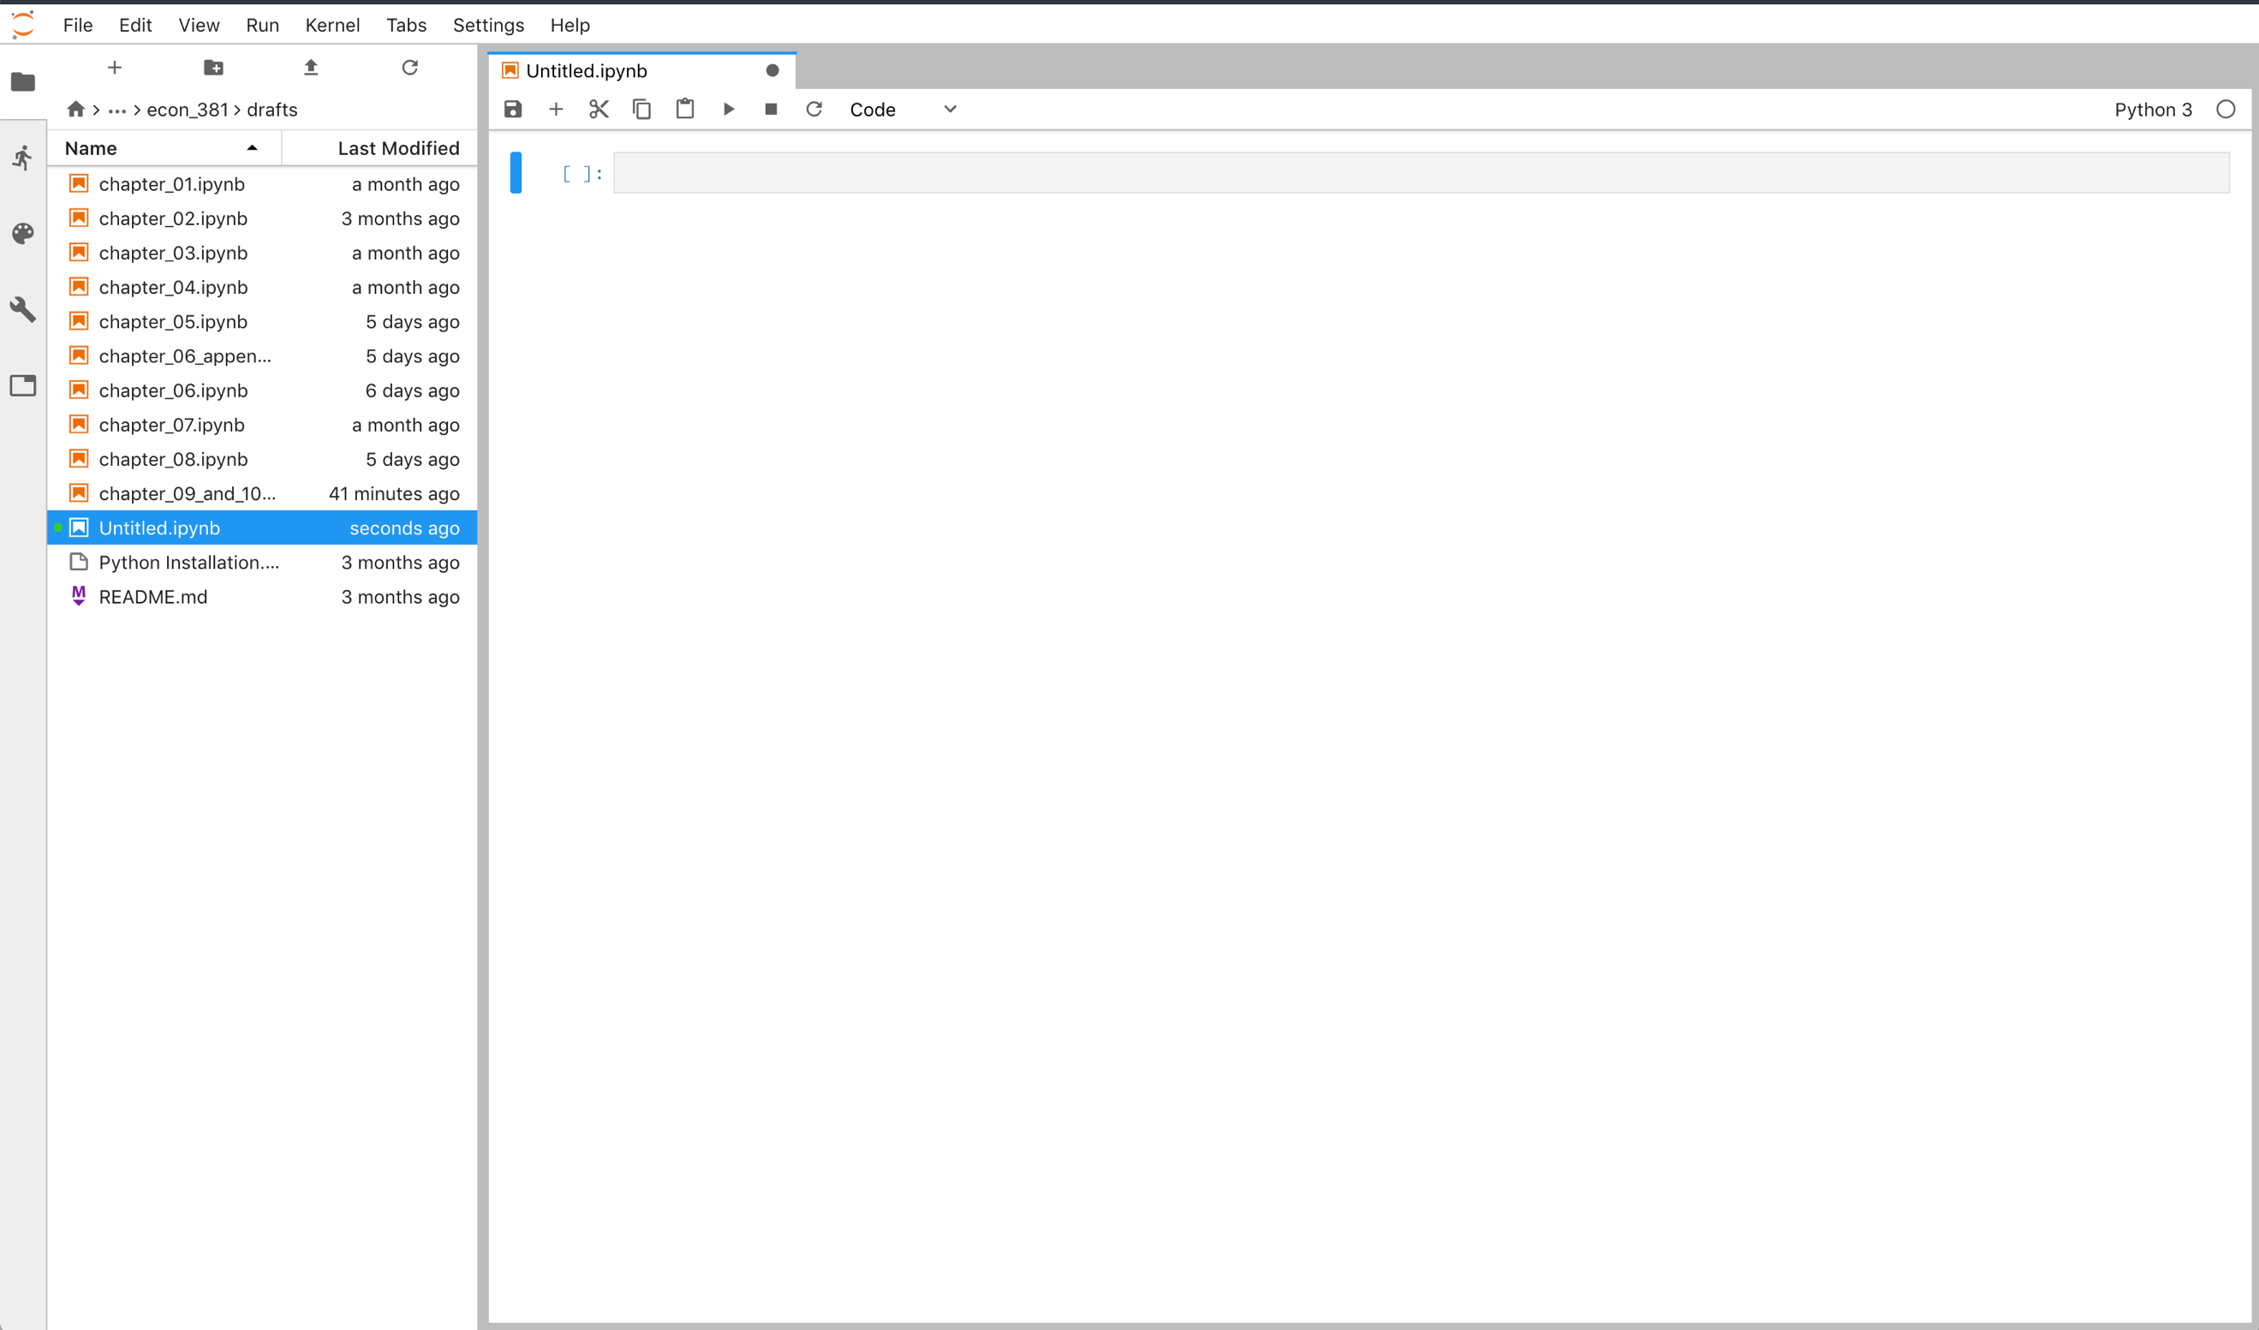

**Working with Jupyter Lab Notebooks**

1. After creating a new Jupyter Lab Notebook, use the link to read the selected sections on how to format text and insert Python into the notebook.

<https://www.dataquest.io/blog/jupyter-notebook-tutorial/>

**Sections:**

(a) What is an ipynb File?

(b) The notebook interface

(c) Cells

(d) Keyboard shortcuts

(e) Markdown

(f) Kernels

2. Recreate the following notebook in the screenshot below substituting appropriate information. Upon completion, save the notebook with ‘*lastname_firstname_intro.ipynb’* and then export the notebook as a PDF by selecting **File >> Export Notebook As… >> PDF**. Then submit the PDF to the proper place on iLearn. 