The Jonckheere-Terpstra (JT) test is a non-parametric test for trend. Non-parametric means that the test makes no assumptions about the distribution of the data. Tests such as t-tests and ANOVA assume a normal distribution of the data, but this is not always a valid assumption, therefore, sometimes the use of non-parametric methods is required. A test for trend means that rather than looking for an overall difference between the groups, when the groups have an ordering to them, we may have reason to believe that there will be an increase (or decrease) in the outcome as we move across the groups. A test for trend is more powerful (i.e. more likely to see a difference if it exists) than an overall test for a difference, therefore may be preferred when the groups have an implicit ordering. A significant result from the JT test means that there is an increase (or decrease, you can tell which by looking at a plot, or summary of the data) in median value as you move across the groups.

The Kruskal-Wallis (KW) test is a non-parametric test for an overall difference between groups. A significant result would mean that at least one of the groups is different to the others. Where the KW test reveals a significant difference between groups, it is possible to do (suitably corrected for multiple testing) post-hoc pairwise tests to see which groups there are differences between.

Below are some examples of the interpretation of results. These results are hypothetical data, so in the real data, the pattern might not be quite so clear-cut. For example in figures 3 and 4 the expression values for AA and GG, might not have exactly the same medians and the distribution in the groups might not be the same. AA, AG, GG will be referred to as groups in the explanations below.

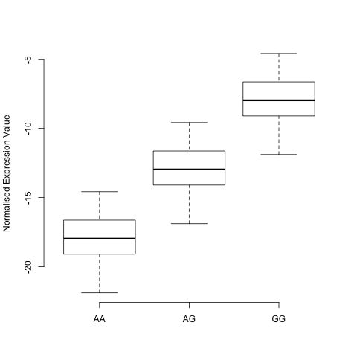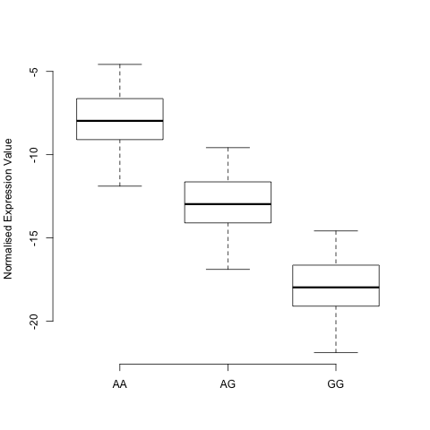

Figure 1 Figure 2

In figure 1 a significant JT test would mean that the expression value increased with increasing “dose” of G (as the groups have 0, 1, 2 copies of G), i.e. the more G alleles the greater the gene expression. Alternatively this can be viewed as gene expression increasing with decreasing dose of A (2, 1, 0 copies). In figure 2 we have the opposite, a significant JT test would mean that expression value increased with decreasing “dose” of G. Alternatively this can be viewed as expressing increasing with increasing dose of A. We would not be able to tell however, if it was the A dose or the G dose or the combination of the two driving the change in gene expression (these doses would be said to be confounded).

If in figures 1 and 2, the KW test is not significant it means that the difference in gene expression between AA and GG is not large enough to produce a significant difference. However, the more powerful JT test is able to find a significant trend in gene expression. If the KW test is significant, pairwise tests can be used to see which groups have significantly different gene expression. In figures 1 and 2, there may be significant differences in gene expression between AA and GG, but no evidence of a difference in expression between AA and AG, and AG and GG.

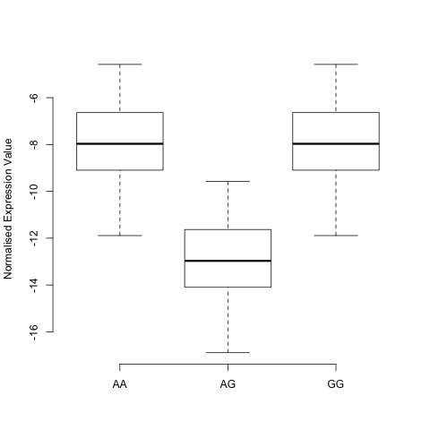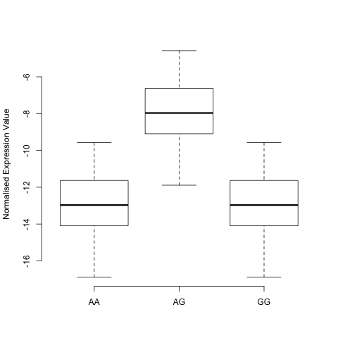

Figure 3 Figure 4

In figures 3 and 4 the JT test is unlikely to be significant as there is no evidence of a trend. A significant result from the KW test would suggest that there is a difference in expression between homozygotes and heterozygotes. Again it would not be possible to tell whether it was the homozygotes or the heterozygotes driving the difference.

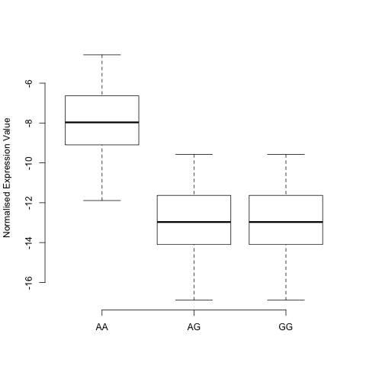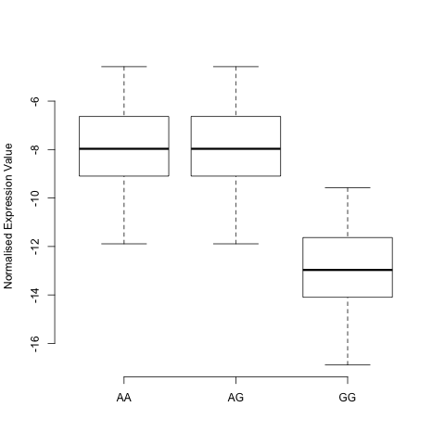

Figure 5 Figure 6

Figures 5 and 6 may or may not lead to a significant JT result, depending on the size of the difference in gene expression of AA in figure 5 and GG in figure 6 and the number of observations in each group. If a KW test is significant it suggests in figure 5 that either any G alleles lead to a drop in expression or two A alleles lead to an increase in expression. In figure 6 either any A alleles lead to an increase in expression or two G alleles lead to a decrease in expression. Again it is not possible to tell which is the correct interpretation of the results, but both explanations are possible.