MPhil in Epidemiology
MSt in Public Health

Comparing Means of Several Groups: Practical

1. This question is a little tricky. There are hints at the end of the sheet if required. Don’t spend too long on it!

The following table was reported in Furukawa TA, et al. (2000) Course and outcome of depressive episodes: comparison between bipolar, unipolar and subthreshold depression, Psychiatry Research, 96, 211-220.

The authors compare the months spent unwell for three types of depressive disorder, but do not report the full ANOVA table.

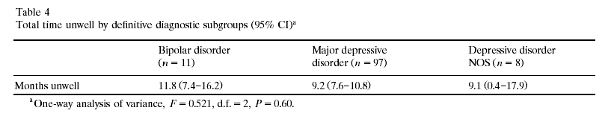

Reconstruct an approximate ANOVA table for their results

Source of Variation | Degrees of Freedom | Sums of Squares | Mean Squares | F Statistic | p-value
Between Groups
Within Groups
Total

The rest of the sheet is a practical exercise in SPSS.

2. Open the file ‘amess.sav’ in SPSS. The data are the red cell folate levels in three groups of cardiac bypass patients given different levels of nitrous oxide (N₂O) and oxygen (O₂) ventilation.

[There is a reference to the source of this data in Altman, Practical Statistics for Medical Research, p. 208.]

The treatments are
- 50% N₂O and 50% O₂ continuously for 24 hours
- 50% N₂O and 50% O₂ during the operation
- No N₂O but 35-50% O₂ continuously for 24 hours

4. Draw boxplots of the data. Does it look as though the assumptions for ANOVA are satisfied?

5. Perform t-tests for each of the three pair-wise comparisons. Make note of the t-test statistics obtained. Which groups, if any, differ from one another?

6. Perform an analysis of variance on the data. Why is this a more valid analysis? Interpret the output.

7. Choose any pair of treatments and repeat the ANOVA for just these two treatments. Compare the test statistic value to the results of the t-test from question 3.

8. If the assumptions for ANOVA don’t hold, then there are non-parametric alternatives available.

- If the assumption of normality doesn’t hold then we might look at the Kruskal-Wallis test.

- If the assumption of equal variances doesn’t hold then we might use the median test.

Perform these tests. Do they give the same answer as ANOVA? If not, why not?

How important were the assumptions?

Hints for Question 2

1) Fill in the p-value and F statistic.
2) Identify N and k and fill in the degrees or freedom.
3) Fill in one more box, and the rest should follow using the arithmetic of the ANOVA table
4) The between-group sum of squares is the easiest to obtain.

