Chapter 1

* 1. Preferences

* Not sure the meaning of ‘binary relation’. Does it refer to relationships between two objects?
* What does ‘acquaintance’ example mean?
* Given that R stands for relation, what does xRy means? Does it mean the relationship between x and y? If so, what does yRx mean?

* I am still confused with the concept of ‘reflexivity’ after reading these paragraphs. Does it mean all ‘x’ are the same?
  1. Preference formation 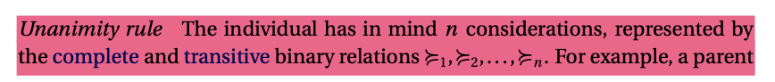A picture containing knife

     Description automatically generated
* Not sure what this unanimity rule means

1.3 An experiment

- Everything makes sense to me

1.4 Utility functions

I don’t understand the entire sections, since I can’t understand the minimal and maximal alternatives and since the following parts do not make sense to me.