IE221 - BÀI THỰC HÀNH 1

Họ tên: Nguyễn Trần Bảo Anh

MSSV: 22520066

Lớp: IE221.Q11.1

1. Command Prompt  
   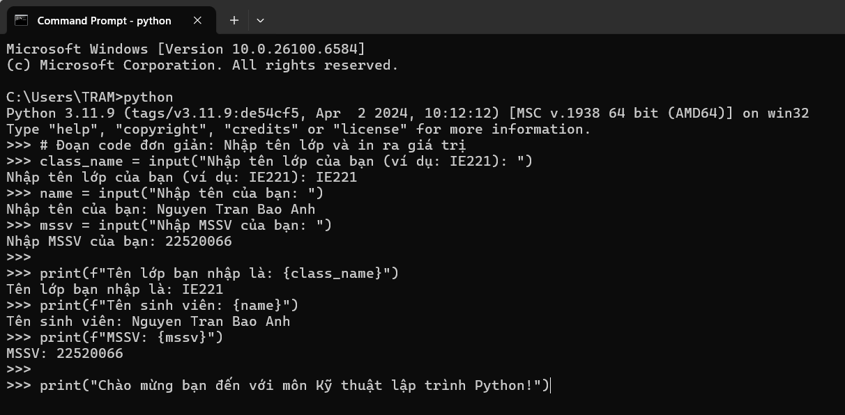
2. IDLE Shell  
   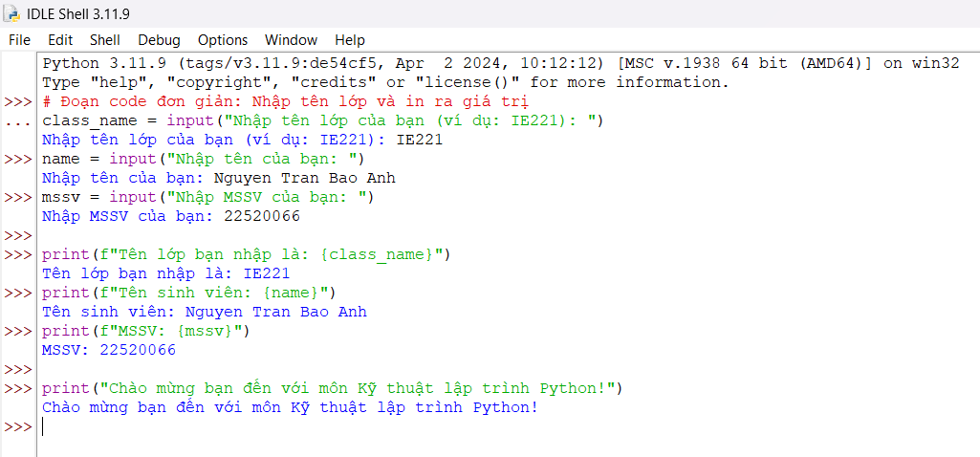
3. VS Code  
   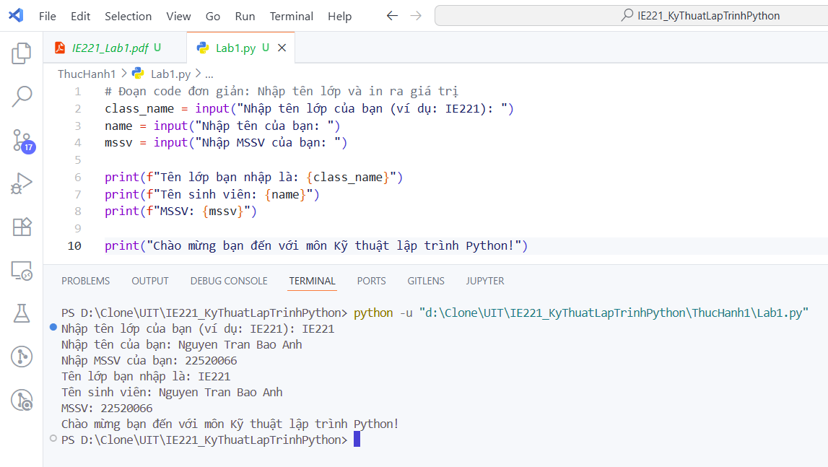
4. Google Colab  
   A screenshot of a computer program

   AI-generated content may be incorrect.
5. Kaggle  
   A screenshot of a computer

   AI-generated content may be incorrect.