P1801

*BasicPlot*

Visualizer: Read file and return data frame

draw_stem

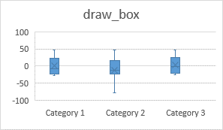

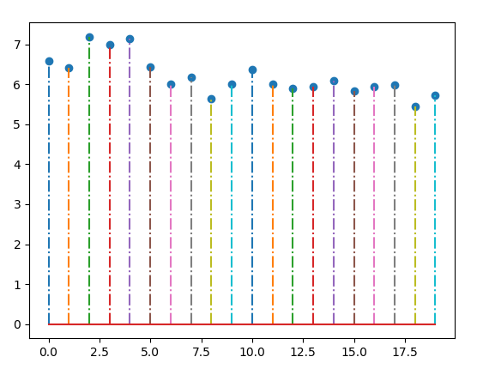

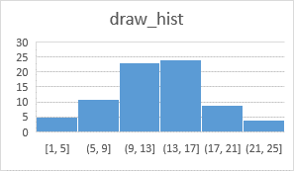

**Visualizer**

draw_violin

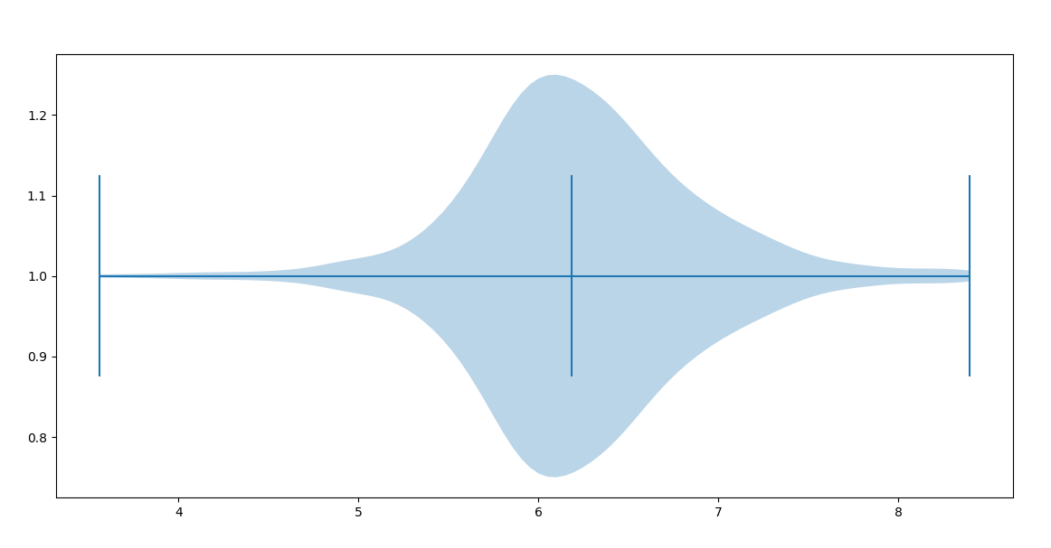

*ScatterPlot(comming soon)*