Introducing the I’-chart: an improved individuals chart for quality improvement and control

2025-05-31

## Supplementary materials: Plots

### I’-chart for measurement data

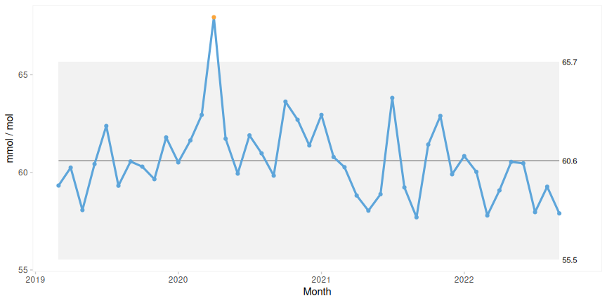

Figure 1: I-chart of average HbA1c without denominator. The grey region represents the region between the control limits.

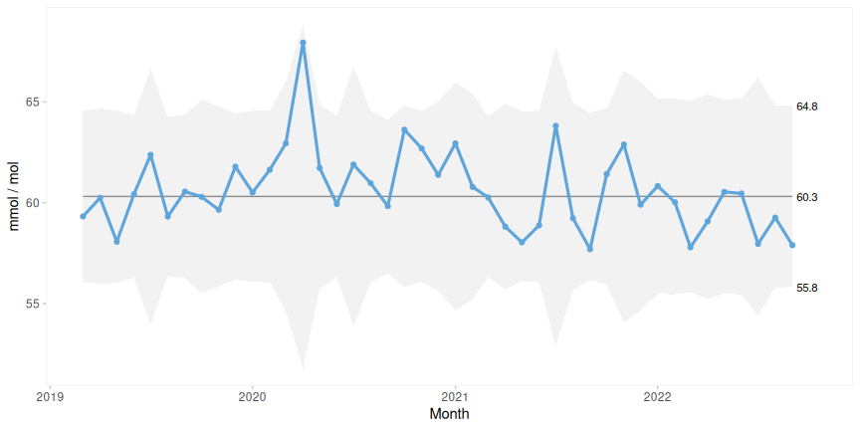

Figure 2: I’-chart of average HbA1c with denominator.

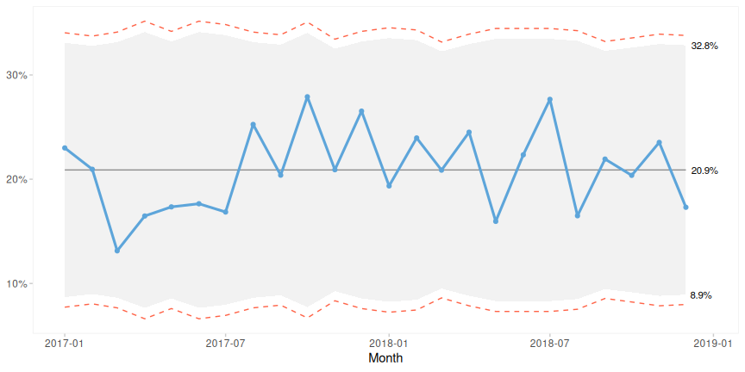

Figure 3: P-chart of proportion patients who died of bacteremia. Grey background: control limits from P-chart. Dashed lines: control limits from I’-chart.

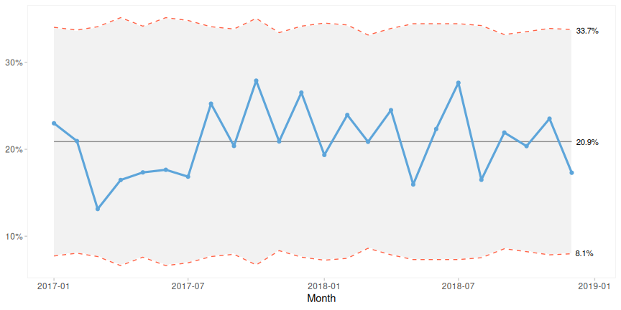

Figure 4: P’-chart of proportion patients who died of bacteremia. Grey background: control limits from P’-chart. Dashed lines: control limits from I’-chart.

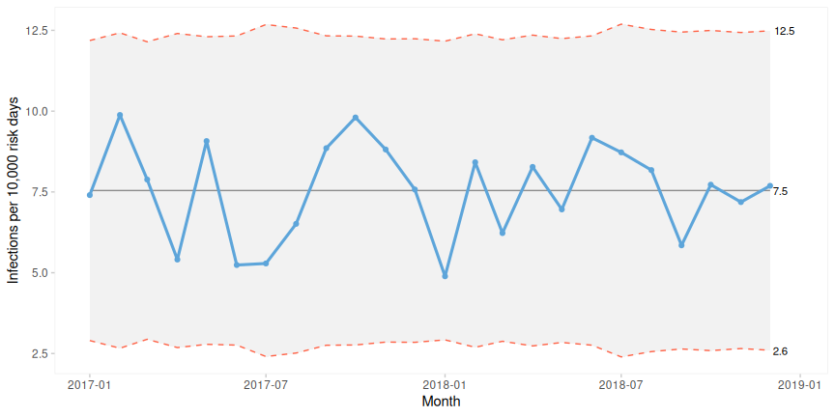

Figure 5: U’-chart of infection rates. Grey background: control limits from U’-chart. Dashed lines: control limits from I’-chart.

### I- and I’-charts from individual random normal measurements

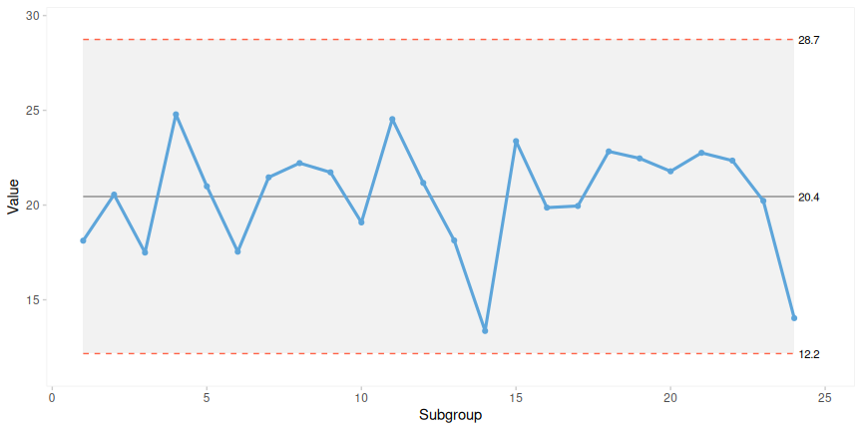

Figure 6: I-chart from 24 random data from a normal distribution (mean = 20, SD = 3, seed = 1) without denominator. Grey background: control limits from I-chart. Dashed lines: control limits from I’-chart.

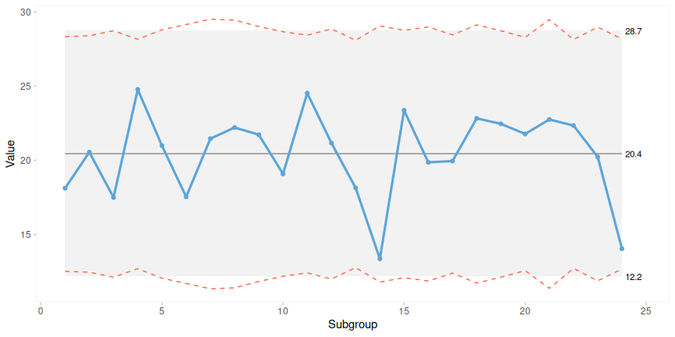

Figure 7: I’-chart from 24 random, normal data (mean = 20, SD = 3, seed = 1) with denominators ranging from 80 to 120. Grey background: control limits from I-chart. Dashed lines: control limits from I’-chart.

### Xbar-charts from multiple random normal measurements

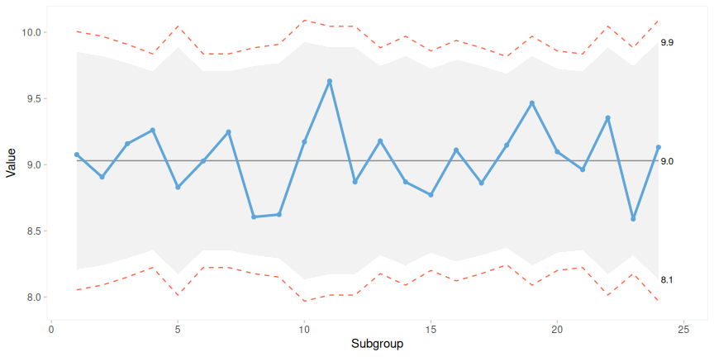

Figure 8: Xbar-chart from 24 subgroups of 10 to 20 random normal data (mean = 9, SD = 1, seed = 1). I’ limits a bit wider than Xbar limits. Grey background: control limits from Xbar-chart. Dashed lines: control limits from I’-chart.

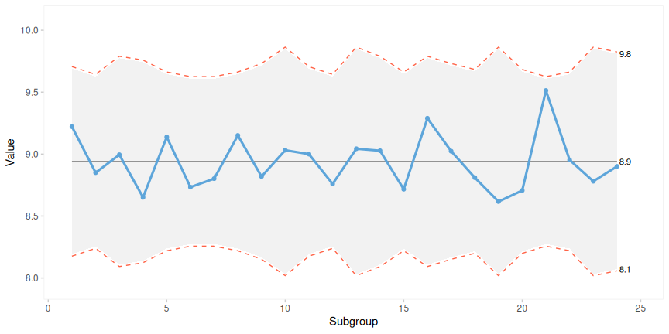

Figure 9: Xbar-chart from 24 subgroups of 10 to 20 random normal data (mean = 9, SD = 1, seed = 6). I’ limits close to Xbar limits. Grey background: control limits from Xbar-chart. Dashed lines: control limits from I’-chart.

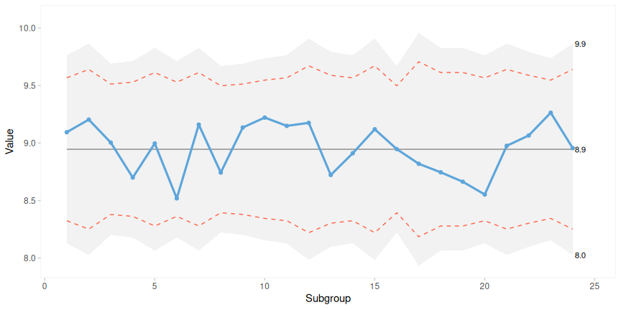

Figure 10: Xbar-chart from 24 subgroups of 10 to 20 random normal data (mean = 9, SD = 1, seed = 8). I’ limits a bit tigther than Xbar limits. Grey background: control limits from Xbar-chart. Dashed lines: control limits from I’-chart.

### P- and P’-charts from random binomial data

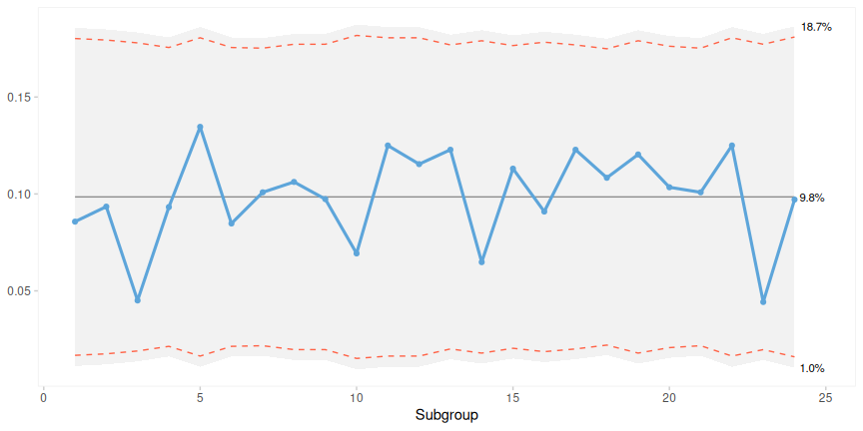

Figure 11: P-chart of 24 random data from a binomial distribution (p = 0.1, subgroup size ranging from 100 to 120, seed = 1). Grey background: control limits from P-chart. Dashed lines: control limits from I’-chart.

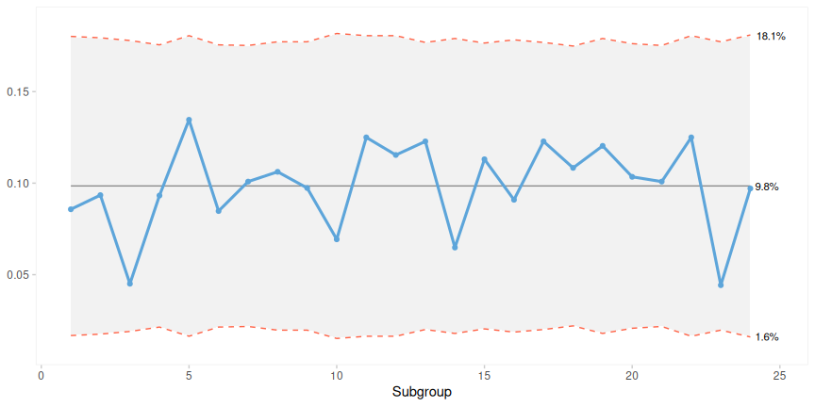

Figure 12: P’-chart of 24 random data from a binomial distribution (p = 0.1, subgroup size ranging from 100 to 120, seed = 1). Grey background: control limits from P’-chart. Dashed lines: control limits from I’-chart.

### U- and U’-charts from random poisson data

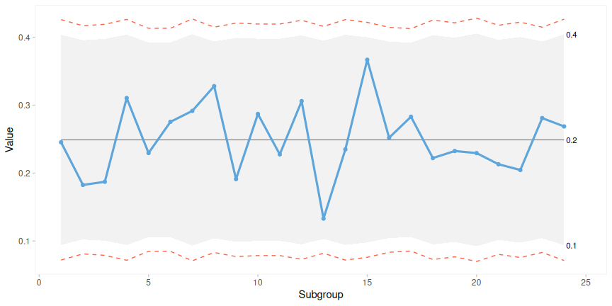

Figure 13: U-chart from 24 random data from a poisson distribution (mean = 25, subgroup size ranging from 90 to 110, seed = 2). Grey background: control limits from U’-chart. Dashed lines: control limits from I’-chart.

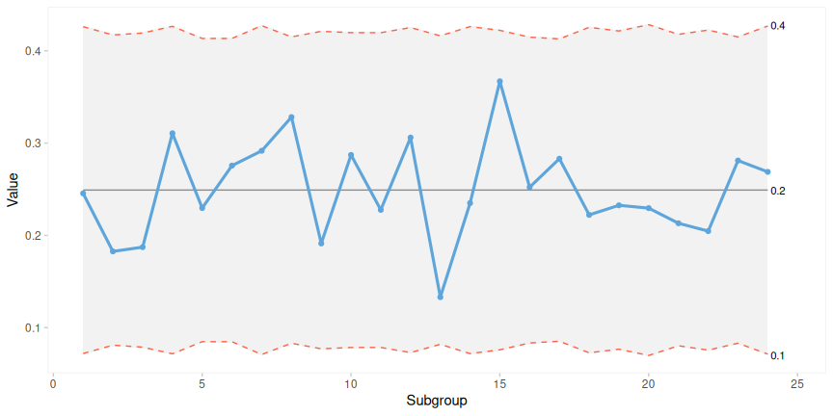

Figure 14: U’-chart from 24 random data from a poisson distribution (mean = 25, subgroup size ranging from 90 to 110, seed = 2). Grey background: control limits from U’-chart. Dashed lines: control limits from I’-chart.