**Question 2 (5 points):**

The following Java method processes an employee's salary, calculating bonuses and deductions based on years of service, basic salary, and performance rating. Your task is to design test cases using **JUnit** to validate this method. Apply **equivalence partitioning** and **boundary value analysis** for the input parameters. Additionally, ensure that your test cases cover all **four branches** of the code for 100% code coverage.

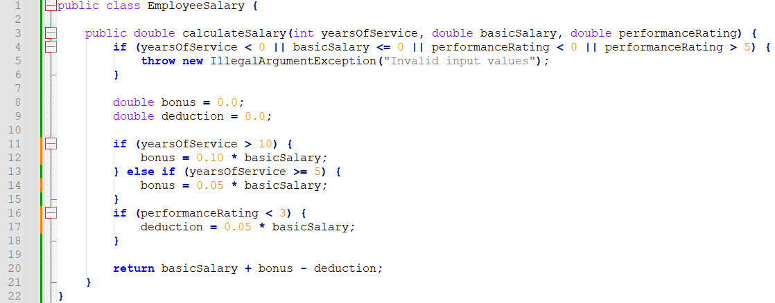

**Sample JUnit Test Class for Completion**

The following is a partially written JUnit test class for the **EmployeeSalaryTest** method. Students are tasked with completing this class by adding the required test cases to achieve full **equivalence partitioning**, **boundary value analysis**, and **branch coverage** for the **calculateSalary** method.

