Anh Pham

http://www.metropolia.fi/fileadmin/template/images/Metropolia_RGB_B_eng.png



Assignments

Introduction to SQL Server

Contents

Introduction part 2

Exercise 1 3

Exercise 2 4

Exercise 3 5

Exercise 4 6

Video 1 7

Intermediate part 8

Exercise 5 9

Exercise 6 10

Exercise 7 11

Exercise 8 12

Exercise 9 13

Exercise 10 14

Exercise 11 15

Advanced part 16

Exercise 12 17

Exercise 13 18

Exercise 14 19

Exercise 15 20

Exercise 16 21

Diary 22

First day diary 23

Second day 24

Third day 25

Fourth day 26

Feedback from the teacher 27

# Introduction part

## Exercise 1

**Text files vs. XML files vs. Relational database** (Slide 5)



Bradly Cooper wants to star in a movie as an IT specialist. He wants to know about comparing storing information methods, using text files, xml files, and relational database. Describe for him these methods and advantages and disadvantages of them.

[Answer]

|  |  |  |  |
| --- | --- | --- | --- |
|  | Text file | XML database | Relational database |
| Description | A text file (or “flat file") is a kind of computer file that is structured as a sequence of lines of electronic text. A text file exists within a computer file system. The end of a text file is often denoted by placing one or more special characters, known as an end-of-file marker, after the last line in a text file. | An XML database is a data persistence software system that allows data to be specified, and sometimes stored, in XML format. These data can then be queried, transformed, exported and returned to a calling system. XML databases are a flavor of document-oriented databases which are in turn a category of NoSQL database (meaning Not (only) SQL). | A relational database is a digital database whose organization is based on the relational model of data. This model organizes data into one or more tables of rows and columns, with a unique key for each row. Generally, each entity type described in a database has its own table, the rows representing instances of that type of entity and the columns representing values attributed to that instance. |
| Pros | - Simplicity  - Easy to recover and continue processing the remaining contents  - All records are stored in one place  - Easy to understand | - Providing developers with a tool that concisely defines the format of data records  - Near ubiquitous support in a wide array of languages and frameworks. | - Flexible and well-established.  - Standard data access language through SQL.  - Costs and risks associated with large databases.  - The fundamental structure is easily understood - The design and normalization process is well defined. |
| Cons | - Low entropy  - Almost no security  - Potential duplication  - Non-unique records  - Hard to update  - Inherently inefficient  - Hard to change data format  - Poor at complex queries | - Parsers tend to be very large  - Limited data types.  - Limited columns in tables.  - Columns cannot be part of a primary or foreign key.  - No unique columns.  - No primary key with more than 15 columns table. | - Lack of support for complex base types  - SQL is limited when accessing complex data.  - Knowledge of the database structure is required to create ad hoc queries. |

## Exercise 2

**Solutions for hosting our projects** (Slide 12)



Taylor Swift wants to host its website for her fans, but as she stated before she knows nothing about the technology, and specially information technology! Help her to find a solution.

[Answer]

|  |  |  |  |  |
| --- | --- | --- | --- | --- |
|  | Local PC + Static IP | Web hosting company | Dedicated Server | Cloud |
| Pros | Cheap  Easy to upgrade and maintain  No need for remote connection  Suitable for testing | Affordable solution  Many plans for many purposes  Can connect admin portal anytime, anywhere | High performance  Customizable  Maximum controls over the web server is stored | New solution  High performance  High uptime rate  Customizable |
| Cons | Server has to be on all the time  Power consumption  Security problems  High traffic problems | Quality depend on money  Information security  High traffic levels limited  Can be affected by other sites on the same server | Expensive  Need skills to maintain and run server  Need software licenses | Expensive |
| Require | 1 PC  Static IP  High speed Internet connection | Subscribe a web hosting plan from a web hosting company | Buy a dedicate server from a web hosting company | Subscribe a plan from cloud service |

I think she should host her website by choosing “Web hosting company” method because it is affordable, easy to start and also she can upgrade the plan whenever she wants. Also, she has many fans, so I think she should choose a proper because maybe high traffic will be reached at some times. Moreover, she can access to admin portal to control everything whenever she wants, I think this is the wisest choice. I found an very good website for her: <http://www.devhorizon.com/different-ways-to-host-a-website> Within 4$/month she can start.

## Exercise 3

**Descriptions and comparison of SQL Servers** (Slide 19)



Barack Obama wants to learn to program its mobile phone, and he wants to know more about the current powerful SQL Servers. Help him to compare them and select one of them (except MS SQL Server) and write more about its advantageous and abilities.

[Answer]

|  |  |  |  |
| --- | --- | --- | --- |
|  | Oracle | MySQL | MS SQL |
| Description | Widely used RDBMS | Widely used open source RDBMS | Microsofts relational |
| Implementation language | C and C++ | C and C++ | C++ |
| Server operating systems | AIX, HP-UX, Linux, OS X, Solaris, Windows, z/OS | FreeBSD, Linux, OS X, Solaris, Windows | Windows |
| Supported programming languages | C, C#, C++, Clojure, Cobol, Eiffel, Erlang, Fortran, Groovy, Haskell, Java, JavaScript, Lisp, Objective C, OCaml, Perl, PHP, Python, R, Ruby, Scala, Tcl, Visual Basic | Ada, C, C#, C++, D, Eiffel, Erlang, Haskell, Java, Objective-C, OCaml, Perl, PHP, Python, Ruby, Scheme, Tcl | .Net, Java, PHP, Python, Ruby, Visual Basic |
| Server-side scripts | PL/SQL | Yes | Transact-SQL and .NET languages |
| User concepts | Fine grained access rights according to SQL-standard | Users with fine-grained authorization concept | Users with fine-grained authorization concept |

In my opinion, because he want to learn to program, so he should choose MySQL because there are many advantages and abilities listed below:

* Scalability and Flexibility
* High Performance
* High Availability
* Robust Transactional Support
* Web and Data Warehouse Strengths
* Strong Data Protection
* Comprehensive Application Development
* Management Ease
* Open Source Freedom and 24 x 7 Support
* Lowest Total Cost of Ownership

## Exercise 4

**Microsoft SQL Server management tools – SQLCMD** (Slide 32)



Someone gave Jon Snow a time machine and he realized before he goes back to the past to save his father from King Joffrey, he needs to come to our time and use SQLCMD! Find online material for SQLCMD commands and provide some important screenshots from this tool. Then in your words compare it briefly with MS SQL Management Studio.

[Answer]

|  |  |
| --- | --- |
| SQLCMD | MS SQL Management Studio |
| No GUI  Enter Transact-SQL statements, system procedures, and script files at the command prompt, in Query Editor in SQLCMD mode, in a Windows script file or in an operating system (Cmd.exe) job step of a SQL Server Agent job.  Uses ODBC to execute Transact-SQL batches.  SQLCMD does not require a space between the command line option and the value | GUI  Uses the Microsoft .NET Framework SQLClient for execution in regular and SQLCMD mode in Query Editor.  Different behavior when execute the same query in SQLCMD depends on different default options  When sqlcmd is run from the command line, sqlcmd uses the ODBC driver.  MS SQL Management Studio require a space between the command line option and the value |

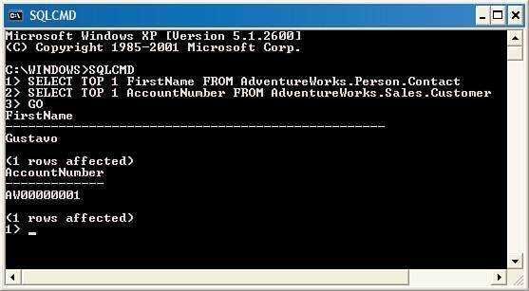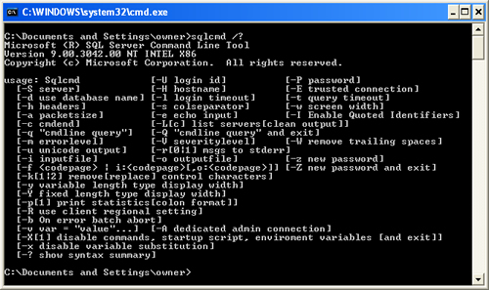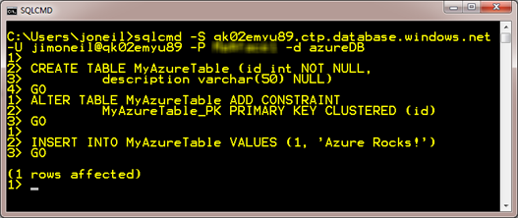

## Video 1

**Title: DNS Explained**

**Duration: 6 min**

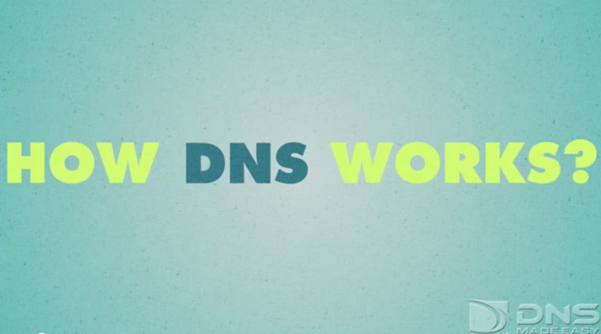

Link: <https://www.youtube.com/watch?v=72snZctFFtA>

**How was it? Anything new you learned?Your answer**

[Answer]

In my opinion, I think that is quite general and also sufficient to know simple thing about DNS. After watching this video, I have reviewed things I have learnt in the Network course. Anyway, this video is quite interesting and attractive.

# Intermediate part

## Exercise 5

**Data types and art of selecting proper ones** (Slide 6)



Write the best possible data types for the following cases:

|  |  |
| --- | --- |
| **Case** | **Data type** |
| If the user uploaded his/her profile photo or not | bit |
| ActionType field in a table which actions can has the type from 1-10 | tinyint |
| Start date and time of our class | date, time |
| Storing messages up to 1000 from people all around the world with their own mother tongue. | nvarchar(1000) |
| Specific dates for the years 2000-2014 | date |
| Row ID for a table with people of Finland information | int |
| Row ID for a table with people of the Earth information | bigint |
| English messages up to 255 character. | varchar(255) |
| Balance value of users of a bank | float |
| Storing random numbers from 0-30’000 | real |

## Exercise 6

**Understanding primary key and foreign key** (Slide 12)

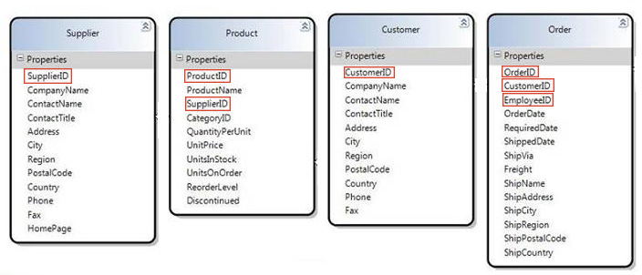

Write which of the following fields are primary keys and which are foreign keys.

|  |  |  |
| --- | --- | --- |
| **Table** | **Field** | **Type** |
| Supplier | SupplierID | Primary key |
| Product | ProductID | Primary key |
| Product | SupplierID | Foreign key |
| Customer | CustomerID | Primary key |
| Order | OrderID | Primary key |
| Order | CustomerID | Foreign key |
| Order | EmployeeID | Foreign key |

## Exercise 7

**Working with tables inside a database** (Slide 16, 20)

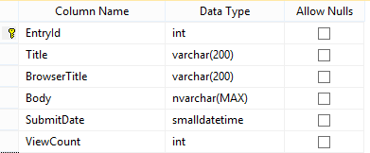

Write a query to create the table which has been shown in the figure.

[Answer]

CREATE TABLE Table01(

EntryId int PRIMARY KEY NOT NULL,

Title varchar(200) NOT NULL,

BrowserTitle varchar(200) NOT NULL,

Body nvarchar(MAX) NOT NULL,

SubmitDate smalldatetime NOT NULL,

ViewCount int NOT NULL,

)

GO

## Exercise 8

**SELECT statement** (Slide 22)

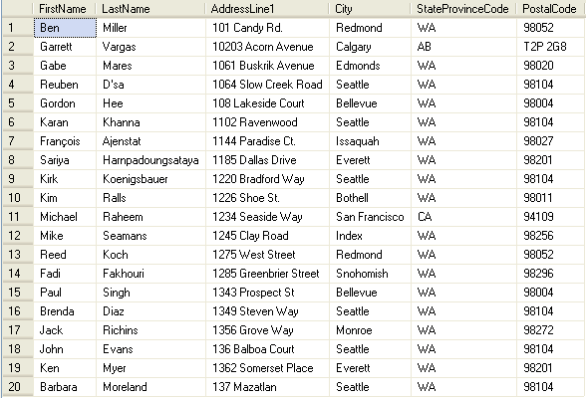

Consider this table, write the following queries:

Getting all the information from this table

[Answer]

SELECT *

FROM Customers

Getting the records which “StateProvienceCode” is “WA” and “City” is “Seattle”

[Answer]

SELECT *

FROM Customers

WHERE (StateProvinceCode = 'WA') AND (City = 'Seattle')

Getting only “FirstName” and “LastName” sorted by “PostalCode”

[Answer]

SELECT

FirstName,

LastName

FROM Customers

ORDER BY PostalCode ASC

Getting the cities which has been listed in this table (each city only once)

[Answer]

SELECT DISTINCT City  
FROM Customers

## Exercise 9

**INSERT statement** (Slide 30)



Consider this table, write a query to insert a sample row.

[Answer]

INSERT INTO Customers

VALUES

('Anh', 'Pham', 'Vanha mantie 6', 'Espoo', 'ES',02580)

## Exercise 10

**UPDATE statement** (Slide 32)



Consider this table, write the following queries:

Change records with FirstName “Paul” to “John”

[Answer]

UPDATE Customers  
SET FirstName = 'John'  
WHERE FirstName = 'Paul'

Change “PostalCode” to “12345” of the records with “FirstName”, “Paul” and “LastName” “Singh”.

[Answer]

UPDATE Customers  
SET PostalCode = 12345  
WHERE (FirstName = 'Paul') AND (LastName = 'Singh')

## Exercise 11

**DELETE statement** (Slide 34)



Consider this table, write the following queries:

Remove all the records which “City” is “Redmond”

[Answer]

DELETE FROM Customers

WHERE City = 'Redmond'

Write a query to delete all the table’s data (only the data not the table itself)

[Answer]

DELETE FROM Customers

# Advanced part

## Exercise 12

**Indexes** (Slide 34)



Consider this table, write the following indexes:

FirstName + LastName

[Answer]

CREATE INDEX Name_index  
ON Customers (FirstName, LastName)

City

[Answer]

CREATE INDEX City_index  
ON Customers (City)

## Exercise 13

**Built-in functions** (Slide 34)



Write the name of 6 functions you researched about on the following document:

<https://docs.google.com/document/d/1Ztn1cYsuWT1dZzMqtnAkwD-x2Bj4w43zvIKj4wBgSBw/edit?usp=sharing>

[Answer]

STR, STUFF, SUBSTRING, PATINDEX, TEXTPTR, TEXTVALID

## Exercise 14

**Stored Procedures** (Slide 34)



Write these 3 Stored Procedures for this table:

Stored Procedure 1 – For adding a row:

[Answer]

CREATE PROCEDURE insertInfo @FirstName varchar(200),

@LastName varchar (200),

@Address varchar(200),

@City varchar(50),

@StateCode varchar(10),

@PostCode int

AS

BEGIN

SET NOCOUNT ON;

INSERT INTO Customers

VALUES

(@FirstName, @LastName, @Address, @City, @StateCode, @PostCode)

END

GO

Stored Procedure 2 – For deleting a row (Consider those numbers are UserId):

[Answer]

CREATE PROCEDURE deleteInfo @InputID int

AS

BEGIN

SET NOCOUNT ON;

DELETE FROM Customers

WHERE UserID = @InputID

END

GO

Stored Procedure 3 – For selecting a row (Consider those numbers are UserId):

[Answer]

CREATE PROCEDURE selectInfo @InputID int

AS

BEGIN

SET NOCOUNT ON;

SELECT *

FROM Customers

WHERE UserID = @InputID

END

GO

## Exercise 15

**Views** (Slide 34)



Write a view for this table which hide AddressLine1 field and returns the other fields.

[Answer]

CREATE VIEW UserInfo AS

SELECT

FirstName,

LastName,

City,

StateProvinceCode,

PostalCode

FROM Users

## Exercise 16

**Triggers** (Slide 34)

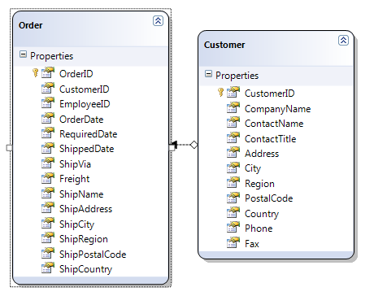

Consider “Customer” table has “OrdersCount” field. Write 2 triggers (ForInsert and ForDelete) for “Order” table that +1 and -1 the specific user’s “OrderCount” column.

[Answer]

CREATE TRIGGER ForInsert

ON Orders

FOR INSERT

AS

BEGIN

DECLARE @CustomerID int;

SET @CustomerID = (SELECT CustomerID FROM inserted);

UPDATE Customers

SET

OrdersCount = OrdersCount + 1

WHERE (CustomerID = @CustomerID)

END;

CREATE TRIGGER ForDelete

ON Orders

FOR DELETE

AS

BEGIN

DECLARE @CustomerID int;

SET @CustomerID = (SELECT CustomerID FROM deleted);

UPDATE Customers

SET

OrdersCount = OrdersCount - 1

WHERE (CustomerID = @CustomerID)

END;

# Diary

## First day diary

Write briefly about your first day. (The stuff you learned, the stuff you already were familiar with, and anything else related to our session) (If you were absent just write I was absent and yes you will not get points from this question, sorry.)

[Answer]

First day passed with so much theory. Anyway, I knew the schedule of this course, clearly saw the goal and steps to do it. I knew a little bit more about how to host a project and also many comparisons in your opinion.

As it was all theory, so it is quite sleepy and a little bit boring. By the way, I think that the last part is quite interesting because we know that MS SQL Server Express is free for all of us at mcp.metropolia.fi. Another thing is that I knew how to use the VMware view Client to connect to several computer for specific purposes.

## Second day

Write briefly about your second day. (The stuff you learned, the stuff you already were familiar with, and anything else related to our session) (If you were absent just write I was absent and yes you will not get points from this question, sorry.)

[Answer]

Second day was quite more fun, because we took a step into the syntax and also the data types can be stored in SQL Database Server. Because I have experienced in some programming languages so it did not take me much time to get familiar with them.

Anyway, I had fun time working with tables and do some labs.

## Third day

Write briefly about your third day. (The stuff you learned, the stuff you already were familiar with, and anything else related to our session) (If you were absent just write I was absent and yes you will not get points from this question, sorry.)

[Answer]

Third day we continue to figure out some more syntax and also many advanced parts. But I think it is not too much challenge for me as I programmed in some languages. All have gone through Procedure, Function, View and Trigger. It all has their own fun in syntax.

We also went through some helpful tips for us to work with database in the future. At the end of this day, I did some labs but it is not so hard to do it.

## Fourth day

Write briefly about your fourth day. (The stuff you learned, the stuff you already were familiar with, and anything else related to our session) (If you were absent you cannot pass this course since doing group project and quiz were compulsory!)

[Answer]

This was the final day of this course. We spent all morning for some integration of SQL database and Visual Studio through ASP.NET. Anyway, I cannot figure out all the thing you did. By the way, I knew basically what you were doing. After this, I did the quiz with much confident. :-D In the afternoon, before we did Group Project, we took a picture together, I think it is very funny moment of this course. Then, we continued to do the Group Project. I think this part is the most practical one of this course.

Finally, the course has gone, I think that I learnt a lot in just 4 days. I will keep on researching in the future because it helps my work in the future.

# Feedback from the teacher

|  |  |  |  |
| --- | --- | --- | --- |
|  | **Question** | **Your Score** | **Max Score** |
| Introduction | Exercise 1 |  | 5 |
| Exercise 2 |  | 5 |
| Exercise 3 |  | 5 |
| Exercise 4 |  | 5 |
| Video 1 |  | 2 |
| Intermediate | Exercise 5 |  | 5 |
| Exercise 6 |  | 5 |
| Exercise 7 |  | 5 |
| Exercise 8 |  | 5 |
| Exercise 9 |  | 4 |
| Exercise 10 |  | 4 |
| Exercise 11 |  | 5 |
| Advanced | Exercise 12 |  | 5 |
| Exercise 13 |  | 5 |
| Exercise 14 |  | 5 |
| Exercise 15 |  | 5 |
| Exercise 16 |  | 5 |
| Diary | First day (Tuesday) |  | 5 |
| Second day (Wednesday) |  | 5 |
| Third day (Thursday) |  | 5 |
| Fourth day (Friday) |  | 5 |
|  | **Total Score:** |  | **100** |

**Feedback:**