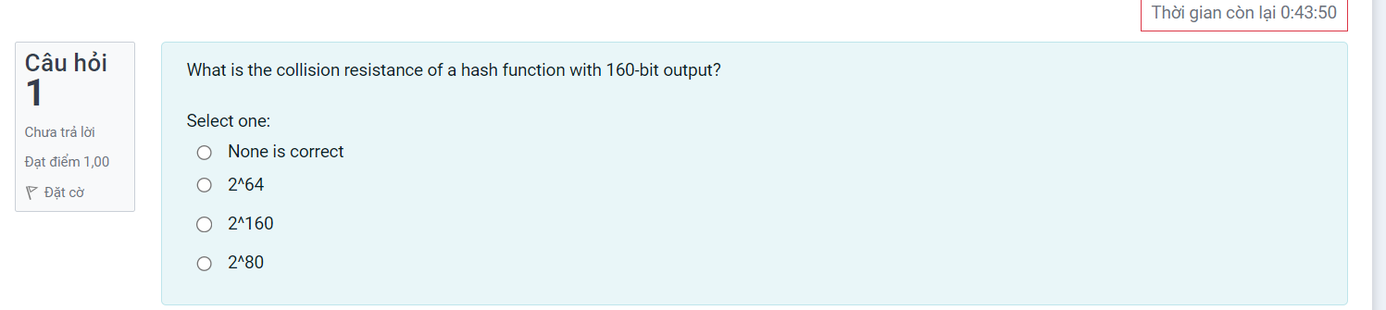

2^80 = 2^160/2

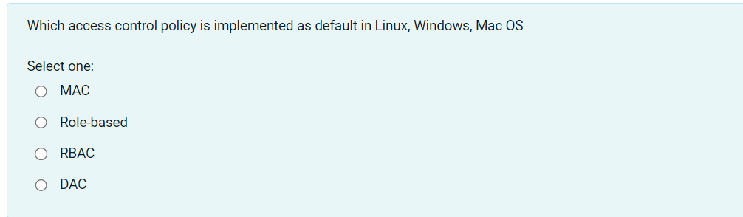

MAC controls operating system.

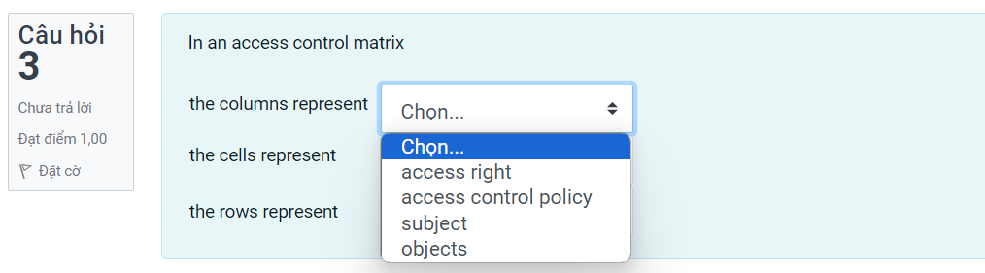

Rows represent subjects, columns represent objects, cells represent access control policy

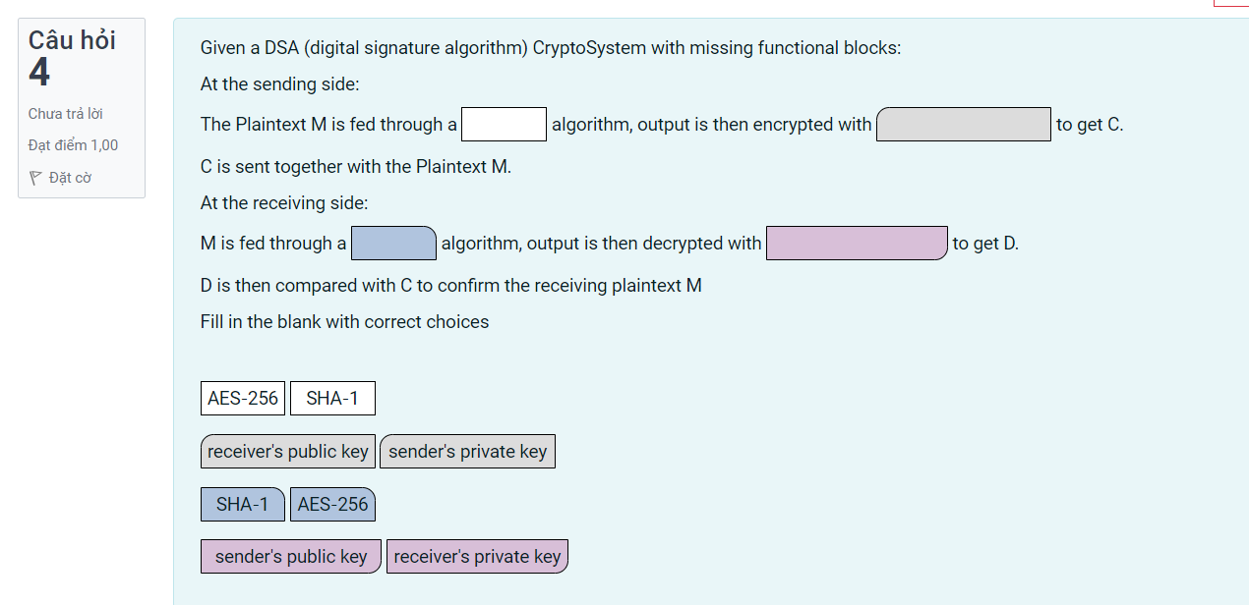

Deo biet lam

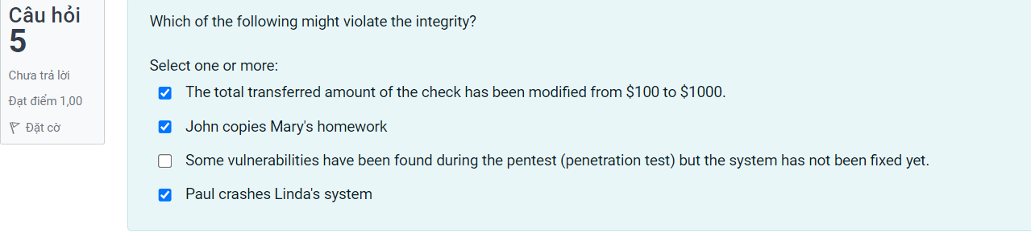

The total, paul crashes

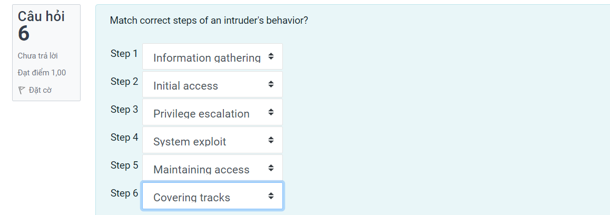

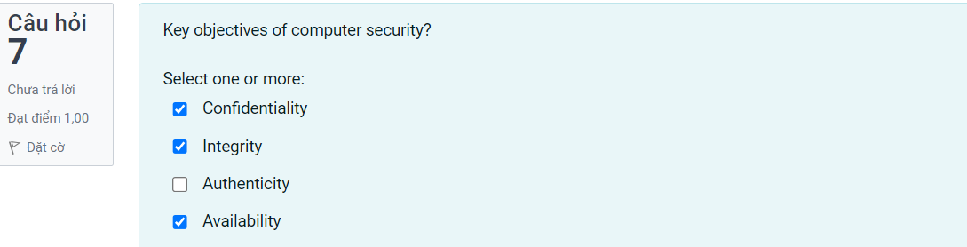

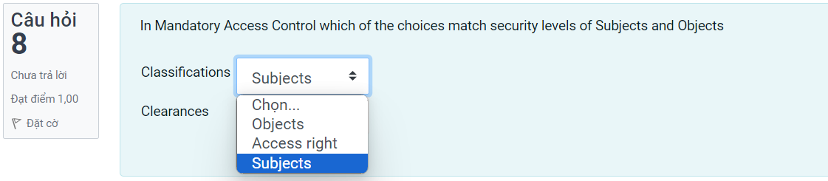

Subjects

Objects

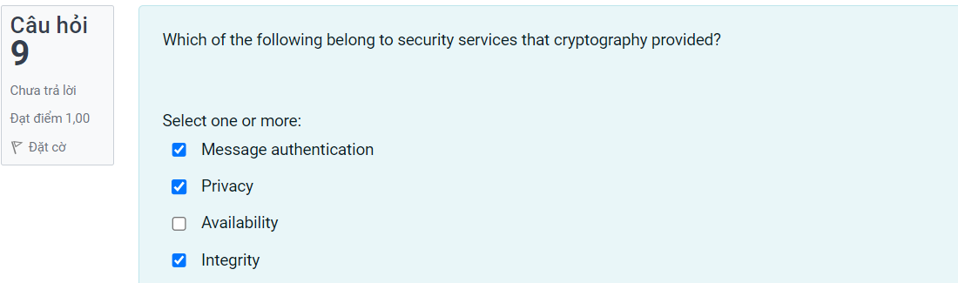

Availability, Intergrity, message authentication.

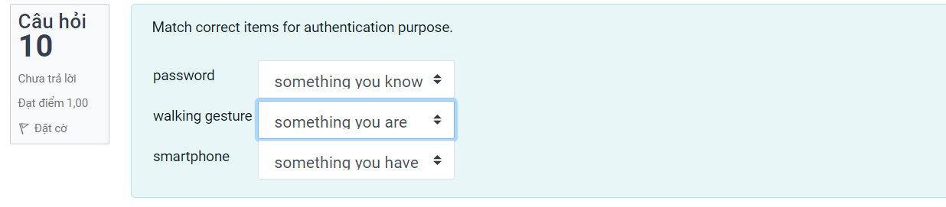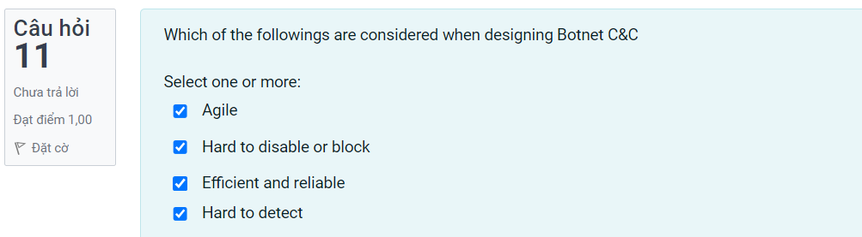

Efficient and reliable, Hard to detect (stealthy), hard to disable or block(Resilient) . CHAPTER 5 (BOTNET C&C DESIGN CONSIDERATIONS)

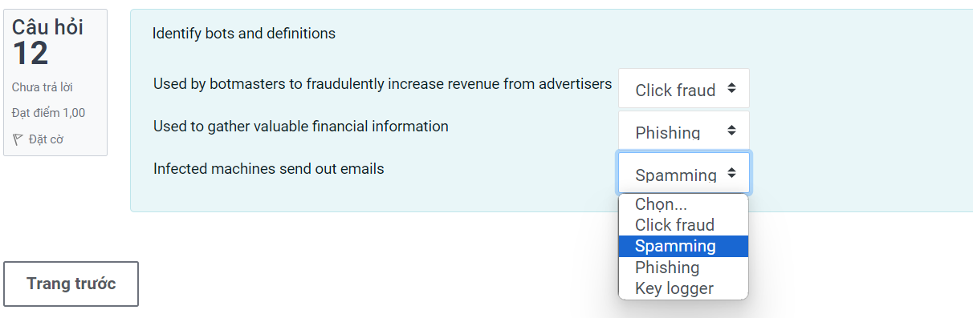

Used by bot master -> Spamming

Used to gather -> Click fraud

Infected machines -> Phising.

CHAPTER 5. BOTNET C&C DESIGN CONSIDERATIONS

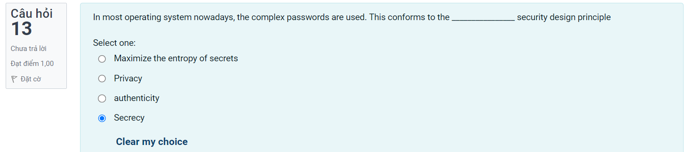

Maximize the entropy of secrets

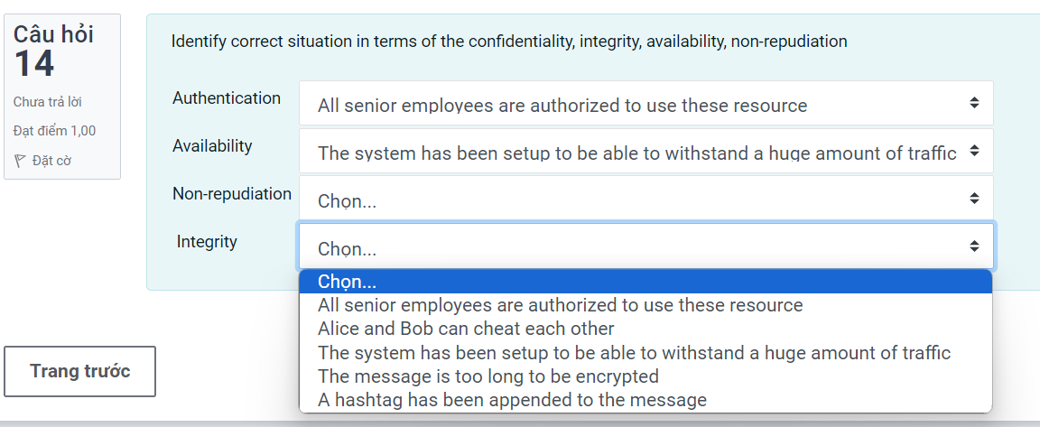

Authentication -> All senior employees are authorized to use these resources.

Availability -> The system has been setup

Non-repudiation -> Alice and Bob

Intergrity -> A hashtag has been appended to the messages

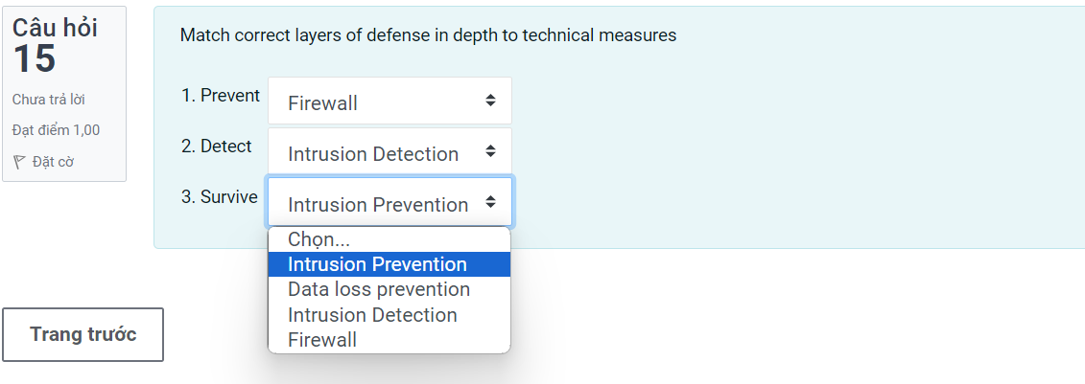

Prevent ->Firewall ,Detect -> Intrusion detection, Survive -> Data loss prevention

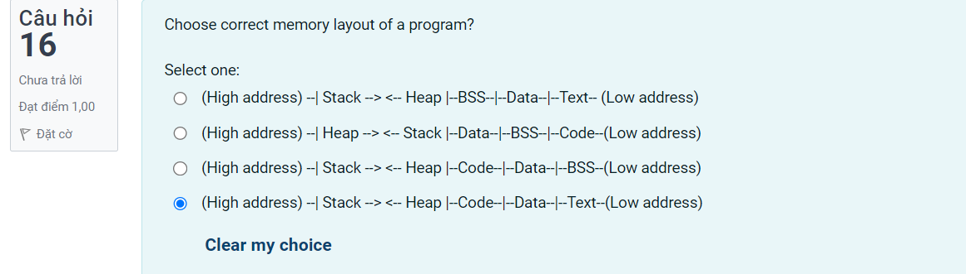

High address BSS

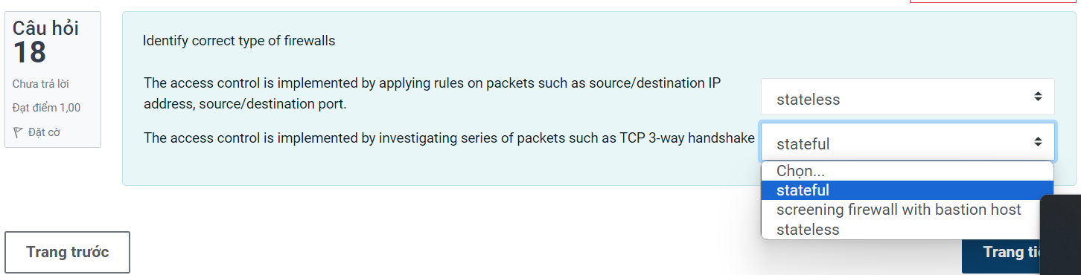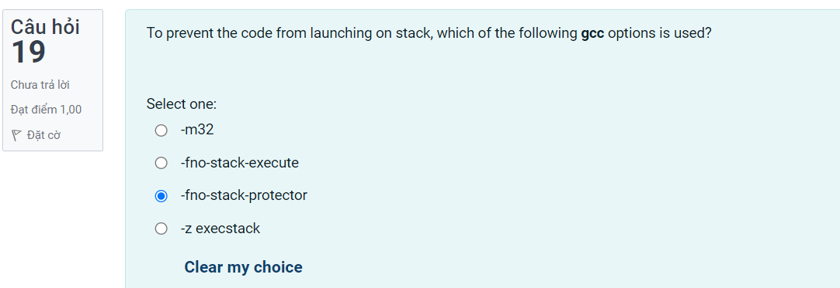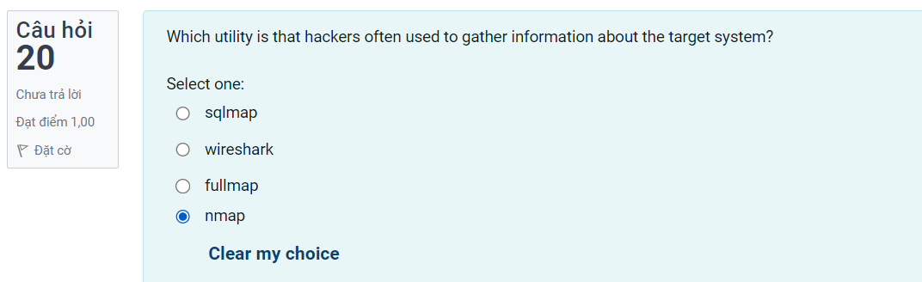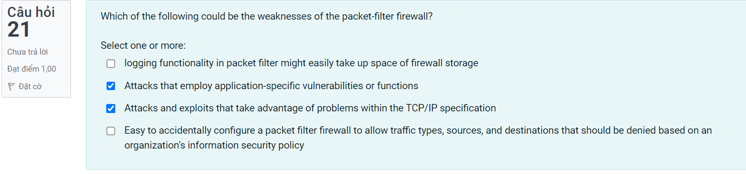

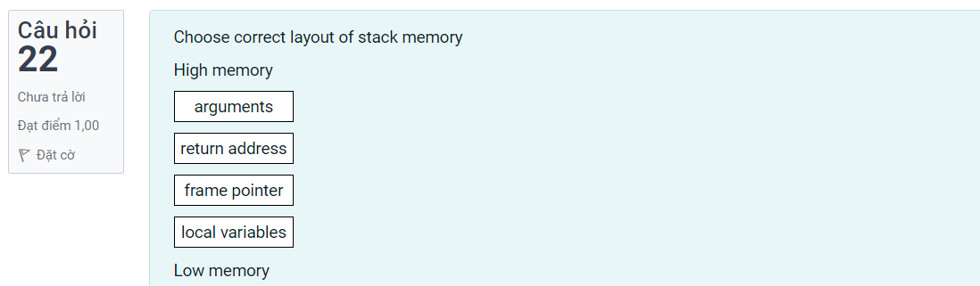

Chapter 3 page 13 co van

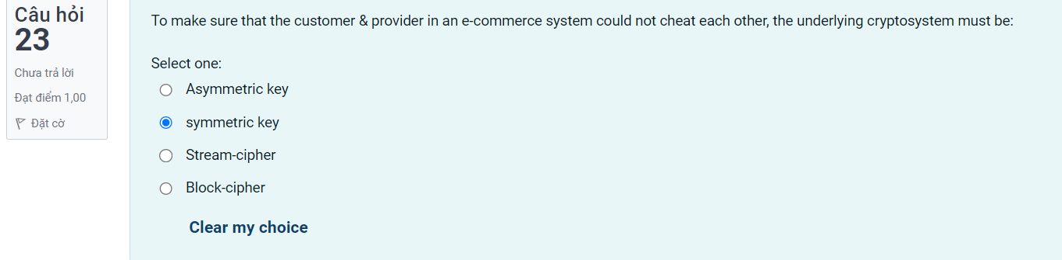

Asymetric key (chapter10 page22)

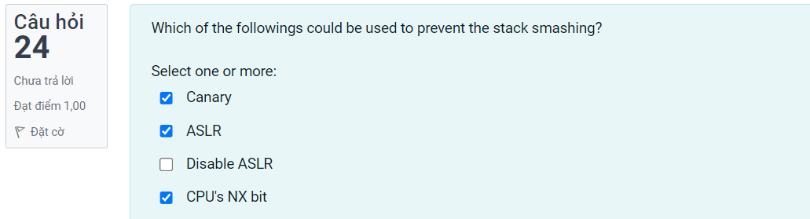

Chapter 2 Software and security thay quang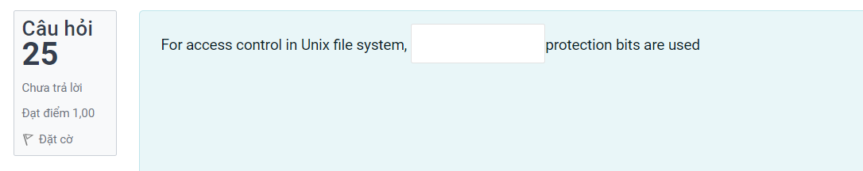

9 protection bits

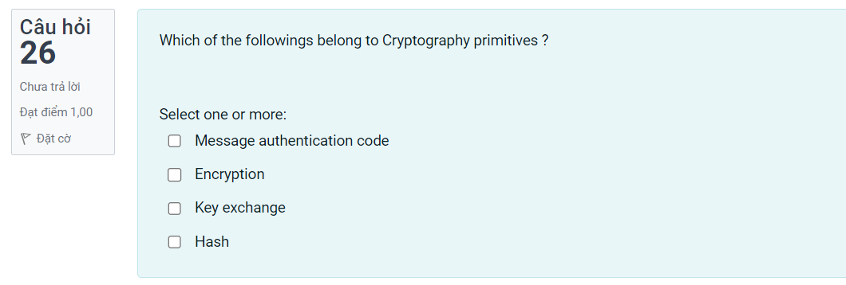

Chapter 7 thay quang: Encryption, Hash, Message authentication

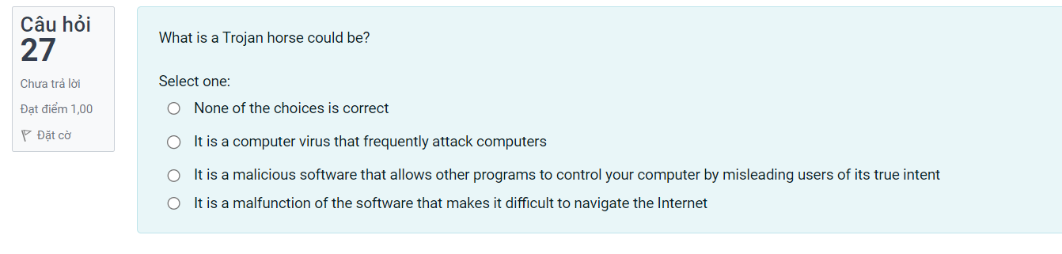

It is a malicious software that allows other program to control your computer by … (Chapter 10 co van)

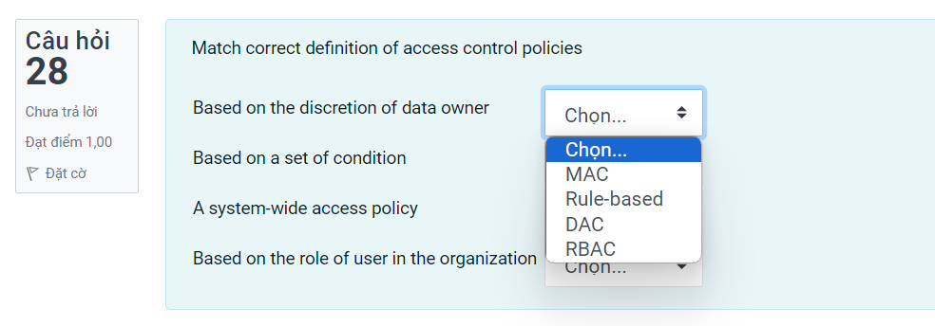

Based ib discretion -> DAC

Based ib a set of condition -> Rule-based

A system -> MAC

Based on role of user -> RBACs