Download and install Anaconda navigator:

Create a new environment (tf stands for tensorflow)

conda create --name tf_env python=3.12.4

conda activate tf_env

Install libraries

pip install opencv-python

pip install tensorflow

pip install pandas

pip install netcdf4

pip install matplotlib

In Spyder: Tools>Preferences>IPython console

On the Graphics tab, for ‘Graphics backend’, select ‘Automatic’

This will make the plots to show in popped up windows.

Clone github repository:   
<https://github.com/anhphanbb/cloud.git>

Folder with q20 camera data of November:

[l1r_11_updated_07032024](https://usu-my.sharepoint.com/:f:/g/personal/a02400392_aggies_usu_edu/EgEd_MAsCa9KrSYwzD4AX8sBZljDv3YOXQSkcmMN71EuQw?e=HQO2gd)

(Maybe only download a couple files to view)

Folder with one orbit predicted.

[one_nc_file_with_mlcloud](https://usu-my.sharepoint.com/:f:/g/personal/a02400392_aggies_usu_edu/EpLrOgiz3v1Eo4pIDTVynn0BsafN9ODHfWy5GBOSz-n-SA?e=Viey3x)

After downloading, put the folders with the designated names into the cloned github folder.

* To view netCDF file and look for cloud intervals:

Open Spyder (Remember to use the newly set up environment).

Open script ‘view_images_aug_6.py’

Look at the code. Make sure that the folder name in ‘parent_directory’ is correct.

Define the orbit number (pick an orbit that you downloaded).

Click run.

You will see this interface:   
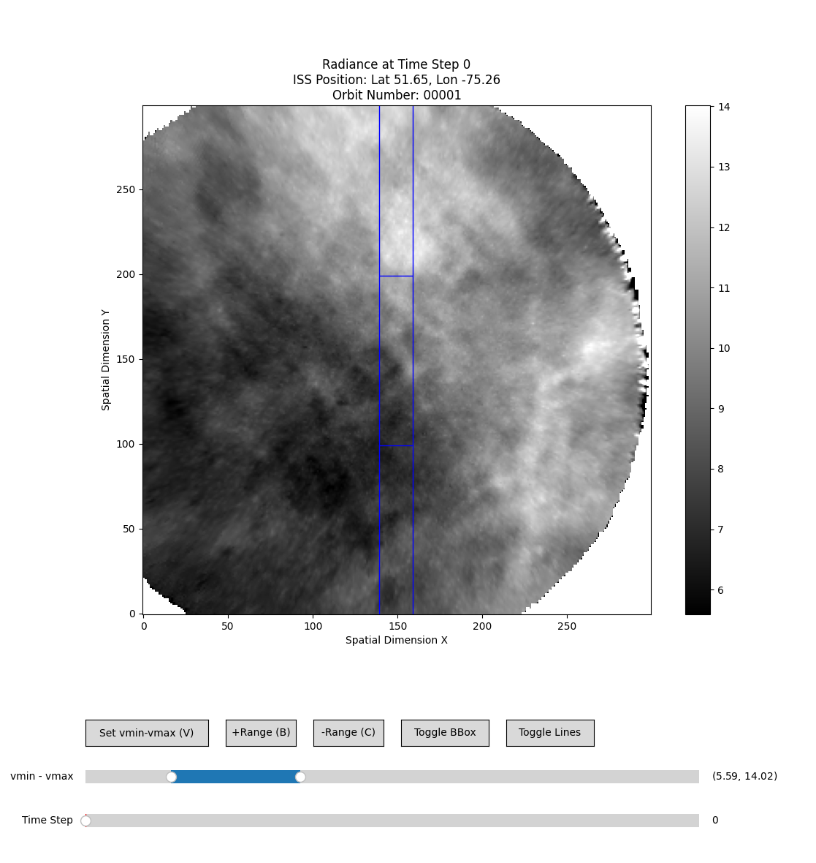

Then you can use the mouse, the keys (up, down, left, right, V, B, C) to go through the images and look for clouds.

The current intervals are in: [cloud_intervals_112024_D (1).xlsx](https://usu-my.sharepoint.com/:x:/g/personal/a02280307_aggies_usu_edu/EYwZyRdJubdBmWMgGqBZpAQBhpXdgKoCMjWJINqqe3WkqQ?e=cxrZh3)

To view a netCDF file with predictions shown for each segment, open ‘view_clouds.py’.

Make sure that ‘parent_directory’ and ‘orbit_number’ is correct. And click run.   
You will see an interface like this:

