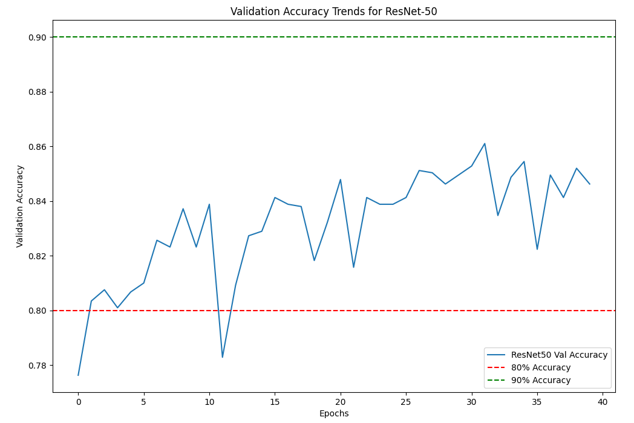

**Time needed to predict all 5 orbits: 569.10 seconds**

**Orbit 75:**

**Accuracy: 83.63%**

**True Negatives: 856 (59.12%)**

**False Positives: 101 (6.98%)**

**False Negatives: 136 (9.39%)**

**True Positives: 355 (24.52%)**

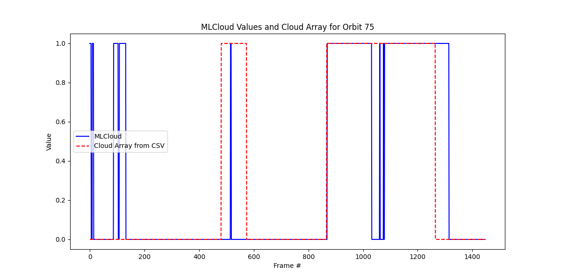

**Orbit 90:**

**Accuracy: 68.92%**

**True Negatives: 539 (37.90%)**

**False Positives: 399 (28.06%)**

**False Negatives: 43 (3.02%)**

**True Positives: 441 (31.01%)**

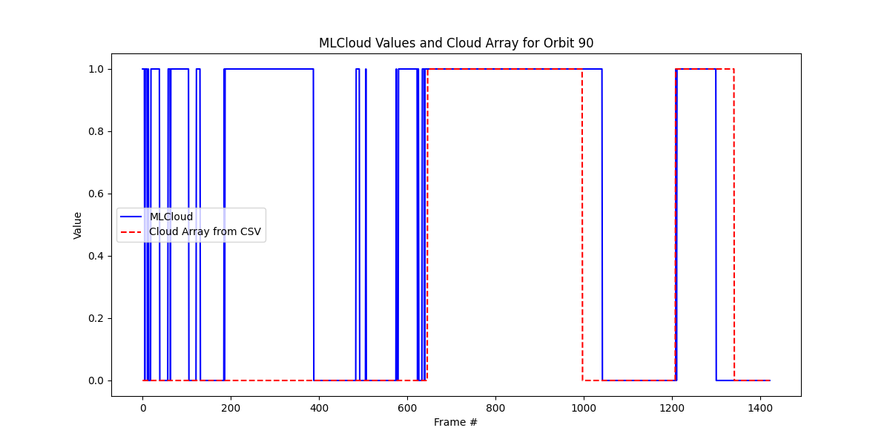

**Orbit 105:**

**Accuracy: 91.21%**

**True Negatives: 849 (60.64%)**

**False Positives: 99 (7.07%)**

**False Negatives: 24 (1.71%)**

**True Positives: 428 (30.57%)**

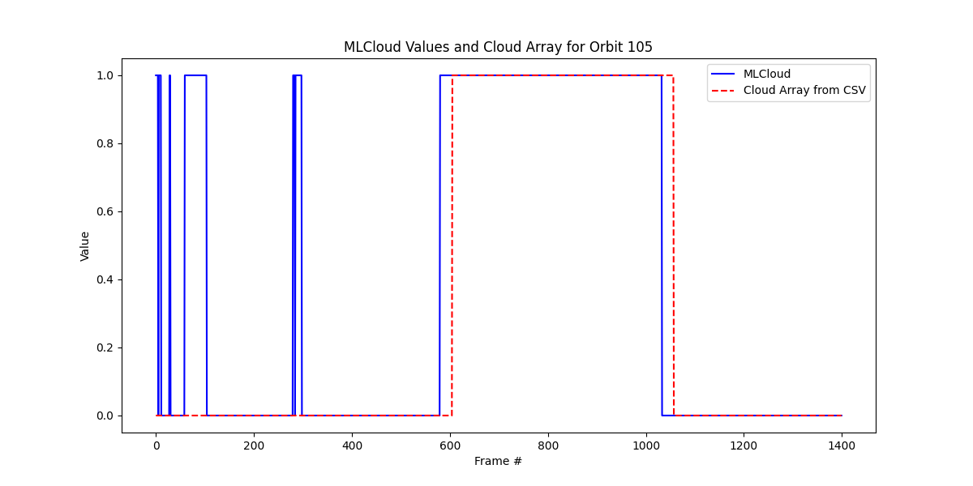

**Orbit 120:**

**Accuracy: 85.10%**

**True Negatives: 757 (54.74%)**

**False Positives: 99 (7.16%)**

**False Negatives: 107 (7.74%)**

**True Positives: 420 (30.37%)**

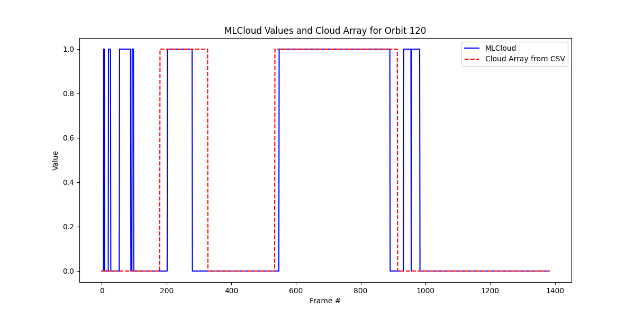

**Orbit 135:**

**Accuracy: 94.81%**

**True Negatives: 1578 (83.62%)**

**False Positives: 85 (4.50%)**

**False Negatives: 13 (0.69%)**

**True Positives: 211 (11.18%)**

