Họ và tên: Nguyễn Đặng Anh Phương

MSSV: 1813621

**DDL STATEMENTS FOR LIBRARY SYSTEM**

**1. INSERT Statements**

a. Insert a new publisher whose name is ‘Pearson’ and address is ‘123 Street Name, London, UK’.

Lệnh: 

Kết quả:

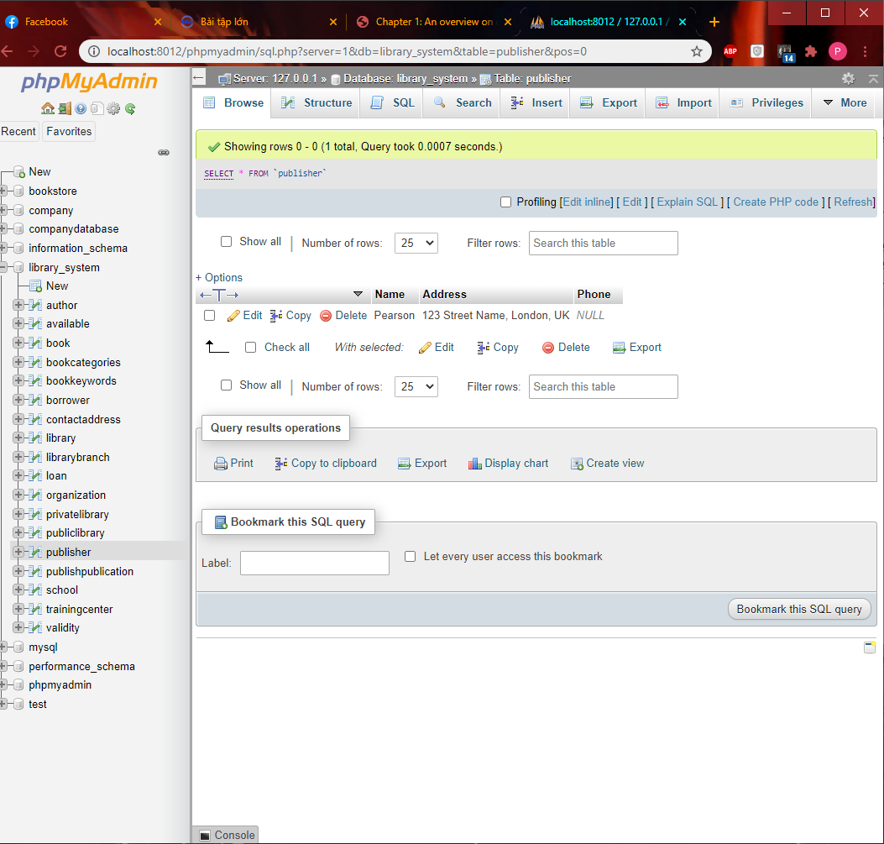

b. Insert a new book whose name is ‘Fundamentals of Database Systems’, ISBN is ‘978-0-13-397077-7’, authors are ‘Ramez Elmasri’ at the University of Texas at Arlington and ‘Shamkant B. Navathe’ in Georgia Institute of Technology. This book is published by Pearson in 2016 and has the 7th edition.