**COMPUTER NETWORKS**

**Lab 3b**

**Name: Nguyễn Đặng Anh Phương**

**Student ID: 1813621**

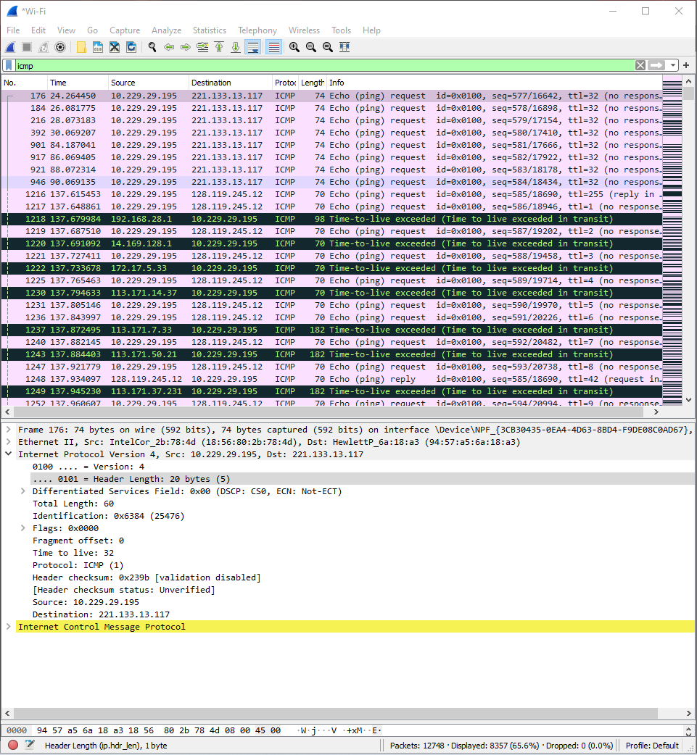**Answer the questions:**

1. Select the first ICMP Echo Request message sent by your computer, and expand the Internet Protocol part of the packet in the packet details window. What is the IP address of your computer?

**Answer:** 10.229.29.195.

2. Within the IP packet header, what is the value in the upper layer protocol field?

**Answer:** The value of upper layer protocol field is ICMP (1)

3. How many bytes are in the IP header? How many bytes are in the payload of the IP datagram? Explain how you determined the number of payload bytes.

**Answer:** There are 20 bytes in the IP header and 60 bytes in total length. That means there are 40 bytes in the payload of the IP datagram.

4. Has this IP datagram been fragmented? Explain how you determined whether or not the datagram has been fragmented.

**Answer:** This IP datagram hasn’t been fragment. Because the **More fragment** flag is set to 0.

5. Which fields in the IP datagram always change from one datagram to the next within this series of ICMP messages sent by your computer?

**Answer:** The Identification, TTL and Checksum always change.

6. Which fields stay constant? Which of the fields must stay constant? Which fields must change? Why?

**Answer:**

Fields that stay constant:

- Version

- Protocol

- Source

- Destination

- Header length

- Differentiated Services

Fields that must change:

- ID

- Time to live

- Header checksum

Above fields that stays constant because they have to use the same version, source and destination, informations that identify the connection.

Above fields that must change because they have to be differentiate, that information must change to suit for each of their purposes.

7. Describe the pattern you see in the values in the Identification field of the IP datagram

**Answer:** It is in hexadecimal form and decreases with each request.

8. What is the value in the Identification field and the TTL field?

**Answer:**

Identification: 25476

TTL: 32

9. Do these values remain unchanged for all of the ICMP TTL-exceeded replies sent to your computer by the nearest (first hop) router? Why?

**Answer:**

ID is unique value so it always change. If it remains the same value, that means they are fragments of a huge IP datagram.

TTL for first hop remains the same.

10. Find the first ICMP Echo Request message that was sent by your computer after you changed the Packet Size in pingplotter to be 2000. Has that message been fragmented across more than one IP datagram? [Note: if you find your packet has not been fragmented, you should download the zip file http://gaia.cs.umass.edu/wireshark-labs/wireshark-traces.zip and extract the ipethereal-trace-1packet trace. If your computer has an Ethernet interface, a packet size of 2000 should cause fragmentation.3]

**Answer:** Yes.

11. Print out the first fragment of the fragmented IP datagram. What information in the IP header indicates that the datagram been fragmented? What information in the IP header indicates whether this is the first fragment versus a latter fragment? How long is this IP datagram?

**Answer:** The datagram has been fragmented ‘cause Fragment offset is bigger than 0.

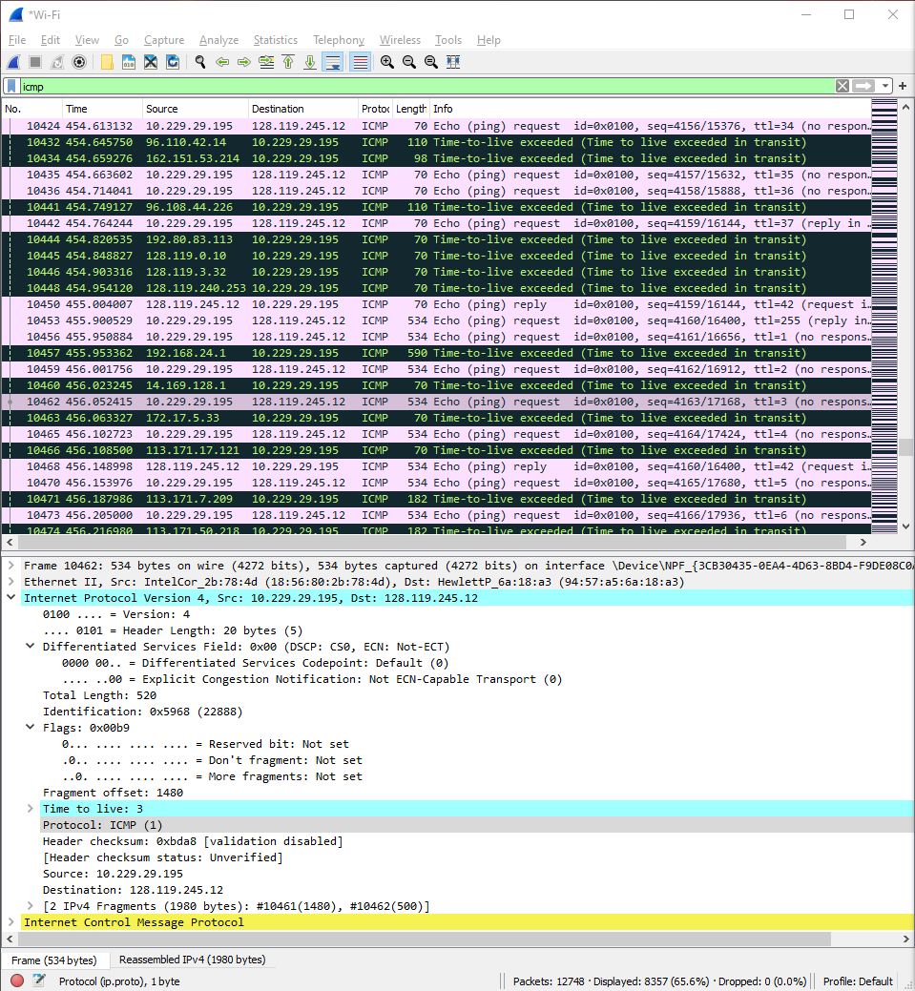

12. Print out the second fragment of the fragmented IP datagram. What information in the IP header indicates that this is not the first datagram fragment? Are the more fragments? How can you tell?

**Answer:** The fragment offset is 1480.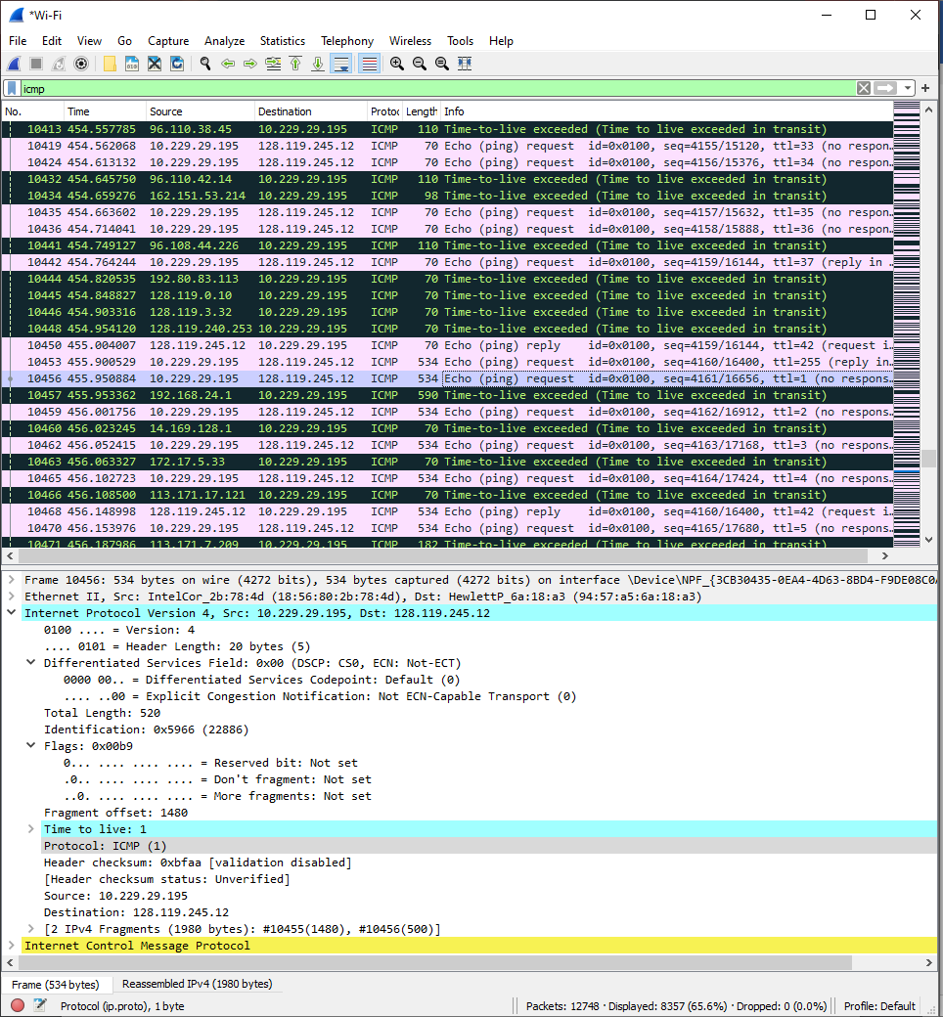

13. What fields change in the IP header between the first and second fragment?

**Answer:** Total length, flags, fragment offset and checksum

14. How many fragments were created from the original datagram?

**Answer:** 3 packets were created from the original datagram.

15. What fields change in the IP header among the fragments?

**Answer:**