**COMPUTER NETWORKS**

**Lab 5**

**Name: Nguyễn Đặng Anh Phương**

**Student ID: 1813621**

**Answer the questions:**

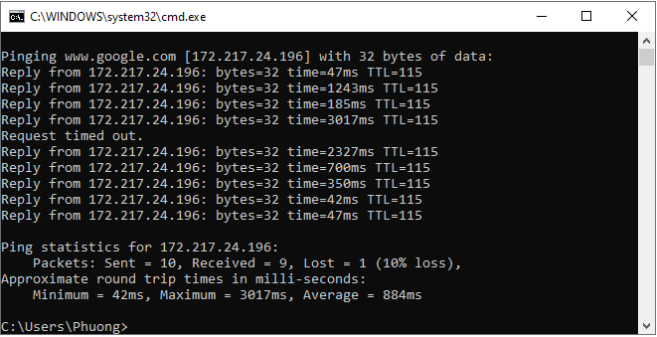

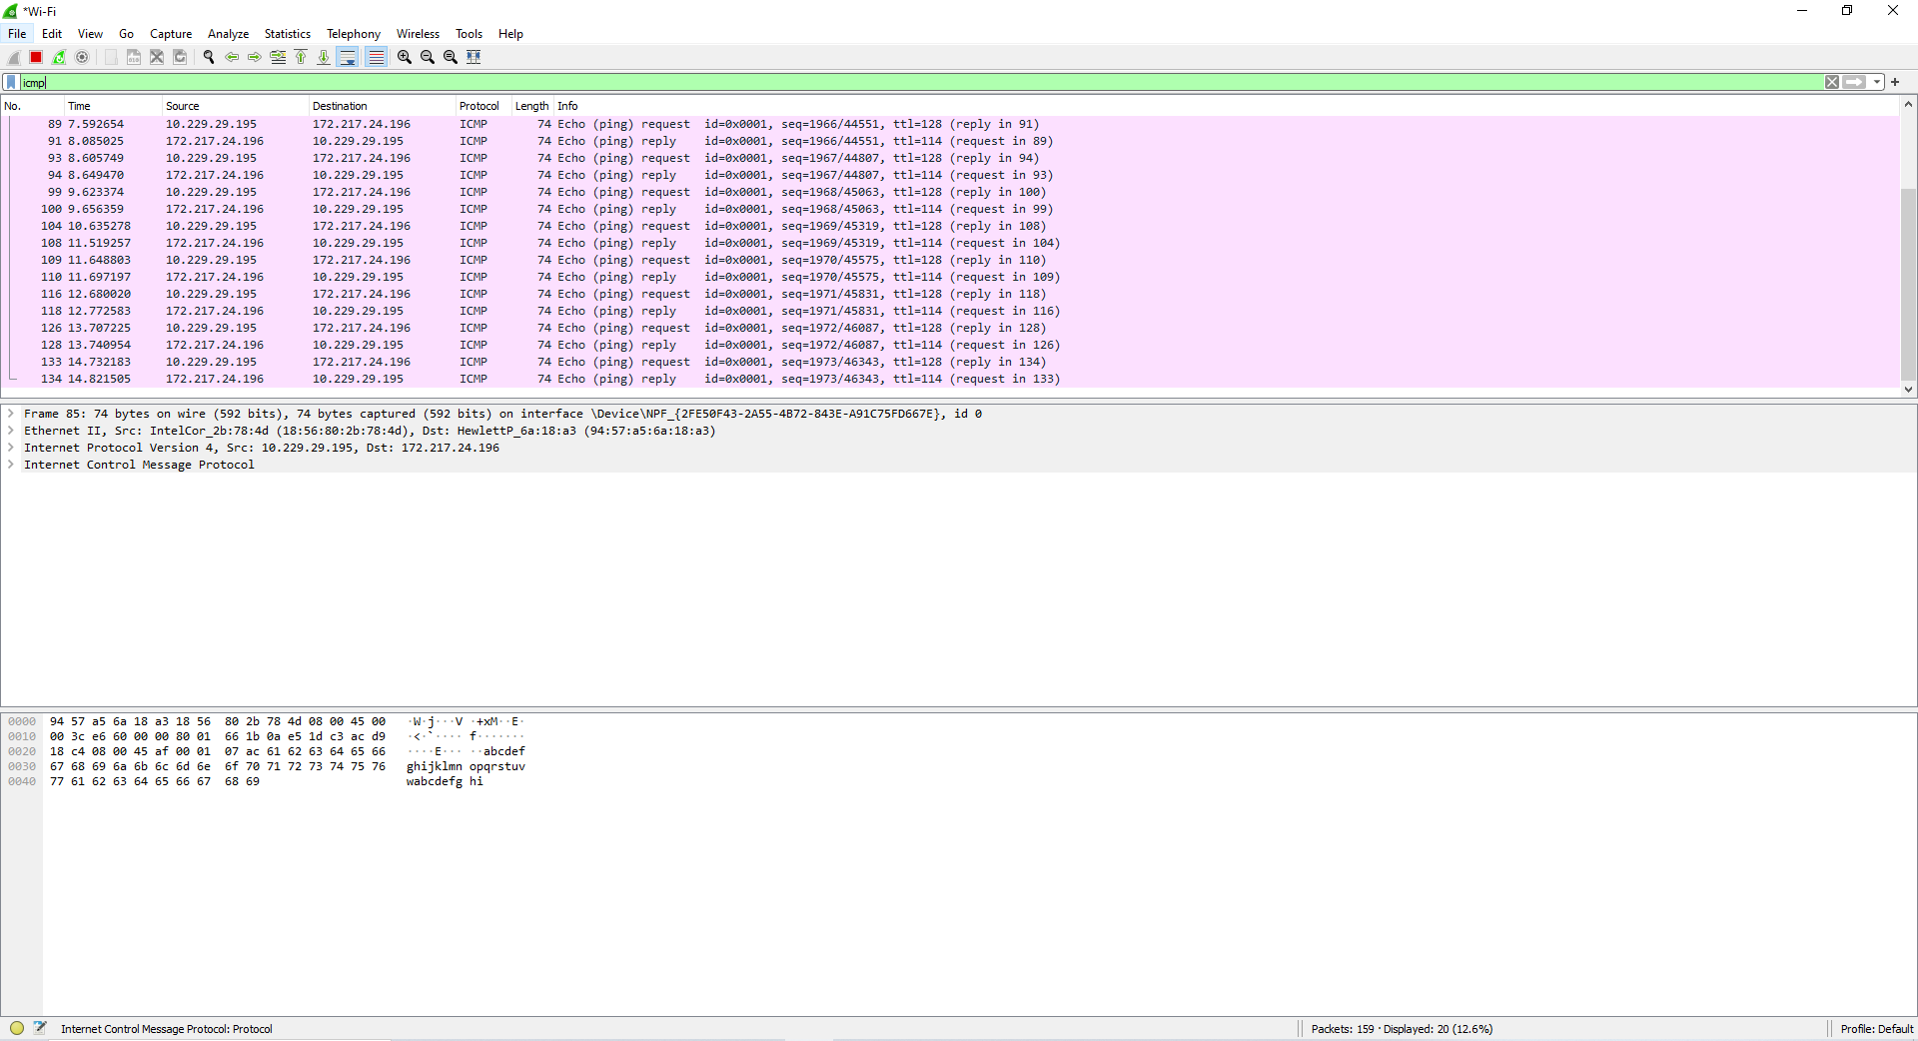

1. What is the IP address of your host? What is the IP address of the destination

host?

**Answer:** The IP address of my host: 10.229.29.195. The IP address of the destination host ([www.google.com](http://www.google.com)): 172.217.24.196

2. Why is it that an ICMP packet does not have source and destination port

numbers?

**Answer:** Because ICMP packet is used by hosts and routers to communicate network-layer information. So it doesn’t have port numbers in its packet.

3. Examine one of the ping request packets sent by your host. What are the ICMP

type and code numbers? What other fields does this ICMP packet have? How

many bytes are the checksum, sequence number and identifier fields?

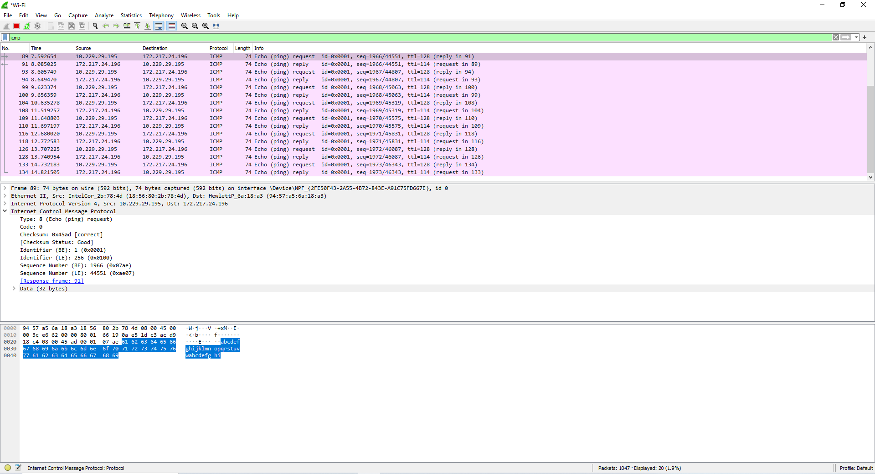

**Answer:** ICMP type: 8

ICMP code: 0

The other fields this ICMP packet has: checksum (2 bytes), Identifier (2 bytes), Sequence number (2 bytes).

4. Examine the corresponding ping reply packet. What are the ICMP type and code

numbers? What other fields does this ICMP packet have? How many bytes are the

checksum, sequence number and identifier fields?

**Answer**: 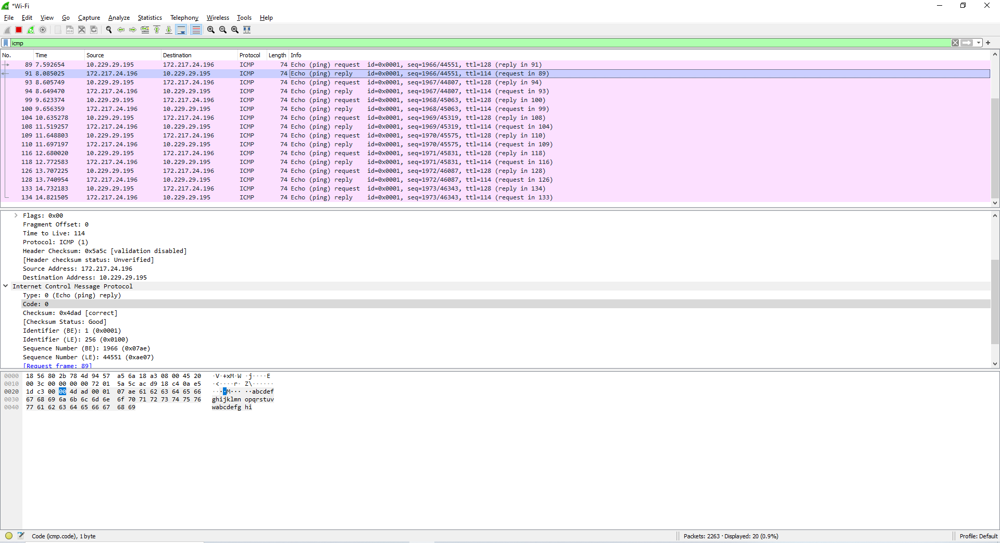

ICMP type: 0

ICMP code: 0

The other fields this ICMP packet has: checksum (2 bytes), Identifier (2 bytes), Sequence number (2 bytes).

**Answer the questions:**

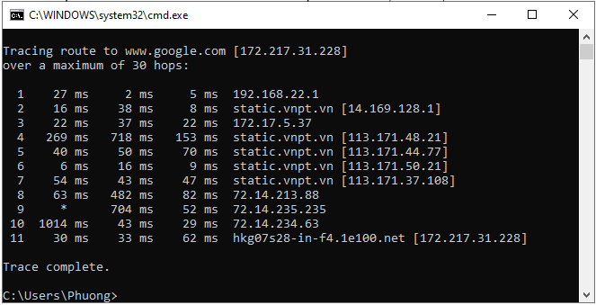 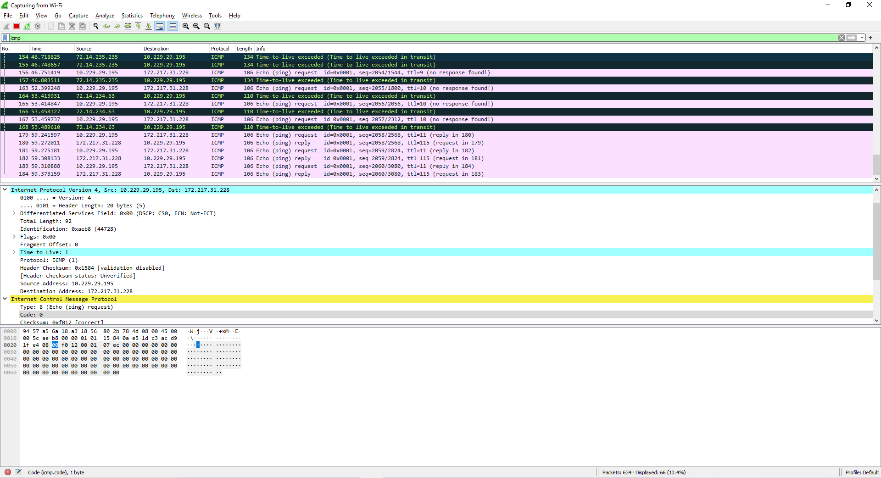

5. What is the IP address of your host? What is the IP address of the target

destination host?

**Answer:** My IP address: 10.229.29.195. Host’s IP address ([www.google.com](http://www.google.com)): 172.217.31.228

6. If ICMP sent UDP packets instead (as in Unix/Linux), would the IP protocol

number still be 01 for the probe packets? If not, what would it be?

**Answer:** 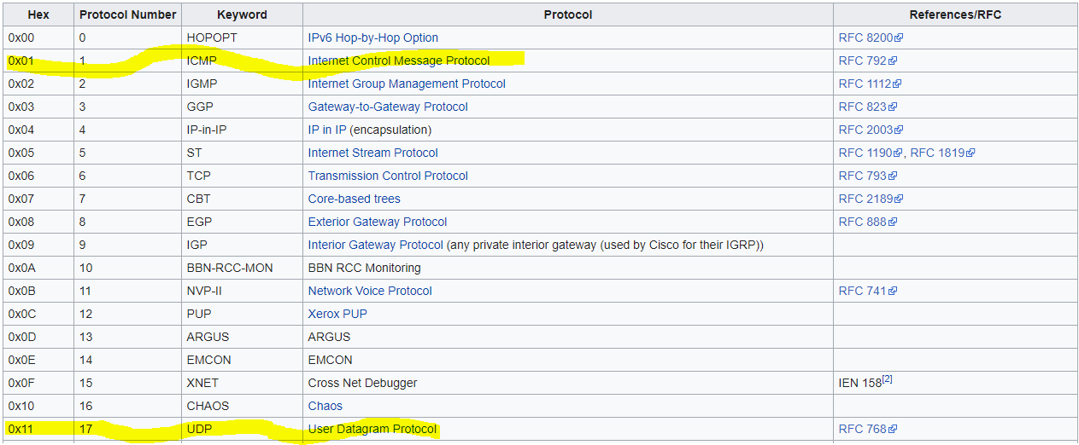

**Answer:** Based on the table of IP protocol number hex code, the answer here is No. In this case, it would be 0x11

7. Examine the ICMP echo packet in your screenshot. Is this different from the

ICMP ping query packets in the first half of this lab? If yes, how so?

**Answer:** There is no different between two packets.

8. Examine the ICMP error packet in your screenshot. It has more fields than the

ICMP echo packet. What is included in those fields?

**Answer:** Those fields is IP header and the first 8 bytes of an original ICMP packet.

9. Examine the last three ICMP packets received by the source host. How are these

packets different from the ICMP error packets? Why are they different?

**Answer:** The ICMP type is 0 instead of 11. They are different because they have to reach destination before the TTL ends.

10. Within the tracert measurements, is there a link whose delay is significantly

longer than others? Refer to the screenshot in Figure 4, is there a link whose

delay is significantly longer than others? On the basis of the router names, can

you guess the location of the two routers on the end of this link?

**Answer:** There are 2 link whose delay is significanlty longer than others. In figure 4 there are 2 also. I can’t guess the location of the 2 routers above.