**COMPUTER NETWORKS**

**Lab 6**

**Name: Nguyễn Đặng Anh Phương**

**Student ID: 1813621**

**Answer the questions:**

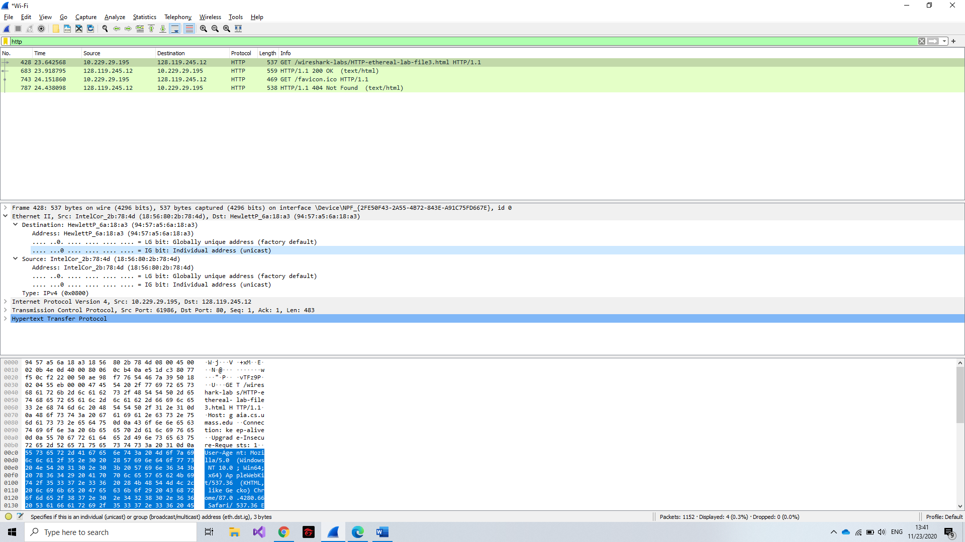

1. What is the 48-bit Ethernet address of your computer?

**Answer:** My Ethernet address: **18:56:80:2b:78:4d**.

2. What is the 48-bit destination address in the Ethernet frame? Is this the Ethernet

address of gaia.cs.umass.edu? (Hint: the answer is no). What device has this as its

Ethernet address? [Note: this is an important question, and one that students

sometimes get wrong. Re-read pages 468-469 in the text and make sure you

understand the answer here.]

**Answer:** The destination address in the Ethernet frame is 94:57:a5:6a:18:a3. It is not the address of gaia.cs.umass.edu. It is the address of my Linksys router.

3. Give the hexadecimal value for the two-byte Frame type field. What upper layer

protocol does this correspond to?

**Answer:** 0x0800. This correspond to the IP protocol.

4. How many bytes from the very start of the Ethernet frame does the ASCII “G” in

“GET” appear in the Ethernet frame?

**Answer:** The “G” appears 54 bytes from the start of the Ethernet frame: 14 bytes of Ethernet frame + 20 bytes of IP header + 20 bytes of TCP header and then HTTP data is encountered

5. What is the value of the Ethernet source address? Is this the address of your

computer, or of gaia.cs.umass.edu (Hint: the answer is no). What device has this

as its Ethernet address?

**Answer:** The source address in the Ethernet frame is 94:57:a5:6a:18:a3. It is neither the address of gaia.cs.umass.edu nor my computer address. It is the address of my Linksys router.

6. What is the destination address in the Ethernet frame? Is this the Ethernet address

of your computer?

**Answer:** The destination address 00:09:5b:61:8e:6d is the address of my computer.

7. Give the hexadecimal value for the two-byte Frame type field. What upper layer

protocol does this correspond to?

**Answer:** 0x0800. This correspond to the IP protocol.

8. How many bytes from the very start of the Ethernet frame does the ASCII “O” in

“OK” (i.e., the HTTP response code) appear in the Ethernet frame?

**Answer:** The “O” appears 54 bytes from the start of the Ethernet frame: 14 bytes of Ethernet frame + 20 bytes of IP header + 20 bytes of TCP header and then HTTP data is encountered.

9. Write down the contents of your computer’s ARP cache. What is the meaning of each column value?

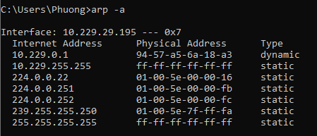**Answer:**

The Internet Address contains IP address, Physical Address contains MAC address, Type contains protocol type.

*ARP request message:*

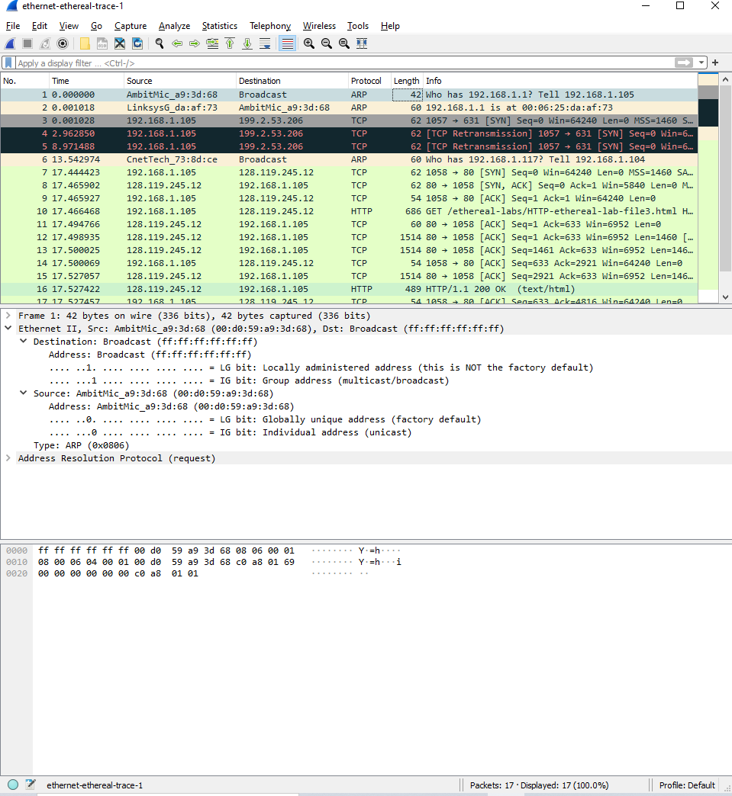

10. What are the hexadecimal values for the source and destination addresses in the

Ethernet frame containing the ARP request message?

**Answer:** Source: 00:d0:59:a9:3d:68. Destination: ff:ff:ff:ff:ff:ff

11. Give the hexadecimal value for the two-byte Ethernet Frame type field. What

upper layer protocol does this correspond to?

**Answer:** 0x0806. This corredspond to IP protocol.

12. Download the ARP specification from

ftp://ftp.rfc-editor.org/in-notes/std/std37.txt. A readable, detailed discussion of

ARP is also at http://www.erg.abdn.ac.uk/users/gorry/course/inet-pages/arp.html.

a) How many bytes from the very beginning of the Ethernet frame does the

ARP opcode field begin?

**Answer:** 20 bytes

b) What is the value of the opcode field within the ARP-payload part of the

Ethernet frame in which an ARP request is made?

**Answer:** 0x0001, for request.

c) Does the ARP message contain the IP address of the sender?

**Answer:** Yes.

d) Where in the ARP request does the “question” appear – the Ethernet

address of the machine whose corresponding IP address is being queried?

**Answer:** The field “Target MAC address” is set to 00:00:00:00:00:00 to request machine.

*ARP reply*

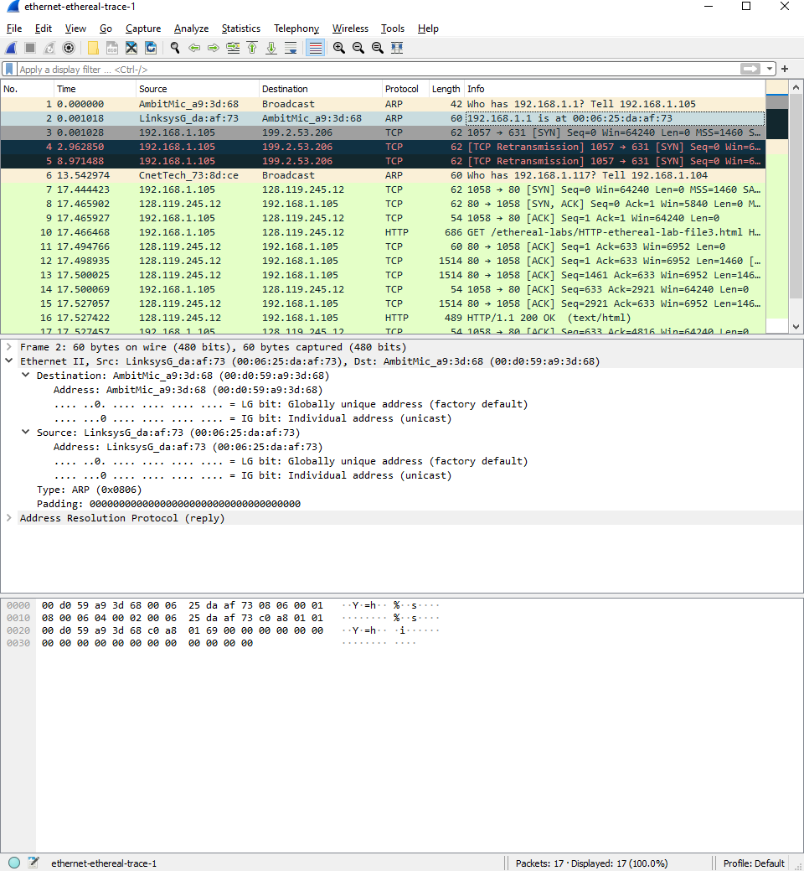

13. Now find the ARP reply that was sent in response to the ARP request.

a) How many bytes from the very beginning of the Ethernet frame does the

ARP opcode field begin?

**Answer:** 20 bytes.

b) What is the value of the opcode field within the ARP-payload part of the

Ethernet frame in which an ARP response is made?

**Answer:** 0x0002, for reply.

c) Where in the ARP message does the “answer” to the earlier ARP request

appear – the IP address of the machine having the Ethernet address whose

corresponding IP address is being queried?

**Answer:** In the “Sender MAC address” field.

14. What are the hexadecimal values for the source and destination addresses in the

Ethernet frame containing the ARP reply message?

**Answer:** The hex value for the source address is 00:06:25:da:af:73 and for the destination is 00:d0:59:a9:3d:68.

15. Open the ethernet-ethereal-trace-1 trace file in

http://gaia.cs.umass.edu/wireshark-labs/wireshark-traces.zip. The first and second

ARP packets in this trace correspond to an ARP request sent by the computer

running Wireshark, and the ARP reply sent to the computer running Wireshark by

the computer with the ARP-requested Ethernet address. But there is yet another

computer on this network, as indicated by packet 6 – another ARP request. Why

is there no ARP reply (sent in response to the ARP request in packet 6) in the

packet trace?

**Answer:** There is no reply in this trace because we are not at the machine which sent the request. The ARP request is broadcast, but the ARP reply is sent back to the sender’s Ethernet address directly.