**Project Management - Git**

1. **Github and Bitbucket**

Visit <https://github.com/>

Visit <https://bitbucket.org/product>

1. **Installation Git**

Visit <https://git-scm.com/downloads> and download latest version of Git for Windows and install follow the instruction step by step

1. **Basic command line for Git**

*git checkout*

*git branch*

*git fetch*

*git pull*

*git push*

*git add*

*git merge*

*git log*

*git stash*

*git revert*

*git cherry-pick*

…

1. **Installation SourceTree**

Visit <https://www.sourcetreeapp.com/> and download latest version of SourceTree for Windows and install follow the instruction step by step

1. **Git Integration for Eclipse**

Open Eclipse -> **Help** -> **Eclipse Marketplace** -> Search **EGit** keyword -> Click **Install** button at **EGit - Git Integration for Eclipse** section and follow the instruction step by step

**Apache Maven**

1. **Maven is a tool with multiple facets:**

* A **Build** tool – Generated artifacts (jar, war, ear, …)
* A **Dependency Management** tool
* A **Documentation** tool – Generated test results, quality metrics, Javadoc, …

1. **Require**

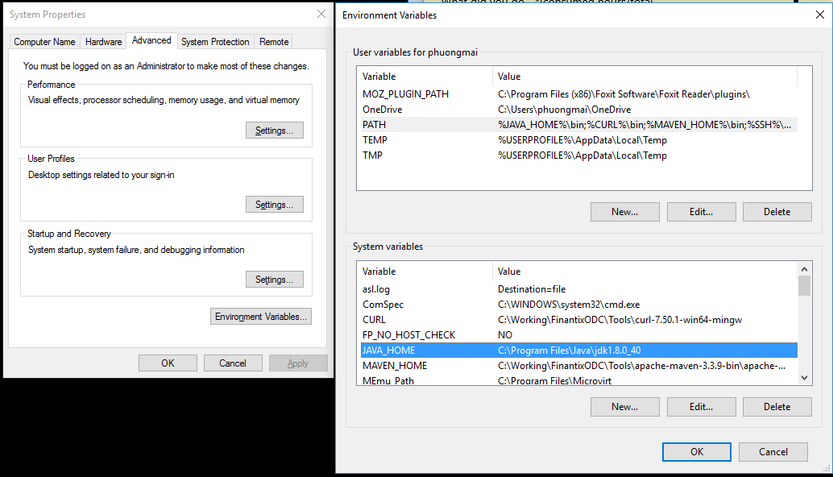Make sure JDK is installed and JAVA_HOME variable is added

1. **Installation:**

Visit <http://maven.apache.org/download.cgi> and download Maven zip file ***apache-maven-3.5.0-bin.zip***

Unzip the file in a local directory such as*:* ***C:\maven***

Set environment variables:

***MAVEN_HOME=C:\maven***

***PATH=%MAVEN_HOME%\bin***

1. **Verification**

Open cmd and enter **mvn – version** in the command line

1. **Maven eclipse plugin (for eclipse old version)**
2. Open Eclipse -> Click **Help** -> **Install New Software** -> Click **Add** button at top corner and fill up

***Name=Maven*** *and* ***Location=***[***http://download.eclipse.org/technology/m2e/releases/***](http://download.eclipse.org/technology/m2e/releases/)

A **check-box** will appear in the pop window, **Check** and click **Next** button and follow the instruction step by step

Another way to install Maven plugin:

1. Open Eclipse -> **Help** -> **Eclipse Marketplace** -> Search **Maven** keyword -> Click **Install** button at **Maven Integration for Eclipse** section and follow the instruction step by step
2. **Maven command structure**

**mvn eclipse:eclipse** //generated maven project for Eclipse IDE

**mvn clean**

**mvn clean install** // install the artifact in your local respository(${user.home}/.m2/repository)

**mvn compile**

**mvn package**

**mvn test**

…

1. **Create Maven project using Eclipse IDE**

Open Eclipse -> File -> New -> **Maven Project**

Select default Workspace location

Select the maven archetype as: **maven-archetype-webapp**

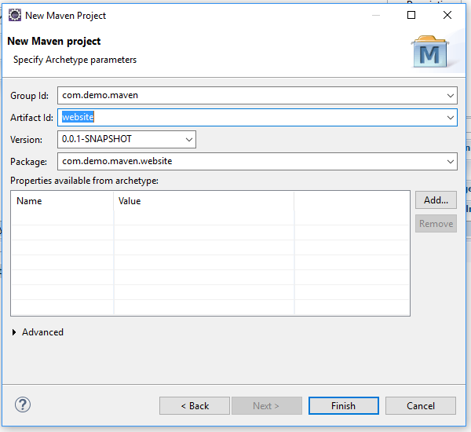Fill out details and click Finish

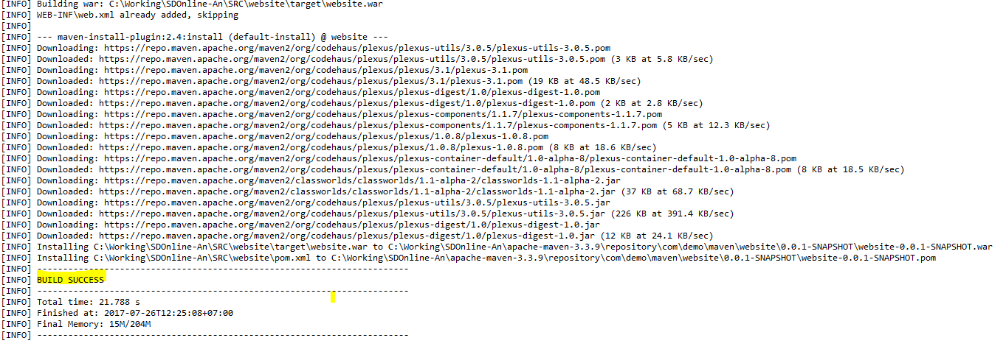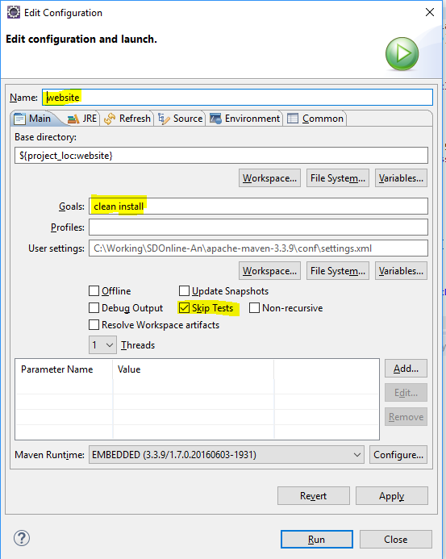Now build project with **maven clean install** to check dependency issues with project and deploy application on Apache Tomcat Server

**Apache Tomcat Server**

1. **Installation**

Visit <https://tomcat.apache.org/download-70.cgi> and download Apache tomcat server zip file

Upzip the file in local directory such as: ***C:\tomcat***

1. **Create tomcat server on Eclipse**
2. **Deploy project into tomcat server on Eclipse**

**Hibernate with MySQL**

1. **Create maven project from Eclipse IDE**

*(Review last session)*

1. **Add Hibernate and Mysql dependency**

Hibernate is required ***dom4j, commons-logging, commons-collections and cglib*** as dependency library

In case using Anotation, it’s required to download the Hibernate annotation library ***hibernate-annotations and hibernate-commons-annotations and repository.jboss***

Modify the ***pom.xml*** file.

|  |
| --- |
| ...  <repositories>  <repository>  <id>JBoss repository</id>  <url>http://repository.jboss.com/maven2/</url>  </repository>  </repositories>  <dependencies>  <!-- MySQL database driver -->  <dependency>  <groupId>mysql</groupId>  <artifactId>mysql-connector-java</artifactId>  <version>5.1.9</version>  </dependency>  <!-- Hibernate core -->  <dependency>  <groupId>hibernate</groupId>  <artifactId>hibernate3</artifactId>  <version>3.2.3.GA</version>  </dependency>  <!-- Hibernate annotation -->  <dependency>  <groupId>hibernate-annotations</groupId>  <artifactId>hibernate-annotations</artifactId>  <version>3.3.0.GA</version>  </dependency>  <dependency>  <groupId>hibernate-commons-annotations</groupId>  <artifactId>hibernate-commons-annotations</artifactId>  <version>3.0.0.GA</version>  </dependency>  <!-- Hibernate library dependecy start -->  <dependency>  <groupId>dom4j</groupId>  <artifactId>dom4j</artifactId>  <version>1.6.1</version>  </dependency>  <dependency>  <groupId>commons-logging</groupId>  <artifactId>commons-logging</artifactId>  <version>1.1.1</version>  </dependency>  <dependency>  <groupId>commons-collections</groupId>  <artifactId>commons-collections</artifactId>  <version>3.2.1</version>  </dependency>  <dependency>  <groupId>cglib</groupId>  <artifactId>cglib</artifactId>  <version>2.2</version>  </dependency>  <!-- Hibernate library dependecy end -->  <dependency>  <groupId>javax.transaction</groupId>  <artifactId>jta</artifactId>  <version>1.1</version>  </dependency>  <dependency>  <groupId>javax.persistence</groupId>  <artifactId>persistence-api</artifactId>  <version>1.0.2</version>  </dependency>  <dependency>  <groupId>javax.persistence</groupId>  <artifactId>persistence-api</artifactId>  <version>1.0.2</version>  </dependency>  </dependencies>  ... |

1. Now build project with **mvn eclipse:eclipse** to check dependency issues with project and update the Eclipse’s project classpath
2. **Create Hibernate configuration file**

Create a Hibernate’s configuration file and put under the resources root folder, ***src/main/resources/hibernate.cfg.xml***

|  |
| --- |
| <?xml version=*"1.0"* encoding=*"UTF-8"*?>  <!DOCTYPE hibernate-configuration PUBLIC  "-//Hibernate/Hibernate Configuration DTD 3.0//EN"  "http://hibernate.sourceforge.net/hibernate-configuration-3.0.dtd">  <hibernate-configuration>  <session-factory>  <property name=*"hibernate.connection.driver_class"*>com.mysql.jdbc.Driver</property>  <property name=*"hibernate.connection.url"*>jdbc:mysql://localhost:3306/website</property>  <property name=*"hibernate.dialect"*>org.hibernate.dialect.MySQLDialect</property>  <property name=*"hibernate.connection.username"*>root</property>  <property name=*"hibernate.connection.password"*>admin</property>  <property name=*"hibernate.bytecode.use_reflection_optimizer"*>false</property>  <!-- JDBC connection pool settings -->  <property name=*"connection_pool_size"*>10</property>  <!-- Echo the SQL -->  <property name=*"show_sql"*>true</property>  <!-- Create or Update the database schema on startup -->  <property name=*"hibernate.hbm2ddl.auto"*>update</property>    <!-- Using for xml mapping file -->  <mapping resource=*"com/website/demo/Student.hbm.xml"*></mapping>  <!-- Using for annotation -->  <mapping class=*"com.website.demo.dao.Student"*></mapping>  </session-factory>  </hibernate-configuration> |

1. Create Hibernate configuration + Model class

* **For XML Mapping**: create hibernate mapping file

Create **Student.java** class in package **src/main/java/com/website/demo/dao**

|  |
| --- |
| **package** com.website.demo.dao;  **public** **class** Student **implements** java.io.Serializable {  **private** **static** **final** **long** ***serialVersionUID*** = 1L;  **private** Long id;  **private** String firstName;  **private** String lastName;  **private** Integer age;  **public** Student() { }  **public** Student(String firstName, String lastName, Integer age) {  **this**.firstName = firstName;  **this**.lastName = lastName;  **this**.age = age;  }  // TODO: generate getter and setter method  } |

Create **Student.hbm.xml** in **src/main/resources/com/website/demo/**

|  |
| --- |
| <?xml version=*"1.0"* encoding=*"UTF-8"*?>  <!DOCTYPE hibernate-mapping PUBLIC "-//Hibernate/Hibernate Mapping DTD 3.0//EN"  "http://hibernate.sourceforge.net/hibernate-mapping-3.0.dtd">  <hibernate-mapping>  <class name=*"com.website.demo.dao.Student"* table=*"student"* catalog=*"website"*>  <id name=*"id"* type=*"long"*>  <column name=*"ID"* />  <generator class=*"identity"* />  </id>  <property name=*"firstName"* type=*"string"*>  <column name=*"FIRST_NAME"* length=*"20"* not-null=*"true"*/>  </property>  <property name=*"lastName"* type=*"string"*>  <column name=*"LAST_NAME"* length=*"20"* not-null=*"true"*/>  </property>  <property name=*"age"* type=*"integer"*>  <column name=*"AGE"* length=*"20"* not-null=*"true"*/>  </property>  </class>  </hibernate-mapping> |

* **For Annotation:** hibernate mapping on model class

Create **Student.java** class in package **src/main/java/com/website/demo/dao**

|  |
| --- |
| **package** com.website.demo.dao;  **import** javax.persistence.Column;  **import** javax.persistence.Entity;  **import** javax.persistence.GeneratedValue;  **import** **static** javax.persistence.GenerationType.IDENTITY;  **import** javax.persistence.Id;  **import** javax.persistence.Table;  @Entity  @Table(name = "student", catalog = "website", appliesTo = "")  **public** **class** Student **implements** java.io.Serializable {  **private** **static** **final** **long** ***serialVersionUID*** = 1L;  **private** Long id;  **private** String firstName;  **private** String lastName;  **private** Integer age;  //TODO: generate constructor for Student  @Id  @GeneratedValue(strategy = IDENTITY)  @Column(name = "ID", unique = **true**, nullable = **false**)  **public** Long getId() {  **return** id;  }  **public** **void** setId(Long id) {  **this**.id = id;  }    @Column(name = "FIRST_NAME", length = 20)  **public** String getFirstName() {  **return** firstName;  }  **public** **void** setFirstName(String firstName) {  **this**.firstName = firstName;  }  @Column(name = "LAST_NAME", length = 20)  **public** String getLastName() {  **return** lastName;  }  **public** **void** setLastName(String lastName) {  **this**.lastName = lastName;  }  @Column(name = "AGE")  **public** Integer getAge() {  **return** age;  }  **public** **void** setAge(Integer age) {  **this**.age = age;  }  } |

1. **Create Hibernate Utility class**

To take care of Hibernate start up and retrieve the session easily

Create **HibernateUtil.java** in **src/main/java/com/website/demo/persistence**

* **For XML Mapping**

|  |
| --- |
| **package** com.website.demo.persistence;  **import** org.hibernate.SessionFactory;  **import** org.hibernate.cfg.Configuration;  **public** **class** HibernateUtil {  **private** **static** **final** SessionFactory ***sessionFactory*** = *buildSessionFactory*();  **private** **static** SessionFactory buildSessionFactory() {  **try** {  // Create the SessionFactory from hibernate.cfg.xml  **return** **new** Configuration().configure().buildSessionFactory();  } **catch** (Throwable ex) {  // Make sure you log the exception, as it might be swallowed  System.***err***.println("Initial SessionFactory creation failed." + ex);  **throw** **new** ExceptionInInitializerError(ex);  }  }  **public** **static** SessionFactory getSessionFactory() {  **return** ***sessionFactory***;  }  **public** **static** **void** shutdown() {  // Close caches and connection pools  *getSessionFactory*().close();  }  } |

* **For Annotation Mapping**

|  |
| --- |
| **package** com.website.demo.persistence;  **import** org.hibernate.SessionFactory;  **import** org.hibernate.cfg.AnnotationConfiguration;  **public** **class** HibernateUtil {  **private** **static** **final** SessionFactory ***sessionFactory*** = *buildSessionFactory*();  **private** **static** SessionFactory buildSessionFactory() {  **try** {  // Create the SessionFactory from hibernate.cfg.xml  **return** **new** AnnotationConfiguration().configure().buildSessionFactory();  } **catch** (Throwable ex) {  // Make sure you log the exception, as it might be swallowed  System.***err***.println("Initial SessionFactory creation failed." + ex);  **throw** **new** ExceptionInInitializerError(ex);  }  }  **public** **static** SessionFactory getSessionFactory() {  **return** ***sessionFactory***;  }  **public** **static** **void** shutdown() {  // Close caches and connection pools  *getSessionFactory*().close();  }  } |

1. **Testing**

|  |
| --- |
| **public** **static** **void** main(String[] args) {  System.***out***.println("Maven + Hibernate + MySQL");  Session session = HibernateUtil.*getSessionFactory*().openSession();  session.beginTransaction();  Student student = **new** Student();  student.setFirstName("Phuong");  student.setLastName("Mai");  student.setAge(29);  session.save(student);  session.getTransaction().commit();  } |

**Hibernate with MySQL (2)**

1. **Mapping Types**

|  |  |  |
| --- | --- | --- |
| MAPPING TYPE | JAVA TYPE | SQL TYPE |
| **integer** | *int or java.lang.Integer* | *INTEGER* |
| **long** | *long or java.lang.Long* | *BIGINT* |
| **float** | *float or java.lang.Float* | *FLOAT* |
| **double** | *double or java.lang.Double* | *DOUBLE* |
| **big_decimal** | *java.math.BigDecimal* | *NUMERIC* |
| **character** | *java.lang.String* | *CHAR(1)* |
| **string** | *java.lang.String* | *VARCHAR* |
| **byte** | *byte or java.lang.Byte* | *TINYINT* |
| **boolean** | *boolean or java.lang.Boolean* | *BIT* |
| **binary** | *byte[]* | *VARBINARY (or BLOB)* |
| **blob** | *java.sql.Blob* | *BLOB* |
|  | | |
| **date** | *java.util.Date or java.sql.Date* | *DATE* |
| **time** | *java.util.Date or java.sql.Time* | *TIME* |
| **timestamp** | *java.util.Date or java.sql.Timestamp* | *TIMESTAMP* |
| **calendar** | *java.util.Calendar* | *TIMESTAMP* |
| **calendar_date** | *java.util.Calendar* | *DATE* |

1. **Collection Mapping**

|  |  |
| --- | --- |
| COLLECTION TYPE | MAPPING |
| **<list>** | *java.util.List* |
| **<set>** | *java.util.Set* |
| **<map>** | *java.util.Map* |

1. **ORM – Object Relationship Mapping**

* **One – to – One**

**Using XML mapping**

Create **Address.java** class in package **src/main/java/com/website/demo/dao** and **Address.hbm.xml** in **src/main/resources/com/website/demo/**

|  |
| --- |
| **package** com.website.demo.dao;  **public** **class** Address **implements** java.io.Serializable {  **private** **static** **final** **long** ***serialVersionUID*** = 1L;  **private** Long id;  **private** String street;  **private** String district;  **private** String city;  //TODO: generate constructor & getter and setter methods    } |
|  |
| <?xml version=*"1.0"* encoding=*"UTF-8"*?>  <!DOCTYPE hibernate-mapping PUBLIC "-//Hibernate/Hibernate Mapping DTD 3.0//EN"  "http://hibernate.sourceforge.net/hibernate-mapping-3.0.dtd">  <hibernate-mapping>  <class name=*"com.website.demo.dao.Address"* table=*"address"* catalog=*"website"*>  <id name=*"id"* type=*"long"*>  <column name=*"ID"* />  <generator class=*"identity"* />  </id>  <property name=*"street"* type=*"string"*>  <column name=*"STREET"* length=*"20"* not-null=*"true"*/>  </property>  <property name=*"district"* type=*"string"*>  <column name=*"DISTRICT"* length=*"20"* not-null=*"true"*/>  </property>  <property name=*"city"* type=*"string"*>  <column name=*"CITY"* length=*"20"* not-null=*"true"*/>  </property>  </class>  </hibernate-mapping> |

Update **Student.java** class in package **src/main/java/com/website/demo/dao** and **Student.hbm.xml** in **src/main/resources/com/website/demo/**

|  |
| --- |
| **package** com.website.demo.dao;  **public** **class** Student **implements** java.io.Serializable {  **private** **static** **final** **long** ***serialVersionUID*** = 1L;  **private** Long id;  **private** String firstName;  **private** String lastName;  **private** Integer age;  **private** Address address;  //TODO: generate constructor & getter and setter methods  } |
|  |
| <?xml version=*"1.0"* encoding=*"UTF-8"*?>  <!DOCTYPE hibernate-mapping PUBLIC "-//Hibernate/Hibernate Mapping DTD 3.0//EN"  "http://hibernate.sourceforge.net/hibernate-mapping-3.0.dtd">  <hibernate-mapping>  <class name=*"com.website.demo.dao.Student"* table=*"student"* catalog=*"website"*>  <id name=*"id"* type=*"long"*>  <column name=*"STUDENT_ID"* />  <generator class=*"identity"* />  </id>  <property name=*"firstName"* type=*"string"*>  <column name=*"FIRST_NAME"* length=*"20"* not-null=*"true"*/>  </property>  <property name=*"lastName"* type=*"string"*>  <column name=*"LAST_NAME"* length=*"20"* not-null=*"true"*/>  </property>  <property name=*"age"* type=*"integer"*>  <column name=*"AGE"* length=*"20"* not-null=*"true"*/>  </property>  <one-to-one name=*"address"* class=*"com.website.demo.dao.Address"* cascade=*"save-update"* lazy=*"false"*></one-to-one>  </class>  </hibernate-mapping> |

**Using Annotation mapping**

Create **Address.java** class in package **src/main/java/com/website/demo/dao** and Update **Student.java** class in package **src/main/java/com/website/demo/dao**

|  |
| --- |
| **package** com.website.demo.dao;  **import** **static** javax.persistence.GenerationType.***IDENTITY***;  **import** javax.persistence.Column;  **import** javax.persistence.Entity;  **import** javax.persistence.GeneratedValue;  **import** javax.persistence.Id;  **import** javax.persistence.Table;  @Entity  @Table(name = "address", catalog = "website")  **public** **class** Address **implements** java.io.Serializable {  **private** **static** **final** **long** ***serialVersionUID*** = 1L;  **private** Long id;  **private** String street;  **private** String district;  **private** String city;  //TODO: generate constructor for Address  @Id  @GeneratedValue(strategy = ***IDENTITY***)  @Column(name = "ID", unique = **true**, nullable = **false**)  **public** Long getId() {  **return** id;  }  **public** **void** setId(Long id) {  **this**.id = id;  }  @Column(name = "STREET", length = 20)  **public** String getStreet() {  **return** street;  }  **public** **void** setStreet(String street) {  **this**.street = street;  }  @Column(name = "DISTRICT", length = 20)  **public** String getDistrict() {  **return** district;  }  **public** **void** setDistrict(String district) {  **this**.district = district;  }  @Column(name = "CITY", length = 20)  **public** String getCity() {  **return** city;  }  **public** **void** setCity(String city) {  **this**.city = city;  }  } |
|  |
| **package** com.website.demo.dao;  **import** **static** javax.persistence.GenerationType.***IDENTITY***;  **import** java.util.List;  **import** javax.persistence.CascadeType;  **import** javax.persistence.Column;  **import** javax.persistence.Entity;  **import** javax.persistence.FetchType;  **import** javax.persistence.GeneratedValue;  **import** javax.persistence.Id;  **import** javax.persistence.OneToOne;  **import** javax.persistence.PrimaryKeyJoinColumn;  **import** javax.persistence.Table;  @Entity  @Table(name = "student", catalog = "website")  **public** **class** Student **implements** java.io.Serializable {  **private** **static** **final** **long** ***serialVersionUID*** = 1L;  **private** Long id;  **private** String firstName;  **private** String lastName;  **private** Integer age;  **private** Address address;  //TODO: generate constructor for Student  @Id  @GeneratedValue(strategy = ***IDENTITY***)  @Column(name = "STUDENT_ID", unique = **true**, nullable = **false**)  **public** Long getId() {  **return** id;  }  **public** **void** setId(Long id) {  **this**.id = id;  }  @Column(name = "FIRST_NAME", length = 20)  **public** String getFirstName() {  **return** firstName;  }  **public** **void** setFirstName(String firstName) {  **this**.firstName = firstName;  }  @Column(name = "LAST_NAME", length = 20)  **public** String getLastName() {  **return** lastName;  }  **public** **void** setLastName(String lastName) {  **this**.lastName = lastName;  }  @Column(name = "AGE")  **public** Integer getAge() {  **return** age;  }  **public** **void** setAge(Integer age) {  **this**.age = age;  }  @OneToOne(fetch = FetchType.***LAZY***, cascade = CascadeType.***ALL***)  @PrimaryKeyJoinColumn  **public** Address getAddress() {  **return** address;  }  **public** **void** setAddress(Address address) {  **this**.address = address;  }  } |

* **Many – to – Many**

**Using XML Mapping**

Create **Course.java** class in package **src/main/java/com/website/demo/dao** and **Course.hbm.xml** in **src/main/resources/com/website/demo/**

|  |
| --- |
| **package** com.website.demo.dao;  **public** **class** Course **implements** java.io.Serializable {  **private** **static** **final** **long** ***serialVersionUID*** = 1L;  **private** Long id;  **private** String courseName;    //TODO: generate constructor & getter and setter methods  } |
|  |
| <?xml version=*"1.0"* encoding=*"UTF-8"*?>  <!DOCTYPE hibernate-mapping PUBLIC "-//Hibernate/Hibernate Mapping DTD 3.0//EN"  "http://hibernate.sourceforge.net/hibernate-mapping-3.0.dtd">  <hibernate-mapping>  <class name=*"com.website.demo.dao.Course"* table=*"course"* catalog=*"website"*>  <id name=*"id"* type=*"long"*>  <column name=*"COURSE_ID"* />  <generator class=*"identity"* />  </id>  <property name=*"courseName"* type=*"string"*>  <column name=*"COURSE_NAME"* length=*"20"* not-null=*"true"*/>  </property>  </class>  </hibernate-mapping> |

Update **Student.java** class in package **src/main/java/com/website/demo/dao** and **Student.hbm.xml** in **src/main/resources/com/website/demo/**

|  |
| --- |
| **package** com.website.demo.dao;  **import** java.util.List;  **public** **class** Student **implements** java.io.Serializable {  **private** **static** **final** **long** ***serialVersionUID*** = 1L;  **private** Long id;  **private** String firstName;  **private** String lastName;  **private** Integer age;  **private** Address address;  **private** List<Course> courses;  //TODO: generate constructor & getter and setter methods  } |
|  |
| <?xml version=*"1.0"* encoding=*"UTF-8"*?>  <!DOCTYPE hibernate-mapping PUBLIC "-//Hibernate/Hibernate Mapping DTD 3.0//EN"  "http://hibernate.sourceforge.net/hibernate-mapping-3.0.dtd">  <hibernate-mapping>  <class name=*"com.website.demo.dao.Student"* table=*"student"* catalog=*"website"*>  <id name=*"id"* type=*"long"*>  <column name=*"STUDENT_ID"* />  <generator class=*"identity"* />  </id>  <property name=*"firstName"* type=*"string"*>  <column name=*"FIRST_NAME"* length=*"20"* not-null=*"true"*/>  </property>  <property name=*"lastName"* type=*"string"*>  <column name=*"LAST_NAME"* length=*"20"* not-null=*"true"*/>  </property>  <property name=*"age"* type=*"integer"*>  <column name=*"AGE"* length=*"20"* not-null=*"true"*/>  </property>  <one-to-one name=*"address"* class=*"com.website.demo.dao.Address"*  cascade=*"save-update"* lazy=*"false"*></one-to-one>  <list name=*"courses"* table=*"STUDENT_COURSE"* cascade=*"all"*>  <key column=*"STUDENT_ID"* />  <list-index column=*"index"* />  <many-to-many column=*"COURSE_ID"* class=*"com.website.demo.dao.Course"* />  </list>  </class>  </hibernate-mapping> |

**Using Annotation Mapping**

Create **Course.java** class in package **src/main/java/com/website/demo/dao** and Update **Student.java** class in package **src/main/java/com/website/demo/dao**

|  |
| --- |
| **package** com.website.demo.dao;  **import** javax.persistence.Column;  **import** javax.persistence.Entity;  **import** javax.persistence.GeneratedValue;  **import** **static** javax.persistence.GenerationType.***IDENTITY***;  **import** javax.persistence.Id;  **import** javax.persistence.Table;  @Entity  @Table(name = "course", catalog = "website")  **public** **class** Course **implements** java.io.Serializable {  **private** **static** **final** **long** ***serialVersionUID*** = 1L;  **private** Long id;  **private** String courseName;  //TODO: generate constructor for Course  @Id  @GeneratedValue(strategy = ***IDENTITY***)  @Column(name = "COURSE_ID", unique = **true**, nullable = **false**)  **public** Long getId() {  **return** id;  }  **public** **void** setId(Long id) {  **this**.id = id;  }  @Column(name = "COURSE_NAME", length = 20)  **public** String getCourseName() {  **return** courseName;  }  **public** **void** setCourseName(String courseName) {  **this**.courseName = courseName;  }  } |
|  |
| **package** com.website.demo.dao;  **import** **static** javax.persistence.GenerationType.***IDENTITY***;  **import** java.util.List;  **import** javax.persistence.CascadeType;  **import** javax.persistence.Column;  **import** javax.persistence.Entity;  **import** javax.persistence.FetchType;  **import** javax.persistence.GeneratedValue;  **import** javax.persistence.Id;  **import** javax.persistence.JoinTable;  **import** javax.persistence.JoinColumn;  **import** javax.persistence.ManyToMany;  **import** javax.persistence.OneToOne;  **import** javax.persistence.PrimaryKeyJoinColumn;  **import** javax.persistence.Table;  @Entity  @Table(name = "student", catalog = "website")  **public** **class** Student **implements** java.io.Serializable {  **private** **static** **final** **long** ***serialVersionUID*** = 1L;  **private** Long id;  **private** String firstName;  **private** String lastName;  **private** Integer age;  **private** Address address;  **private** List<Course> courses;  //TODO: generate constructor for Student  @Id  @GeneratedValue(strategy = ***IDENTITY***)  @Column(name = "STUDENT_ID", unique = **true**, nullable = **false**)  **public** Long getId() {  **return** id;  }  **public** **void** setId(Long id) {  **this**.id = id;  }  @Column(name = "FIRST_NAME", length = 20)  **public** String getFirstName() {  **return** firstName;  }  **public** **void** setFirstName(String firstName) {  **this**.firstName = firstName;  }  @Column(name = "LAST_NAME", length = 20)  **public** String getLastName() {  **return** lastName;  }  **public** **void** setLastName(String lastName) {  **this**.lastName = lastName;  }  @Column(name = "AGE")  **public** Integer getAge() {  **return** age;  }  **public** **void** setAge(Integer age) {  **this**.age = age;  }  @OneToOne(fetch = FetchType.***LAZY***, cascade = CascadeType.***ALL***)  @PrimaryKeyJoinColumn  **public** Address getAddress() {  **return** address;  }  **public** **void** setAddress(Address address) {  **this**.address = address;  }  @ManyToMany(cascade = CascadeType.***ALL***)  @JoinTable(name = "STUDENT_COURSE", joinColumns = { @JoinColumn(name = "STUDENT_ID") }, inverseJoinColumns = { @JoinColumn(name = "COURSE_ID") })  **public** List<Course> getCourses() {  **return** courses;  }  **public** **void** setCourses(List<Course> courses) {  **this**.courses = courses;  }  } |

* **One – to – Many / Many – to – One**

*(base on* ***one – to – one*** *and* ***many – to – many*** *for practice yourselft)   
For ex: Object* **Course** *contain* ***List<HomeWork>*** *as properties**and Object HomeWork contain* ***Course*** *as property also.*

**Hibernate with MySQL (3)**

1. **HQL – Hibernate Query Language**

the syntax is quite similar to database SQL language.

The main difference between is HQL uses **class name** instead of **table name**, and **property names** instead of **column name**.

* **SELECT**

|  |
| --- |
| Session session = HibernateUtil.*getSessionFactory*().openSession();  session.beginTransaction();  Query query = session.createQuery("from Address as A where A.city = ‘HCM’");  List list = query.list(); *// return list objects*  Query query1 = session.createQuery("select S from Student as S where S.firstName = :fName");  Query1.setParameter("fName", "Phuong");  Student student = (Student) query1.uniqueResult(); *// return single object*    session.getTransaction().commit(); |

* **UPDATE**

|  |
| --- |
| Query query = session.createQuery("update Student set firstName = :fName, lastName = :lName where id = :id");  query.setParameter("fName", "Phuong1");  query.setParameter("lName", "Mai1");  query.setParameter("id", 1);  **int** result = query.executeUpdate(); *// return number of record has been updated* |

* **DELETE**

|  |
| --- |
| Query query = session.createQuery("delete Student where id = :id");  query.setParameter("id", 1);  **int** result = query.executeUpdate(); *// return number of record has been deleted* |

* **INSERT** – HQL only support insert from another table**: INSERT INTO … SELECT ….**

|  |
| --- |
| Query query = session.createQuery("insert into Address(street, district, city) select tmp.street, tmp.district, tmp.city from Address_temp as tmp");  **int** result = query.executeUpdate(); *// return number of record has been inserted* |

* **PAGINATION**

|  |
| --- |
| Query query = session.createQuery("from Address");  query.setFirstResult(20); *// set offset*  query.setMaxResults(10); *// set limit*  List list = query.list(); |

* **AGGREGATE** – HQL support function such as **min(…), max(…), avg(…), sum(…), count(…), etc**

|  |
| --- |
| ***// count total number of Student***  Query query = session.createQuery("select count(id) from Student");  ***// get min age of Student***  Query query = session.createQuery("select min(age) from Student ");  ***// get max number of Student***  Query query = session.createQuery("select max(age) from Student ");  ***// get average age of Student***  Query query = session.createQuery("select avg(age) from Student ");  ***// get total age of Student***  Query query = session.createQuery("select sum(age) from Student "); |

1. **HCQL – Hibernate Criteria Query Language**

|  |
| --- |
| ***// get all the records***  Criteria criteria = session.createCriteria(Student.**class**);  List students = criteria.list();  ***// pagination with limit and offset***  Criteria criteria = session.createCriteria(Student.**class**);  criteria.setFirstResult(0);  criteria.setMaxResults(10);  List students = criteria.list();  ***// set order ASC***  Criteria criteria = session.createCriteria(Student.**class**);  criteria.addOrder(Order.*asc*("age"));  List students = criteria.list();  ***// set order DES***  Criteria criteria = session.createCriteria(Student.**class**);  criteria.addOrder(Order.*desc*("age"));  List students = criteria.list();  ***// set restrictions***  Criteria criteria = session.createCriteria(Student.**class**);  criteria.add(Restrictions.*between*("age", 10, 20)); *// set between constraint*  criteria.add(Restrictions.*like*("firstName", "Phuong")); *// set like constraint*  criteria.add(Restrictions.*eq*("age", 29)); *// set equal constraint*  criteria.add(Restrictions.*ne*("age", 20)); *// set not equal constraint*  criteria.add(Restrictions.*lt*("age", 20)); *// set less than constraint*  criteria.add(Restrictions.*le*("age", 20)); *// set less than or equal constraint*  criteria.add(Restrictions.*gt*("age", 20)); *// set greater than constraint*  criteria.add(Restrictions.*ge*("age", 20)); *// set greater than or equal constraint*  List students = criteria.list(); |

1. **Native SQL** – You can use native SQL to express database queries

|  |
| --- |
| *// Entity queries*  SQLQuery query = session.createSQLQuery("SELECT * FROM STUDENT");  query.addEntity(Student.**class**);  List students = query.list();  *// Scalar queries*  SQLQuery query = session.createSQLQuery("SELECT * FROM STUDENT as s, ADDRESS as a where s.STUDENT_ID = a.ID");  query.setResultTransformer(Criteria.***ALIAS_TO_ENTITY_MAP***);  List students = query.list();  *// Named SQL queries*  SQLQuery query = session.createSQLQuery("SELECT * FROM STUDENT WHERE id = :id");  query.addEntity(Student.**class**);  query.setParameter("id", 1);  List students = query.list(); |

**Spring – Spring MVC**

1. **Spring framework and SpringMVC**

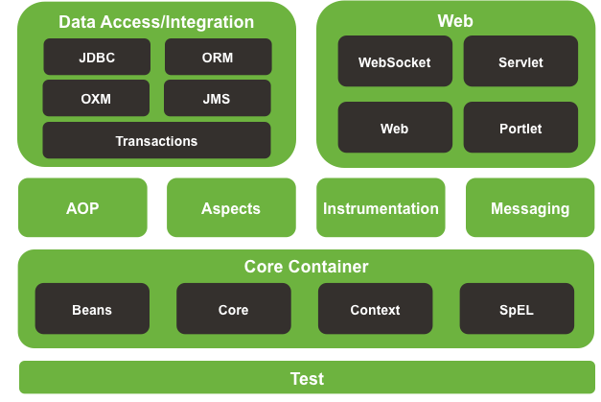The Spring Framework consists of features organized into about 20 modules. These modules are grouped into Core Container, Data Access/Integration, Web, AOP (Aspect Oriented Programming), Instrumentation, Messaging, and Test, as shown in the following diagram.

* + **Modularity** – Spring has layered architecture. Use what you need and leave you don't need now
  + **Dependency Injection and Inversion of Control**: removes the dependency from the programming code.
  + **Spring web MVC** is helpful for develop web application. We can develop web application to fast
  + **Spring bean and spring context** are helpful for initial and manage bean
  + Open source and no vendor lock-in

1. **The Life-Cycle in Spring MVC**

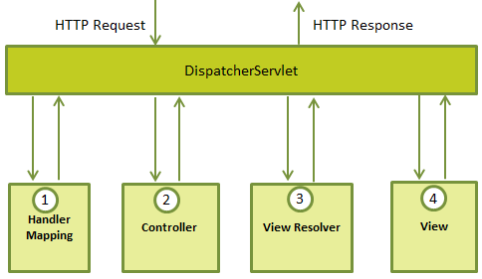The Spring Web MVC framework is designed around a **DispatcherServlet** that handles all the HTTP requests and responses.

1. After receiving an HTTP request, **DispatcherServlet** consults the **HandlerMapping** to call the appropriate Controller.
2. The Controller takes the request and calls the appropriate service methods based on used GET or POST method. The service method will set model data based on defined business logic and returns view name to the **DispatcherServlet**.
3. The **DispatcherServlet** will take help from **ViewResolver** to pick-up the defined view for the request.
4. Once view is finalized, The **DispatcherServlet** passes the model data to the view which is finally rendered on the browser.
5. **IoC – Inversion of Control**

Inversion of Control is a design pattern that removes the dependency from the programming code. That means we have inverted the control of creating the object. We provide metadata to the IOC container either by XML file or annotation and container will create the object for us.

In Spring support 3 types of IoC containers: **BeanFactory**, **ApplicationContext** and **WebApplicationContext.**

1. **DI – Dependency Injection**

Dependency Injection (DI) is a sub-type of IoC and It’s implemented by **Constructor Injection** and **Setter Injection**. Dependency Injection makes our programming code loosely coupled and easier for testing.

* **Constructor Injection**: Dependencies are provided as constructor parameters.

|  |
| --- |
| <bean id=*"Student"* class=*"com.website.demo.Student"*>  <constructor-arg>  <ref bean=*"Address"* />  </constructor-arg>  </bean>  <bean id=*"Address"* class=*"com.website.demo.Address"* /> |

* **Setter Injection**: Dependencies are assigned through JavaBeans properties.

|  |
| --- |
| <bean id=*"Student"* class=*"com.website.demo.Student"*>  <property name=*"address"* ref=*"Address"* />  </bean>  <bean id=*"Address"* class=*"com.website.demo.Address"* /> |

1. **What is @Component, @Controller and @Service** annotations in Spring?

* **@Component** is used to indicate that a class is a component. These classes are used for auto detection and configured as bean, when annotation based configurations are used
* **@Controller** is a specific type of component, used in MVC applications and mostly used with **@RequestMapping** annotation.
* **@Service** is used to indicate that a class is a Service. Usually the business facade classes that provide some services are annotated with this.

1. **Practice: Create maven project from Eclipse IDE and add SpringMVC dependency**Update pom.xml

|  |
| --- |
| ...  <properties>  <!-- Generic properties -->  <java.version>1.7</java.version>  <!-- Web -->  <jsp.version>2.2</jsp.version>  <jstl.version>1.2</jstl.version>  <servlet.version>3.1.0</servlet.version>  <!-- Spring -->  <spring-framework.version>4.1.8.RELEASE</spring-framework.version>  <!-- Logging -->  <slf4j.version>1.7.5</slf4j.version>  <!-- Skip Test -->  <skipTests>false</skipTests>  </properties>  <dependencies>  <!-- Spring MVC -->  <dependency>  <groupId>org.springframework</groupId>  <artifactId>spring-webmvc</artifactId>  <version>${spring-framework.version}</version>  </dependency>  <dependency>  <groupId>org.springframework</groupId>  <artifactId>spring-context</artifactId>  <version>${spring-framework.version}</version>  </dependency>  <!-- Other Web dependencies -->  <dependency>  <groupId>javax.servlet</groupId>  <artifactId>jstl</artifactId>  <version>${jstl.version}</version>  </dependency>  <dependency>  <groupId>javax.servlet</groupId>  <artifactId>javax.servlet-api</artifactId>  <version>${servlet.version}</version>  <scope>provided</scope>  </dependency>  <dependency>  <groupId>javax.servlet.jsp</groupId>  <artifactId>jsp-api</artifactId>  <version>${jsp.version}</version>  <scope>provided</scope>  </dependency>  <!-- Logging with SLF4J -->  <dependency>  <groupId>org.slf4j</groupId>  <artifactId>slf4j-api</artifactId>  <version>${slf4j.version}</version>  <scope>compile</scope>  </dependency>  </dependencies>  <build>  <plugins>  <plugin>  <groupId>org.apache.maven.plugins</groupId>  <artifactId>maven-compiler-plugin</artifactId>  <configuration>  <source>${java.version}</source>  <target>${java.version}</target>  <encoding>UTF-8</encoding>  </configuration>  </plugin>  <plugin>  <groupId>org.apache.maven.plugins</groupId>  <artifactId>maven-surefire-plugin</artifactId>  <version>2.18.1</version>  <configuration>  <skipTests>${skipTests}</skipTests>  </configuration>  </plugin>  </plugins>  <finalName>springmvc</finalName>  </build>  ... |

1. **SpringMVC Configuration**

* **With XML configuration**

Create **web.xml** (if not) in **src/main/webapp/WEB-INF/web.xml**

|  |
| --- |
| <?xml version=*"1.0"* encoding=*"UTF-8"*?>  <web-app xmlns:xsi=*"http://www.w3.org/2001/XMLSchema-instance"*  xmlns=*"http://java.sun.com/xml/ns/javaee"*  xsi:schemaLocation=*"http://java.sun.com/xml/ns/javaee http://java.sun.com/xml/ns/javaee/web-app_3_0.xsd"*  id=*"WebApp_ID"* version=*"3.0"*>  <display-name>Spring MVC Web Application</display-name>  <servlet>  <servlet-name>spring-web</servlet-name>  <servlet-class>org.springframework.web.servlet.DispatcherServlet</servlet-class>  <init-param>  <param-name>contextConfigLocation</param-name>  <param-value>/WEB-INF/spring-mvc-config.xml</param-value>  </init-param>  <load-on-startup>1</load-on-startup>  </servlet>  <servlet-mapping>  <servlet-name>spring-web</servlet-name>  <url-pattern>/</url-pattern>  </servlet-mapping>  <session-config>  <session-timeout>60</session-timeout>  </session-config>  </web-app> |

Create **spring-mvc-config.xml** in **src/main/webapp/WEB-INF/spring-mvc-config.xml**

|  |
| --- |
| <beans xmlns=*"http://www.springframework.org/schema/beans"*  xmlns:context=*"http://www.springframework.org/schema/context"*  xmlns:xsi=*"http://www.w3.org/2001/XMLSchema-instance"* xmlns:mvc=*"http://www.springframework.org/schema/mvc"*  xsi:schemaLocation=*"*  *http://www.springframework.org/schema/beans*  *http://www.springframework.org/schema/beans/spring-beans-3.2.xsd*  *http://www.springframework.org/schema/mvc*  *http://www.springframework.org/schema/mvc/spring-mvc-3.2.xsd*  *http://www.springframework.org/schema/context*  *http://www.springframework.org/schema/context/spring-context-3.2.xsd"*>  <context:component-scan base-package=*"com.website.springmvc"* />  <bean class=*"org.springframework.web.servlet.view.InternalResourceViewResolver"*>  <property name=*"prefix"*>  <value>/views/jsp/</value>  </property>  <property name=*"suffix"*>  <value>.jsp</value>  </property>  </bean>  <mvc:resources mapping=*"/resources/**"* location=*"/resources/"* />  <mvc:annotation-driven />  </beans> |

* **With Annotation configuration**

**Create** DispatcherServletInitializer.java in

|  |
| --- |
|  |

1. **Controller & Mapping**
2. **JSP Views**