BEGING

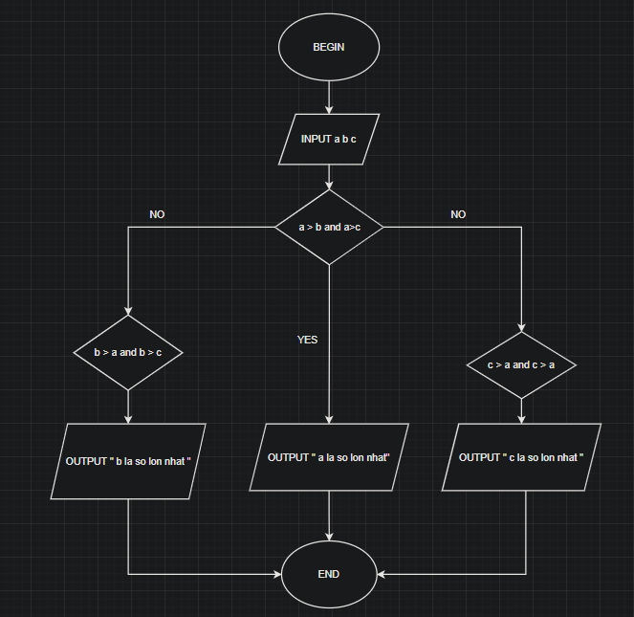

INPUT a b c

IF a > b AND a > c

OUTPUT "a la so lon nhat "

ELSE b > a AND b > c

OUTPUT " b la so lon nhat "

ELSE c > a AND c > b

OUTPUT " c la so lon nhat "

END