BEGIN

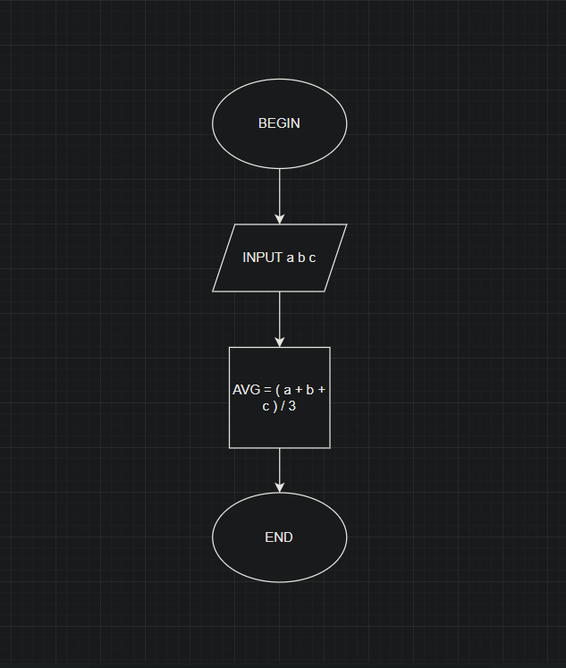

INPUT a b c

avg = (a + b + c)/3

OUTPUT avg

END