BEGIN

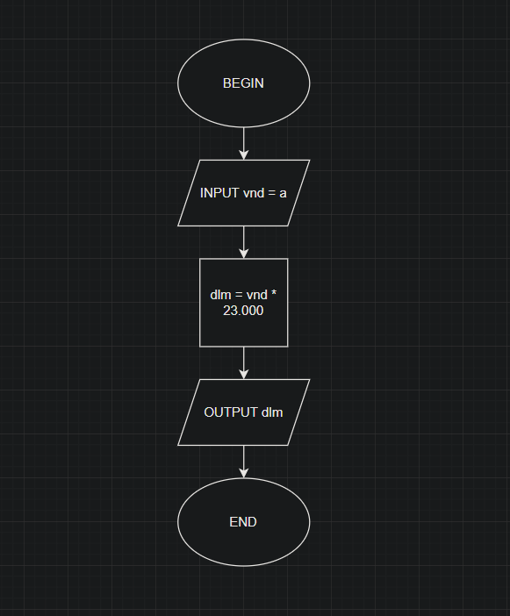

INPUT vnd = a

dlm = vnd \* 23.000

OUTPUT dl

END