* 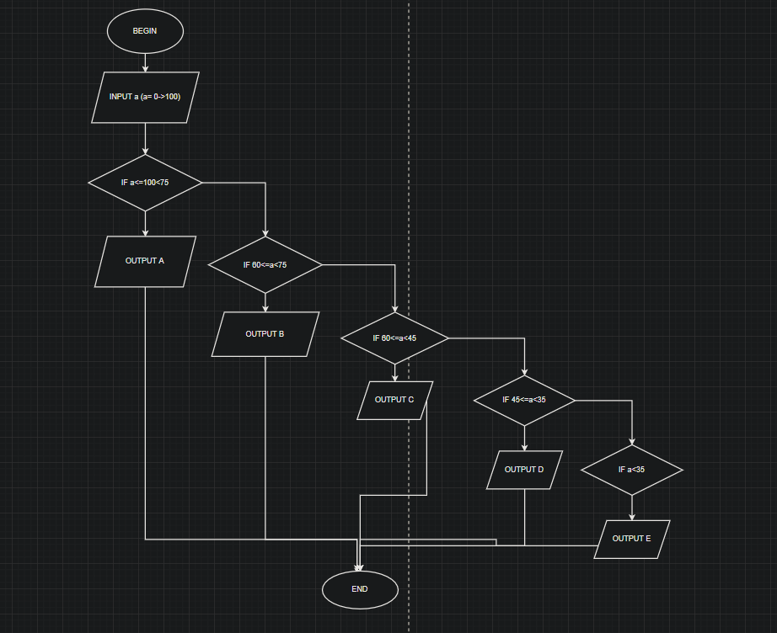  
  BEGIN
  + INPUT a (a = 1->100)
  + IF a >= 75
    - OUTPUT A
  + FALSE
    - IF 60<=a<75
      * OUTPUT B
    - FLASE 45<=a<60
      * OUTPUT C
      * IF a<=35<45
        + OUTPUT D
      * FLASE a<35
        + OUTPUT E
* END