**User**

Database mobel documentation

Created with Vertabelo.com

1. Model details 3

2. Tables 4

2.1. Table Checkin 4

2.2. Table User 4

2.3. Table Checkout 4

3. References 6

3.1. Reference ci_user_id_FK 6

3.2. Reference co_user_id_FK 6

# 1. Model details

**Model name:**User

**Version:**2.3

**Database engine:**mysql

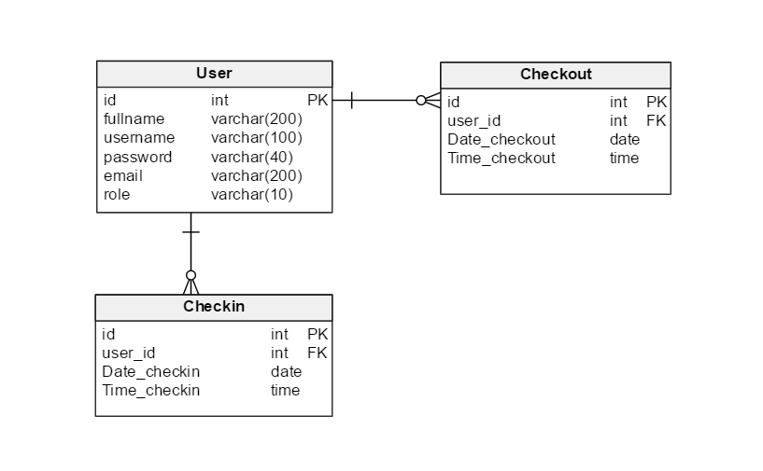

# 2. Tables

## 2.1. Table Checkin

2.1.1. Columns

|  |  |  |  |
| --- | --- | --- | --- |
| **Column name** | **Type** | **Properties** | **Description** |
| id | int |  |  |
| user_id | int |  |  |
| Date_checkin | date |  |  |
| Time_checkin | time |  |  |

## 2.2. Table User

2.2.1. Columns

|  |  |  |  |
| --- | --- | --- | --- |
| **Column name** | **Type** | **Properties** | **Description** |
| id | int |  |  |
| fullname | varchar(200) |  |  |
| username | varchar(100) |  |  |
| password | varchar(40) |  |  |
| email | varchar(200) |  |  |
| role | varchar(10) |  |  |

## 2.3. Table Checkout

2.3.1. Columns

|  |  |  |  |
| --- | --- | --- | --- |
| **Column name** | **Type** | **Properties** | **Description** |
| id | int |  |  |
| user_id | int |  |  |
| Date_checkout | date |  |  |
| Time_checkout | time |  |  |

# 3. References

## 3.1. Reference ci_user_id_FK

|  |  |  |
| --- | --- | --- |
| **User** | **0..\*** | **Checkin** |
| id | <-> | user_id |

## 3.2. Reference co_user_id_FK

|  |  |  |
| --- | --- | --- |
| **User** | **0..\*** | **Checkout** |
| id | <-> | user_id |