Project Scope and Plan – AI Factories Access Call for Science and Collaborative EU Projects

Project title
Research field
AI technologies used
Proposal abstract

Principal Investigator (PI)
Title (Dr., Prof., etc.)
First (given) name
Last (family) name
Organization name
Department
Group
Country

Co-PIs/Team members (same information)
Provide the details of any Co-PIs and Team members in the project, including Title, First (given) name, Last (family) name, Organisation, Department, Group and Country.
It is mandatory to include all team members on the online form.

Co-Principal Investigator (Co-PI)/Team member
Title (Dr., Prof., etc.)
First (given) name
Last (family) name
Organisation name
Department
Group
Country

IMPORTANT NOTICE

All of the sections and subsections below MUST BE COMPLETED (unless stated otherwise). In case you wish to leave a section empty, please provide a reason. The reviewers will not be able to evaluate proposals that neither provide the requested information nor a justification for the lack of such information for each section.
Applicants are strongly encouraged to base their proposal on reliable benchmark data obtained on the target machine(s) from previous calls or access programmes. Such data and support to properly collect these can be obtained from the EuroHPC Benchmark Access call. In order to have the necessary data on time, please submit your Benchmark proposals at least 1 month before the submission deadline. For additional questions, please contact the Peer-Review office at access@eurohpc-ju.europa.eu.
The structure and formatting settings of this template must be preserved and respected (change in font size or margin and spacing settings are not allowed). The maximum number of pages allowed is 10 pages, including graphs and tables, but not counting the cover page, Team Members information and References at the end of this document. Reviewers will be instructed not to consider any pages out of the limit. Instruction paragraphs can be removed from the proposal text.
Upload a single document, based on the present template, in PDF format without exceeding 8 MB.
Proposals that do not follow the template or that are incomplete will be administratively rejected and will not be further evaluated.

EXCELLENCE (~ 3 pages)

Proposed methodologies and outcomes
Describe the proposed methods/research and the main advances that you will achieve with the requested EuroHPC allocation. Describe the concept, motivation, objectives and challenges of the problem. Describe and justify the choice of computational methods used. Demonstrate the technical robustness of your AI-based system. Provide a list of expected outcomes of your proposal and, if relevant, the interdisciplinary value of your proposal.
<Enter your text here>

Resources request justification
Provide a justification for the requested resources and why the proposed work needs access time on the EuroHPC JU systems and cannot be achieved on local clusters.
<Enter your text here>

INNOVATION AND IMPACT (~ 3 pages)

Innovative aspects and foreseen impact
Demonstrate the innovative aspects of the application and how the proposed work will contribute to the advancement of potential innovations. Demonstrate the overall impact of the proposed work, what is the potential impact on societal, economic and/or technological dimensions?
<Enter your text here>

State-of-the-art and comparison with state-of-the-art
Describe to which extent the proposed work is state-of-the-art or beyond. Place the project in the context of competing work. Explain the relative advantages and drawbacks of your approach.
<Enter your text here>

QUALITY AND EFFICIENCY OF THE IMPLEMENTATION (~ 4 pages)

Technical feasibility of the proposal
Describe all codes, libraries and software modules you are using in the proposal. Provide code performance data, including GPU usage and efficiency tests. If applicable, provide scaling plots demonstrating code scalability on the requested system. Note that the software performance must be clearly linked to the justification of the computing resources requested.
<Enter your text here>

Milestones (quarterly basis)
Goals and milestones should clearly outline the different project phases and be detailed enough to assess the progress of the project. You must provide clear connections between the project’s overarching milestones, the planned runs, and the compute time expected to be required for these runs. Please clarify any dependencies of milestones on other milestones. The table below has been provided as an example; applicants may change it in accordance with their needs. It is essential to include an accurate estimation of total node hours per type of run.

Run Type | Code(s) | No. of runs | No. of nodes or GPUs | No. of steps per run | No of cores per node | Time per step(s) | Total node hours
A | Code X
B | Code Y
C | Code Z
… | …

<Enter your text here>

Gantt Chart
Provide a Gantt Chart of the runs indicating job sizes and scheduling of computing tasks, highlighting any consumption peaks. The Gantt Chart should also include a data transfer plan and a communication plan, a strategy and a timeline for the dissemination of the results. Please ensure that the node hour consumption is regular, preferably linear, throughout the allocation or provide a requested schedule after consultation with the centres. The table provided below is only an example and should be removed from your application.; applicants should provide their own chart and add as much information as necessary for their project case.

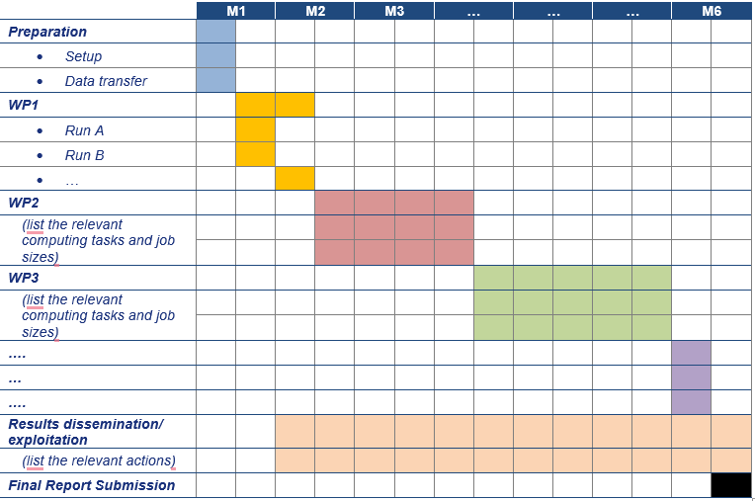

<Enter your Gantt Chart here>

<Enter your text here>

Personnel and Management Plan
What personnel are already in place and what are their roles on the project? If applicable, describe (i) personnel that will be hired for the project in the future and their responsibilities and (ii) potential personnel turnover that may occur during the project and a strategy for replacing them. The Access call welcomes proposals from individual PIs or teams of collaborators. Outline the focus of each individual or subgroup and their interrelationships.

<Enter your text here>

REFERENCES (Maximum 15)

<Enter your text here>

