Project Proposal

- Project Details
Project Title: File Organizer System
Project Type: GUI-based application using C and GTK3 (Console-based core logic with optional GUI)
Problem Statement: Windows users often accumulate large numbers of files and folders. Managing them manually is time-consuming and error-prone. Tasks such as creating, renaming, moving, deleting, or quickly locating files become cumbersome without a proper tool.
Purpose of the System:
- Provide an intuitive file management system for Windows using C programming.
- Allow users to browse, preview, and organize files efficiently.
- Implement batch operations, drag & drop, multiple view modes, and optional features like tagging, auto-sort rules, theme switching, and keyboard shortcuts to enhance usability.
Target Users:
- Individual users, students, and office employees managing large numbers of documents, images, and media files.
- Example: A user wants to organize downloaded files, preview images, create/rename/move/delete multiple files at once, compress files, or access recently used files quickly.
2. Technology & Tools
Programming Language: C
Compiler: MSYS2 with MinGW-w64 GCC
Code Editors: Visual Studio Code, CodeBlocks
Data Storage Method:
File Handling: All data such as user preferences, logs, and optional tags will be stored using File I/O in C.
Additional Libraries:
- GTK3 (GUI interface)
- GDK-Pixbuf (Image preview)
- Standard C libraries: stdio.h, stdlib.h, string.h, dirent.h, windows.h
3. System Design
Block Diagram:
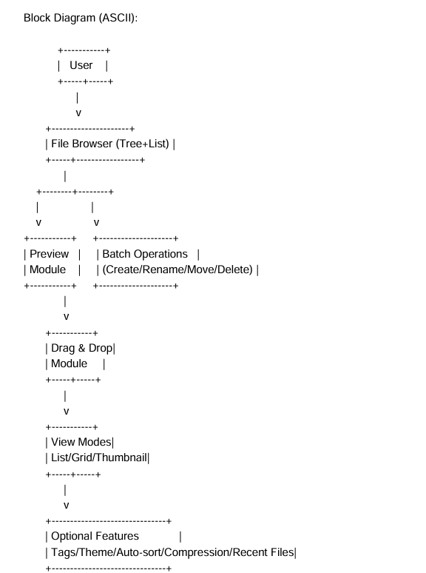

4. Feature List

1.File Browser | Displays files and folders in tree and list format.
2. View Modes | Switch between list, grid, or thumbnail views.
3. Batch Operations | Allows creating, renaming, moving, or deleting multiple files at once.
4. Advanced Search & Filter | Search and filter files by name, type, or other criteria.
5. Tag / Label System | Allows tagging or labeling files for organization.
6. Drag and Drop | Supports moving or copying files via drag & drop.
7. Trash / Restore System | Deleted files go to Trash and can be restored.
8. Auto-Sort Rules | Automatically sort new files into specific folders.
9. Plugin / Extension Support | Allows adding extensions or plugins for extra functionality.
10. Theme & Keyboard Shortcuts Customization | Switch between light/dark themes and customize shortcuts.
11. File Compression / Extract Support | Compress files into ZIP or extract archives.
12. Recent Files / Quick Access | Displays recently accessed files for faster access.

5. Team Member Roles & Use Distribution
Member Name | Features Assigned
Nafisa Anzum | 1,2,3
Rubiya Islam Aesha | 4,5,6
Tahsin Talukder | 7,8,9
Sefaton Nahar | 10,11,12

