Reading the Research Paper: A Simple Guide
Plain-English guide to “A Vision-Based Dual-Mode Hand Gesture Interface … Four-Wheel Omnidirectional Mobile Robot” (reports/research_paper/paper_en.pdf). The Vietnamese paper has the same content, figures and numbers.
How to use this guide
Open the paper (PDF) next to this guide. Read in this order: Part 1 (what the paper says) → Part 2 (how to read charts, used for every figure) → Part 3 (each section and figure of the paper) → Part 4 (key numbers and self-test questions).
Every figure is explained in 3 steps: What is it? → Read it step by step → What does it tell us?

Part 1. What is the paper about? (2-minute read)
The problem. When people control a robot with hand gestures, the hand usually only gives move commands (go, back, turn). To change mode, set speed or press emergency stop, the user still needs a mouse or keyboard.
The idea. Use one laptop webcam for both jobs at the same time:
- The main hand (right hand) moves a virtual mouse cursor on a web dashboard: it clicks buttons and drags sliders.
- The other hand (left hand) drives the robot: point in 8 directions, two fingers to turn, fist to stop.
The robot has 4 omni wheels in an X shape, so it can move in any direction (forward, sideways, diagonal) and turn in place. The laptop sends commands over Wi-Fi to an ESP32 on the robot. The ESP32 controls each wheel's speed 100 times per second.
Three main contributions (Section I):
1. A two-hand interface, with a part that fixes the left/right hand label by itself (the camera image is mirrored).
2. A laptop ↔ ESP32 link over UDP on the robot's own Wi-Fi, with a one-driver lock, safety timers on both sides (no signal → stop) and acceleration limits.
3. A speed controller for each wheel: feed-forward + PI, with protection against integrator wind-up. Its settings were measured on the real motors.
Main results (from 13,080 logged control cycles, about 34 minutes of real driving):
Quantity | Result | In simple words
Camera + AI speed (no hand) | 29.9 frames/s; AI 18.5 ms/frame | Almost the full 30 fps of the camera
With real hands (session 2) | 18–25.5 fps; AI 45–56 ms | AI is clearly slower when a hand is seen
Network round trip (UDP) | median 6.6–8.1 ms | Network is very fast, not the bottleneck
Wheel speed error | mean 1.5–3.2 % of top speed | Wheels spin at almost the commanded speed
Robot body motion (from encoders) | 0.1–2.5 % off the command | Robot goes where it is told
Camera frame → wheel at 50 % speed | 427 ms (median of 15) | This is the slowest part
Cursor filter and “click anchor” on a real hand | almost no benefit | Negative result, reported honestly

Key point
The paper shows that the robot and network work well (strong data). The cursor on a real hand is not as good as the simulation said, and the paper says so openly. Everything comes from one robot and one user, with no user study.

Part 2. Basic skills: how to read charts and statistics
The paper uses a few ideas and chart types again and again. Learn them first, and every figure becomes easy.

2.1. General rules for any chart
1. Read the title and caption under the figure: what is being compared?
2. Read the horizontal axis (x) and vertical axis (y): what quantity, and what unit (ms, px, %, s)?
3. Read the legend: what does each color or line style mean?
4. Find the reference line (dashed line, y = x line, 5 % mark…). It is the “good / bad” border.
5. Only then look at the data: high or low, same or different, close together or spread out?

2.2. Common statistics words
Word | Meaning | Example in the paper
Mean (average) | Add all values and divide by how many. A few very big values can pull it up. | Mean wheel error 2.5 %
Median | Sort the values and take the middle one. Half are smaller, half are bigger. A few strange values do not change it much. | Median RTT 6.6 ms
95th percentile (P95) | 95 % of values are below this. It shows the “bad but still common” case. | RTT P95 = 16.1 ms
Maximum (max) | The single worst value seen. | RTT max = 909 ms
Normalized units | Scaled to 0 → 1. For wheel speed, 1.0 = 4300 encoder counts per second = top speed. | Forward command 0.472 = 47 % of top speed
% of full scale | Error divided by top speed (not by the current speed). | Error 0.025 = 2.5 %
ms, px, fps | milliseconds (1/1000 s); pixels; frames per second. | 30 fps → 33 ms per frame

Why does the paper use the median and not the mean?
Network delay is sometimes huge (909 ms), but only once. That one value would pull the mean up and make the network look slow. The median shows the typical case; P95 and max show the bad cases. The paper always gives all three: median / P95 / max.

2.3. The chart types in the paper

a) Block diagram (Figure 1)
No axes and no measured numbers. Each box is a part of the system; each arrow shows data moving from one part to another.

b) Time plot (Figure 5a, 5b)
The x axis is time. There are usually 2 lines: the set-point (what we want, dashed) and the measured value (what really happens, solid). The closer the two lines, the better the controller.

c) Histogram (Figure 4a, 6b)
The x axis is cut into bins, for example 0–2 ms, 2–4 ms… The height of each bar = how many samples fall in that bin (or what share). The tallest bar is the most common value. The long “tail” on the right shows rare, slow cases.
Log scale (Figure 4a): on the y axis, each big step is 10 times the one below: 10⁻³ = 0.1 %, 10⁻² = 1 %, 10⁻¹ = 10 %. It lets us see a very tall bar (60 %) and a very small one (0.1 %) in the same picture.

d) Box plot (Figure 5d, 6a)
One box sums up a whole group of numbers:
- Line inside the box = median.
- Bottom and top of the box = 25th and 75th percentile. Half of all samples are inside the box. A taller box means more spread.
- Whiskers (the lines above and below) = the range where most samples are. In Figure 5d they go from P5 to P95.
- Diamond (Figure 5d) = mean.

e) Scatter plot with a y = x line (Figure 3)
Each dot is one trial. The diagonal y = x line is where both values are equal. A dot above the line → the y value is bigger; a dot below → the y value is smaller.

f) Paired bar chart (Figure 4b)
Each group has 2 bars side by side: command and measured result. Equal height is good.

g) Straight line y = a + b·x (Figure 5c)
a = where the line meets the vertical axis (the value at x = 0). b = the slope (how much y grows when x grows by 1).

Part 3. The paper, section by section and figure by figure

Abstract and keywords
The abstract puts the whole paper into one paragraph: problem → solution → result numbers → limits. The numbers are the same as in the table in Part 1. The last sentence, “All results come from one robot and one operator, and no user study was performed”, is an honest statement of limits: the reader knows right away how far to trust the results.

Section I. Introduction
- An omni robot has 3 independent motions: vₓ (forward/back), v_y (left/right), ω (turn). Controlling all three at once is harder than driving a normal car.
- MediaPipe Hands is an AI model that finds 21 landmarks on a hand (finger joints, fingertips, wrist).
- Hardware problem: cheap L298N drivers and motors have a dead zone: a wheel does not move until the PWM is high enough. This threshold differs between wheels by 2.7 times (5.5 % to 14.8 % PWM). With the same PWM on all 4 wheels, the robot drifts and turns by itself.

Section II-A. Host–edge architecture — Figure 1
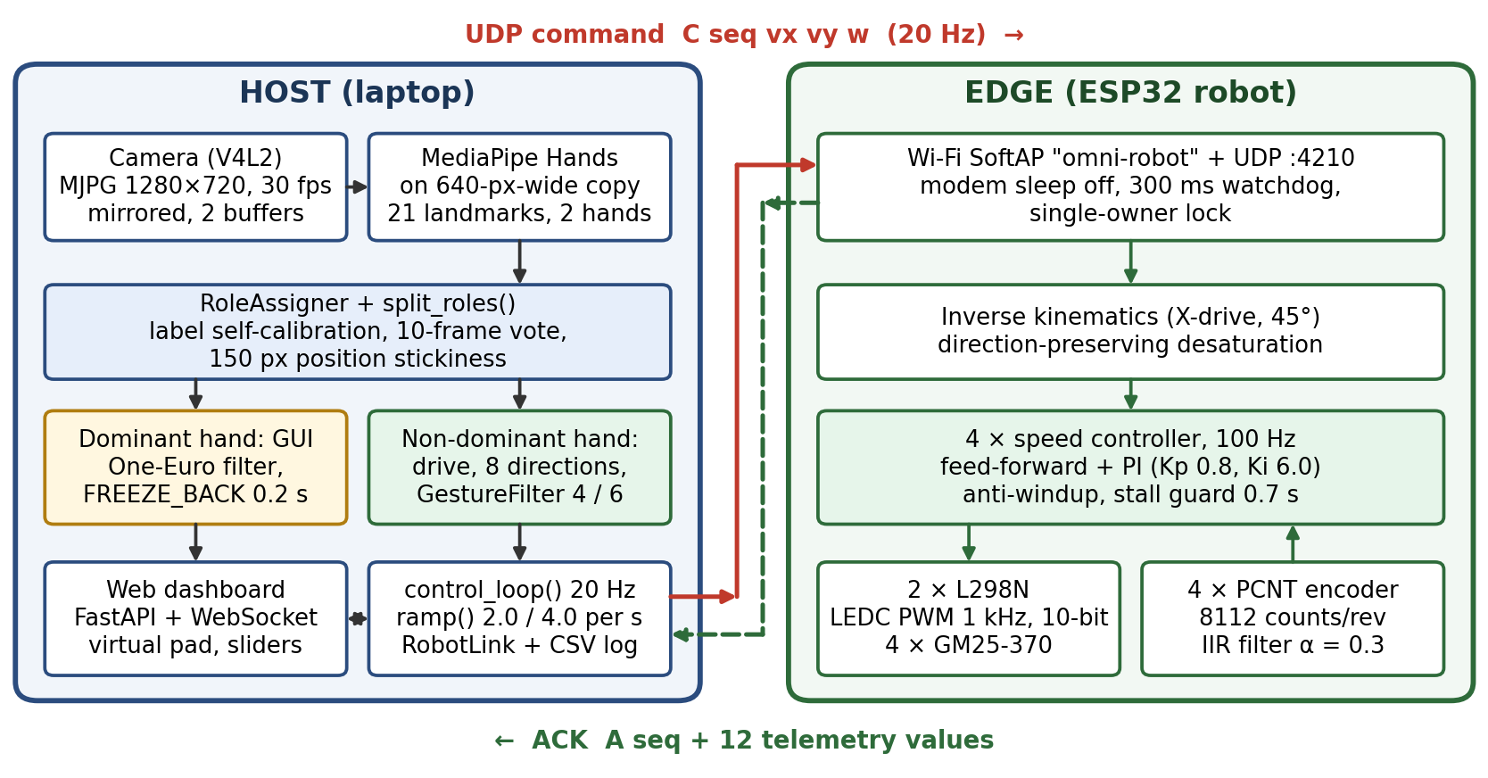
Figure 1 in the paper – system architecture.

What is it?
A block diagram of the whole system. Left box (HOST) = laptop. Right box (EDGE) = ESP32 on the robot.

Read it step by step
1. Laptop side, top to bottom: Camera (MJPG 1280×720, 30 fps, mirrored image, 2 buffers) → MediaPipe finds 21 landmarks for up to 2 hands on a smaller 640-px-wide copy (sharp image for the screen, small image so the AI runs fast) → RoleAssigner decides which hand is the UI hand and which is the drive hand.
2. It splits into two branches. Yellow box = main hand controls the GUI (One-Euro filter, click anchor FREEZE_BACK 0.2 s). Green box = other hand drives the robot (8 directions; GestureFilter 4/6 means 4 frames in a row to start, 6 to stop).
3. UI hand → Web dashboard (FastAPI + WebSocket). Drive hand → control_loop at 20 Hz (sends a command 20 times per second, speeds up at most 2.0/s, slows down 4.0/s, writes a CSV log).
4. Solid red arrow at the top: the UDP command “C seq vx vy w” goes to the robot 20 times per second.
5. Robot side, top to bottom: its own Wi-Fi “omni-robot”, UDP port 4210, 300 ms watchdog (no command for 300 ms → stop), commands accepted from one laptop only → inverse kinematics (turns vₓ, v_y, ω into 4 wheel speeds) → 4 speed controllers at 100 Hz → L298N drivers power the motors; encoders count pulses to measure the real speed and send it back up to the controller (upward arrow).
6. Dashed green arrow at the bottom: the robot replies “A seq” + 12 values (for each wheel: target speed, measured speed, PWM).

What does it tell us?
The laptop does the heavy work (AI, interface). The ESP32 does the fast and safe work (wheel control at 100 Hz, stop by itself if the network is lost). There are 2 safety layers: the ESP32 stops after 300 ms with no command, and the laptop replaces any command older than 0.4 s with zero.

Section II-B. Kinematic model — Figure 2 and equations (1), (2)
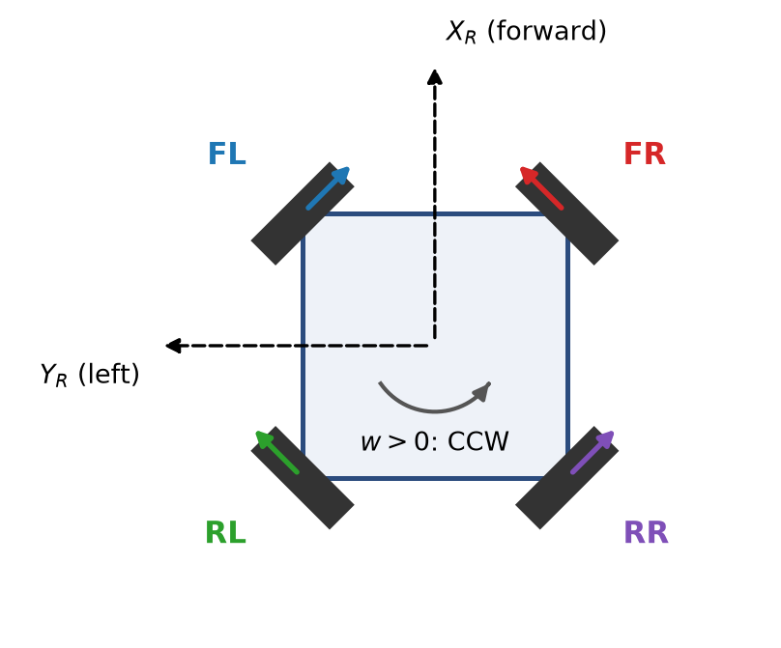
Figure 2 in the paper – X-configuration geometry.

What is it?
The robot seen from above. The square is the body. The 4 black bars at 45° are the wheels: FL (front-left), FR (front-right), RL (rear-left), RR (rear-right).

Read it step by step
1. X_R axis points up = robot's front. Y_R axis points left = robot's left. The curved arrow: ω > 0 means turning counter-clockwise (CCW). This is the standard ROS rule.
2. The colored arrow on each wheel = the direction that wheel pushes the robot when it spins forward. The wheels sit at 45°, so each one pushes diagonally.
3. Example go straight forward: all 4 wheels spin forward. The sideways parts cancel out; only forward push remains.
4. Example go sideways to the left: FL and RR spin backward, FR and RL spin forward (the v_y column in the matrix: −1, +1, +1, −1). The forward/back parts cancel; only a push to the left remains.

What the equations say (in words)
- (1) Inverse kinematics: multiply the command (vₓ, v_y, ω) by a 4×3 matrix to get the 4 wheel speeds. If any wheel would go above 1.0, all 4 wheels are divided by the same number. The robot keeps the same direction and just goes slower. (Cutting each wheel on its own would bend the path.)
- (2) Forward kinematics: the reverse. From the measured wheel speeds, work out how the robot is really moving. The matrix is simple: the transpose divided by 4. This gives Table III and Figure 4b.
- Encoder: 8112 counts per wheel turn. The ESP32's PCNT hardware counts the pulses, with a 12.5 µs noise filter.

Section III. Gesture interface and wheel control

III-A. Which finger is straight — equation (3)
A finger counts as straight if the distance wrist → fingertip is more than 1.15 times the distance wrist → middle finger joint. Because it is a ratio, it works whether the hand is near or far from the camera. Only the index finger straight → measure the pointing angle and round it to 8 directions, 45° each. Index + middle finger pointing left/right → turn. Fist or open palm → stop.

III-B. Hand roles
The image is mirrored, so MediaPipe calls the left hand “right”. The role assigner works like this. With 2 hands, it uses the left/right position of the wrists in the image, and learns by itself whether the labels are flipped (a trust score cₖ; it switches when cₖ < −0.6). With 1 hand, it takes a vote over 10 frames. If one hand just disappeared and the other moved less than 150 px, the old role is kept.

III-C. Cursor, click anchor, slider grab, frame edge
- One-Euro filter: hand still → strong smoothing (less shaking); hand moving fast → light smoothing (no lag).
- UI hand poses: index only = move the cursor (hold still 0.8 s = click); index + middle = click or drag.
- Click anchor (equation 4): raising the middle finger may pull the index fingertip away. So the system uses the position from 0.2 s earlier as the click point. (On a real hand this did not help; see Figure 3.)
- Mapping near the frame edge: when the hand is close to the image border, the AI loses it. So in the middle the cursor follows the finger exactly, and near the edge the cursor moves faster than the finger (up to 1.35×). It reaches the screen edge while the finger is still 6 % away from the image border. A first version jumped to 1.67× suddenly and made the cursor “run ahead”, so it was replaced.

III-D. Speed control for each wheel — equation (5) and Table I
Every 10 ms, each wheel's PWM is the sum of 3 parts:
- Feed-forward uᶠᶠ = a + b·|r|: a “first guess” of the PWM needed for speed r. a = the smallest PWM that starts the wheel (dead zone); b = extra PWM for each unit of speed.
- P = Kp × error (Kp = 0.8): corrects the error right now.
- I = sum of past errors (Ki = 6.0): removes small errors that last. Anti-windup: it stops summing while the robot is speeding up or the PWM is at its limit, so the wheel does not overshoot.
Table I gives a and b for each wheel (measured with the wheels lifted off the floor) and the mean error on the floor:
Wheel | a (start PWM) | b (slope) | Error v1 gesture | Error v2 two-hand
FL front-left | 0.076 | 0.470 | 1.9 % | 2.5 %
FR front-right | 0.148 | 0.594 | 2.5 % | 2.6 %
RL rear-left | 0.055 | 0.453 | 1.6 % | 2.3 %
RR rear-right | 0.060 | 0.464 | 1.7 % | 2.5 %

How to read it: FR is the “stiffest” wheel. It needs 14.8 % PWM just to start, 2.7 times more than RL (5.5 %). Because each wheel has its own a and b, the errors stay similar (about 2–2.6 %) even though the wheels are different.

Section IV-A. Experimental setup — Table II
Run | Log rows | Time (s) | RTT: median / P95 / max (ms)
Manual (v1) | 3240 | 1512 | 7.8 / 22.5 / 97
Gesture (v1) | 4820 | 247 | 8.1 / 26.1 / 101
Two-hand (v2) | 5020 | 266 | 6.6 / 16.1 / 909
Total | 13080 | 2026 | –

How to read it: 3 real runs on the floor, logged 20 rows per second. RTT (round-trip time) = time from the laptop sending a command to getting the robot's reply. Read the columns: the median is only about 7–8 ms (very fast); 95 % of packets are under 16–26 ms; but there is one worst case of 909 ms in the v2 run. That is longer than the 300 ms watchdog, so the robot stopped by itself at that moment. The safety system worked.
The manual run is much longer (1512 s) but has fewer rows, because the log is written mostly while driving.

Section IV-B. Vision and the cursor negative result — Figure 3
Speed: over 359 frames in a row with no hand: 29.9 fps, AI takes 18.5 ms per frame on average (P95 = 27.1 ms). With only 1 driver buffer instead of 2, the speed fell from 28.9 to 14.5 fps.
Tests: 55 automatic checks with simulated hands + 49 cursor checks in a browser. All passed.
Gesture stability: about 94 % of gesture segments lasted more than 0.3 s. Only about 6 % were very short (maybe wrong detections, but this was not checked).
Negative result: on a simulated hand, the filter cut shaking by 65.5 % and the anchor cut the click shift by 83.6 %. On a real hand that did not happen:
- Shaking: hand still for 8 s, raw fingertip moved 2.26 px, filtered cursor 2.14 px, only 5 % less.
- Clicking: the fingertip moved only 1.65 px when raising the middle finger (the simulation assumed 29.2 px). So there was almost nothing to fix.
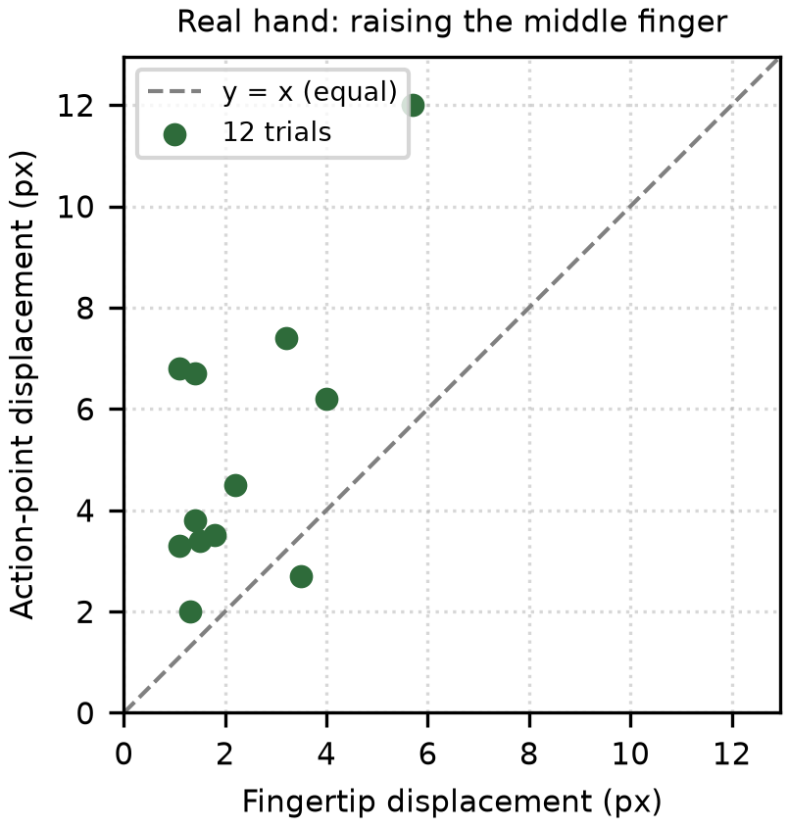
Figure 3 in the paper – real hand, 12 clicks.

What is it?
A scatter plot. Each green dot is one click trial (12 in total).

Read it step by step
1. Horizontal axis: how many pixels the index fingertip moved when the middle finger went up (without the anchor, the click point would move this much).
2. Vertical axis: how many pixels the real click point (with the anchor) moved.
3. Dashed line y = x: both values equal. Dot below → the anchor helped. Dot above → the anchor made it worse.
4. Count: 11 of 12 dots are above the line. Only 1 dot (x ≈ 3.5, y ≈ 2.7) is below.
5. Look at the size: all values are just a few pixels (1–12 px). The dwell-click circle is 30 px, so the real effect on clicking is probably small.

What does it tell us?
On a real hand, the anchor does not help; it adds about 2.5 px of shift. Looking 0.2 s back picks a moment when the finger was still drifting a little. The paper calls this a negative result. That is honest and good science, but with only 12 clicks from 1 person it is only an early sign.

Section IV-C. Link latency — Figure 4
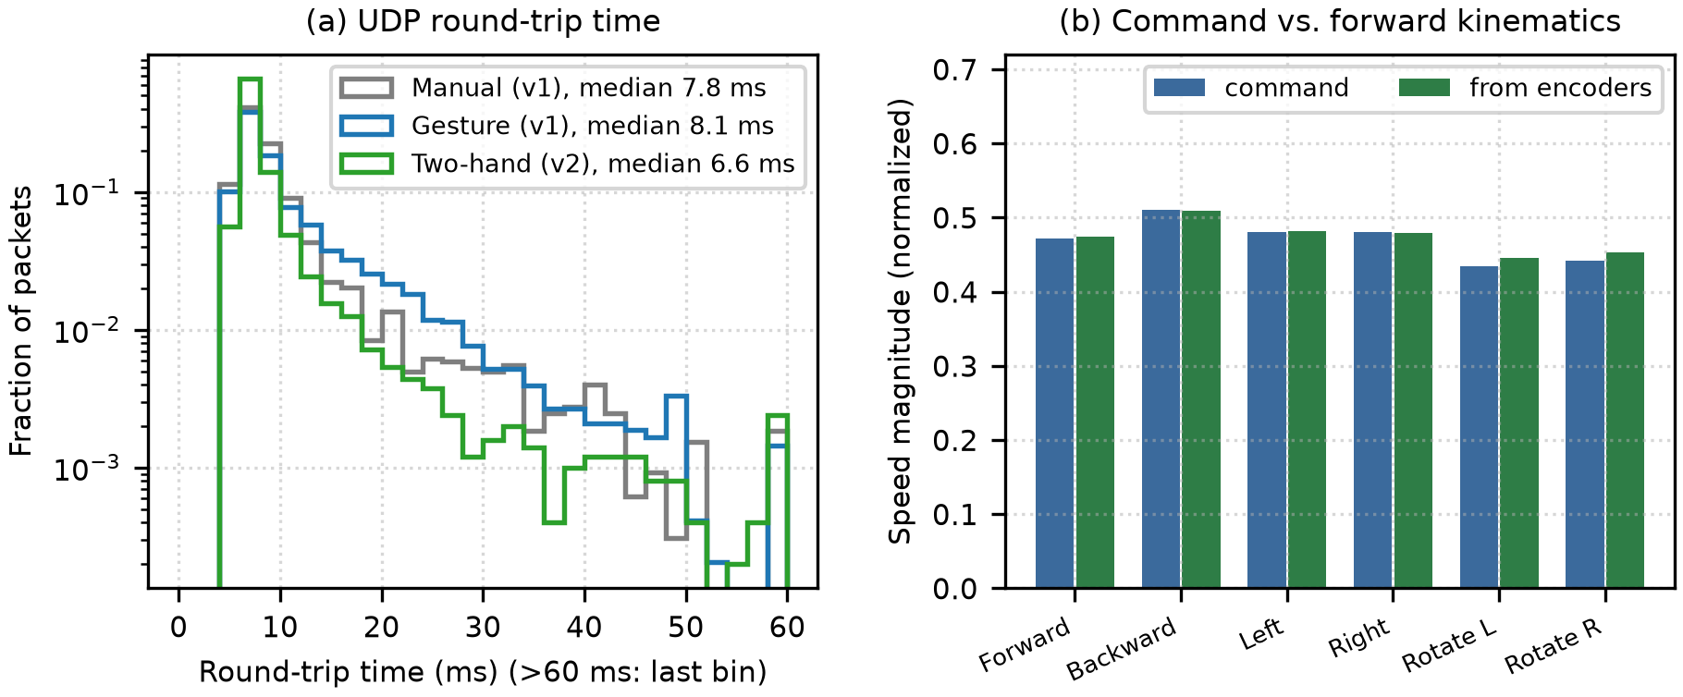
Figure 4 in the paper – (a) RTT distribution; (b) command vs. encoder-based velocity.

Figure 4a – histogram of UDP round-trip time
1. Horizontal axis: RTT in ms, from 0 to 60. Every packet slower than 60 ms is put in the last bar at 60.
2. Vertical axis (log scale): share of packets. 10⁻¹ = 10 %, 10⁻² = 1 %, 10⁻³ = 0.1 %.
3. Three colored lines = three runs (grey: manual v1; blue: gesture v1; green: two-hand v2).
4. Sharp peak at about 6–8 ms, close to 10⁰ (≈ 40–60 % of packets): most packets come back very fast.
5. The tail goes down to the right: at 30 ms only about 0.5 % of packets; at 50 ms about 0.1–0.3 %.
6. The bar at 60 ms goes up a little: these are all the packets slower than 60 ms put together (about 0.2 %).
7. The green line (v2) is lowest in the tail, so it had the fewest slow packets, even though the single worst packet (909 ms) was in this run.
What it tells us: the robot's own Wi-Fi is very fast (a few ms) and rarely slow. The network is not the bottleneck. Note: RTT is only the network part. It does not include camera, AI or gesture filtering time.

Figure 4b – command vs. velocity from the encoders
1. Horizontal axis: 6 basic motions (forward, backward, left, right, rotate left, rotate right).
2. Vertical axis: speed size in normalized units (1.0 = top speed).
3. Each group has a blue bar = command and a green bar = how the robot really moved (from the encoders, equation 2).
4. The two bars are almost the same height. Only for the two rotations is the green bar a little taller (turning about 2.5 % faster than commanded).
What it tells us: the robot does what it is told. Note: these numbers come from the wheel encoders, so wheel slip on the floor is not seen. This is not a true position error measured by an outside camera.

Table III – detailed numbers for Figure 4b
Motion | Command (vₓ, v_y, ω) | From encoders | Main-axis error | Max other axis
Forward | (+0.472, 0, 0) | (+0.474, +0.001, +0.002) | +0.6 % | 0.002
Backward | (−0.510, 0, 0) | (−0.510, −0.001, −0.001) | −0.1 % | 0.001
Left | (0, +0.480, 0) | (+0.004, +0.482, +0.002) | +0.4 % | 0.004
Right | (0, −0.480, 0) | (−0.003, −0.479, 0) | −0.2 % | 0.003
Rotate left | (0, 0, +0.435) | (+0.003, +0.001, +0.446) | +2.5 % | 0.003
Rotate right | (0, 0, −0.442) | (−0.001, 0, −0.453) | +2.4 % | 0.001

How to read one row: “Forward” was commanded vₓ = 0.472. The encoders show 0.474, so +0.6 % off. Sideways drift (v_y) and turning (ω) are only 0.001–0.002, almost zero. So the robot goes straight, with no drift and no turning. The two diagonal rows (v2) have no main-axis error because there is no single main axis.
Reaction time: from the logged gesture to the moment the most loaded wheel reaches 50 % of its new speed takes about 257–260 ms (median). Most of this time comes from the deliberate acceleration limit. It does not include the 4 frames (≈133 ms) needed to confirm the gesture.

Section IV-D. Wheel tracking — Figure 5
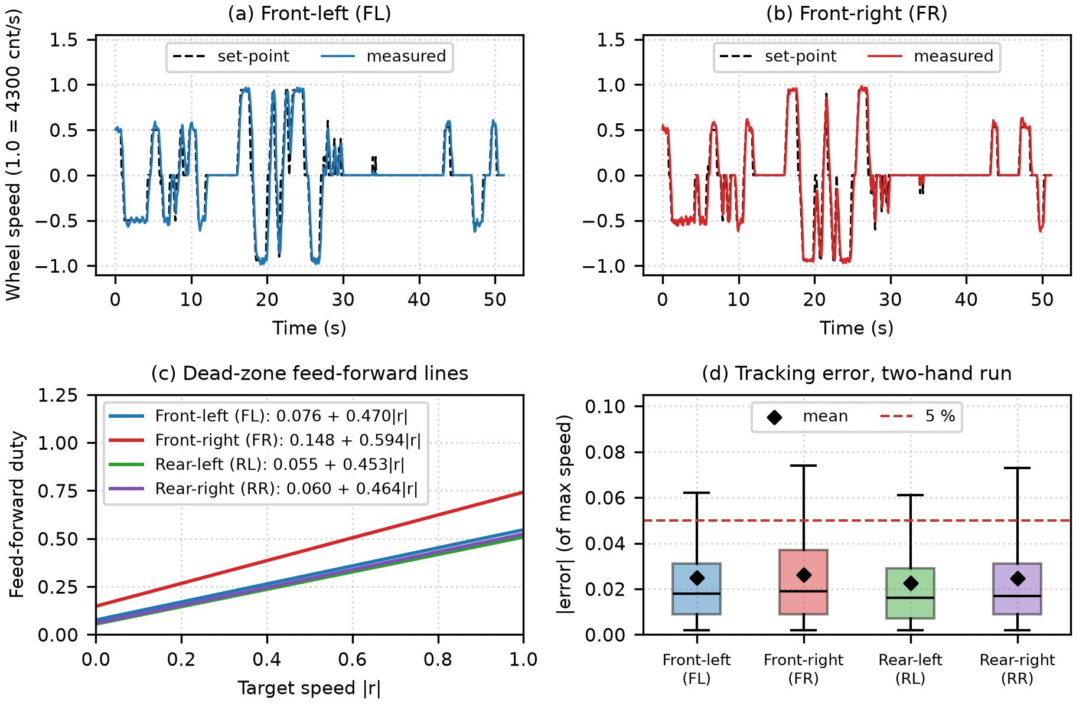
Figure 5 in the paper – wheel speed control in the two-hand run.

Figure 5a, 5b – speed over time for wheels FL and FR
1. Horizontal axis: time, 0–50 seconds. Vertical axis: wheel speed (1.0 = 4300 counts/s = top speed; negative = spinning backward).
2. Black dashed line = set-point (what the controller wants). Colored solid line = measured (what really happens).
3. The two lines almost cover each other for the whole 50 s, even when going from +1 to −1 (around 17–27 s).
4. At each change, the colored line comes a little late after the dashed line, with a few small wiggles. That is motor inertia.
5. Around 28–35 s there are a few short dashed spikes that the colored line does not fully follow: the command was too short for the wheel to speed up.

Figure 5c – feed-forward lines of the 4 wheels
1. Horizontal axis: wanted speed |r|. Vertical axis: PWM to apply (0–1).
2. Where a line meets the vertical axis (|r| = 0) = a = smallest PWM that starts the wheel. Red (FR) meets it at 0.148; the other three at about 0.06–0.08.
3. Slope: the red line is the steepest. At top speed FR needs about 0.74 PWM; the others need only about 0.51–0.55.
What it tells us: the FR wheel is much harder to turn (more friction or a weaker motor). With one shared line for all 4 wheels, FR would always be slower and the robot would drift. Each wheel needs its own line.

Figure 5d – box plot of tracking error
1. Vertical axis: |error| as a share of top speed. 0.02 = 2 %. Only counted when the command has been steady for at least 0.3 s.
2. Black line in the box (median) is about 0.017–0.019: half the time the error is under about 1.8 %.
3. Diamond (mean) is about 0.023–0.026, above the median: a few large errors pull the mean up.
4. Top of the box is about 0.03–0.037: 75 % of the time the error is under about 3–3.7 %.
5. Top whisker (P95) is about 0.061–0.074, above the red 5 % line: in the worst 5 % of the time the error is 6–7.4 %.
6. The FR box is a little taller. That matches FR being the hardest wheel to control.

What does it tell us?
The mean error meets the < 5 % goal, but the tail (P95) does not in the v2 run. The paper also admits it did not compare against a plain PID or open-loop control, so it has not proved that this controller is better than those.

Section IV-E. Second session: real hands, end-to-end delay, cursor at the edge — Table IV and Figure 6
After the runs above, 4 more sessions A, B, C, D were logged, one row per camera frame. A and B used a 640×480 camera and a 1:1 cursor. C and D used 1280×720 and a cursor that is “stretched” near the edge (C: piecewise, D: smooth). A and B had the robot connected; C and D tested only the cursor.
Session | Camera | Cursor | Time (s) | fps | AI 0 hands (ms) | AI 1 hand | AI 2 hands
A | 640×480 | 1:1 | 186 | 25.5 | 27.7 | 45.5 | 43.3
B | 640×480 | 1:1 | 76 | 21.9 | 31.3 | 50.1 | 47.5
C | 1280×720 | piecewise | 363 | 18.0 | 30.7 | 55.5 | 48.3
D | 1280×720 | smooth | 214 | 21.9 | 28.9 | 52.4 | 47.2

How to read it: compare down each column. With no hand, AI takes about 28–31 ms; with hands, 43–56 ms, almost double. The whole-session fps is only 18–25.5, below the 29.9 fps of Section IV-B, because the server also encodes and streams video to the web page. The 4 sessions differ in what the user did and in length, so this is not a controlled comparison.
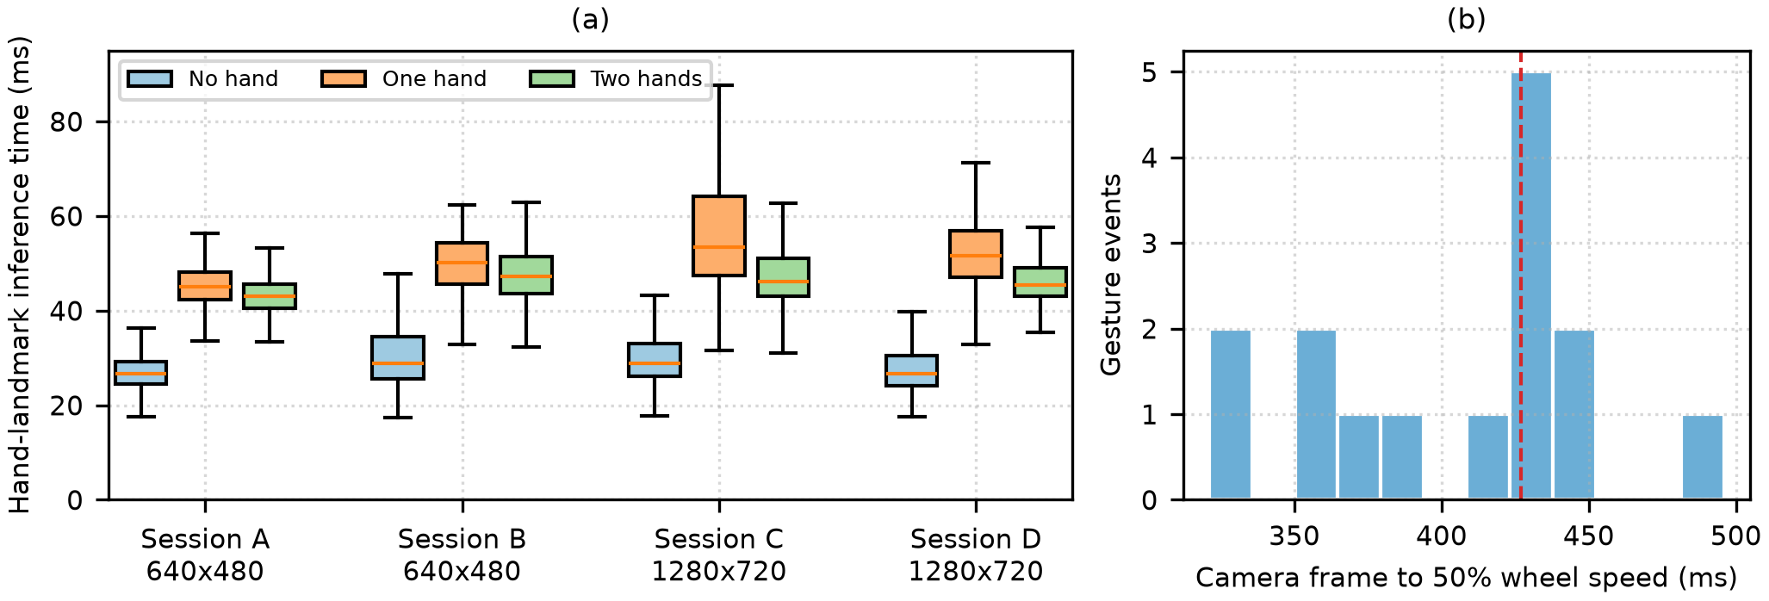
Figure 6 in the paper – (a) AI time per session and number of hands; (b) end-to-end delay in session A.

Figure 6a – box plot of AI inference time
1. Horizontal axis: 4 sessions, each with 3 boxes: blue = no hand, orange = 1 hand, green = 2 hands.
2. Vertical axis: time for the AI to process one frame (ms). The orange line in each box is the median.
3. In all 4 sessions, the blue box is lowest (about 27–29 ms) and the orange box is highest.
4. Surprise: 1 hand (orange) is slower than 2 hands (green). The paper guesses the AI keeps searching for the second hand, but this was not tested.
5. Session C has the tallest, widest orange box (whisker up to about 88 ms): a lot of variation.
6. Raising the resolution to 1280×720 (C, D) did not change the no-hand time, because the AI still runs on a 640-px-wide copy.

Figure 6b – histogram of end-to-end delay (session A)
1. Horizontal axis: time from the camera frame that confirmed a gesture to the moment the wheel reached 50 % of its new speed (ms).
2. Vertical axis: how many gestures fall in each bin. 15 in total.
3. Red dashed line = median 427 ms. The tallest bar (5 gestures) is right at about 425–440 ms.
4. Values range from about 320 to 496 ms.
What it tells us: from making a gesture to clear robot motion takes about 0.4–0.5 seconds. Of that: the command leaves the laptop after about 37 ms; about 0.2 s is the deliberate slow speed-up (acceleration limit 2.0/s, average target 0.81 of top speed); and about 120–140 ms for the 4-frame filter is not even included. This is larger than the 257–260 ms in Section IV-C because the start point is earlier (camera frame, not log row) and the target speeds are different. The network is fast; the slow part is camera + AI + filter + speed-up.

The other two points of Section IV-E
- Wheel tracking: mean error 0.9–1.5 %. In session A the PWM hit the 0.95 ceiling in 4–8 % of samples: at high speed the 12 V battery had no spare voltage, so the wheel could not reach the set speed.
- Cursor at the edge: with the stretched mapping (C, D), the cursor reached the screen edge more often (8.2 % and 4.6 % of frames, against 2.3 % and 1.4 %). But in C and D the user was trying to reach the corner, so these numbers only show the cursor can reach the edge, not that hand loss went down.

Sections V and VI. Limitations and conclusion
Limitations (the paper lists them itself): only 1 robot, 1 floor, 1 person; no user study; real-hand cursor tests had only 12 clicks; no comparison of the controller with a baseline; end-to-end delay from only 15 events; no obstacle sensor, so the human driver is the only safety layer.
Conclusion: one webcam and one ESP32 are enough to drive an omni robot and use its dashboard at the same time with two hands. The network takes a few ms, the wheels track well, and the robot moves in the right direction. What needs work is the interaction delay (about 427 ms), not the network. Next steps: a user study, comparison with baseline controllers, a heading sensor and obstacle sensors.

Part 4. Quick memory and self-test

The 10 most important numbers
# | Number | Where | What it says
1 | 13,080 cycles, 2026 s | Table II | Amount of real data used
2 | 29.9 fps; 18.5 ms | IV-B | Camera + AI with no hand
3 | 18–25.5 fps; 45–56 ms | Table IV, Fig. 6a | With real hands and the full system running
4 | RTT 6.6–8.1 ms (median) | Table II, Fig. 4a | The network is very fast
5 | 909 ms (max) | Table II | One link drop; the watchdog stopped the robot
6 | 1.5–3.2 % (mean) | Table I, Fig. 5d | Wheel speed error
7 | P95 6.1–7.4 % (v2) | Fig. 5d | The tail goes above the 5 % mark
8 | ≤ 0.6 % moving; 2.5 % turning | Table III, Fig. 4b | The robot follows the command
9 | 427 ms | Fig. 6b | End-to-end delay, the part to improve
10 | −5 % shaking; 11/12 clicks worse | Fig. 3 | Negative cursor result

Self-test questions (you may be asked these)
Q: Why report the median RTT and not the mean?
A: A few very large values (909 ms) pull the mean up. The median shows the typical case; P95/max show the bad cases.
Q: In Figure 3, what does a dot above the y = x line mean?
A: The click point with the anchor moved more than the raw fingertip, so the anchor made it worse. 11 of 12 dots are like that.
Q: Why does FR need the most PWM?
A: It has the largest dead zone (a = 0.148) and the steepest slope (b = 0.594). See the red line in Figure 5c.
Q: Does the wheel error meet the 5 % goal?
A: The mean does (1.5–3.2 %). The P95 in the v2 run does not (6.1–7.4 %): the whiskers in Figure 5d go above the red line.
Q: Is Table III the true position error of the robot?
A: No. It comes from the wheel encoders, so wheel slip is not seen. A true error needs an outside camera or another sensor.
Q: Why is the 427 ms delay bigger than 257–260 ms?
A: Different start points (the camera frame is about 37 ms earlier than the log row), different target sizes, and most of it is the deliberate acceleration limit.
Q: What is the biggest weakness of the paper?
A: 1 robot, 1 person, no user study, no controller comparison with a baseline, no obstacle sensor.

