Quiz App E2E Localization and Review Flow Report
Scenario: create account -> publish quiz -> participant submission -> creator answer review
Executed on | 2026-04-29 08:24:21
Environment | Local workspace on http://localhost:3000 with API on http://localhost:3001/api
Coverage type | Live browser walkthrough plus dedicated Playwright E2E spec
Deliverables | DOCX report plus captured evidence screenshots under docs/test-artifacts

Outcome: PASS
The requested end-to-end path completed successfully in the running application. Localization was verified on the login page in both EN and VI, a creator account was created, a quiz was authored and published, a participant submitted an answer, and the creator reviewed that answer in the result detail view.

Validation Summary
- Web lint: passed (`pnpm.cmd --filter @quiz-app/web lint`).
- Web build: passed (`pnpm.cmd --filter @quiz-app/web build`).
- Focused E2E automation: passed (`pnpm.cmd --filter @quiz-app/e2e test specs/creator-review-flow.spec.ts`).
- Live browser walkthrough with screenshots: passed.
- Repo-wide lint/build remain blocked by a pre-existing API TypeScript issue in `apps/api/src/modules/auth/infrastructure/persistence/mongo-user.repository.ts`.

Executed Steps
Step | Description | Status
1 | Verified the locale switcher on the login page by capturing EN and VI states. | PASS
2 | Created a brand-new creator account and confirmed access to My Quizzes. | PASS
3 | Created a one-question quiz, saved it, and published it from management. | PASS
4 | Opened the public quiz page as a participant and started the attempt. | PASS
5 | Submitted the participant answer and confirmed the result summary screen. | PASS
6 | Opened creator results and reviewed the participant answer detail panel. | PASS
7 | Re-ran the same flow as an automated Playwright spec. | PASS

Figure 1. Login in Vietnamese
Automated evidence showing the login page after switching the locale selector to VI.
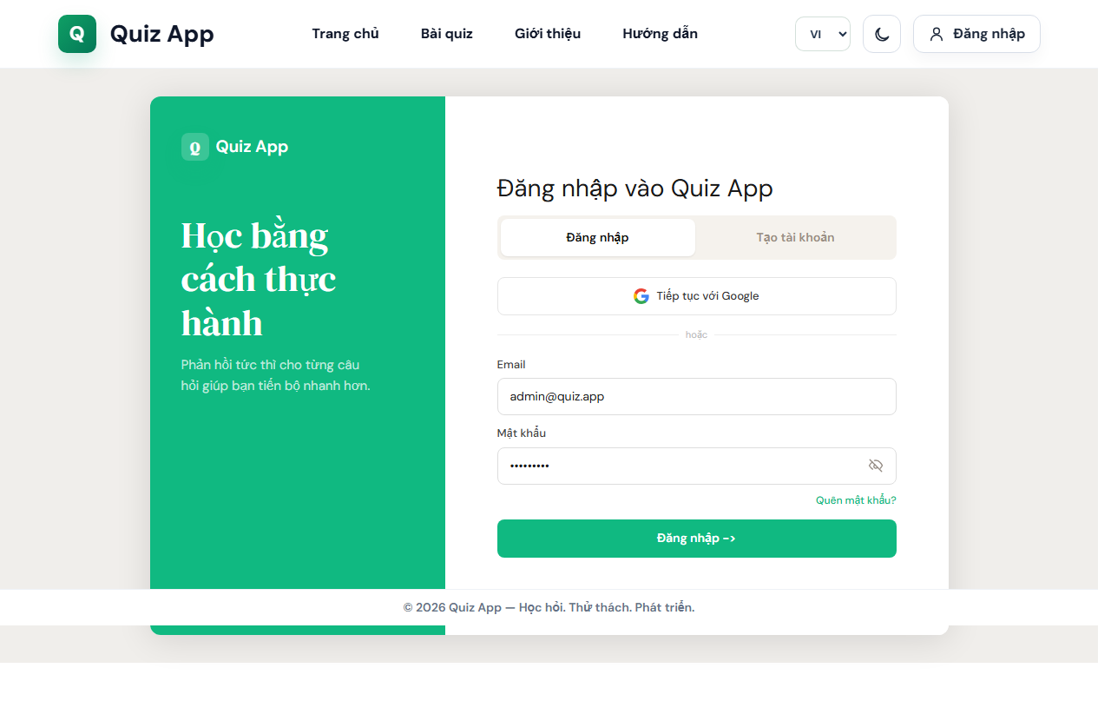
auto-01-login-vi.png

Figure 2. Creator Account Created
The new creator account lands in the management area.
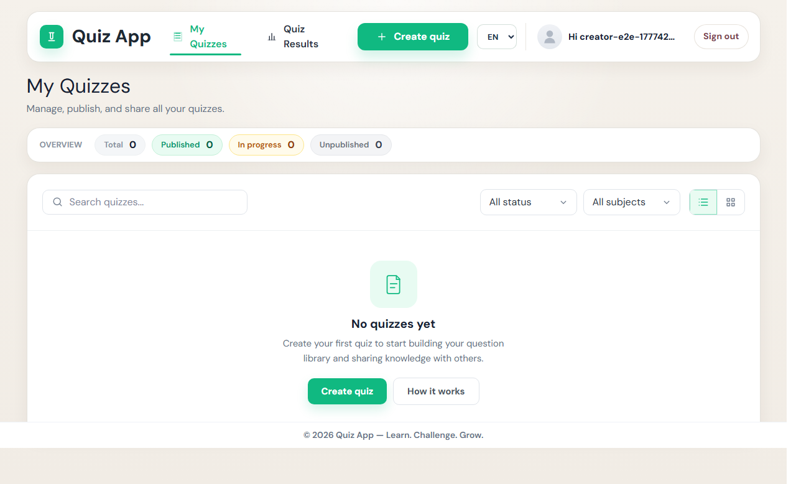
auto-02-creator-account-created.png

Figure 3. Question Builder
The quiz creation flow reaches the question entry step.
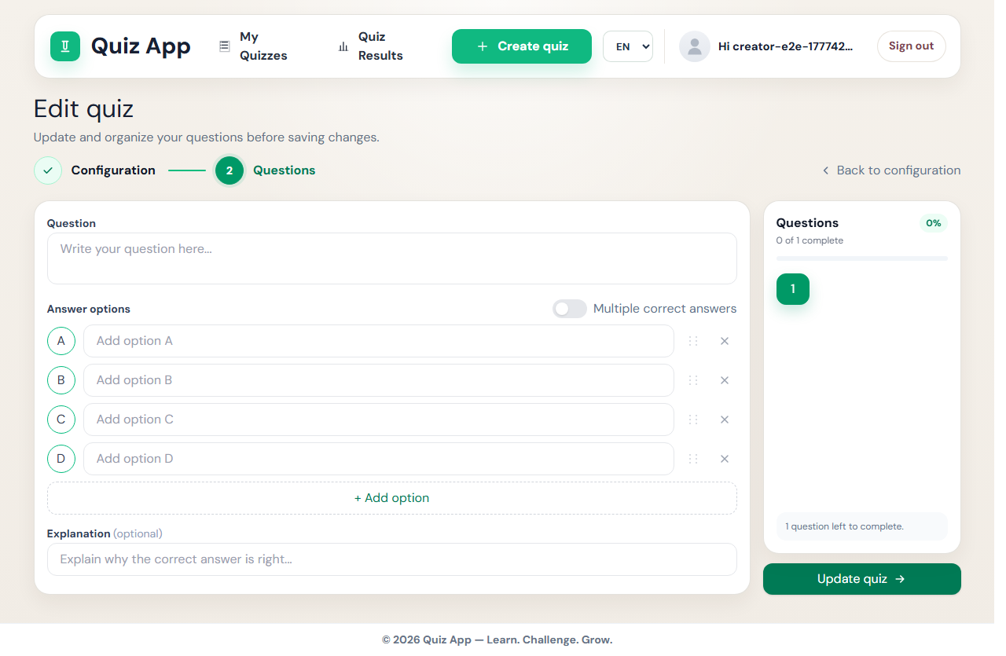
auto-03-question-builder.png

Figure 4. Quiz Published
The authored quiz is visible as Published in management.
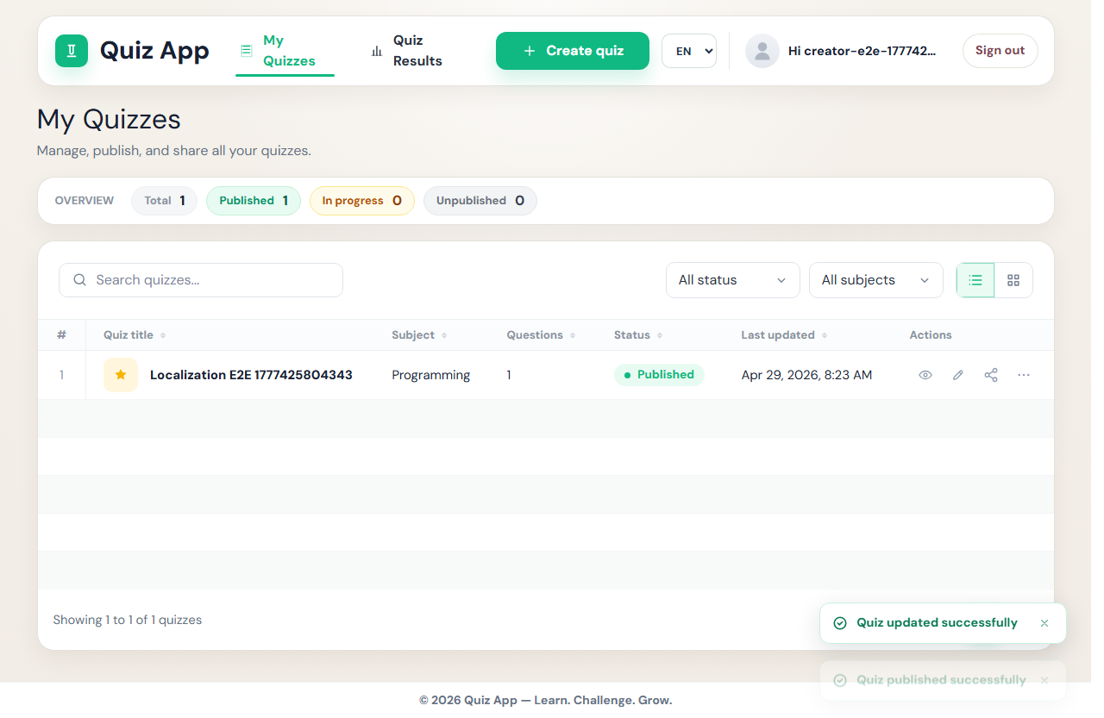
auto-04-quiz-published.png

Figure 5. Participant Result
Participant submission completes with a visible score summary.
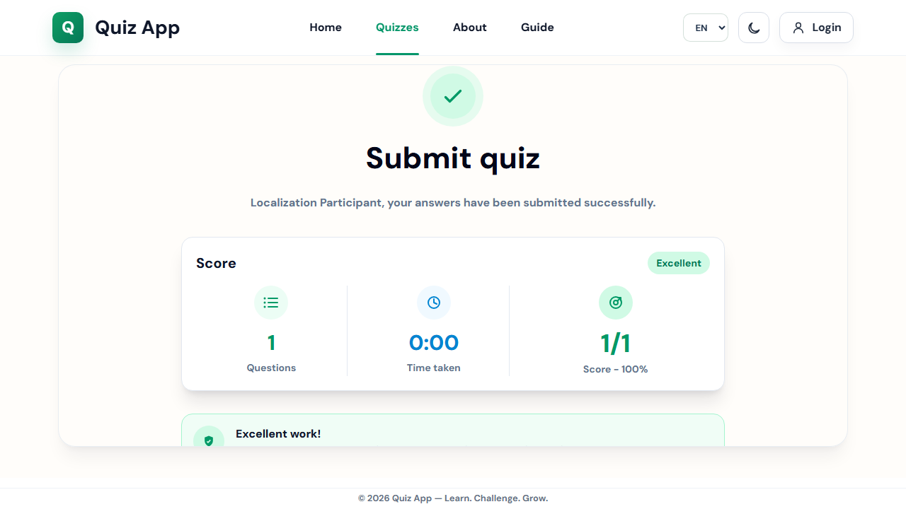
auto-06-participant-results.png

Figure 6. Creator Answer Review
The creator-side result detail shows the participant answer review panel.
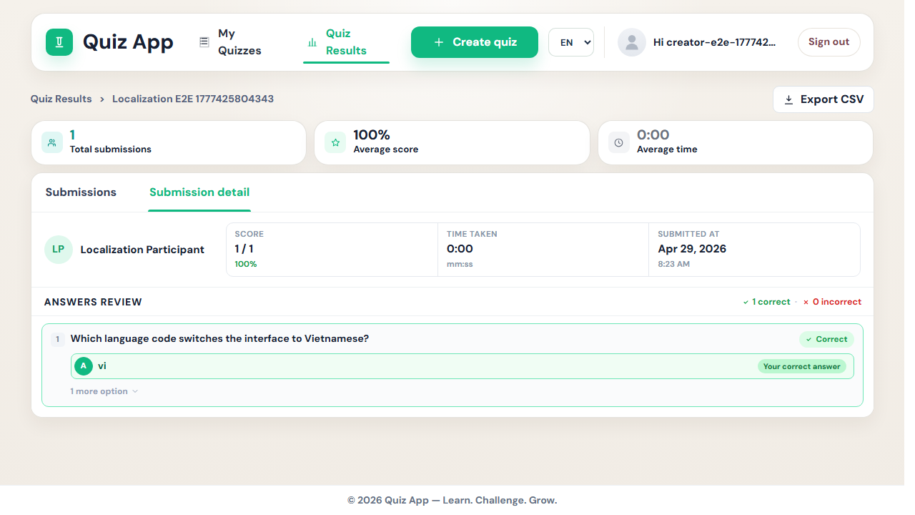
auto-07-creator-answer-review.png

Notes
This report documents both the live walkthrough and the focused automated scenario. The images embedded here were captured during execution and saved under docs/test-artifacts.

