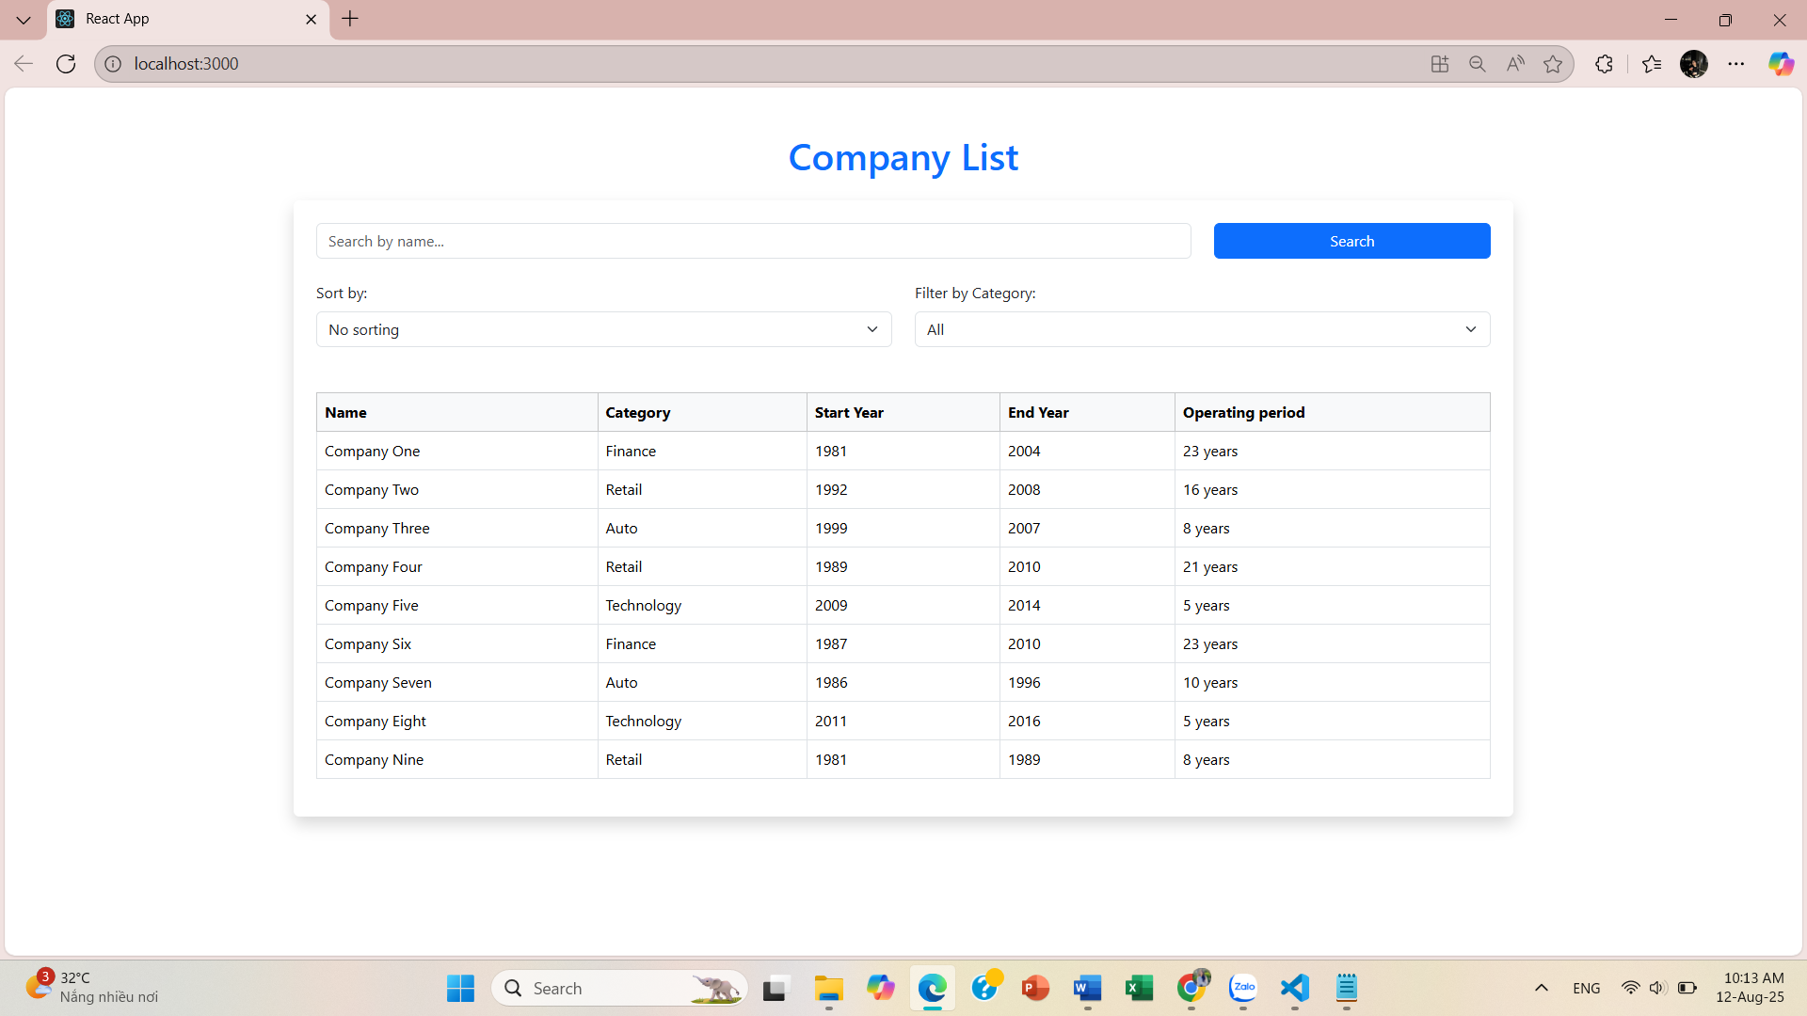

**CategoryFilter.js**

const CategoryFilter = ({ *selectedCategory*, *onCategoryChange*, *categories* }) => {

  return (

    <div *className*="mb-4">

      <label *className*="form-label">Filter by Category:</label>

      <select

*value*={*selectedCategory*}

*onChange*={(*e*) => onCategoryChange(*e*.target.value)}

*className*="form-select"

      >

        <option *value*="">All</option>

        {*categories*.map((*category*) => (

          <option *key*={*category*} *value*={*category*}>

            {*category*}

          </option>

        ))}

      </select>

    </div>

  );

};

export default CategoryFilter;

**CompanyTable.js**

const CompanyTable = ({ *companies* }) => {

  if (*companies*.length === 0) {

    return (

      <div *className*="text-center py-4 text-secondary">

        <p>No result</p>

      </div>

    );

  }

  return (

    <div *className*="table-responsive">

      <table *className*="table table-bordered table-hover align-middle">

        <thead *className*="table-light">

          <tr>

            <th>Name</th>

            <th>Category</th>

            <th>Start Year</th>

            <th>End Year</th>

            <th>Operating period</th>

          </tr>

        </thead>

        <tbody>

          {*companies*.map((*company*, *index*) => (

            <tr *key*={*index*}>

              <td>{*company*.name}</td>

              <td>{*company*.category}</td>

              <td>{*company*.start}</td>

              <td>{*company*.end}</td>

              <td>{*company*.end - *company*.start} years</td>

            </tr>

          ))}

        </tbody>

      </table>

    </div>

  );

};

export default CompanyTable;

**SearchBox.js**

const SearchBox = ({ *searchTerm*, *onSearchChange*, *onSearch* }) => {

  return (

    <div *className*="row mb-4">

      <div *className*="col-9">

        <input

*type*="text"

*placeholder*="Search by name..."

*value*={*searchTerm*}

*onChange*={(*e*) => onSearchChange(*e*.target.value)}

*className*="form-control"

        />

      </div>

      <div *className*="col-3">

        <button

*onClick*={*onSearch*}

*className*="btn btn-primary w-100"

        >

          Search

        </button>

      </div>

    </div>

  );

};

export default SearchBox;

**components/SortDropdown.js**

const SortDropdown = ({ *sortOption*, *onSortChange* }) => {

  return (

    <div *className*="mb-4">

      <label *className*="form-label">Sort by:</label>

      <select

*value*={*sortOption*}

*onChange*={(*e*) => onSortChange(*e*.target.value)}

*className*="form-select"

      >

        <option *value*="">No sorting</option>

        <option *value*="year-asc">Year ascending</option>

        <option *value*="year-desc">Year descending</option>

        <option *value*="duration">Operating period</option>

      </select>

    </div>

  );

};

export default SortDropdown;

**App.js**

import { useState } from "react";

import SearchBox from "./components/SearchBox";

import SortDropdown from "./components/SortDropdown";

import CategoryFilter from "./components/CategoryFilter";

import CompanyTable from "./components/CompanyTable";

export default function App() {

  const companies = [

    { name: "Company One", category: "Finance", start: 1981, end: 2004 },

    { name: "Company Two", category: "Retail", start: 1992, end: 2008 },

    { name: "Company Three", category: "Auto", start: 1999, end: 2007 },

    { name: "Company Four", category: "Retail", start: 1989, end: 2010 },

    { name: "Company Five", category: "Technology", start: 2009, end: 2014 },

    { name: "Company Six", category: "Finance", start: 1987, end: 2010 },

    { name: "Company Seven", category: "Auto", start: 1986, end: 1996 },

    { name: "Company Eight", category: "Technology", start: 2011, end: 2016 },

    { name: "Company Nine", category: "Retail", start: 1981, end: 1989 }

  ];

  const [searchTerm, setSearchTerm] = useState('');

  const [appliedSearchTerm, setAppliedSearchTerm] = useState('');

  const [sortOption, setSortOption] = useState('');

  const [selectedCategory, setSelectedCategory] = useState('');

  const categories = [...**new** *Set*(companies.map(*company* => *company*.category))];

  const handleSearch = () => {

    setAppliedSearchTerm(searchTerm);

  };

  const filteredAndSortedCompanies = () => {

    let result = [...companies];

    if (appliedSearchTerm) {

      result = result.filter(*company* =>

*company*.name.toLowerCase().includes(appliedSearchTerm.toLowerCase())

      );

    }

    if (selectedCategory) {

      result = result.filter(*company* => *company*.category === selectedCategory);

    }

    if (sortOption === 'year-asc') {

      result.sort((*a*, *b*) => *a*.start - *b*.start);

    } else if (sortOption === 'year-desc') {

      result.sort((*a*, *b*) => *b*.start - *a*.start);

    } else if (sortOption === 'duration') {

      result.sort((*a*, *b*) => (*a*.end - *a*.start) - (*b*.end - *b*.start));

    }

    return result;

  };

  return (

    <div *className*="container py-5">

      <h1 *className*="mb-4 text-primary text-center">Company List</h1>

      <div *className*="bg-white rounded shadow p-4">

        <*SearchBox*

*searchTerm*={searchTerm}

*onSearchChange*={setSearchTerm}

*onSearch*={handleSearch}

        />

        <div *className*="row mb-4">

          <div *className*="col-md-6">

            <*SortDropdown*

*sortOption*={sortOption}

*onSortChange*={setSortOption}

            />

          </div>

          <div *className*="col-md-6">

            <*CategoryFilter*

*selectedCategory*={selectedCategory}

*onCategoryChange*={setSelectedCategory}

*categories*={categories}

            />

          </div>

        </div>

        <*CompanyTable* *companies*={filteredAndSortedCompanies()} />

        </div>

    </div>

  );

}