- Configuration Tables
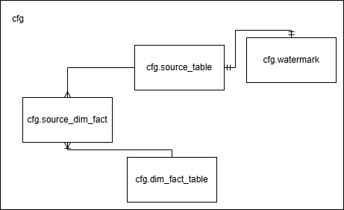
  - cfg.source_table
Purpose: Stores source system configurations used for Bronze ingestion.
Column | Data Type | Description
id | bigint | Unique identifier of the source configuration
source_system | varchar(100) | Source system name (e.g., CRM, Policy System, Payment System)
source_type | varchar(20) | Source type such as database, file, or API
source_name | varchar(100) | Source entity name (e.g., customers, quotations, policies)
source_location | varchar(255) | Source location such as database table or file path
source_format | varchar(20) | Source data format (table, csv, json, parquet)
delimiter | varchar(5) | Delimiter used for delimited file formats
load_type | varchar(20) | Loading strategy (full or incremental)
primary_key | varchar(255) | Primary key column(s) used for merge and deduplication
silver_transform_name | varchar(50) | Custom transformation function applied during Bronze-to-Silver processing.
watermark_column | varchar(100) | Source column used for incremental extraction
bronze_table_name | varchar(100) | Target Bronze table name
bronze_path | varchar(255) | Target Bronze storage path
load_sequence | int | Execution order of source ingestion
is_active | boolean | Indicates whether the source configuration is active
created_at | timestamp | Record creation timestamp
updated_at | updated_at | updated_at

  - cfg.dim_fact_table
Purpose: Stores metadata for Gold layer dimension and fact tables.
Column | Data Type | Description
id | bigint | Unique identifier of the table configuration
table_name | varchar(100) | Target dimension or fact table name
table_type | varchar(20) | Table type (dimension or fact)
gold_transform_name | varchar(50) | Custom transformation function applied during Silver-to-Gold processing.
load_sequence | int | Execution order of Gold table processing
upsert_key | int | Key used for merge or upsert operations
is_active | boolean | Indicates whether the configuration is active
created_at | timestamp | Record creation timestamp
updated_at | timestamp | Last update timestamp

  - cfg.watermark
Purpose: Stores the latest source watermark value used for incremental extraction from Source to Bronze.
Column | Data Type | Description
source_table_id | bigint | Source table configuration identifier
watermark_value | timestamp | Latest processed source watermark value
created_at | timestamp | Record creation timestamp
updated_at | timestamp | Last update timestamp

  - cfg.source_dim_fact
Purpose: Defines the many-to-many relationship between source tables and Gold dimension/fact tables.
Column | Data Type | Description
dim_fact_table_id | bigint | Gold dimension/fact table configuration identifier
source_table_id | bigint | Source table configuration identifier
created_at | timestamp | Record creation timestamp
updated_at | timestamp | Last update timestamp

- Audit and Logging Tables
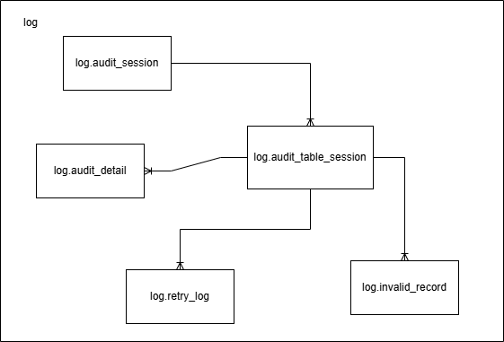
  - log.audit_session
Purpose: Stores execution-level audit information for each pipeline run.
Column | Data Type | Description
id | bigint | Unique pipeline execution session identifier
session_status | varchar(20) | Overall pipeline execution status
run_mode | varchar(20) | Execution mode (NEW, RECOVERY)
batch_id | int | Logical batch identifier being processed
pipeline_name | varchar(20) | Pipeline name
pipeline_run_id | varchar(100) | Pipeline execution identifier
session_started | timestamp | Pipeline execution start timestamp
session_finished | timestamp | Pipeline execution completion timestamp
Column | Data Type | Description
created_at | timestamp | Record creation timestamp
updated_at | timestamp | Last update timestamp
  - log.audit_table_session
Purpose: Stores table-level execution status across Bronze, Silver, and Gold layers.
Column | Data Type | Description
id | bigint | Unique table execution session identifier
session_id | bigint | Related audit session identifier
source_table_id | bigint | Related table configuration identifier
table_session_status | varchar(20) | Overall processing status of the table
bronze_status | varchar(20) | Bronze layer processing status
silver_status | varchar(20) | Silver layer processing status
gold_status | varchar(20) | Gold layer processing status
load_type | varchar | Load strategy used during processing
bronze_started_at | timestamp | Bronze processing start timestamp
silver_started_at | timestamp | Silver processing start timestamp
gold_started_at | timestamp | Gold processing start timestamp
bronze_ended_at | timestamp | Bronze processing completion timestamp
silver_ended_at | timestamp | Silver processing completion timestamp
gold_ended_at | timestamp | Gold processing completion timestamp
retry_count | int | Number of retry attempts
last_retry_at | timestamp | Timestamp of the latest retry attempt
created_at | timestamp | Record creation timestamp
updated_at | timestamp | Last update timestamp

  - log.audit_detail
Purpose: Stores processing metrics and execution details for each table and layer.
Column | Data Type | Description
id | bigint | Unique audit detail identifier
table_session_id | bigint | Related table execution session identifier
detail_status | varchar(20) | Processing detail status
source_row_count | int | Number of records extracted from the source
inserted_row | int | Number of inserted records
updated_row | int | Number of updated records
deleted_row | int | Number of deleted records
rejected_row | int | Number of rejected records
layer | varchar(20) | Processing layer (Bronze, Silver, Gold)
error_message | text | Error message if processing failed
created_at | timestamp | Record creation timestamp
updated_at | timestamp | Last update timestamp

  - log.retry_log
Purpose: Stores retry execution history for failed processing attempts.
Column | Data Type | Description
id | bigint | Unique retry log identifier
table_session_id | bigint | Related table execution session identifier
layer | varchar(20) | Layer where retry occurred
status | varchar(20) | Retry execution status
error_code | varchar(100) | Error code returned by the failed operation
error_message | text | Error details captured during retry
started_at | timestamp | Retry start timestamp
ended_at | timestamp | Retry completion timestamp
created_at | timestamp | Record creation timestamp

  - log.invalid_record
Purpose: Stores records that fail validation or transformation rules during processing.
Column | Data Type | Description
id | bigint | Unique invalid record identifier
table_session_id | bigint | Related table execution session identifier
layer | varchar(20) | Layer where the validation failure occurred
target_table | varchar(100) | Target table associated with the failed record
record_key | varchar(255) | Business key or primary key of the failed record
raw_data | text | Original record content
error_column | varchar(100) | Column that failed validation
error_reason | text | Validation or processing error description
created_at | timestamp | Record creation timestamp

- Incremental Load Strategy
Source → Bronze:
Use watermark_column > watermark_value.
Assign _batch_id to all records loaded into Bronze.
After Bronze succeeds, update watermark_value = MAX(source.watermark_column).
Bronze → Silver:
Read Bronze records by _batch_id.
Silver → Gold:
Read Silver records by _batch_id.
- Retry rules
Retry is used for short-lived transient system errors, not for data errors.
System errors include timeout, temporary connection failure, Spark execution failure, or storage write failure.
Data errors such as invalid format, null key, or failed validation are captured in log.invalid_record and are not retried.
Retry is handled within the same session_id and batch_id.
Each retry attempt is logged in log.retry_log.
If the system error persists beyond the configured retry limit, recovery is required.
If all retry attempts fail, the related table/layer is marked as FAILED in log.audit_table_session.
- Recovery rules
Recovery is triggered manually when a previous pipeline execution fails.
Recovery is used to resume processing after a failed execution once the underlying issue has been resolved.
A recovery run creates a new session_id and reuses the same batch_id.
The failed batch_id is determined from log.audit_session.
All recovery executions associated with the same failed batch must reuse the same batch_id until the batch is completed successfully.
The pipeline may be rerun from the beginning, but completed layers are skipped based on audit status so recovery resumes from the first failed layer.
A layer is considered successful only when all required tables within that layer are successfully processed.
A new batch must not be started until the failed batch has been successfully recovered.

Example:
batch_id | audit_session_id | run_mode | Bronze | Silver | Gold | Notes
5002 | 1001 | NEW | FAILED | NOT_RUN | NOT_RUN | Bronze failed. Recovery required.
5002 | 1002 | RECOVERY | SUCCESS | FAILED | NOT_RUN | Bronze completed successfully. Silver failed.
5002 | 1003 | RECOVERY | SKIPPED | SUCCESS | FAILED | Recovery resumes from Silver. Gold failed.
5002 | 1004 | RECOVERY | SKIPPED | SKIPPED | SUCCESS | Recovery resumes from Gold. Batch completed successfully.

Note:
This document presents the proposed design and processing strategy based on the current understanding of requirements and assumptions. The design has not yet been implemented and may be refined during the implementation phase.

