Appsettings.json
"ConnectionStrings": {
"MyCnn": "server=localhost;database=PRNSum25_B1_23;Integrated Security=SSPI;TrustServerCertificate=true"
}
appsettings phải dể copy away

dotnet ef dbcontext scaffold "Server=(local);uid=sa;pwd=123;database=PE_PRN222_Trial;TrustServerCertificate=True" Microsoft.EntityFrameworkCore.SqlServer --output-dir Models (--force)

XOÁ
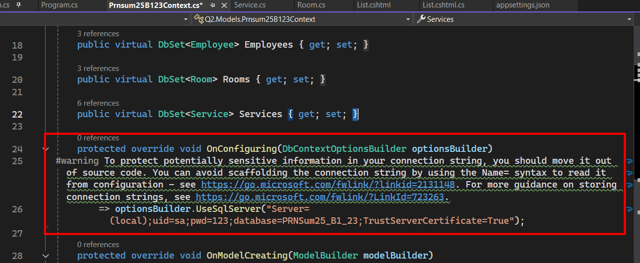
Hoặc thay bằng:
if (!optionsBuilder.IsConfigured) { var config = new ConfigurationBuilder().AddJsonFile("appsettings.json").Build(); optionsBuilder.UseSqlServer(config.GetConnectionString("MyCnn")); }

Program.cs
using Microsoft.EntityFrameworkCore;
using Q2.Models;

var builder = WebApplication.CreateBuilder(args);

builder.Services.AddRazorPages();

builder.Services.AddDbContext<Prnsum25B123Context>(options =>
options.UseSqlServer(builder.Configuration.GetConnectionString("MyCnn")));

var app = builder.Build();

app.MapRazorPages();

app.Run();

Properties/lauchSettings.json
Thêm: "launchUrl": "Employee/List", (theo đề bài)
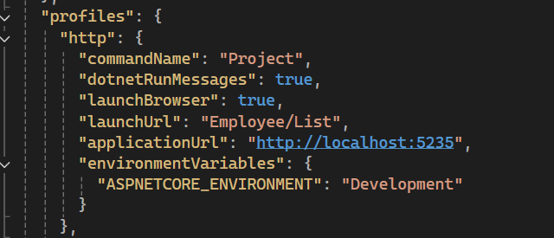

Trước khi nộp bài chạy lệnh:
dotnet publish -c release -o ./[QuestionNumber_NameStudentCode]
dotnet publish -c release -o ./[Q1_anhtthhe181647]
sau đó nộp folder Q1/Q2
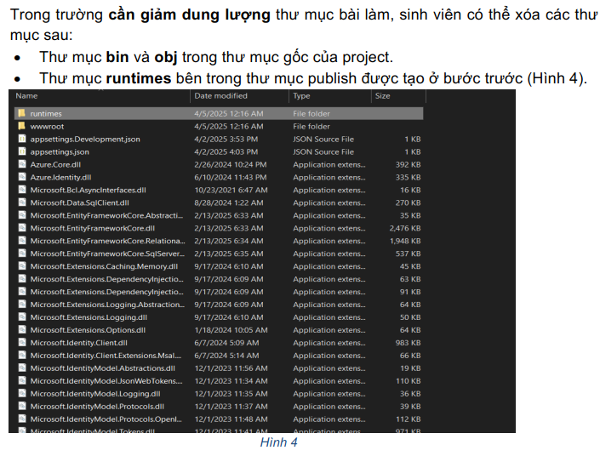

Delete object có 2 pk:
public IActionResult Delete(int movieId)
{
var current = _dbContext
.Movies
.Include(m => m.Stars)
.Include(m => m.Genres) // phải include Genres
.FirstOrDefault(m => m.Id == movieId);

if (current == null) return NotFound();

current.Stars.Clear();
current.Genres.Clear();

_dbContext.SaveChanges();
_dbContext.Movies.Remove(current);

_dbContext.SaveChanges();
return RedirectToAction("Director_Movie");
}

Join String: @string.Join(",", m.Stars.Select(s => s.FullName))

Gọi method OnGetDelete:
<a href="/Movies/Director_Movie?handler=Delete&MovieId=@(m.Id)" id="btn_delete_@(m.Id)"> Delete </a>

Format
