**NUMBER OF QUESTIONS BY CATEGORY (BAR)**

**PERCENTAGE OF QUESTIONS BY CATEGORY (PIE)**

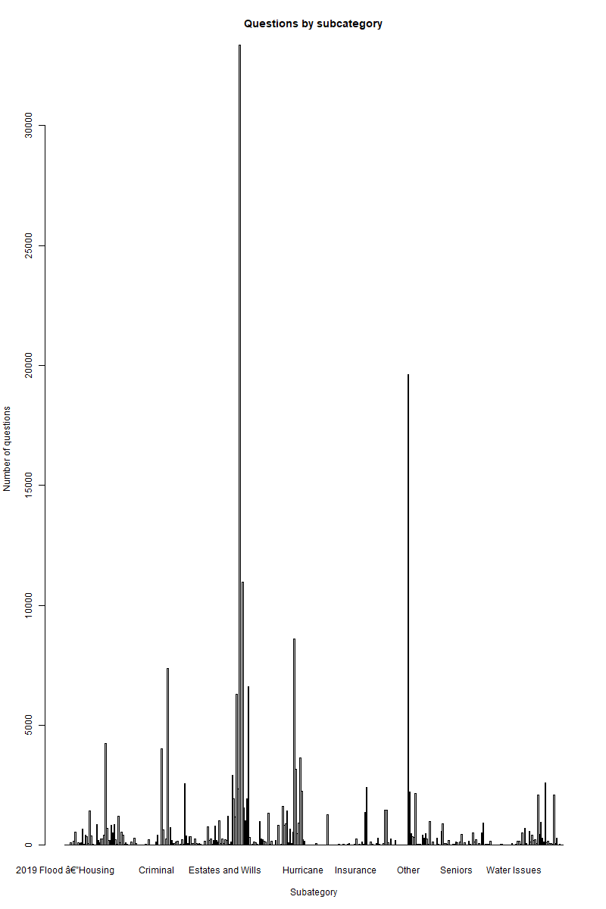

**NUMBER OF QUESTIONS BY SUBCATEGORY (BAR)**

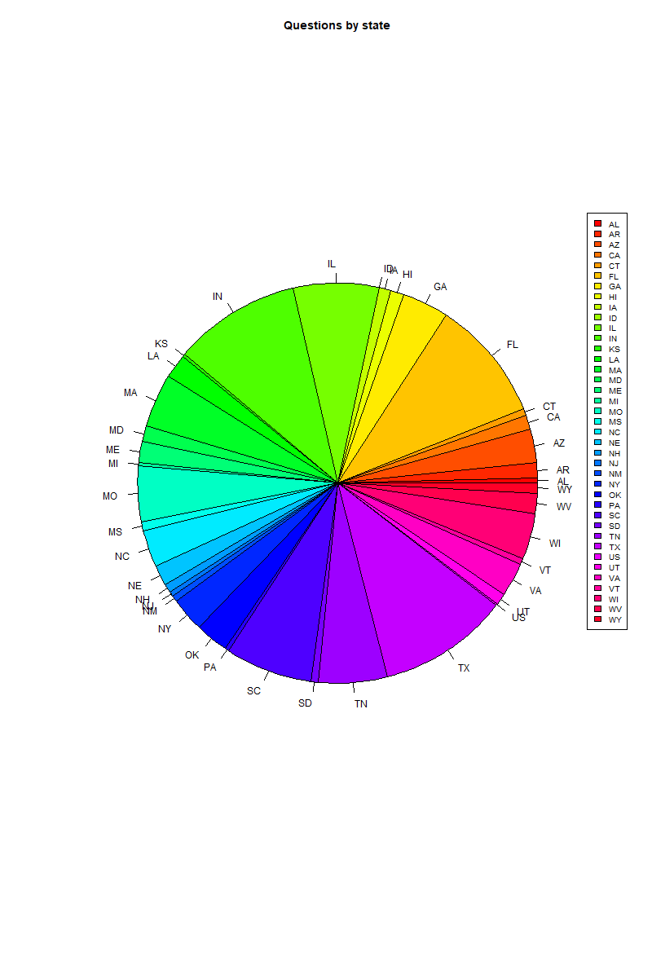

**PERCENTAGE OF QUESTIONS BY STATE (PIE)**

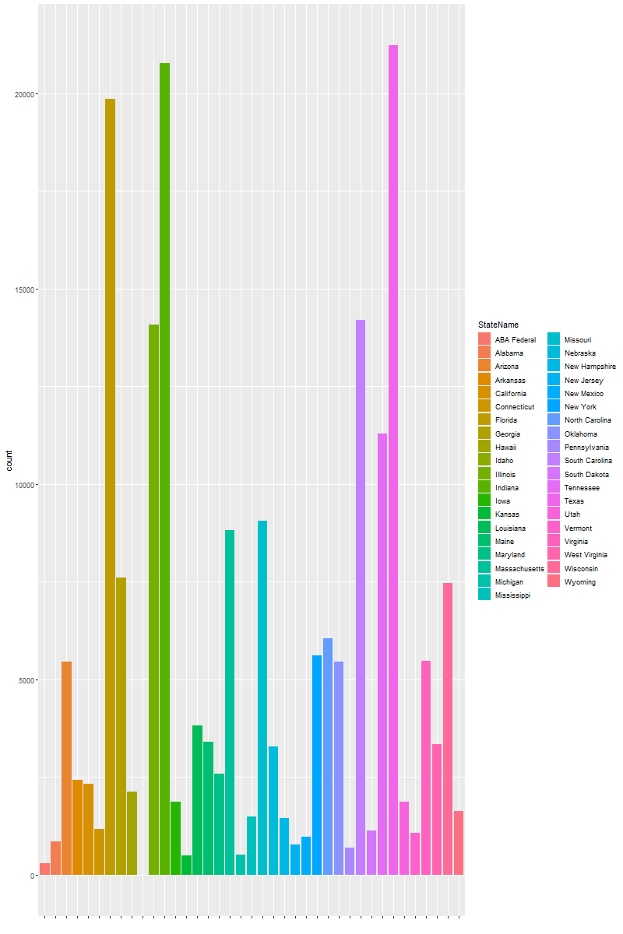

**NUMBER OF QUESTIONS BY STATE (BAR)**

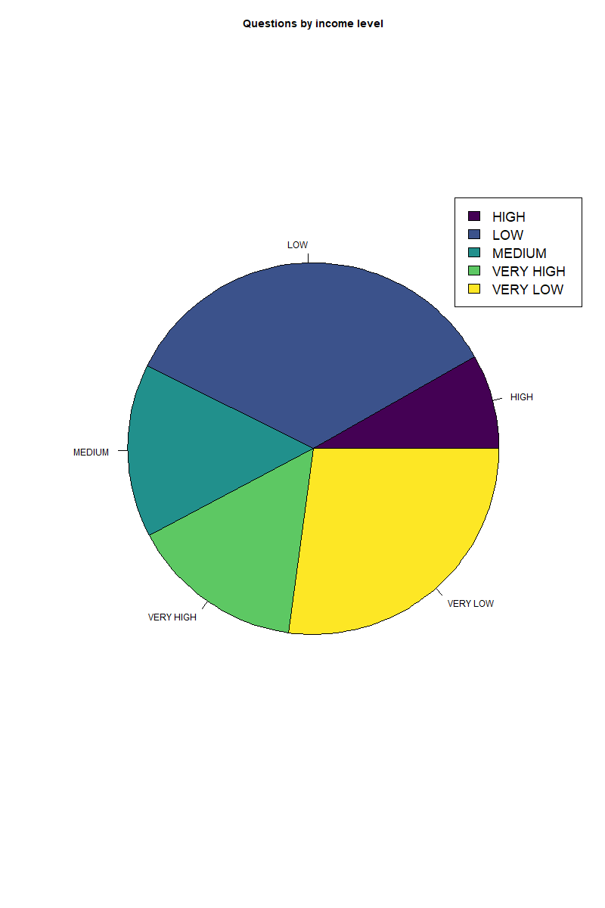

**PERCENTAGE OF QUESTIONS BY INCOME LEVEL (PIE)**

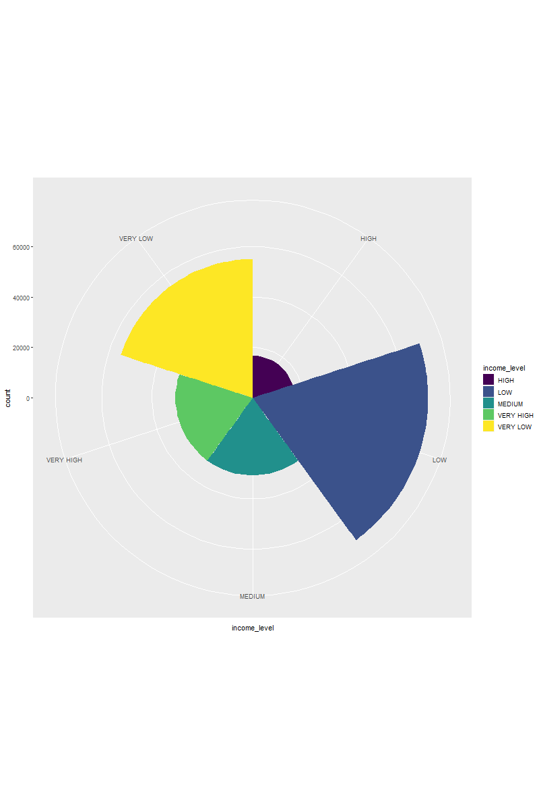 **PERCENTAGE OF QUESTIONS BY INCOME LEVEL (PIE)**

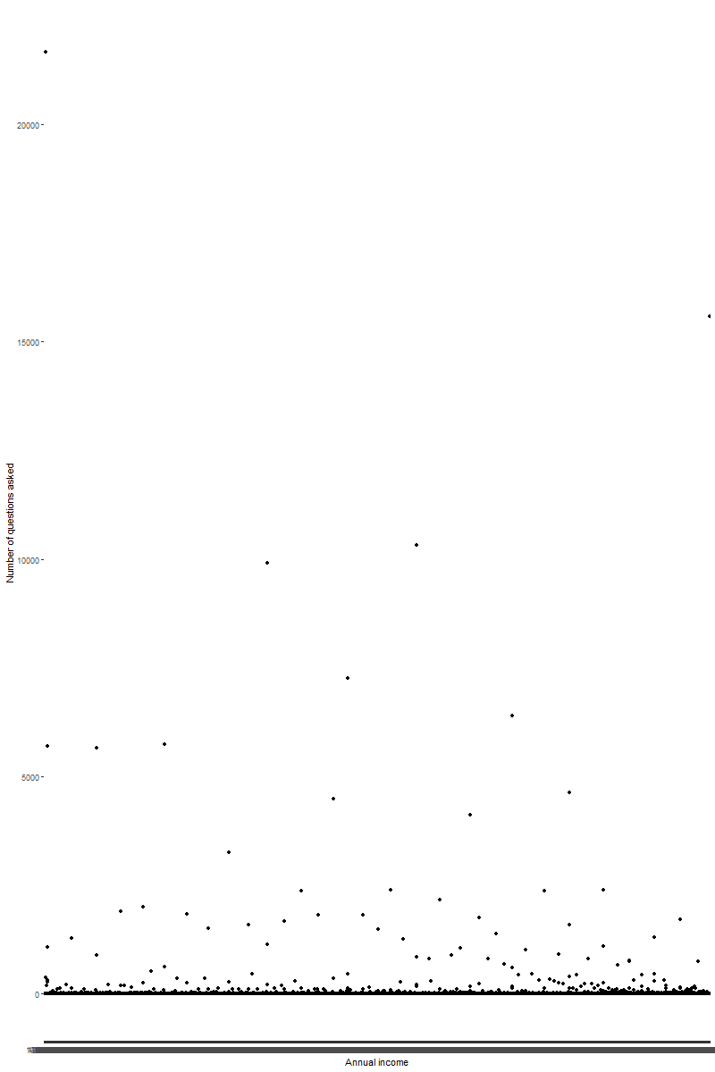

**NUMBER OF QUESTIONS BY ANNUAL INCOME (SCATTERPLOT)**

**PAIRWISE TESTS**

**NUMBER OF QUESTIONS BY INCOME LEVEL**

|  |  |  |  |  |
| --- | --- | --- | --- | --- |
| **P-VALUE** | **VERY HIGH** | **HIGH** | **MEDIUM** | **LOW** |
| **HIGH** | **0.97** | **-** | **-** | **-** |
| **MEDIUM** | **0.79** | **0.85** | **-** | **-** |
| **LOW** | **0.94** | **0.98** | **0.82** | **-** |
| **VERY LOW** | **0.36** | **0.42** | **0.22** | **0.24** |

**Small P-VALUE -> Small prob of similarity in # questions.**

**Large P-VALUE -> High prob of similarity in # questions.**

**P-VALUE increases -> Higher prob of similarity in # questions.**