A – Can – Computer – Devices that – For what
A computer monitor is an example of which type of device? Output device
A LAN is an example of what type of system?
A local network
A microphone falls under which category of devices? Input device
A multi-function printer is considered what type of device? Input and output device
A photocopier is an example of what type of device? Input and output device
Can you give an example of an input device? Keyboard
Can you identify a hardware component of a computer? CPU
Can you provide an example of an input device? Keyboard
Can you provide an example of application software? Microsoft Word
Computer speakers are examples of what type of devices? Output devices
Devices that interpret and process user data for the computer are known as what? Processing devices
For what purpose is a database mainly utilized within computing? Storing and organizing data
HOW
-How are individuals who work in the field of Information Technology commonly referred to? IT professionals
-How do companies today use encoding to secure information? By converting data into a coded format
-How does a heatsink function within a computer system? It dissipates heat from the CPU
-How does quality assurance contribute to software development? By testing and ensuring software meets quality standards
-How is a game controller typically used?
To control movement in video games
-How is a joystick commonly used in computing? To control movement in games
-How is an icon understood in the context of computing? A small graphical representation of a program or file
-How is code defined in programming terms?
A set of instructions written in a programming language
-How is the term "join network" defined in the realm of wireless networks?Connecting to an available wireless network
-How many buttons and additional features does a typical computer mouse have? Two buttons and a scroll wheel
-How would you define a handheld PC? A small, portable computer with similar functions to a desktop PC
-How would you define a shortcut in the context of computing? A quick way to access a file or program
-How would you define software? A set of instructions that tell a computer what to do
-How would you define the action of "dragging" in the context of digital interactions? Moving an object by clicking and holding the mouse
-How would you describe a computer that acts as the central hub for data and resources in a network? Server
-How would you describe a handheld device designed for personal information management, such as contact lists and appointments? PDA
-How would you describe data processing? Collecting, organizing, and analyzing data
-How would you describe software maintenance? The process of updating and fixing software
If – In – Keyboards – On a laptop – PDA – Printers – Sometimes
-If a network does not use cables, what type of network is it? Wireless network
-If multiple devices are unable to connect to the internet, what might be the probable cause?
An issue with the router or ISP
-If you want to expand a computer's capabilities, what can you install? Expansion card
-In a computer, which component distributes power to all parts of the system?
Power Supply Unit (PSU)
-In a graphical user interface, what does a shortcut usually represent? A link to quickly access a file, program, or folder
-In a graphical user interface, what does the term "minimize" mean? To reduce a window to the taskbar without closing it

-In a graphical user interface, what is the function of a pointer? To navigate and interact with on-screen elements
-In a home network, what does the router typically assign? Private IP addresses
-In a home network, which device is often supplied by the ISP to connect to the internet? Modem
-In computer hardware terminology, what is meant by the term "tower"? Desktop computer case
-In computer hardware, what does the acronym GPU represent? Graphics Processing Unit
-In computing, what does the acronym DSL represent? Digital Subscriber Line
-In computing, what does the term "desktop" signify? The main screen where icons and windows are displayed
-In computing, what does the term "online" mean? Connected to a network or the internet
-In display technology, what does the term LCD mean? Liquid Crystal Display
-In information processing, what does the term "encode" signify? Converting information into a different format for security or storage
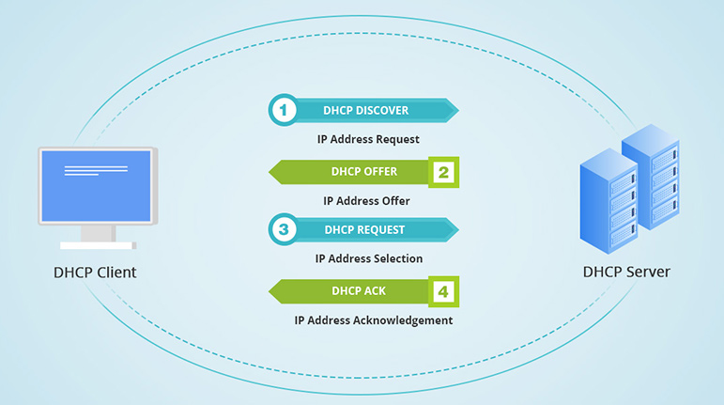
-In office equipment, what does the abbreviation "MFP" stand for? Multi-Function Printer
-In terms of data transmission, what does "broadband" mean? High-speed internet connection
-In the context of computers, what does "peripheral device" mean? A device connected to a computer to add functionality
-In the context of online services, what does "sign up" mean? Creating a new account
-In UX design, what is the purpose of creating a prototype? To test and refine the design before final implementation
-In what situation would a WAN be the most appropriate choice? Connecting networks across long distances
-Keyboards and mice are examples of what kind of devices? Input devices
-On a laptop, what device performs a function similar to that of a mouse on a desktop? Touchpad
-PDA: Personal Digital Assistant
-Printers, monitors, and speakers are examples of what type of devices? Output devices
-Sometimes it is necessary to do what to a network to get it to function properly? Restart it



WHAT (1)
-What are some common uses of a workstation computer? 3D rendering and engineering simulations
-What are the primary duties of a Mobile App Developer? Designing and creating applications for smartphones and tablets
-What are the primary duties of an IT project manager? Planning, organizing, and overseeing IT projects
-What aspects does a Game Developer emphasize in their work? Gameplay, graphics, and user experience
-What category of device does a touch screen belong to? Input and output device
-What component is designed to cool the processor in a computer system? Heatsink
-What component is needed for a computer to operate? Power Supply
-What component is typically used in computer systems to prevent overheating? Cooling Fan
-What component is used to cool the CPU and prevent it from overheating? Cooling Fan
-What component provides temporary storage for data that the CPU is currently using? RAM
-What component translates digital data into analog signals for communication over telephone lines? Modem
-What could be a potential drawback of using a static IP address? It can increase security risks
-What defines a good user interface? Simplicity, ease of use, and responsiveness
-What device allows sound from the external environment to be input into a computer? Microphone
-What device allows users to control the on-screen cursor? Mouse
-What device allows users to control the on-screen cursor? Mouse
-What device captures images and sends them to a computer? Webcam
-What device creates a printed copy of digital documents or images? Printer
-What device do employees need to do before using a limited number of workstations in the company? Log in with their credentials
WHAT(2)
-What device do I typically use for work while traveling by plane? Laptop
-What device do we use to input information into a computer? Keyboard
-What device is commonly used for entering data into a computer? Keyboard
-What device is commonly used to share a single internet connection across multiple devices in a home or office? Router
-What device is necessary to create a Wi-Fi network in a home or office? Router
-What device is often used for video conferencing? Webcam
-What device is often used to display visual information during presentations or meetings? Projector
-What device is typically connected directly to the internet? Router
-What device is typically used for voice communication over the internet? Microphone
-What device is typically used to extend the range of a Wi-Fi network in a home or office? Wi-Fi extender
-What device is used for making and receiving calls? Mobile phone
-What device is used for making and receiving calls? Mobile phone
-What device is used to capture and input images into a computer? Scanner
-What device is used to capture sound on a computer? Microphone
-What device is used to display images on a computer? Monitor
-What device is used to input data into a computer? Keyboard
-What device is used to make a printed copy of digital documents or images? Printer
-What device is used to scan and interpret barcode data? Barcode reader
-What device provides users with immersive experiences in virtual environments? VR headset
-What does a heatsink do in maintaining the CPU's temperature? It absorbs and disperses heat

-What does it mean when you are online? Connected to the internet
WHAT(3)
-What does the abbreviation ISP mean? Internet Service Provider
-What does the abbreviation PAN represent? Personal Area Network
-What does UI stand for in design terminology? User Interface
-What feature is commonly shared between laptops and smartphones? Touchscreen capability
-What function does a hard disk drive (HDD) serve? Storing digital data permanently
-What function does a hard drive serve in a computer system? Store files and programs
-What function does a switch serve within a network? It connects devices and directs data to the right destination
-What function does the Power Supply Unit (PSU) serve within a computer? Converts electricity to a usable form for the computer

-What function does a VR headset in a computer system? To provide an immersive virtual experience
-What is a characteristic feature of dynamic IP addresses? They change periodically
-What is a compact, handheld computer used for tasks like scheduling and managing contacts? PDA (Personal Digital Assistant)
-What is a defining characteristic of a LAN? It connects devices within a limited geographical area
-What is a device used for making and receiving calls? Mobile phone
-What is a handheld PC? A small, portable computer with similar functions to a desktop PC
-What is a key benefit of using a switch instead of a hub in a network? It directs data to the correct device
-What is a key difference between laptops and desktop computers? Laptops are portable, while desktops are not
-What is a possible disadvantage of using dynamic IP addresses? They can change, making remote access difficult



WHAT(4)
-What is a potential drawback of opting for a static IP address? It may increase security vulnerabilities
-What is a quick, short-term memory source in a computer? RAM
-What is a typical characteristic of a dial-up modem connection? Slow speed and uses telephone lines
-What is a typical feature of a wired router? It requires Ethernet cables to connect devices
-What is smaller than a laptop but still includes a keyboard? Netbook
-What is the core objective of an IT Security Specialist? Protecting IT systems from cyber threats
-What is the fundamental goal of information security? Protecting data from unauthorized access
-What is the function of the Recycle Bin in a Windows operating system? To temporarily store deleted files before permanent removal
-What is the key responsibility of a database administrator? Managing and maintaining databases
-What is the main advantage of using dynamic IP addresses instead of static IP addresses? They are automatically assigned and change over time
-What is the main focus of a quality assurance (QA) tester? Ensuring software functions correctly and is free of errors
-What is the main function of a barcode reader? To scan and interpret barcode data
-What is the main function of a finger recognition system? To identify users based on their fingerprints
-What is the main function of a graphics tablet? To allow digital drawing and handwriting input
-What is the main function of a hard drive within a computer system? Store files and programs
-What is the main function of a touch screen? To allow direct interaction with the display
WHAT(5)
-What is the main goal of a User Interface (UI)? To enhance user interaction and experience
-What is the main purpose of a digital camera? To capture and store images digitally
-What is the main purpose of a face recognition system? To identify individuals based on facial features
-What is the main purpose of a mainframe computer? Handling massive amounts of data for large organizations
-What is the main purpose of a PAN? To connect personal devices within a short range
-What is the main purpose of a private IP address? To identify devices within a local network
-What is the main purpose of a scanner in computer systems? To convert physical documents into digital format
-What is the main purpose of an output device in a computer system? To display or produce results from the computer
-What is the main purpose of computer storage? Storing and retrieving digital data
-What is the main purpose of the CMOS battery in a computer? To power the BIOS memory
-What is the main purpose of word processing software? Creating and editing documents
-What is the main role of a modem within a computer network? To convert digital signals to analog and vice versa
-What is the main role of a network administrator? Managing and maintaining network systems
-What is the main role of a Technical Manager? Overseeing technical projects and IT staff
-What is the main role of the Central Processing Unit (CPU) in a computer? Processing instructions and performing calculations
-What is the name of a slotted board containing circuits and ports? Motherboard
WHAT(6)
-What is the primary function of a graphics tablet? To allow digital drawing and handwriting input

-What is the primary purpose of a mainframe computer? Handling massive amounts of data for large organizations
What is the primary purpose of a workstation computer? High-performance tasks like CAD and video editing
-What is the primary role of a folder within a computer system? To organize and store files efficiently
-What is the purpose of the spinning blades inside a computer? To cool down internal components
-What is the purpose of using folders in a computer system? To organize and store files efficiently
-What is the reverse process of encoding? Decoding
-What is the typical operational range of a PAN? A few meters
-What is the type of computer known for its large-scale data processing capabilities, often used in business and government organizations? Mainframe computer
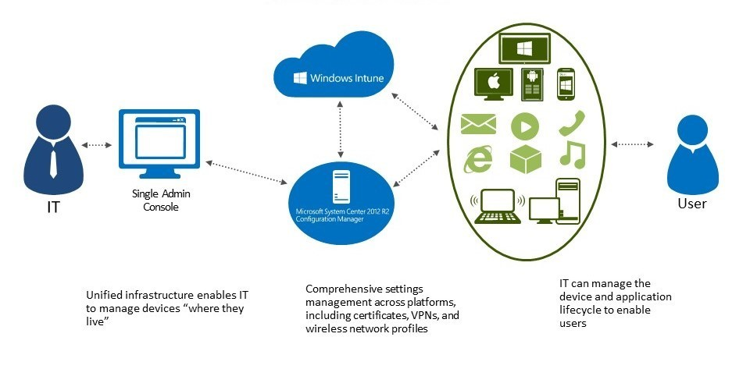
-What kind of computer is a high-speed machine used by a single user with more memory than a standard personal computer? Workstation
-What kind of computer is built for easy portability? Laptop
-What kind of computer is commonly intended for personal use, including a monitor, keyboard, and CPU? Desktop computer
-What kind of computer is often used for graphic design, video editing, and other demanding tasks? Workstation
-What kind of computer is specifically designed for tasks like graphics and video editing, offering high-performance features for multimedia applications? Workstation
-What kind of computer is typically used for scientific research, simulations, and complex calculations? Supercomputer



WHAT(7)
-What machine is considered the most powerful in the world? Supercomputer
-What must be set up correctly for a router to operate effectively? Network settings
-What responsibilities do IT professionals have regarding hardware and software upkeep, and handling technical problems? Maintenance, troubleshooting, and upgrades
-What role does a heatsink play in maintaining the CPU's temperature? It absorbs and disperses heat
-What role does an input device play in a computer system? To send data into the computer
-What role does the sound card play in a computer system? Processes and outputs audio
-What services does an IT consultant generally offer? Providing expert advice on IT strategies and solutions
-What should be your first step when addressing internet connection problems? Restart the router and modem
-What should frequent travelers use to keep their laptop safe? Protective laptop case
-What tasks does a help desk technician usually handle? Providing technical support and troubleshooting issues
-What term describes antennas that can be adjusted or repositioned to enhance signal reception in a wireless network? Adjustable antennas
-What term describes the internal experience a user has when interacting with a product or system? User Experience
-What term is commonly used to describe devices that can both input and output data? Input/output devices
-What term is used for the information or guidance given to users in response to their actions? Feedback
-What term is used for the software that enables computers to operate effectively? Operating System
What(8)
-What term typically refers to high-speed internet connections with significant bandwidth? Broadband
-What type of computer is commonly used in large organizations to manage network resources and provide services to other computers? Server
-What type of computer is commonly used in large organizations to manage network resources and provide services to other computers? Server
-What type of computer is known for its large-scale data processing capabilities, often used in business and government organizations? Mainframe computer
-What type of computer is specifically designed for tasks like CAD (Computer-Aided Design)? Workstation
-What type of computer is typically used by engineers and designers for tasks like CAD (Computer-Aided Design)? Workstation
-What type of display device operates without a keyboard? Tablet
-What type of internet connection offers high speeds and uses fiber-optic cables? Fiber-optic internet
-What type of IP address does an ISP assign to identify a device on the Internet? Public IP address
-What type of IP address is better suited for hosting a website or online service? Static IP address
-What type of IP address is designated for internal use and cannot be routed over the Internet? Private IP address
-What type of IP address is generally more suitable for residential use? Dynamic IP address
-What type of IP address is ideal for easy communication over the internet? Public IP address
-What type of memory provides temporary storage for data that the CPU is currently using? RAM
-What type of modem is often used for high-speed internet via cable television? Cable modem



What(9) – WHEN - WHERE – WHICH(1)
-What type of modem was commonly used in the past to connect to the intrnet through telephone lines? Dial-up modem
-What areas are typically connected within a MAN? A city or metropolitan area
-When an IP address is assigned automatically by a DHCP server, what type of IP is it? Dynamic IP address
-Where are shortcuts typically placed within a computer's interface? Desktop
-Where do you click to select various commands on a computer? Menu bar
-Where is data typically stored within a computer? Hard Drive
-Which component converts digital signals from the computer into images visible on the monitor? Graphics Card
-Which component is needed for a computer to operate? Power Supply
-Which component is used to cool the CPU and prevent it from overheating? Cooling Fan

-Which component provides temporary storage for data that the CPU is currently using? RAM
-Which device allows users to control the on-screen cursor? Mouse
-Which device can establish a local network and connect it to the internet? Router
-Which device creates a printed copy of digital documents or images? Printer
-Which device is commonly used for entering data into a computer? Keyboard
-Which device is typically connected directly to the internet? Router
-Which device is typically used for voice communication over the internet? Microphone
-Which device projects images onto a large screen or surface? Projector
-Which essential component is needed for a computer to operate? Power Supply
-Which function is not typically performed by an MFP? Playing music
-Which kind of IP address remains constant over time? Static IP address
-Which part is commonly found on a computer mouse? Scroll Wheel

WHICH - WHY
-Which part of the human body is used by a face recognition system? Face
-Which part of the body is used in a finger recognition system? Finger
-Which part of the motherboard temporarily holds data that will be processed by the CPU? RAM
-Which protocol is frequently used to assign IP addresses dynamically within a network? DHCP
-Which term describes antennas that can be adjusted or repositioned to enhance signal reception in a wireless network? Adjustable antennas
-Which term describes the internal experience a user has when interacting with a product or system? User Experience
-Which type of internet connection offers high speeds and uses fiber-optic cables? Fiber-optic internet
-Which type of IP address does an ISP assign to identify a device on the Internet? Public IP address
-Which type of IP address is better suited for hosting a website or online service? Static IP address
-Which type of IP address is designated for internal use and cannot be routed over the Internet? Private IP address
-Which type of IP address is ideal for easy communication over the internet? Public IP address
-Which type of memory provides temporary storage for data that the CPU is currently using? RAM
-Why is a graphical user interface (GUI) important in computing? It makes interaction with the computer easier and more intuitive
-Why might dynamic IP addresses be beneficial in a large network? They simplify address management

