1. After I graduate from university, I want to work in Can Tho city.
2. Although she tried very hard, she did not pass the exam.
3. As soon as the exam is over, I will travel to Da Lat city.
4. As soon as the exam is over, I will go for a walk to relax.
5. Because the security guard slept, a bike was stolen.
6. Before you go to the beach, you should learn to swim.
7. Due to the terrible weather, I could not go out.
8. I always try my best to study in order that I can find a high salary.
9. I do not want to go to the movies because I am very tired.
10. I will not get married until she agrees.
11. I will not talk her though she said “sorry” to me.
12. If only I had a lot of money, I would buy a modern car.
13. In case it rains, I will take an umbrella.
14. It is raining so I can not go to school.
15. John said nothing when he was playing games.
16. Lina listens to music whenever she feels sad.
17. Many children do not want to sleep alone because they feel unsafe.
18. My friends studied very hard so they passed the exam.
19. My parents were very happy when I passed B1 exam.
20. My wife loves cats but I love dogs.
21. Unless you come with me, I will stay at home.
22. When he appeared on the stage, he was very attractive.
23. Whenever I feel tired, I will go to sleep.
24. Whenever I have money, I will go shopping.
25. Whenever she watches that movie, she always cries.
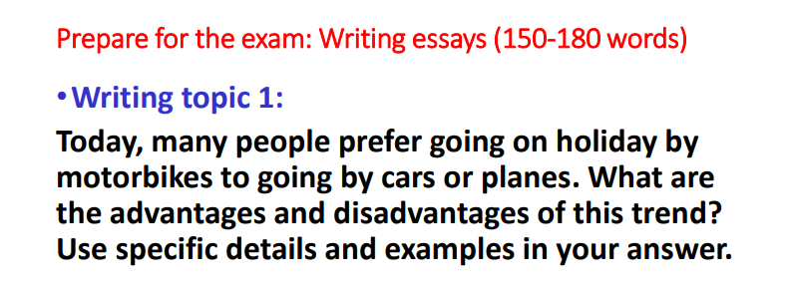
Nowadays, many people like going on holiday by motorbikes. This trend has some advantages and disadvantages. They will be discussed in the following paragraphs.
There are some advantages of going on holiday by motorbikes. Firstly, travelling by motorbikes is very convenient because of their own schedule. They can start or stop whenever they like to take photos or go sightseeing. Secondly, travelling by motorbikes has more effective costs than travelling by planes or cars. They almost do not need to spend any other expenses except for gas and motorbikes maintenance.
However, travelling by motorbikes also has some disadvantages. Firstly, there is the risk of accidents because people often get tired during their riding hours. Therefore, it is necessary for them to make many stops to rest which takes much time. Secondly, there is also the risk of vehicle damage due to traveling a long distance.
In conclusion, travelling by motorbikes is both advantageous and disadvantageous. This trend is only suitable for young and healthy people, therefore, people should consider carefully before choosing to travel by motorbikes.
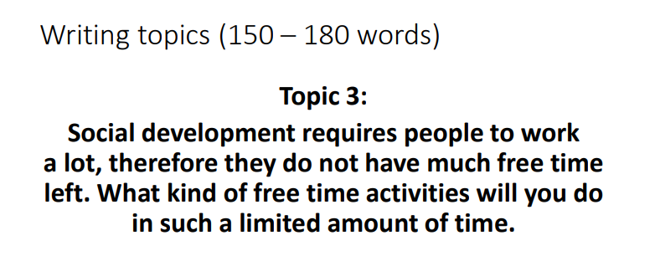
In the modern life, people spend much time for work. As a result, they do not have time for leisure. This essay will offer some useful free time activities.
Firstly, I can play sports. Because playing sports can help me stay healthy and keep fit. Besides, playing sports helps me relax after a tiring day at work. I can play sports like swimming, running or yoga. Secondly, reading books is a good way to relax. I like reading books because it is a useful and interesting hobby. I can find a lot of knowledge of all areas that I need. Finally, going out with friends is very important to enjoy life. I can hang out with our friends, do some interesting activities like going to the cinema or go shopping. It helps me feel comfortable and relax after studying hard.
In conclusion, these free time activities can help you relax in such a limited amount of time. You should balance working time and relaxing time to have a happy life.

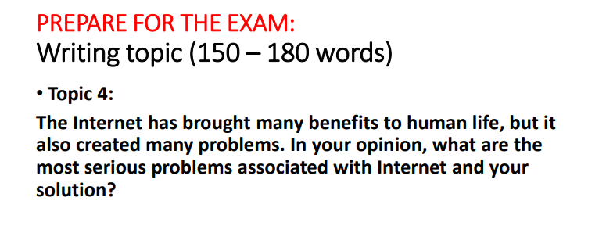
Nowadays, the Internet has brought many benefits to human life, but it also created many problems. This essay will discuss some serious problems associated with the internet and solutions.
The first problem is time consuming. People usually spend more and more time playing online games or chatting on the internet, so they do not have enough time to do other things. For the solution, people should do other outdoor activities with their family or friends. The second problem is the risk of losing personal information. People’s personal details can be stolen on the internet by hackers such as banking details to get money, ID card details to do illegal activities. The solution of this problem is installing security software to protect your information. Last problem is very important that children may access to bad websites with pornographic photos, violence and crime. Thus, the solution is that parents can put a parenting software or blacklist software on the computer.
In conclusion, there are many serious problems associated with the internet. If people know how to use it correctly, there will be many benefits for them activities.

