**DQMusicBox: How to prepare the micro-SD card image**

29 November 2015

# Introduction

This document describes how to create a DQMusicBox system image – a .img file. I (Ross) am probably the only person that needs this document. Mostly people making a DQMusicBox will use the fruit (the .img file) of the process described here, but you don’t need to create your very own .img file unless you really want to.

# No warranty

USE THESE DQMUSICBOX PLANS AND SYSTEM AT YOUR OWN RISK. THE DQMUSICBOX PLANS ARE PROVIDED AS IS WITHOUT WARRANTY OF ANY KIND EITHER EXPRESSED OR IMPLIED, INCLUDING, BUT NOT LIMITED TO, THE IMPLIED WARRANTIES OF MERCHANTABILITY AND FITNESS FOR A PARTICULAR PURPOSE. THE ENTIRE RISK AS TO THE QUALITY AND PERFORMANCE OF THE PLANS AND SYSTEM IS WITH YOU. SHOULD THE PLANS OR SYSTEM PROVE DEFECTIVE, YOU ASSUME THE COST OF ALL NECESSARY SERVICING, REPAIR OR CORRECTION. IN NO EVENT WILL ANY PARTY BE LIABLE TO YOU FOR DAMAGES, INCLUDING ANY GENERAL, SPECIAL, INCIDENTAL OR CONSEQUENTIAL DAMAGES ARISING OUT OF THE USE OR INABILITY TO USE THE PLANS OR SYSTEM.

# Prepare the disk image

This is a record of how I created the disk image. You only need to read this information if you wish to do your own Raspian configuration.

## Install Raspbian on 8GB micro-SD card

Install Raspbian (not via NOOBS) i.e. follow these instructions: <https://www.raspberrypi.org/downloads/raspbian/>. I installed Raspbian Wheezy dated 2015-05-15. I used the [Win32 Disk Imager](http://sourceforge.net/projects/win32diskimager/) (free) to write the disk image to the micro-SD card, and that worked well.  
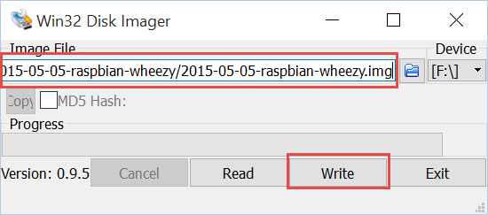

## Reconfigure micro-SD card partitions

For convenience, we want to keep the music on a FAT32 partition. So I expanded the small boot partition to 3.7GB. I used [Paragon Partition Manager](http://www.paragon-software.com/home/pm-personal/eshop.html) (free) on Windows:

1. Move the Raspbian partition so it is last. Don’t otherwise change the partition, just move it. I right-clicked on Ext4 partition, chose “Move/Resize Partition” and increased the “free space before” to the 2,700MB. As you can see, this in effect puts unallocated space before the Ext4 partition. Click Yes to close the dialog.  
   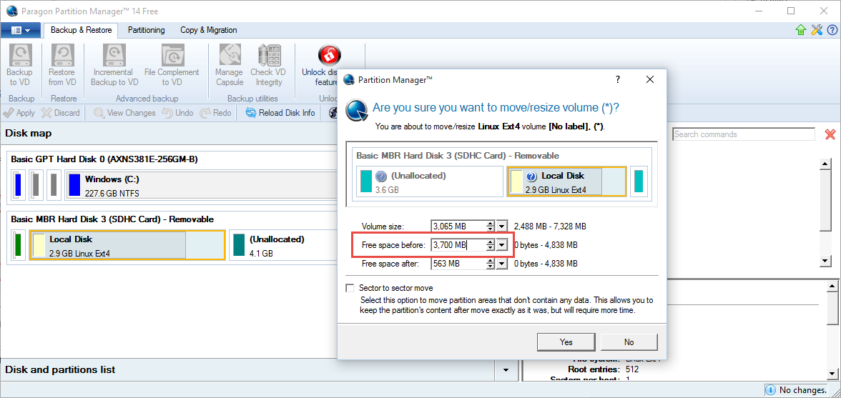
2. Apply the change i.e. click on the green check mark. Make some tea – this might take an hour. 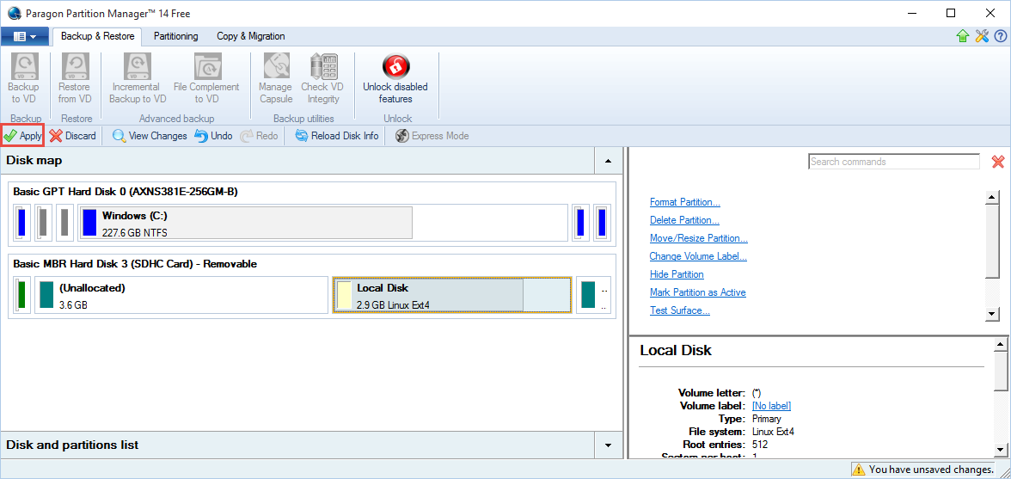
3. Increase the size of the boot partition with “Move/Resize Partition” so it uses all of the unallocated space.  
   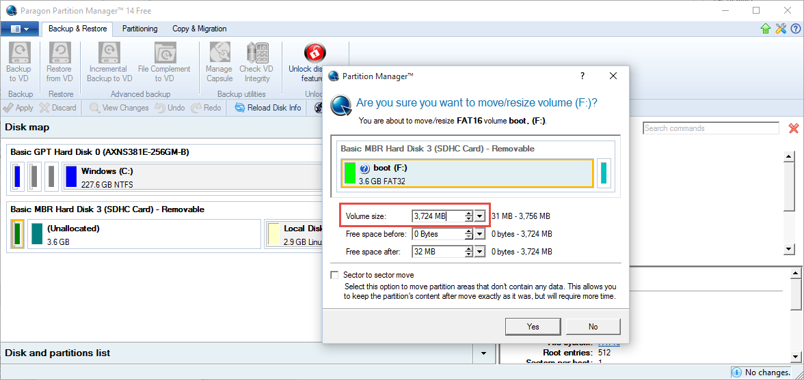
4. Apply the changes.  
   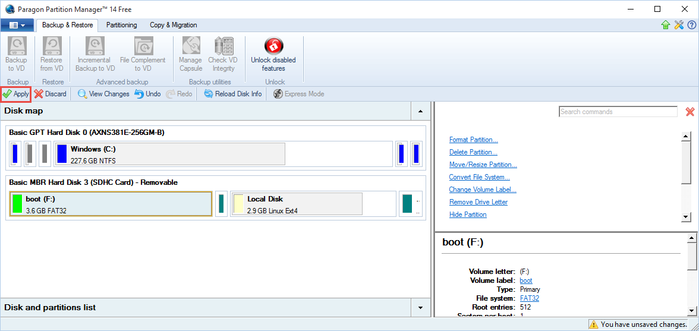

## Make a folder for music in /boot on the micro-SD card

Make a ‘dqmusicbox’ top-level folder in /boot on the micro-SD card  
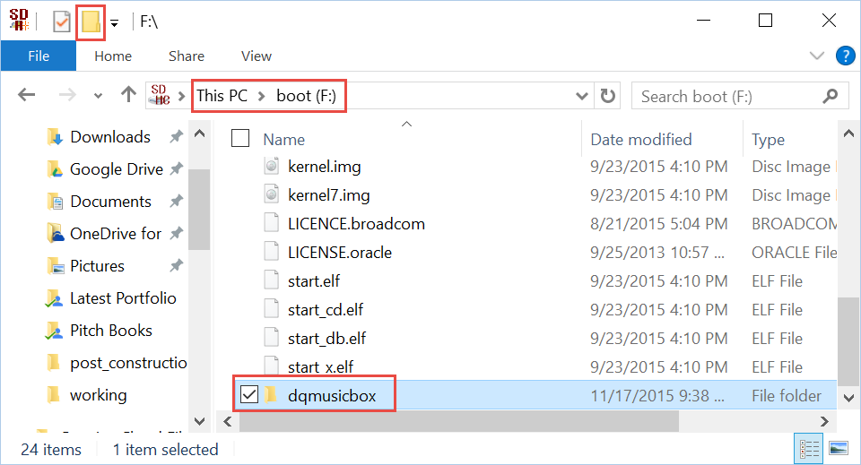

Make a ‘music’ subfolder in ‘dqmusicbox’  
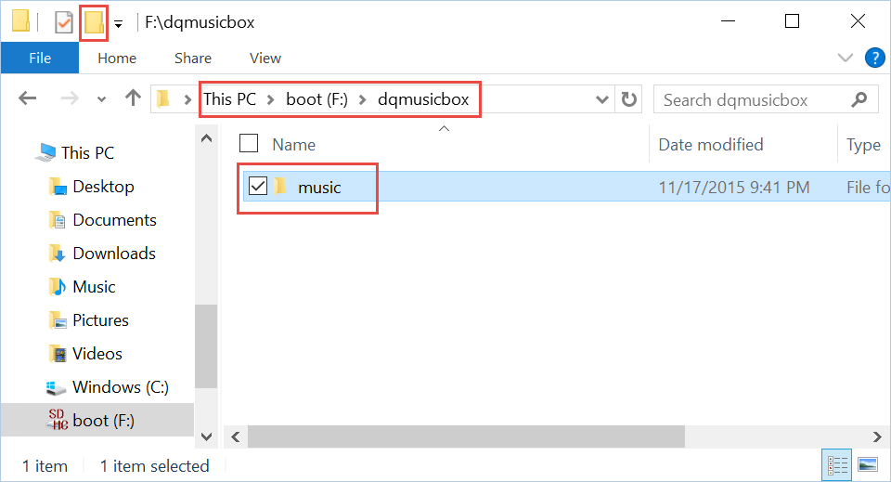

## Copy test tracks (music) to the micro-SD card

The DQMusicBox github repository has test tracks (MP3 files). Copy these to the micro-SD card.  
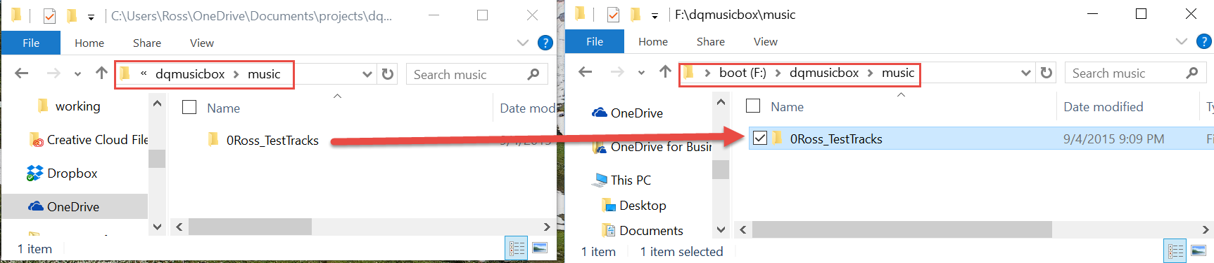

## Boot Raspbian

Move the micro-SD card to the Pi, boot Raspbian. Then continue with the instructions below on the Pi.

## Change hostname to dqmb

Use raspi-config (advanced options) to change the hostname to ‘dqmb’.

|  |
| --- |
| sudo raspi-config |

## Install Samba

We won’t use Samba for file sharing, but Samba will make it easier to connect by name (‘dqmb’).

|  |
| --- |
| sudo apt-get install samba  sudo apt-get install samba-common-bin  sudo nano /etc/samba/smb.conf  Change workgroup to dqmb |

## Set the USB audio device as the default

Linux sound is wonderfully complicated. Below is the simplest method that I have found for setting the default audio device to be USB audio.

First, disable the built-in sound device so the USB audio device is the only remaining audio device:

|  |
| --- |
| sudo nano /etc/modules  Change: snd-bcm2835 To: #snd-bcm2835 |

Now remove the default override of USB audio:

|  |
| --- |
| sudo nano /etc/modprobe.d/alsa-base.conf  Change: options snd-usb-audio index=-2 To: #options snd-usb-audio index=-2 |

Don’t reboot yet.

Start the X Server if you haven’t already.

|  |
| --- |
| startx  Then exit the X server (Menu .. Shutdown .. Logout) |

While the above simplifies the audio configuration, it does cause a problem for a panel item in the startx desktop of recent versions of Raspbian. To remove that unhappy audio control panel item, comments out the five lines associated with the volumealsa plugin:

|  |
| --- |
| sudo nano ~/.config/lxpanel/LXDE-pi/panels/panel  #Plugin { # type=volumealsa # Config { # } #} |

Reboot. Then verify with aplay –l that the USB audio device is the only device shown. For more information above changes: [disable the built-in sound device](https://www.raspberrypi.org/forums/viewtopic.php?f=66&t=18573), [remove default override of USB audio](http://plugable.com/2014/11/06/how-to-switch-to-usb-audio-on-raspberry-pi), [panel](https://www.raspberrypi.org/another-raspbian-desktop-user-interface-update/)

## Install VLC (music player)

|  |
| --- |
| sudo apt-get install vlc |

## Install/clone dqmusicbox, enable

|  |
| --- |
| cd ~  git clone <https://github.com/rosswesleyporter/dqmusicbox/>  sudo chmod 755 ~/dqmusicbox/bin/dqmusicbox.py |

## Install Python bindings for VLC

|  |
| --- |
| Download vlc.py from <https://wiki.videolan.org/Python_bindings>  chmod 755 ~/dqmusicbox/bin/vlc.py |

## Add shell script to automatically start the musicbox

|  |
| --- |
| sudo cp ~/dqmusicbox/bin/dqmusicbox.sh /etc/init.d  sudo chmod 755 /etc/init.d/dqmusicbox.sh  sudo update-rc.d dqmusicbox.sh defaults |

For more information, see Stephen Christopher Phillips’ [terrific page](http://blog.scphillips.com/posts/2013/07/getting-a-python-script-to-run-in-the-background-as-a-service-on-boot/).

## Reboot

|  |
| --- |
| sudo reboot |

## Shutdown

Provided that the reboot went well, shutdown so we can remove the micro-SD card.

|  |
| --- |
| sudo shutdown –h now |

## Use Win32DiskImager to create the master image

Remove the micro-SD card from your Pi and place in the card reader of your computer. Use Win32DiskImager to create an image of Raspbian/DQMusicBox that you just nicely configured.