**DQMusicBox: How to Build**

29 November 2015

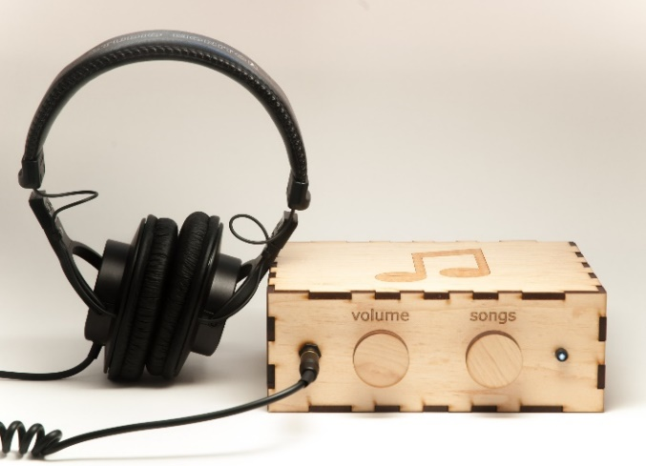DQMusicBox allows some people with dementia to listen to and control their favorite music. It uses a familiar old school car radio interface to control what is effectively a big MP3 player.

That’s DQ in the photo – my Dad. My son & I were inspired to make a music box by the documentary [Alive Inside](http://www.aliveinside.us/#land) -- it suggests that people with dementia come alive when listening to their favorite music. Following that suggestion, I put DQ’s favorite music on an iPad. There was sustained joy on his face – joy from the familiar music and joy from the fact that nothing else in the frustrating world mattered for a few minutes. My Dad is doing pretty well at home. But he can’t operate their big stereo or their iPad. But he can use DMusicBox without assistance.

Now let’s talk about you. I’m assuming that you are a nerd. Like me. But I have done some of the nerdy work for you. You can order the parts from Amazon and Ponoko. They will show up at your door. No soldering required. No laser cutting required. The hardest part is probably copying the software to the micro-SD card, which requires installing software on your computer. And you do have to connect some wires. And use Elmer’s wood glue. If you need help, you probably have a friend that can help you for an afternoon for a good cause like this.



|  |  |
| --- | --- |
| **Parts cost** | $110 - $170, depending on options chosen; includes headphones. |
| **Music cost** | Minimal as you should use the recipient’s existing music collection. |
| **Build time** | About two hours, once you have the parts & music. |
| **Soldering?** | No. |
| **Command-line Linux?** | No. |
| **Tools needed** | A computer with an SD card reader, fingers. |
| **Laser cutter needed?** | No. You can mail order the pre-cut pieces for the wood case. |
| **Beverage?** | Yes. I recommend a hoppy IPA while you are assembling. |

|  |  |
| --- | --- |
|  |  |

# Summary of steps

The point of the summary below is to show that it is not a hard build. But please read the rest of this document before you build – you’ll save yourself some headaches.

|  |  |  |
| --- | --- | --- |
| **1) Order parts from Amazon & Ponoko** | **2) Assemble recipient’s favorite music**  Complete Beethoven Edition, Vol. 1: Symphonies | **3) Copy software to micro-SD card**  http://ecx.images-amazon.com/images/I/71sgCaQGpKL._SL1500_.jpg |
| **4) Receive parts from Ponoko** | **5) Glue case together** | **6) Install front panel items** |
| **7) Place Pi & plastic case** | **8) Connect wires** | **9) Power up & test** |

# No warranty

USE THESE DQMUSICBOX PLANS AND SYSTEM AT YOUR OWN RISK. THE DQMUSICBOX PLANS ARE PROVIDED AS IS WITHOUT WARRANTY OF ANY KIND EITHER EXPRESSED OR IMPLIED, INCLUDING, BUT NOT LIMITED TO, THE IMPLIED WARRANTIES OF MERCHANTABILITY AND FITNESS FOR A PARTICULAR PURPOSE. THE ENTIRE RISK AS TO THE QUALITY AND PERFORMANCE OF THE PLANS AND SYSTEM IS WITH YOU. SHOULD THE PLANS OR SYSTEM PROVE DEFECTIVE, YOU ASSUME THE COST OF ALL NECESSARY SERVICING, REPAIR OR CORRECTION. IN NO EVENT WILL ANY PARTY BE LIABLE TO YOU FOR DAMAGES, INCLUDING ANY GENERAL, SPECIAL, INCIDENTAL OR CONSEQUENTIAL DAMAGES ARISING OUT OF THE USE OR INABILITY TO USE THE PLANS OR SYSTEM.

# Acknowledgements

People were very generous with their time, and I really enjoyed the experience. This is certainly an incomplete list: Alex & Mike & others at [Ada’s](http://blog.seattletechnicalbooks.com/), the super smart staff at [Metrix](http://www.metrixcreatespace.com/), neighbor Randy, [Stephen Christopher Phillips](http://scphillips.com/), [Bob Rathbone](http://www.bobrathbone.com/), [Stephen Rusk](http://www.stephenrusk.com/), [Graham Hill](http://www.ted.com/speakers/graham_hill), support at [Ponoko](https://www.ponoko.com/), and my son.

# What DQMusicBox does

## For the end user

The intent is to keep it simple for the end user, so only three end-user use-cases:

|  |  |
| --- | --- |
| **Name** | **Description & implementation** |
| Start song | Turning either of the knobs will start music playing. |
| Change song | Turn the songs knob. |
| Change volume | Turn the volume knob. |

## For you

DQMusicBox can do more than the above. Here are things that I tend to do:

|  |  |
| --- | --- |
| **Name** | **Description & implementation** |
| Pause | Tap the volume knob. Note that this also happens automatically – music pauses if there are no knob events in one hour. |
| Shut down | Long hold (15-30 seconds) on the volume knob. |
| Reboot | Long hold (15-30 seconds) on the songs knob. |
| Add/remove music | Either by adding/removing files on the memory card, or by connecting over the network. You probably don’t need to do this very often. |
| Troubleshoot | If you make a network-connected DQMusicBox, you can troubleshoot by connecting to it and reviewing the verbose logs. |

# About Ponoko

For this purpose, Ponoko is a company that laser cuts wood and sends you the pieces. You don’t need to use Ponoko – you are welcome to take my case designs to your local maker space and cut there. In other words, Ponoko is convenient but not necessary. Ponoko ships to the US and NZ. If you want to use Ponoko, now would be a good time to create an account at http://ponoko.com.

# The parts

A list of parts is below. Just choose which model you want to build, then order the parts. You may already have a few of these items e.g. wood glue, Velcro.

|  |  |  |
| --- | --- | --- |
|  | **Recommended** | **Value** |
|  | Maple veneer – attractive, does not need protective coating. Attractive, can be administered over the network. Good headphones. | Birch veneer – attractive if you give it a needed protective coating. Cannot be administered over the network. Basic headphones. |
| **Part** | ~$170 + tax + shipping | ~$110 + tax + shipping |
| Wood case | [DQMusicBox maple veneer case](http://www.ponoko.com/design-your-own/products/dqmusicbox-case-maple-12981). Takes ~15 minutes to order. Case pieces arrive in ~2 weeks. Choose “Add to Personal Factory”. If prompted, choose Premium Veneer MDF – Maple, 24’x12’. | [DQMusicBox birch veneer case](http://www.ponoko.com/design-your-own/products/dqmusicbox-case-value-birch-12976). Takes ~15 minutes to order. Case pieces arrive in ~2 weeks. Choose “Add to Personal Factory”. If prompted, choose: Veneer Core - Birch, 0.204 inches thick, P2 size. |
| Raspberry Pi | [Pi 2 Model B (1GB) Basic Starter Kit](http://www.amazon.com/gp/product/B00TFV5QTA?psc=1&redirect=true&ref_=oh_aui_detailpage_o03_s00) | [Raspberry Pi Model A+](http://www.amazon.com/Raspberry-Pi-Model-A-256MB/dp/B00PEX05TO/ref=sr_1_1?ie=UTF8&qid=1445830840&sr=8-1&keywords=raspberry+pi+model+A%2B) |
| Plastic case | Included in kit above | [Acrylic case](http://www.amazon.com/Raspberry-Pi-Acrylic-Case-Emerald/dp/B00PQ86H94/ref=sr_1_15?ie=UTF8&qid=1445830840&sr=8-15&keywords=raspberry+pi+model+A%2B) |
| Power supply | Included in kit above | [2amp power supply](http://www.amazon.com/NorthPada-Supply-Charger-2000mA-Raspberry/dp/B00OY7HR1U/ref=pd_sim_147_4?ie=UTF8&dpID=41FH0W0vNpL&dpSrc=sims&preST=_AC_UL160_SR153%2C160_&refRID=16F88Z8F821HHRNJT2S3) |
| Rotary encoder KY-040 (3) | [KY-040](http://www.amazon.com/gp/product/B00HSX9ZB2?psc=1&redirect=true&ref_=oh_aui_search_detailpage) (3). Order 3 in case one is defective. | [KY-040](http://www.amazon.com/gp/product/B00HSX9ZB2?psc=1&redirect=true&ref_=oh_aui_search_detailpage) (3). Order 3 in case one is defective. |
| USB audio adapter | [Pluggable](http://www.amazon.com/gp/product/B00NMXY2MO?psc=1&redirect=true&ref_=oh_aui_detailpage_o00_s00) | [Pluggable](http://www.amazon.com/gp/product/B00NMXY2MO?psc=1&redirect=true&ref_=oh_aui_detailpage_o00_s00) |
| Indicator LED | [StarTech BEZELWRKIT](http://www.amazon.com/gp/product/B00213KDQK?psc=1&redirect=true&ref_=oh_aui_detailpage_o07_s00) | [StarTech BEZELWRKIT](http://www.amazon.com/gp/product/B00213KDQK?psc=1&redirect=true&ref_=oh_aui_detailpage_o07_s00) |
| 8GB micro-SD card | [Kingston](http://www.amazon.com/gp/product/B00200K1TS?psc=1&redirect=true&ref_=oh_aui_detailpage_o05_s00) | [Kingston](http://www.amazon.com/gp/product/B00200K1TS?psc=1&redirect=true&ref_=oh_aui_detailpage_o05_s00) |
| Male-female jumper wires | [Veewon jumper wires](http://www.amazon.com/Phantom-YoYo-Dupont-Cable-Female/dp/B00KOL5BCC/ref=sr_1_2?ie=UTF8&qid=1448088205&sr=8-2&keywords=jumper+wires+10cm) | [Veewon jumper wires](http://www.amazon.com/Phantom-YoYo-Dupont-Cable-Female/dp/B00KOL5BCC/ref=sr_1_2?ie=UTF8&qid=1448088205&sr=8-2&keywords=jumper+wires+10cm) |
| Short headphone cable | [StarTech 1ft](http://www.amazon.com/gp/product/B004G7U40Y?psc=1&redirect=true&ref_=oh_aui_detailpage_o03_s00) | N/A |
| Panel mount headphone jack | [Thru panel mount jack](http://www.amazon.com/gp/product/B004JX64FE?psc=1&redirect=true&ref_=oh_aui_detailpage_o03_s00) | N/A |
| Sticky back Velcro | [3 1/2" x 3/4" Strips, 4 Sets](http://www.amazon.com/gp/product/B000TGSPV6?psc=1&redirect=true&ref_=oh_aui_search_detailpage) | [3 1/2" x 3/4" Strips, 4 Sets](http://www.amazon.com/gp/product/B000TGSPV6?psc=1&redirect=true&ref_=oh_aui_search_detailpage) |
| Wood glue | [Elmer’s](http://www.amazon.com/Elmers-E7010-Carpenters-Wood-Ounces/dp/B0045PTHH8/ref=sr_1_2?ie=UTF8&qid=1435530734&sr=8-2&keywords=wood+glue) | [Elmer’s](http://www.amazon.com/Elmers-E7010-Carpenters-Wood-Ounces/dp/B0045PTHH8/ref=sr_1_2?ie=UTF8&qid=1435530734&sr=8-2&keywords=wood+glue) |
| Headphones (or use your existing headphones) | [Sennheiser HD 202 II](http://www.amazon.com/gp/product/B003LPTAYI?psc=1&redirect=true&ref_=oh_aui_search_detailpage). My son the musician reports that these headphones are an excellent value at $22. Or upgrade to [Sony MDR7506](http://www.amazon.com/gp/product/B000AJIF4E?psc=1&redirect=true&ref_=oh_aui_search_detailpage). My father reports that with these headphones (~$80), he hears things in the music that he has never heard before. | [Panasonic RP-HT21](http://www.amazon.com/gp/product/B00004T8R2?psc=1&redirect=true&ref_=ox_sc_act_title_2&smid=ATVPDKIKX0DER) ($5). These are basic but surprisingly good headphones. Or upgrade to [AmazonBasics On-Ear](http://www.amazon.com/gp/product/B00NBEWB4U?psc=1&redirect=true&ref_=oh_aui_detailpage_o02_s00) ($15). |

Some additional options:

* **Go fast.** If you need to build a DQMusicBox quickly, the two parts that will likely take the most time to arrive are the wood case and the KY-040 rotary encoders. You can pay wood case maker (Ponoko) more to make and deliver quickly. The KY-040 rotary encoders ship from Hong Kong and take ~3 weeks to arrive in the US. For faster service to the US, try a US-based seller on eBay, but make sure that you get the KY-040 with mounting/screw threads.
* **Add stain and/or clear coat.** The maple case doesn’t really need staining or clear coating – that is one reason why I chose this particular wood. But I brushed on a bit of [linseed oil](http://www.amazon.com/Tried-True-Wood-Finish-Danish/dp/B003DL6VQA/ref=sr_1_3?ie=UTF8&qid=1448501512&sr=8-3&keywords=danish+oil) and that did improve the look a bit. The birch case is thirsty so a protective coating is useful; I used linseed oil. If you have a friend that does woodworking, talk with them, you only need a tiny amount of something that they probably already have.
* **Go cherry.** There is a cherry version of the DQMusicBox. That cherry wood is thirsty, so do stain and/or clear coat it- [linseed oil](http://www.amazon.com/Tried-True-Wood-Finish-Danish/dp/B003DL6VQA/ref=sr_1_3?ie=UTF8&qid=1448501512&sr=8-3&keywords=danish+oil) works well.
* **Go custom.** You don’t have to order the case from Ponoko. The design files are in [Github](https://github.com/rosswesleyporter/dqmusicbox). You are welcome to customize these design files and get the case laser cut at your local maker space.

# Assemble the personalized collection of music

This is the most important step. The personalized (familiar) music is the fundamental magic. You don’t need much music, perhaps 6-10 albums. But only familiar favorites. One of the few benefits of dementia is that you don’t remember what you just listened to and thus don’t get tired of your favorite albums. My Mom mailed me my Dad’s favorite CDs. In some cases, I purchased better recordings of the same songs for him e.g. upgraded him from a generic recording of Beethoven’s 9th, to the 1977 Berlin Philharmonic recording. Organize the music into folders, one folder per album. MP3, FLAC, and AAC/MP4/iTunes files are supported. It will take 2-3 weeks for the electronic parts above to arrive, so you have time to do this well. In the end, you should a set of folders that looks something like this:

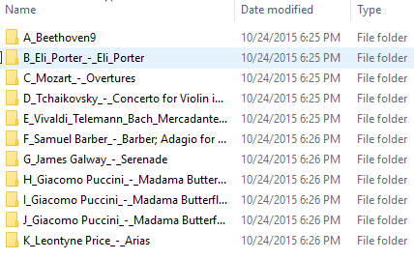

# Prepare the micro-SD card

I prepared a disk image for you. Your job is to download this disk image and then write it to a micro-SD card. The instructions below assume that you are using a Windows computer with an SD card reader/writer. If you don’t have a computer with an SD card reader/writer, you probably have a friend who does, and it only takes 20 minutes to write the image (after downloading). The steps:

1. Download the [DQMusicBox disk image](https://onedrive.live.com/?authkey=%21ACDtkVOa_yd6dfI&cid=607157B747FA4BBF&group=0&id=607157B747FA4BBF%2199193&parId=607157B747FA4BBF%2196855&action=locate). This is a 2.5GB file, so it will take a while to download.  
   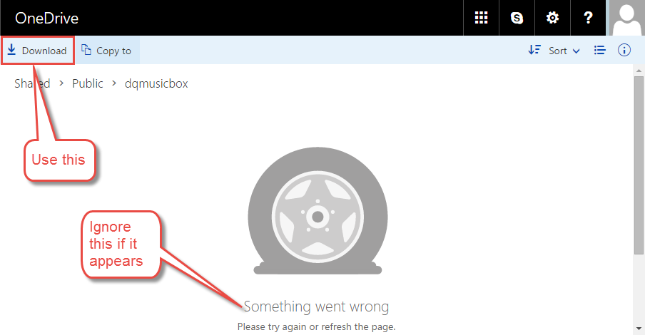
2. Unzip dqmusicbox_2015_11_19.zip. This will extract dqmusicbox_2015_11_19.img – use this .img file below.
3. Install [Win32 Disk Imager](http://sourceforge.net/projects/win32diskimager/) on your Windows computer.
4. Put the micro-SD card into the SD card adapter i.e. put the tiny card into the larger card.
5. Put the SD card adapter into the SD reader/writer in your computer.
6. Start the Win32 Disk Imager program, instruct it to write the image file to the SD card:  
   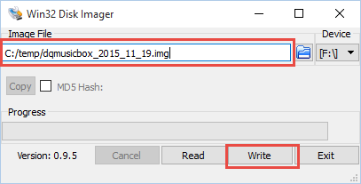
7. Wait for the write to complete. This would be a good time to make a sandwich.

# Copy the personalized collection of music to the micro-SD card

Your computer should now see the micro-SD card as a drive named ‘boot’:

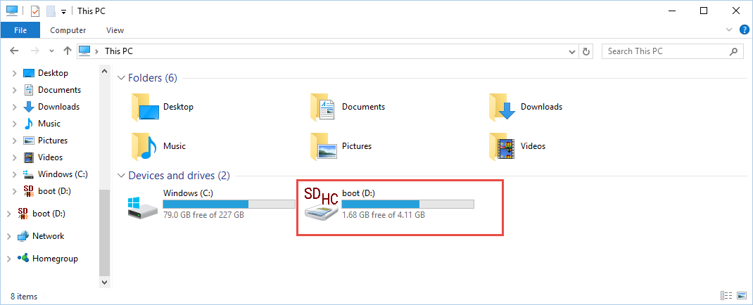

Copy the personalized collection of music to the micro-SD card. That is, copy the folders that you created above into the /dqmusicbox/music folder on your micro-SD card. The result should be something like this:

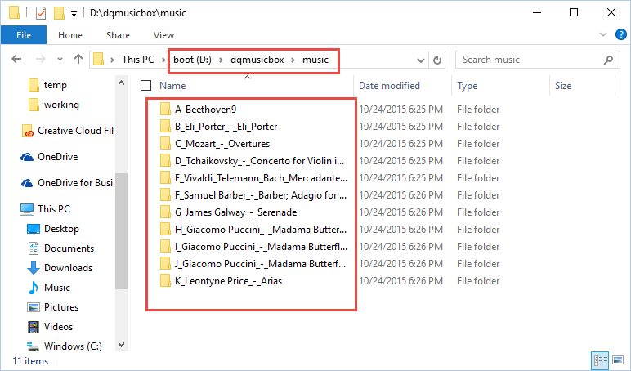

If you see a subfolder named ‘0RossTestTracks’, feel free to delete it now.

# Put it all together

What you should end up with (with top removed):

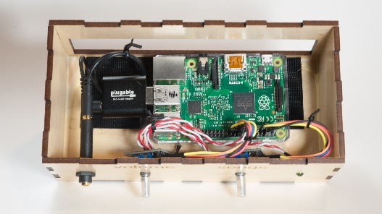

I don’t think you need all the steps listed out. But here are a few tips for putting it all together:

1. Glue the bottom and sides of the wood case. Put the top on, but don’t glue it. Use painter’s tape or other to hold the box together while the glue dries.
2. If using a Raspberry Pi Model A+, assemble the plastic case.
3. Put the Raspberry Pi into the plastic case; insert the USB audio adapter.
4. Use Velcro to hold the Raspberry Pi plastic case in place on the wood case.
5. Mount the rotary encoders in the two medium-sized holes in front panel.
6. Find the LED labeled HDD. Push the LED through the small hole in the front panel.
7. If you are using the maple case, mount the headphone jack connector in the large hole in the front panel.
8. If you are using the birch case, the place the Pi & USB audio adapter such that the side of the wood case keeps the headphone cable in place.
9. Now add the wires:



# Test cases

Now that you have assembled everything, it is time to test.

|  |  |
| --- | --- |
| **Name** | **Description & Expectation** |
| Light 1min after power on | The indicator LED turns on when DQMusicBox is ready to play music, which is generally about 1 minute after power on. |
| Start song | Turning either of the knobs will start music playing. |
| Change song | Turn the songs knob. If you go forward and backward through the song list as expected, then all is well. |
| Change volume | Turn the volume knob. If the volume goes up and down as expected, then all is well. |
| Pause | Tap the volume knob. Tap the songs knob. Both should work. |
| Shut down | Long hold (15-30 seconds) on the volume knob. |
| Reboot | Long hold (15-30 seconds) on the songs knob. |

# If you have an network connected DQMusicBox

If you have a network connected DQMusicBox (maple case containing Raspberry Pi 2, with Ethernet cable attached), then you can administer and troubleshoot over the network. It helps if you are a nerd.

|  |  |
| --- | --- |
| **Name** | **Description & Expectation** |
| SSH | You can get command line access via [PuTTY](http://www.chiark.greenend.org.uk/~sgtatham/putty/download.html) to dqmb. |
| View log files | If connected via SSH, you can view the verbose log file at tail –f /var/log/dqmusicbox.log |
| SFTP | You can transfer files, including music, via [WinSCP](https://winscp.net/eng/download.php) or similar to dqmb. |

# Congratulations

Congratulations! You should have a fully functional DQMusicBox.