Download noobs

<https://www.raspberrypi.org/downloads/noobs/>

Make sure to use the same version as everyone else for consistency

1.9.2

2016-05-27

Format micro sd card to fat32

Extract to the sd card

Boot pi with the card

Check Raspian and install that

I am simply connecting to wifi here

Believe that ethernet can be used

Wait for a little while after boot and then right click on the top right internet thing

And then select the wifi

This RPI super easy compared to past setups

Open browser and go to some website to confirm it works

SSH:

ping raspberrypi

Will return some IP … in my case:

192.168.1.165

ssh pi@192.168.1.165

Password: raspberry

VNC:

sudo apt-get install tightvncserver

<https://www.realvnc.com/download/viewer/>

<https://www.raspberrypi.org/documentation/remote-access/vnc/>

vncviewer -geometry 1920x1080

Once have the IP and the 'key' can use vncviewer to log in

Example:

192.168.1.165:1

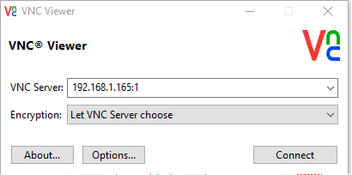

Sound:

<https://www.raspberrypi.org/documentation/configuration/audio-config.md>

Sudo raspi-config

Advanced options

Audio

3.5mm

Enable ssh:

<https://www.raspberrypi.org/documentation/remote-access/ssh/>

Sudo raspi-config

Advanced options

ssh

Pull the repo:

Git clone<https://github.com/bcrafton/Capstone>

Install pyaudio:

sudo apt-get install python-pyaudio

Copy and Paste:

sudo apt-get install autocutsel

nano /home/pi/.vnc/xstartup

*#!/bin/sh*

xrdb $HOME/.Xresources

xsetroot -solid grey

autocutsel -fork

*#x-terminal-emulator -geometry 80x24+10+10 -ls -title "$VNCDESKTOP Desktop" &*

*#x-window-manager &*

*# Fix to make GNOME work*

export XKL_XMODMAP_DISABLE=1

/etc/X11/Xsession

Finding local machines ip on windows:

Control panel

Network and internet

View network status and tasks

Connections ->

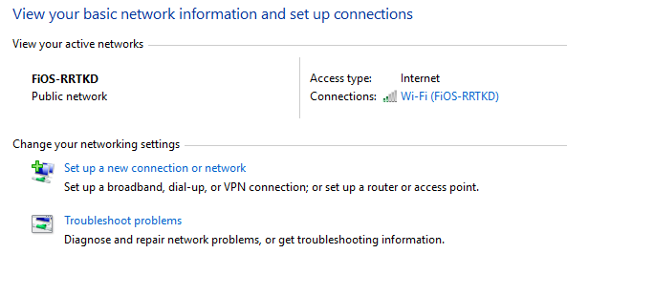

Details

Ip address

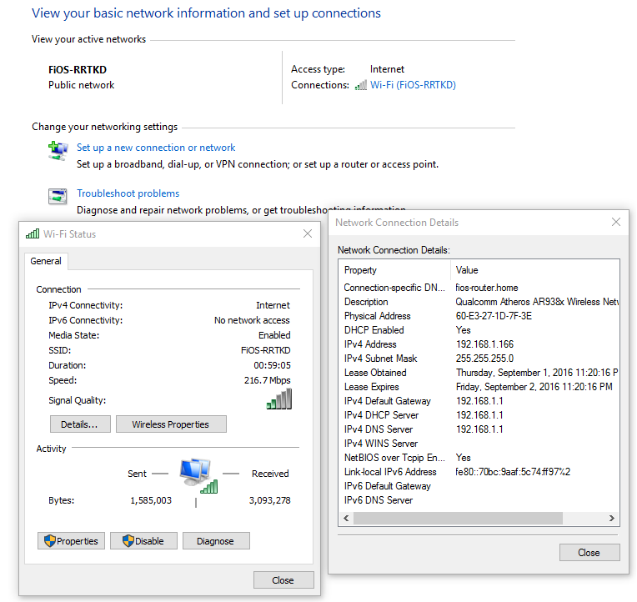

If you run tcpserver.py

And tcpclient.py

And modify the IP addresses

Then you should hear stairway to heaven playing!!!