Github username: anhvietcr

Docker username: anhvietcr

Heroku username: anhvietcr20@gmail.com

NODEJS + NPM + HEROKU

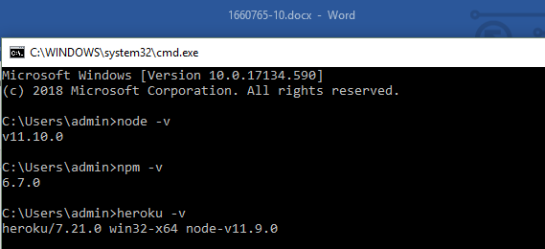

GIT:

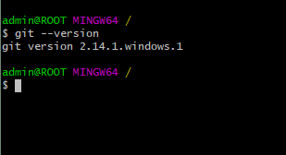

POSTGRESQL + Manager SQL

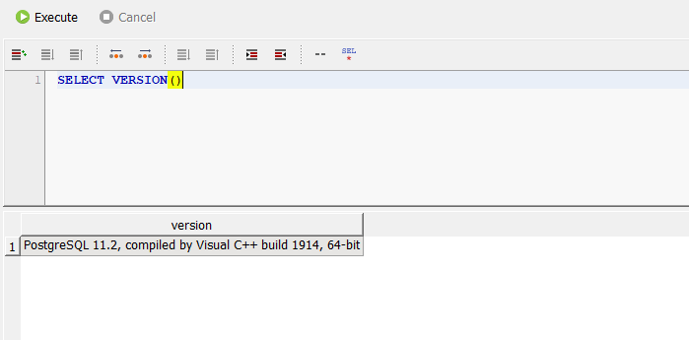

DOCKER:

