**INSTRUCTIONS - PRACTICAL EXAM – CSD201**

Read the instructions below carefully before start coding.

**======================================================================**

**Students are ONLY allowed to use:**

* Software tools must be used: **NetBeans IDE 8.x** and **Java JDK 1.8**.
* His / her own study materials like presentation slides, notes, sample codes, program examples, electronic books stored on his / her computer only.
* For distance learning: Google Meet, Hangout (for Exam Monitoring Purpose).

**Instructions**

* Step 1: run “Clean and Build Project” (Shift+F11) to create **dist** folder and **.jar** file.
* Step 2: Prepare to submit answer:
  + For each question (e.g., question **1**), please create two sub-folders: **run** and **src**.
  + Copy *.**jar** file into **run** folder
  + Compress source code into **.zip**, then copy .**zip** file into **src** folder.
* Step 2: Submit solution for each question:
  + Choose question number (e.g., **1**) in PEA software, and then attach corresponding solution folder (e.g., **1**). Click Submit button to finish submitting this question.
  + 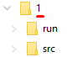

**Notes**

* **Do not use accented Vietnamese** when writing comments in programs.
* Solutions will be marked by Automated Marking Software.
* **If at least one of the above requirements is not followed, the exam will get ZERO.**

**======================================================================**

**Question 1: (3 marks)**

Write a program to build a binary search tree by inserting ***N*** (1 ≤ ***N*** ≤ 100) integer values into the BST one by one. Note that the nodes have no duplicate values.

Your task is to display the pre-order and post-order traversing of the BST.

*For example,*

* Create a BST tree by successively adding to the tree ***N*** integer values as follows: 7, 9, 4, 1, 12, 6, 10.
* The pre-order traversing of the BST tree is: 7, 4, 1, 6, 9, 12, 10.
* The post-order traversing of the BST tree is: 1, 6, 4, 10, 12, 9, 7.

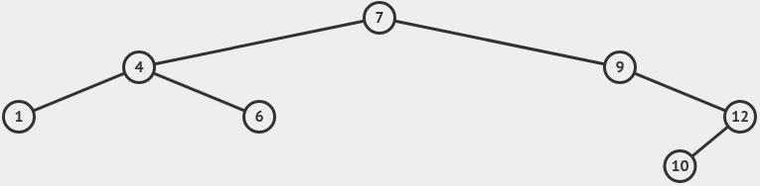

*Figure 1. The BST that created by inserting 7, 9, 4, 1, 12, 6, 10 one by one*

**The input**: are stored in the ***ex01_input.txt*** text file:

* The first line contains a positive integer ***N*** (1 ≤ ***N*** ≤ 100) which is the number of integer values to insert into the BST.
* The second line containing ***N*** integers that will be inserted into the BST one by one, each number separated by at least one space.

**The output:** the results need to be saved to the ***ex01_output.txt*** text file:

* The first line contains the sequence of numbers representing the pre-order traversing of the BST.
* The first line contains the sequence of numbers representing the post-order traversing of the BST.

|  |  |
| --- | --- |
| *Sample Input 1* | *Sample Output 1* |
| 7  7 9 4 1 12 6 10 | 7,4,1,6,9,12,10  1,6,4,10,12,9,7 |

|  |  |
| --- | --- |
| *Sample Input 2* | *Sample Output 2* |
| 9  10 7 6 2 18 13 2 6 4 | 10,7,6,2,4,18,13  4,2,6,7,13,18,10 |

**Question 2: (4 marks)**

Write a program to build an **undirected** graph by giving adjacency matrix.

Your task is finding and showing all edge of the MST of the given undirected graph.

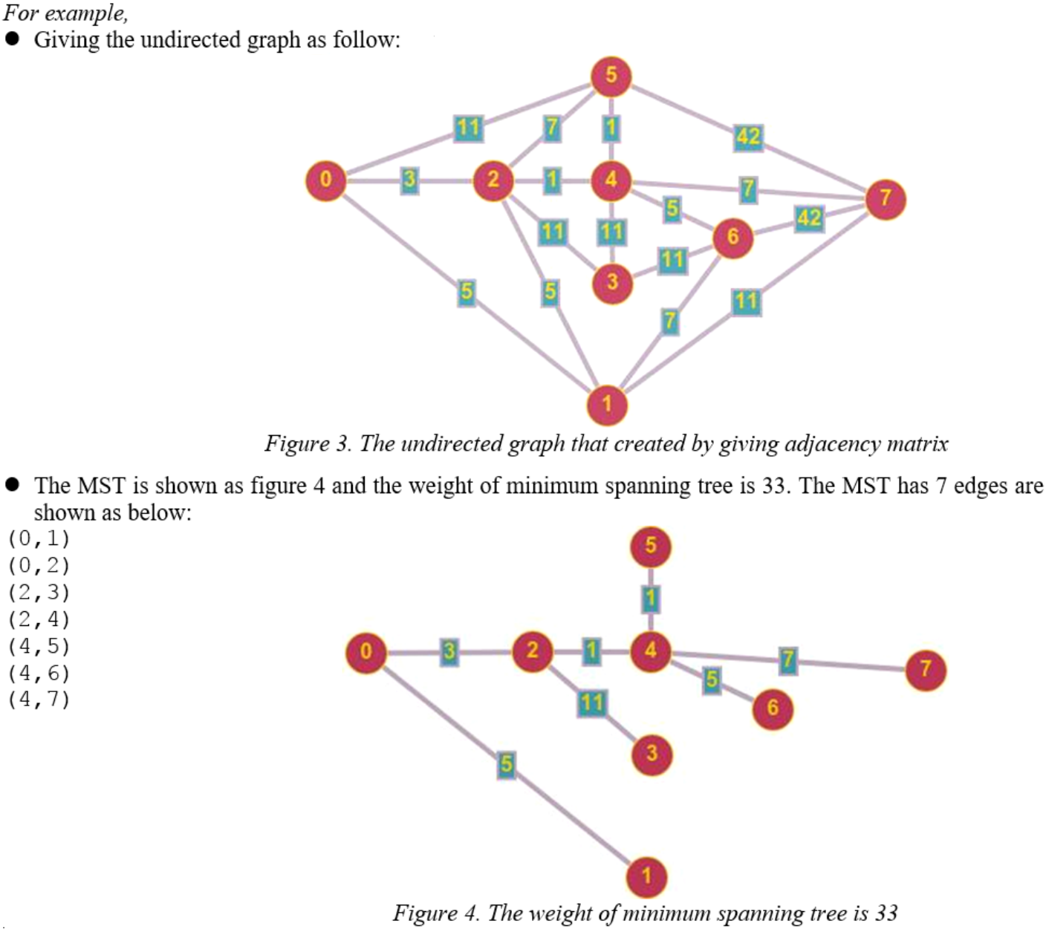

**The input**: are stored in the ***mst_input.txt*** text file:

The first line contains a positive integer ***N*** (1 ≤ ***N*** ≤ 100) which is the number of vertex of undirected graph.

The next ***N*** line, each line containing ***N*** integers that represent the adjacency matrix.

**The output:** the results need to be saved to the ***mst_output.txt*** text file:

One line contains the weight of minimum spanning tree.

|  |  |
| --- | --- |
| *Sample Input 1* | *Sample Output 1* |
| 8  0 5 3 0 0 11 0 0  5 0 5 0 0 0 7 11  3 5 0 11 1 7 0 0  0 0 11 0 11 0 11 0  0 0 1 11 0 1 5 7  11 0 7 0 1 0 0 42  0 7 0 11 5 0 0 42  0 11 0 0 7 42 42 0 | 33 |

|  |  |
| --- | --- |
| *Sample Input 2* | *Sample Output 2* |
| 6  0 7 5 0 0 1  7 0 0 0 0 0  5 0 0 2 3 0  0 0 2 0 7 0  0 0 3 7 0 9  1 0 0 0 9 0 | 18 |

**Question 3: (3 marks)**

Write a program to build a binary search tree by inserting ***N*** (1 ≤ ***N*** ≤ 100) integer values into the BST one by one. Note that the nodes have no duplicate values.

Your task is to display the list of leaves of the BST by pre-order traversing.

*For example,*

* Create a BST tree by successively adding to the tree ***N*** integer values as follows: 7, 9, 4, 1, 12, 6, 10.
* The BST has 3 leaves including 1 and 6 and 10.



*Figure 4. The BST has 3 leaves including 1 and 6 and 10*

**The input**: are stored in the ***ex03_input.txt*** text file:

* The first line contains a positive integer ***N*** (1 ≤ ***N*** ≤ 100) which is the number of integer values to insert into the BST.
* The second line containing ***N*** integers that will be inserted into the BST one by one, each number separated by at least one space.

**The output:** the results need to be saved to the ***ex03_output.txt*** text file:

* Only one line contains the list of leaves of the BST by pre-order traversing, each value separated by one comma.

|  |  |
| --- | --- |
| *Sample Input 1* | *Sample Output 1* |
| 7  7 9 4 1 12 6 10 | 1,6,10 |

|  |  |
| --- | --- |
| *Sample Input 2* | *Sample Output 2* |
| 9  10 7 6 2 18 13 2 6 4 | 4,13 |