CONTENT

Question 1: Given an undirected graph G with a list of edges saved in the file input.txt.
Write a program to perform the degree of each vertex in the graph. The format of file output.txt:
vertex -- degree of vertex

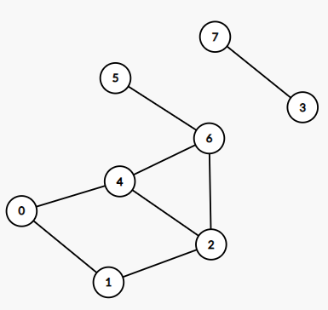
8 8
0 1
0 4
1 2
2 4
2 6
3 7
4 6
5 6
input.txt
0--2
1--2
2--3
3--1
4--3
5--1
6--3
7--1
output.txt

Question 2: Create a binary search tree for the sequence of numbers in the file input.txt.
Write a program to traverse Preorder in the tree. The output format in the output.txt file is:
List of nodes in Preorder traversal

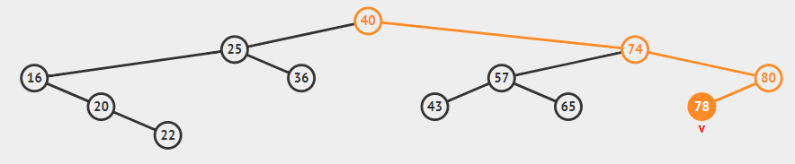

12
40 25 74 57 65 80 16 20 43 22 36 78

input.txt
40,25,16,20,22,36,74,57,43,65,80,78
output.txt

Question 3: Given an undirected graph G with a list of arcs saved in the file input.txt. Write a program to use Dijkstra's algorithm to find the shortest path from vertex 0 to all the remaining vertices of the graph. The format of file output.txt:
vertex --- path length
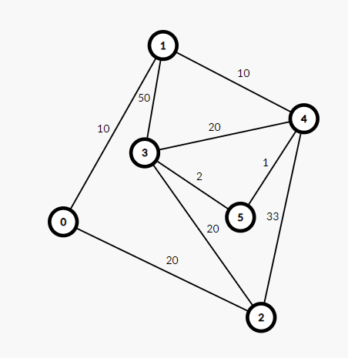
6 9
0 1 10
0 2 20
1 3 50
1 4 10
2 3 20
2 4 33
3 4 20
3 5 2
4 5 1
input.txt
0--0
1--10
2--20
3--23
4--20
5--21
output.txt

